A Tattoo
I started this exercise by looking into the history of tattoos and how they came about and the meaning or history behind them.
Tattoos are a permanent form of body art which belong to many different cultures all over the world. Tattoos come from as far back as on mummified skin believed to be between 3370 BC and 3100 BC. There was an Ice man that was found mummified back in 2012, he had a total of 61 tattoos on his body, the majority were ink inscriptions located on his legs, and these were created using soot and ash.
In ancient China folk heroes and bandits had tattoos and more commonly convicted criminals had one tattoo on their face to warn other members of society that they could not be trusted.
In ancient Egypt tattoos were used as part of medical treatment and to treat ailments, it seems it was only used on women.
In India tattoos are used for tribal reasons and for their own small tribe culture.
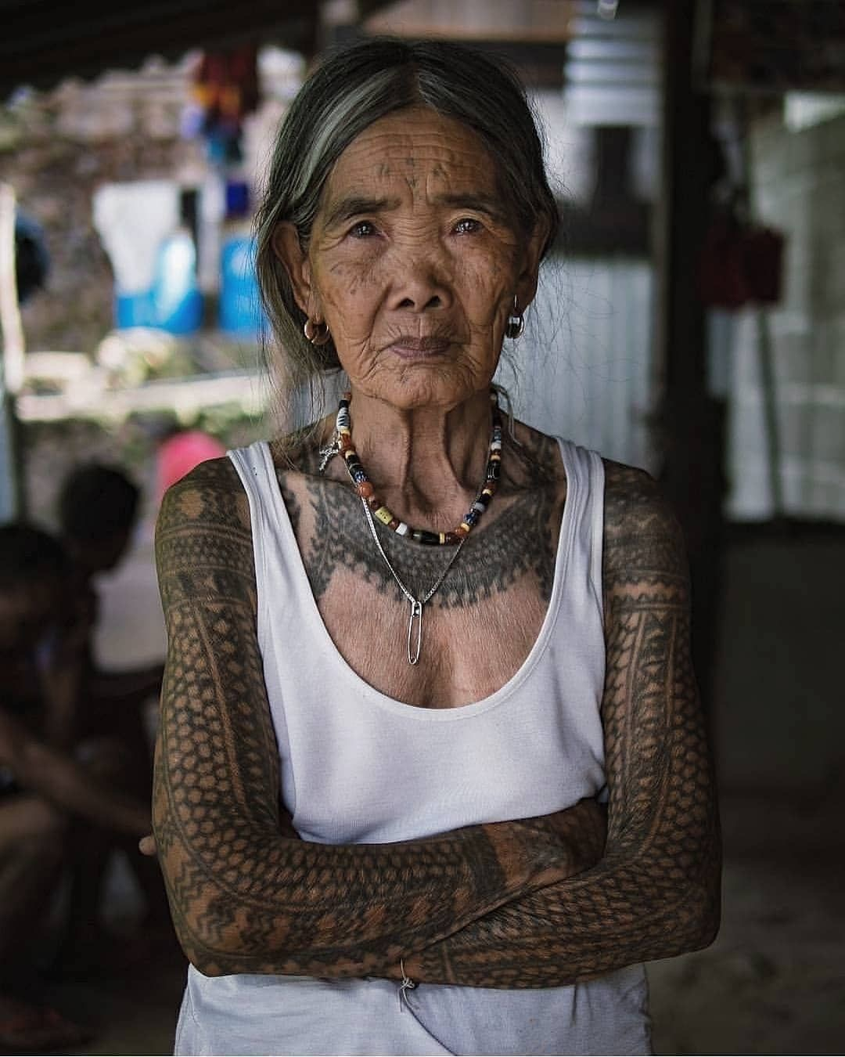

Tattoos were not commonly or socially acceptable until the mid twentieth century, when it became popular in entertainment, tattoos were a popular attraction at fairs and circuses.
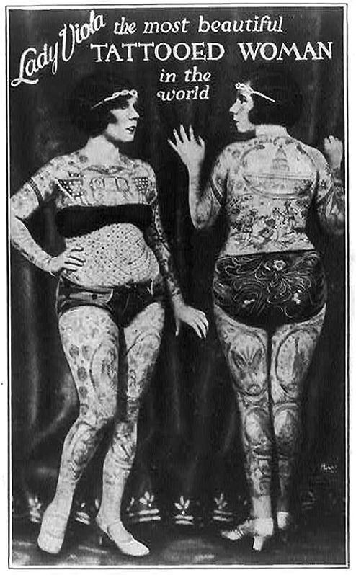
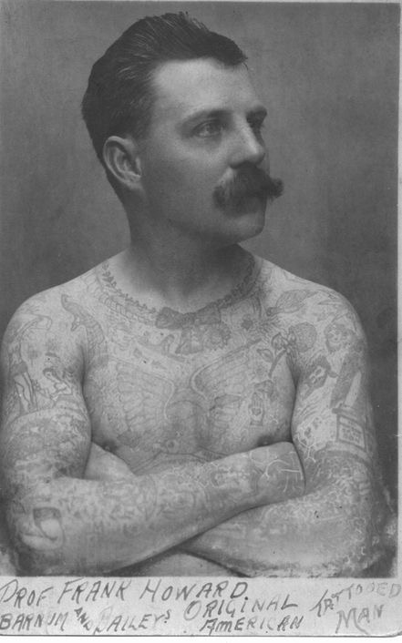
This then moved into the sailing community, when young sailors would come back from trips with tattoos from different parts of the world and the length of their journey, a turtle would mean that they had crossed the equator and a swallow tattoo symbolised a journey of 5000 miles.
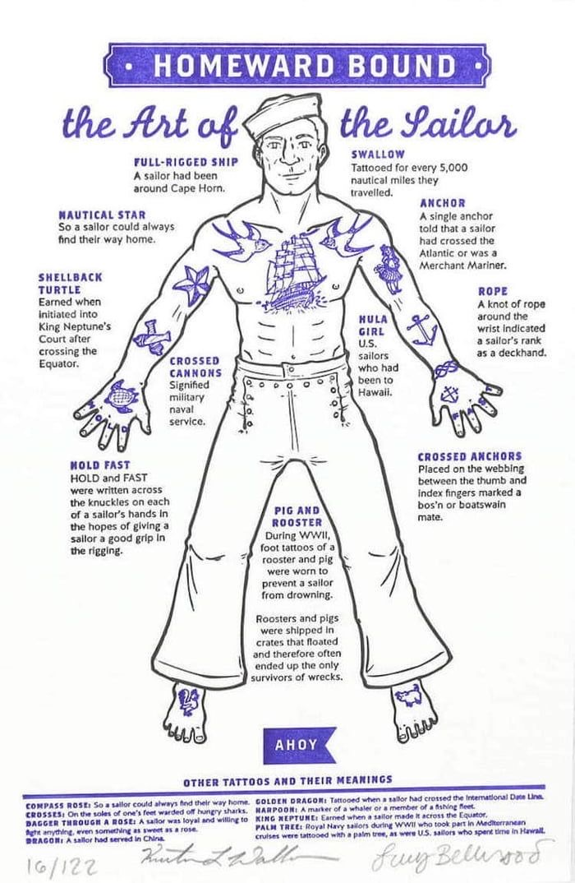

In the 1940’s the sailor jerry style tattoo became popular and the introduction of colour was added by using own pigment, there was a rise in patriotic tattoos due to WW2, also as women were in the work place then, it bought tattoos to women, this made the acceptance of tattoos rise and taboo of them go.
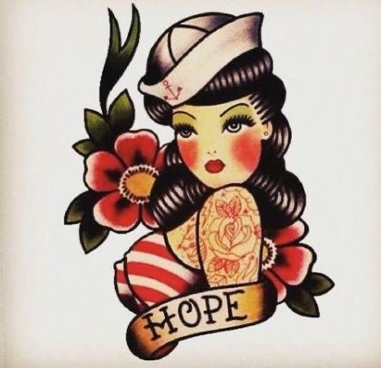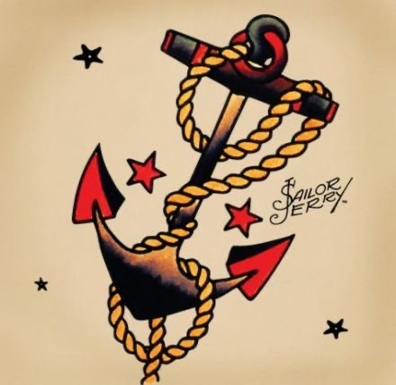
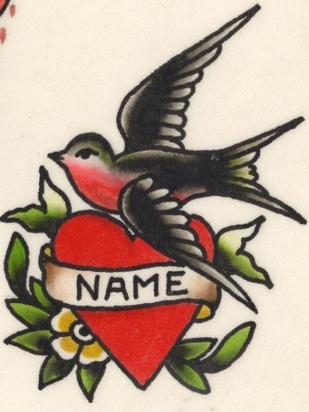
In the 1960’s tattoos became even more popular and even celebrities were getting them, like Janis Joplin. The classic skull and crossbones were particularly popular especially within the biking community.
In the 1970’s tattoos became more mainstream, Peace symbols and messages of peace were particular popular, as well as full sleeves and body suits, the designs became more intricate.
In the 1980’s Tattoos have bigger and brighter, with bold black outlines and Celtic knots and colourful rose designs. The music of the era also impacted the industry with rock and roll designs.
More modern day designs have been inspired by old cultural symbols, but given a modern twist.
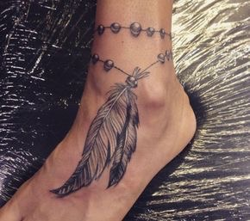
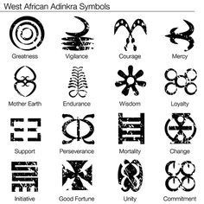
Tattoos today seem to be more refined, delicate and simple. The designs are smaller as more people want tattoos but only on a small scale and in different places.
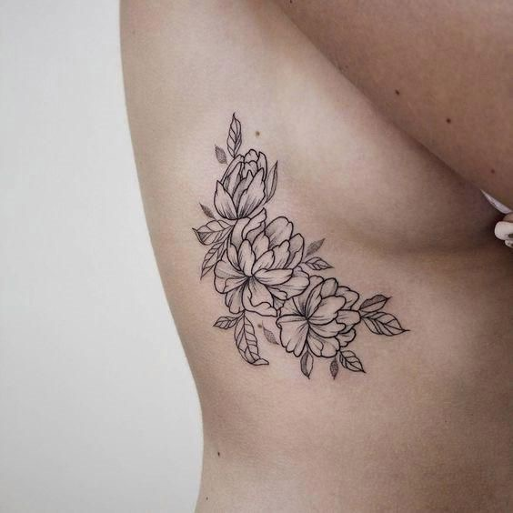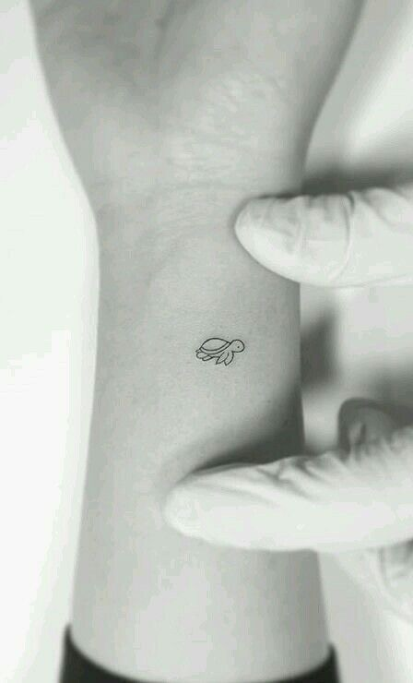
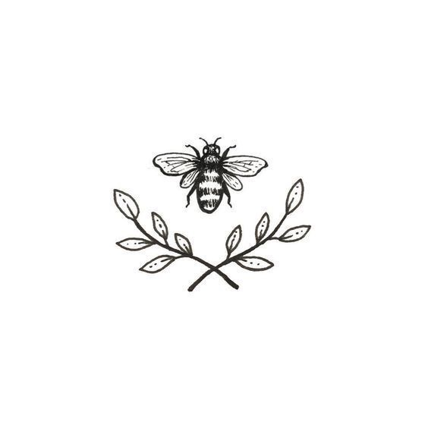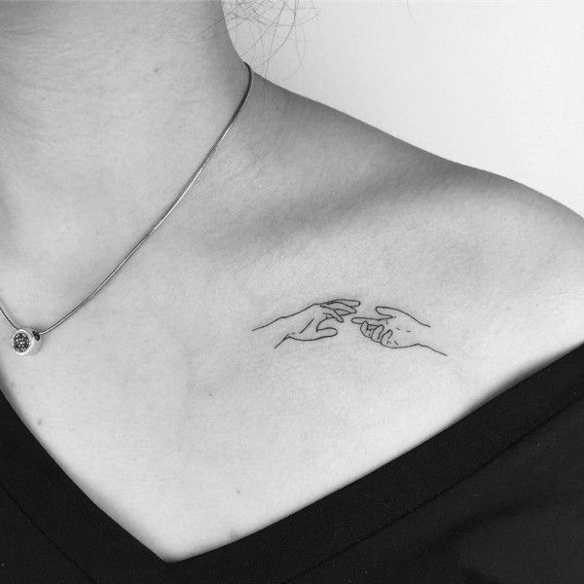
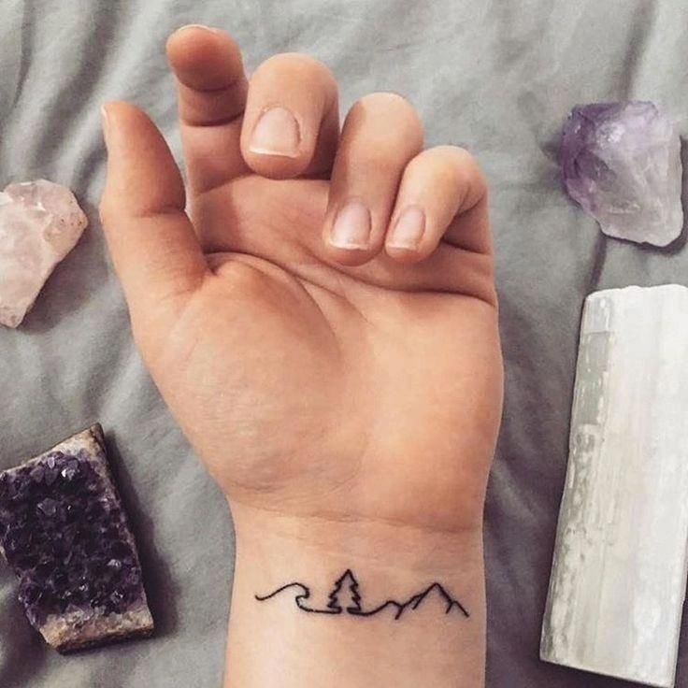
So from this research I also had a look at illustrators that designed tattoos and I found the artist and illustrator DnO Art, He works as a freelance graphic designer, Illustrator and sound Design in his home office in Berlin. DnO designs for Tattoo’s, book-covers, posters, audio branding, logo design, stationary and advertisements.
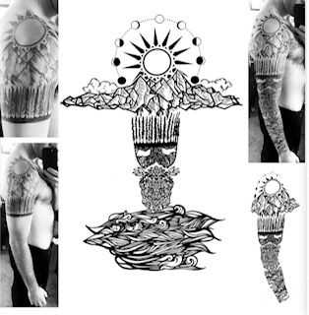
DnO’s work is very refined, it has cultural references and is very detailed yet it also looks simple, I think this is due to his style and the line work he has used.
From looking at all these tattoos and inspiration I started to do a spider diagram, I used the word ‘Mum’ because it is for a mum, but I decided to draw on inspiration from what the ‘mum’ could represent and also what the man would feel appropriate to have on his body, so I tried to look at it in two ways.
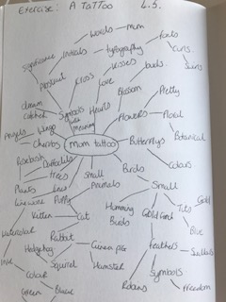

From this Spider diagram I created a mood board on ideas and inspirations.
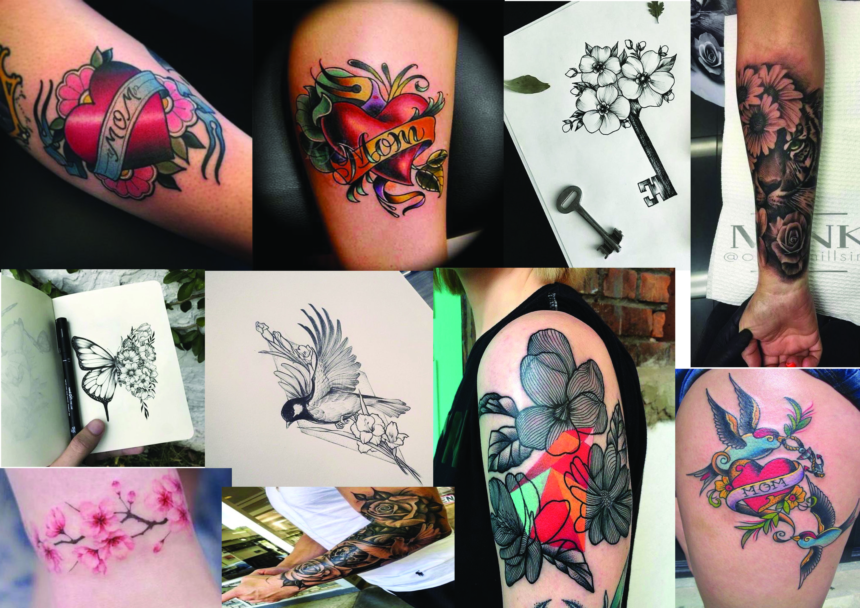

I then started some sketches in my sketch book from all these ideas and inspirations.
I started with some roses, then wrote down some words I wanted to use as inspiration for the feeling of the design, they were:-
Rose’s, Wings, Birds, Mum, Son, Masculine, Feminine, Balance and freedom.
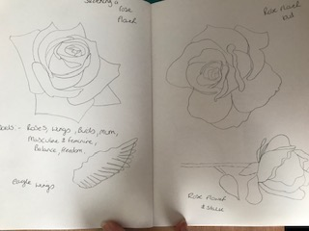
I then did some more detailed sketches and some line work leaves as I thought these might look good in the design, or how I can create a design that’s different.
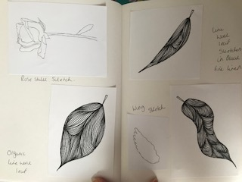
I then did some more detailed sketches of the rose flowers; I’m thinking of using my line work style on these and see how that looks.
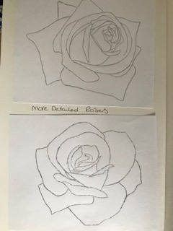
I then did some colour tests with watercolour, with the rose and eagle wings in mind.
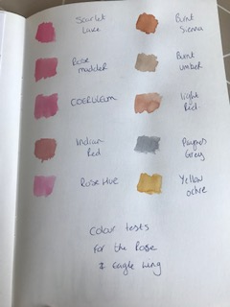
I then started on some thumbnails to put together a composition of the tattoo; The first design was a simple rose with the word ‘Mum’ on a banner.
The second design was the eagle wings with the rose in the centre and the word below on a banner.
The third design was two roses on stalks with the banner and words around the middle.
The fourth design was the eagle wings with the rose poking out the top with the name and banner below.
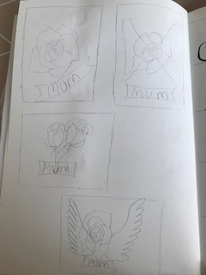
Then I started to work on the typography I decided to use a brush pen again, I started with some more extravagant designs with curls and swirls, but as I practised I liked the more simple fonts the best, I decided the bottom one was the best.
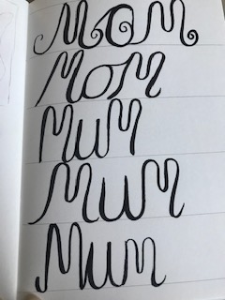
I drew an outline of the rose again then I did my line work detail inside and sketched the line work rose, I was really pleased how this turned out.
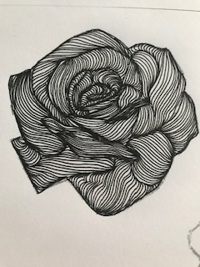
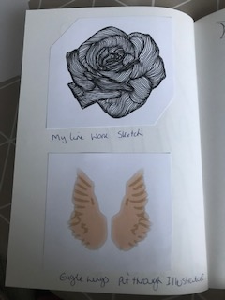
I then started to look at the eagle wings through Illustrator and looked at some effects, this first one was using the fill effect in two different colours.
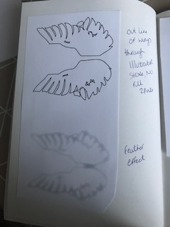
These other two are just using a stroke and no fill on the top one, the bottom one was using the feather effect.
I then did some sketches of simple banners that I could trace and extend through Illustrator.
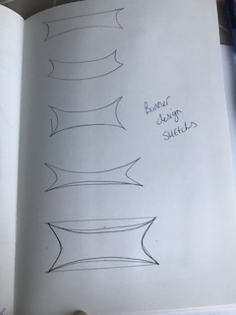
I pulled together the first design I had in my thumbnail ideas, this was the eagle wings with the rose in the middle. I used a simple stroke and no fill on the wings and just copied in the line work rose in the layers.
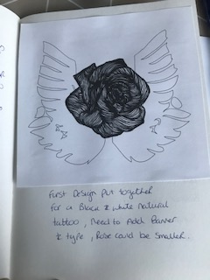
I then pulled together another design from the thumbnails which was the simple rose and banner, this is nice but I feel too simple.
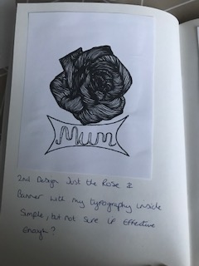
I liked both of the designs, but felt it may need colour, or to try colour to see how it looked.
I painted in watercolour a simple illustration of the rose sketch I had previously drew.
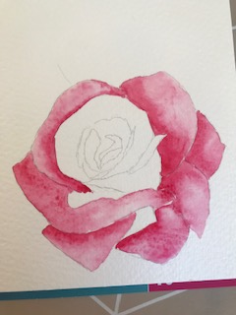

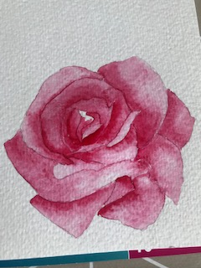
I then used this watercolour in the design to see how it looked, initially I had the banner in black, but it felt too dark against the delicate watercolour style I used, so I used grey instead.
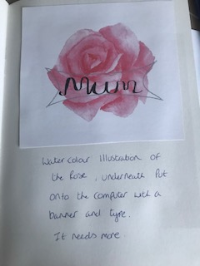
I then decided to combine all the elements I had so far and see how that looked, here you can see the watercolour behind the line work. I liked it very much, but I did take out some of the small lines in the line work rose, to show more of the watercolour, which worked better.
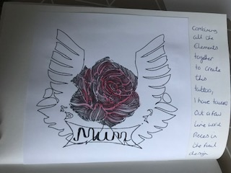

Here you can see it a lot better.
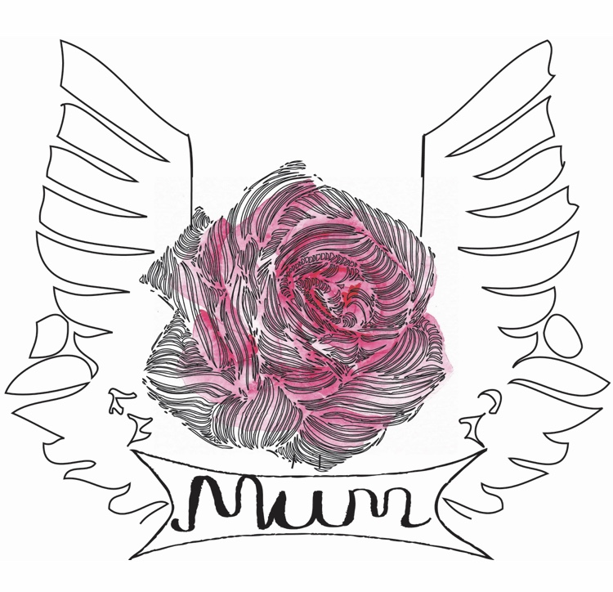
I then took the watercolour back into Photoshop to erase the background so I could place it onto a mock up. This helped me to see how it would look in real life and on the Mothers day card.
Here are the mock ups with my tattoo on different body parts; I think it looks best on the man’s chest, as the colour from the background watercolour shows through more.
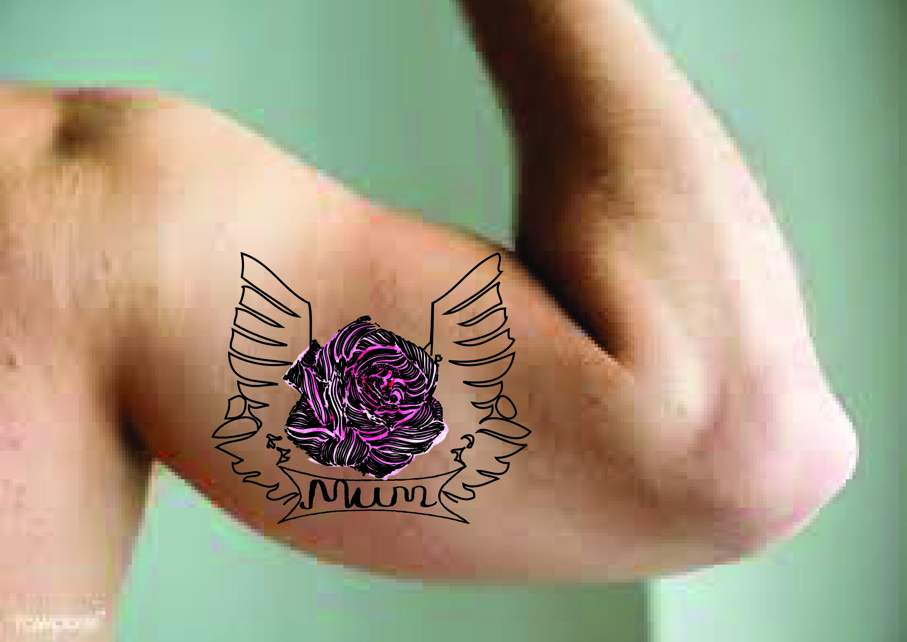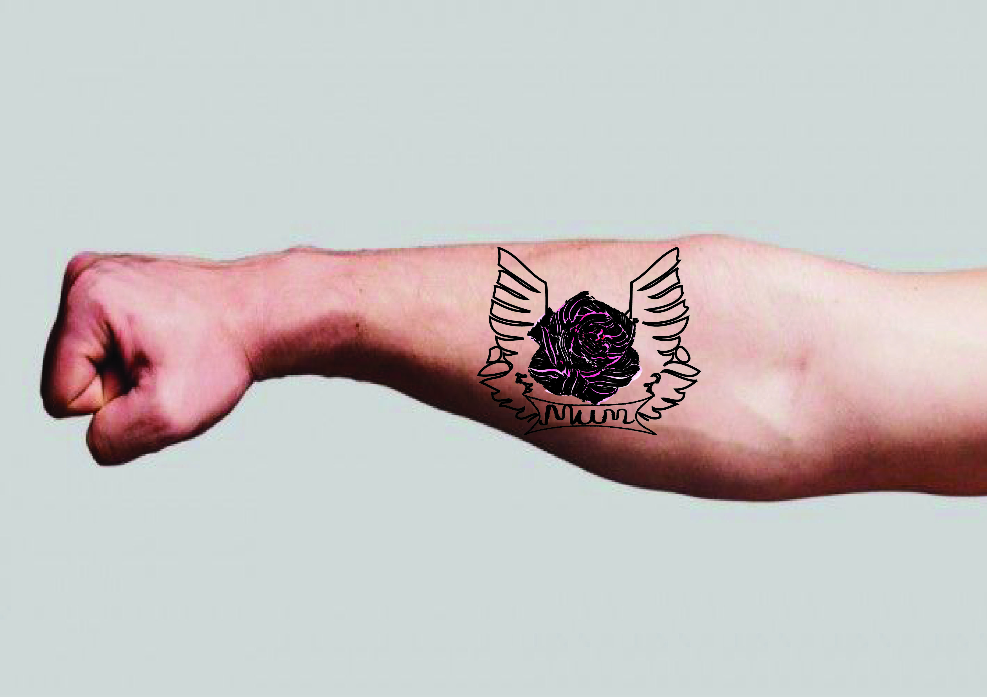
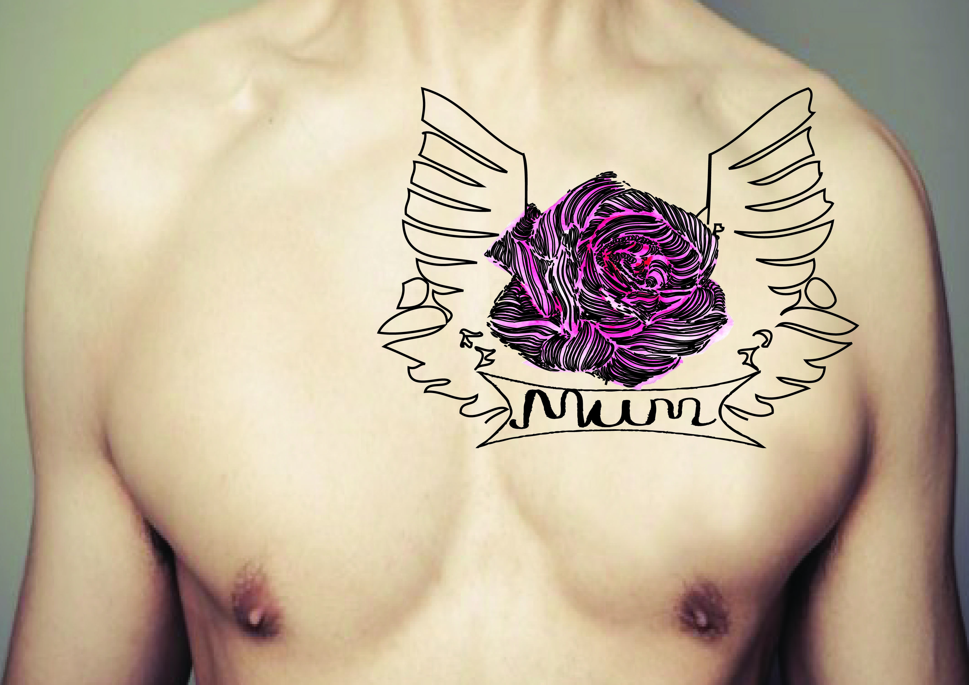
And this is how it looks mocked up onto a greetings card, for the man to send to his mum on mother’s day.
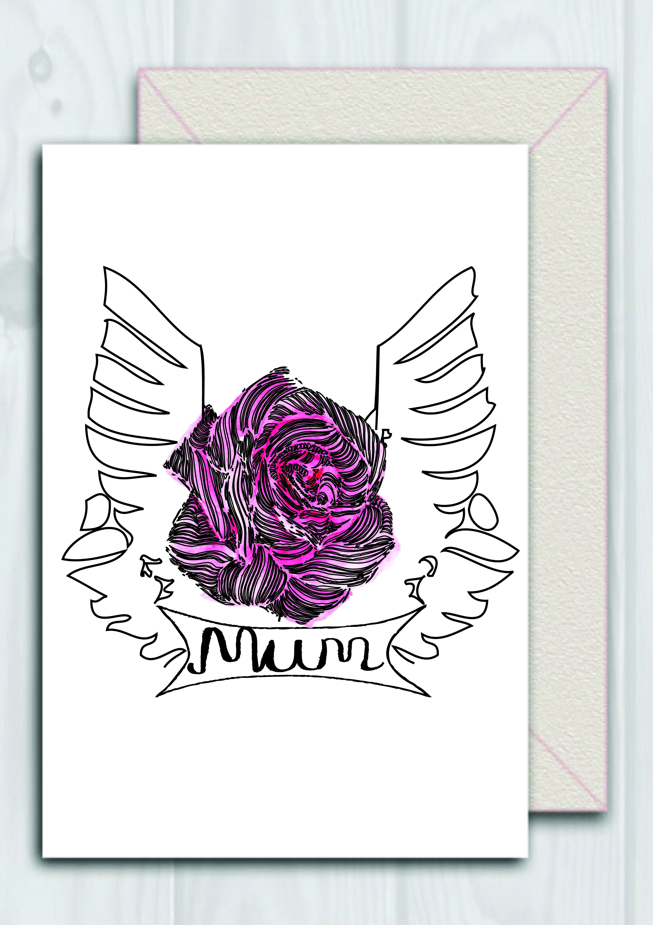
I think it has a biker style to it, which makes it look quite stylized which I like.
What did you think of this exercise?
I was hoping this exercise would be exciting and something different than what I have attempted before. I really enjoyed bringing to elements together, so the feminine intention of the mum and what it means, plus the man’s thoughts on what he would want on his body.
I enjoyed the research and learning about tattoos and the history behind the symbols and styles.
What have you gained from doing this exercise?
I have learnt to think from two points of view, to be able to combine these into one design, which represents both in harmony.
Are there any materials or ideas you would like to explore? What will you do?
I am getting more confident with using mock ups for the final design, which really helps to see how it would look in reality, so I will continue to learn this.
I liked combining my mixed media to create something more edgy and stylised which is out of my comfort zone, but I was surprised how my style can be adapted to different designs and genres. This is encouraging as it was something I was wondering about going forward.

