Identifying tools and materials
I started this exercise by thinking about illustrators that work in a similar way to me, using watercolours, coloured pencils, ink and line work,(Basically mixed media but quite specific).
I had already looked at Beatrice Alemagna for a previous exercise, but thought I would include her into this catalogue.
I also found the work of Felicita Sala, who works in a very similar way to me and Beatrice. Felicita Sala is a self taught illustrator, she took Philosophy at university. Her love of picture books created this desire to be an illustrator. Felicita uses mixed media to create her illustratons, in particular coloured pencils, paint, crayons and fine liners.
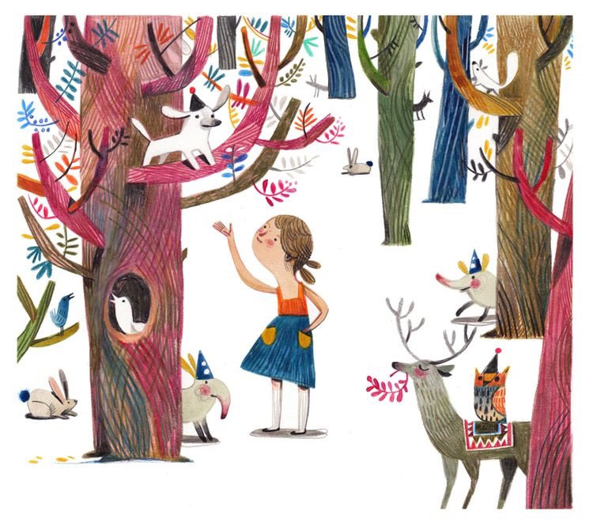
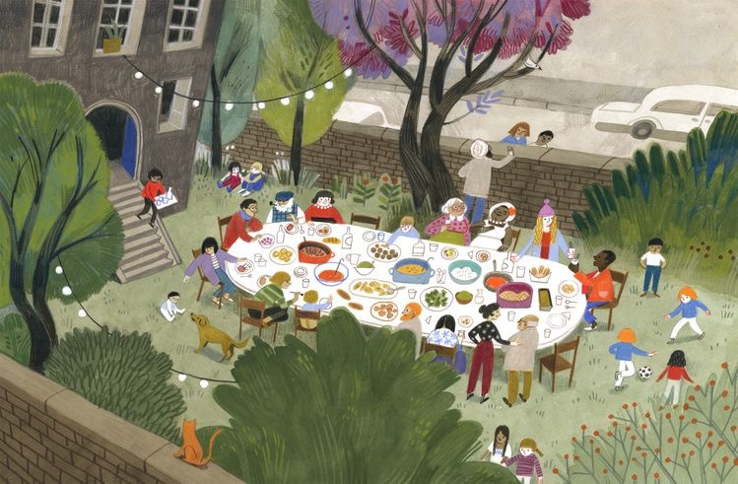
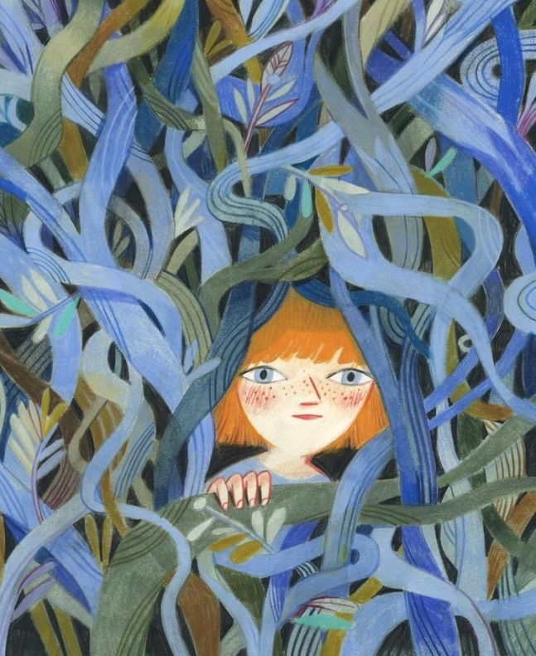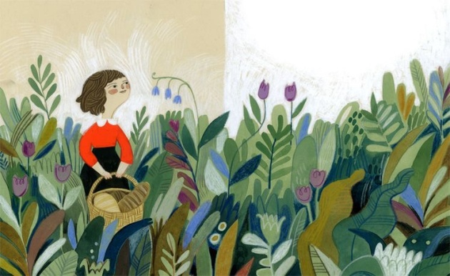
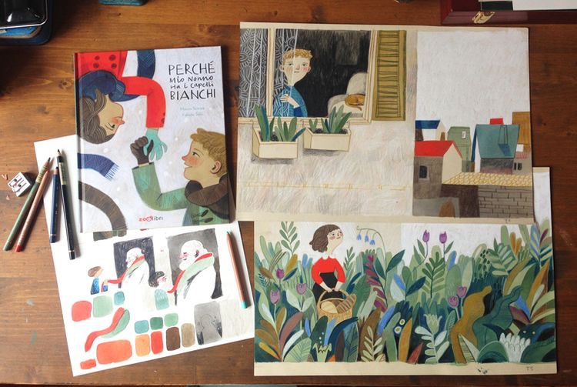

Adelina Lirius is another illustrator that I found worked in mixed media, the same as me and Felicita.
Adelina is from Stockholm in Sweden and spends most of her time sketching in her studio for ideas of stories; she usually portrays animals and nature in a playful and colourful way.
Adelina uses Paint, crayon and coloured pencils in her work in a traditional way, but then processes these through software to give a digital edge to the pictures too.
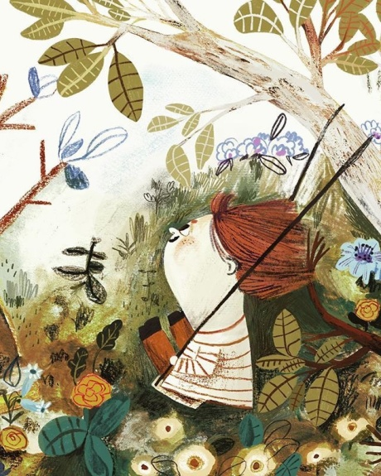
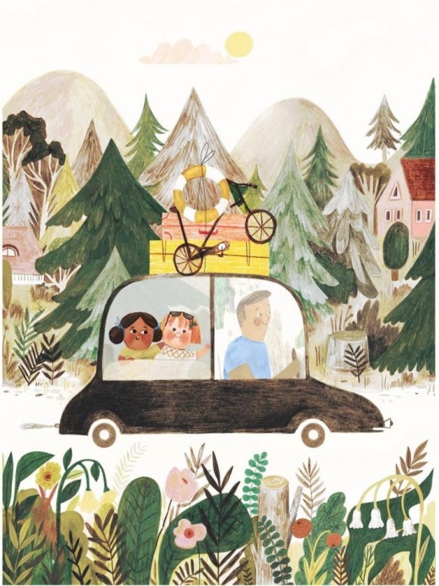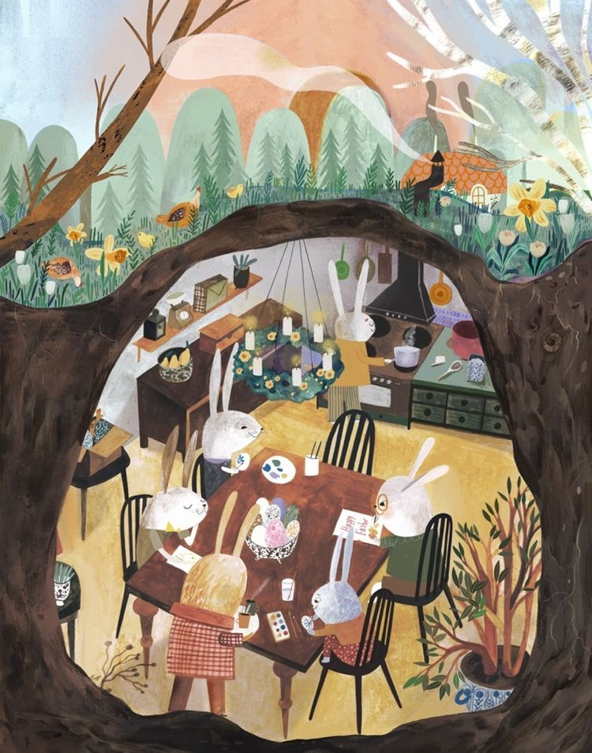
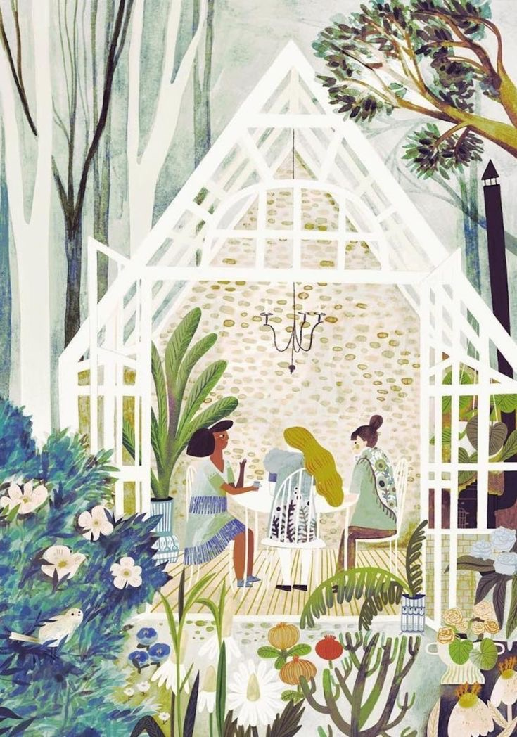
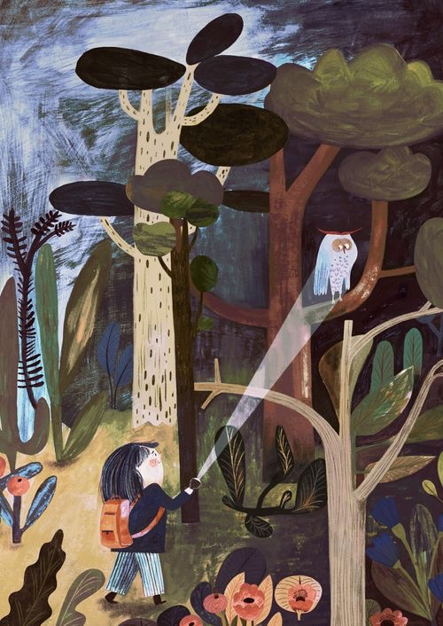
My next Illustrator is of course Beatrice Alemagna, I love her work and they way she uses the mixed media and how much tiny details she has in her textures and the use of colour.
Beatrice is an Italian illustrator and author, she studied graphics at university and moved to Paris where she currently lives, she works as a poster artist for Centre Pompidou for over 10 years now.
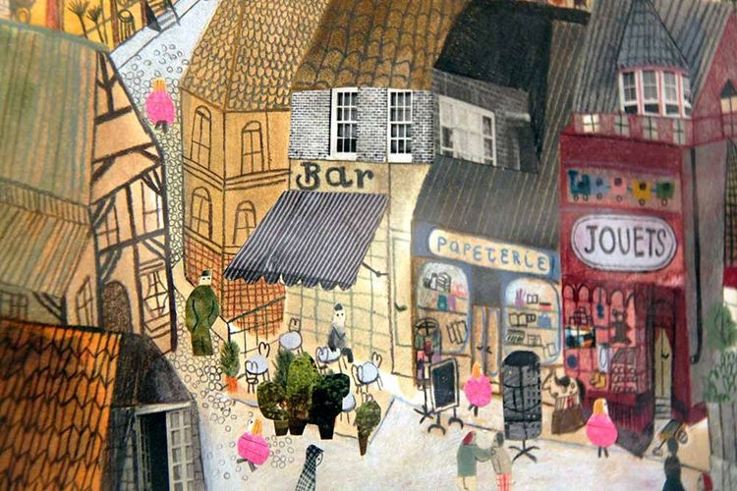
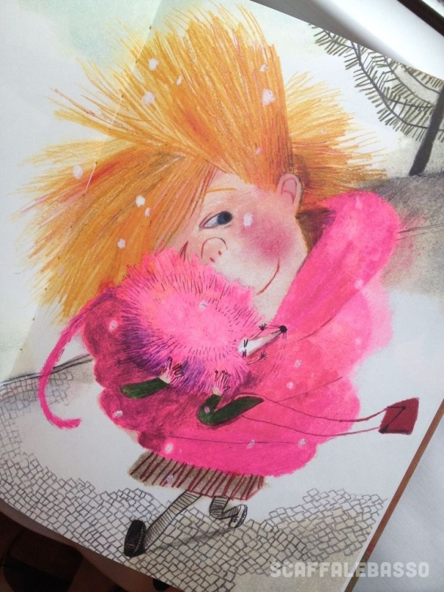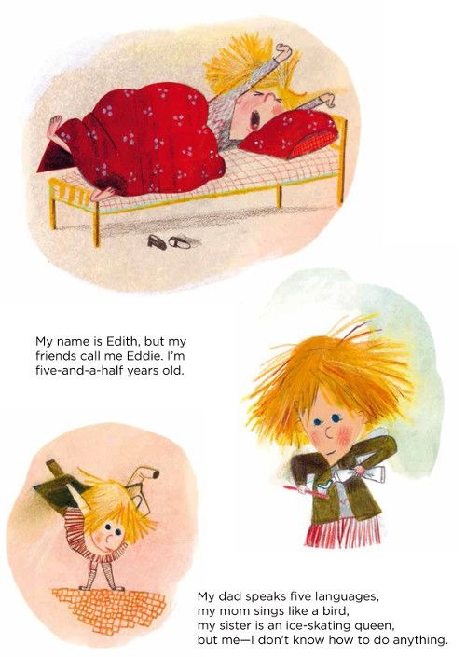
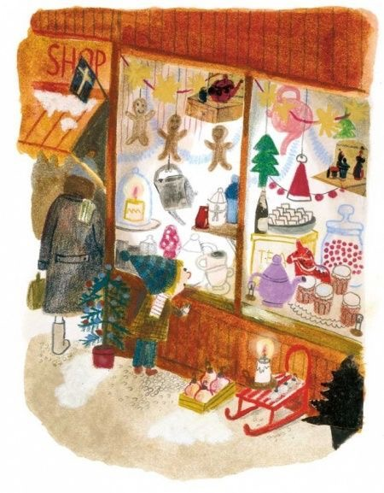
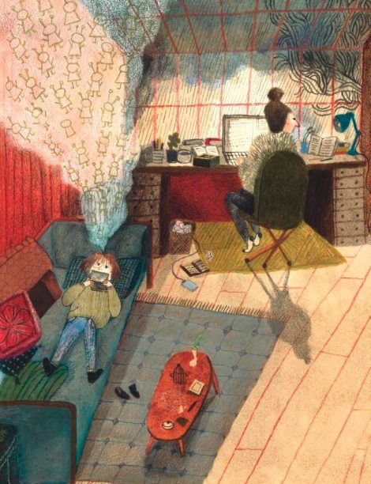
The 4th illustrator I have looked at is Emily Sutton, who is an English illustrator raised in north Yorkshire. Emily went to the Edinburgh college of art and then on to the Rhode Island school of design, Emily has worked in textiles, lithograph and graphic forms, but her illustrations are formed used mixed media, pencil, paint and ink. Emily has a varied variety of work and subjects and can cater for many different companies.
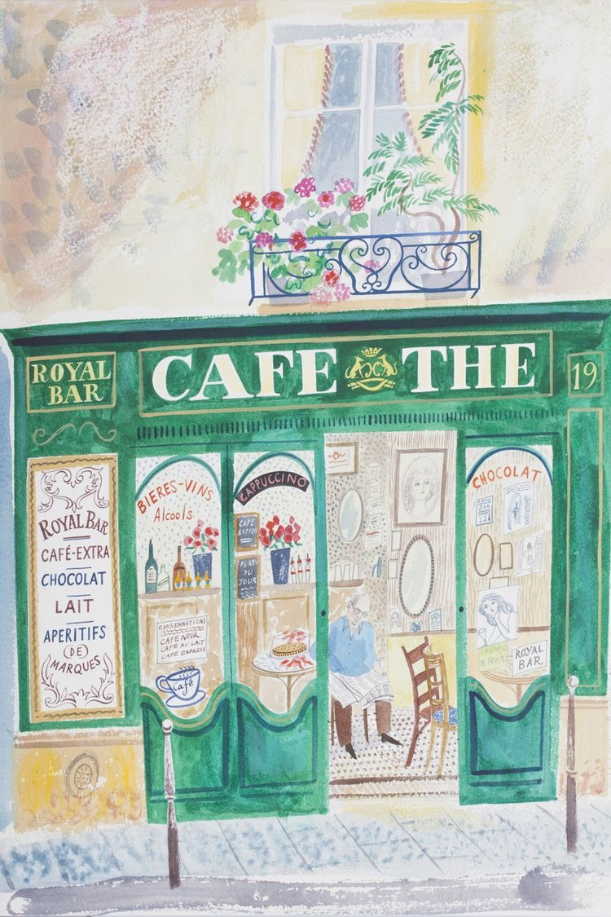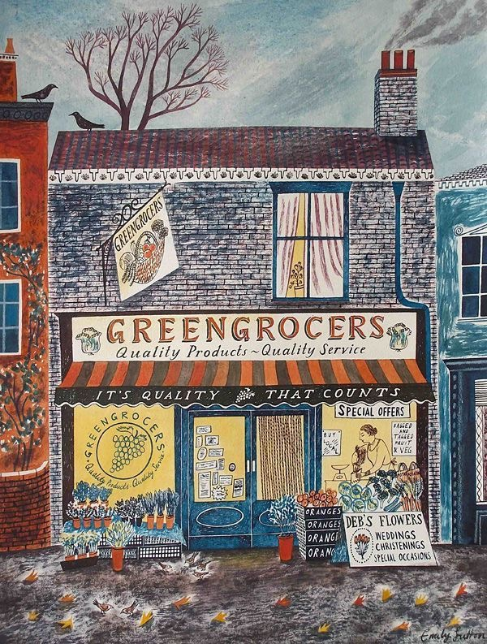
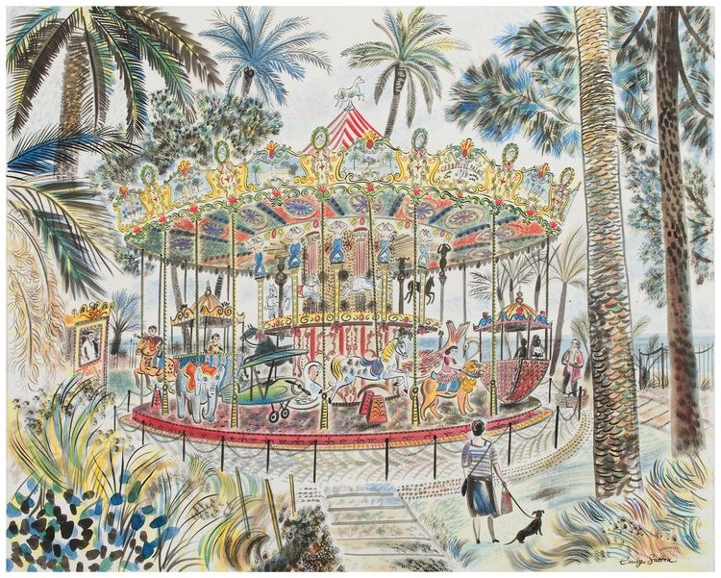
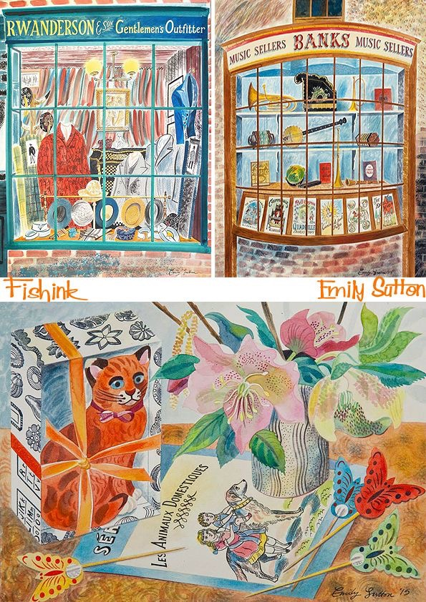
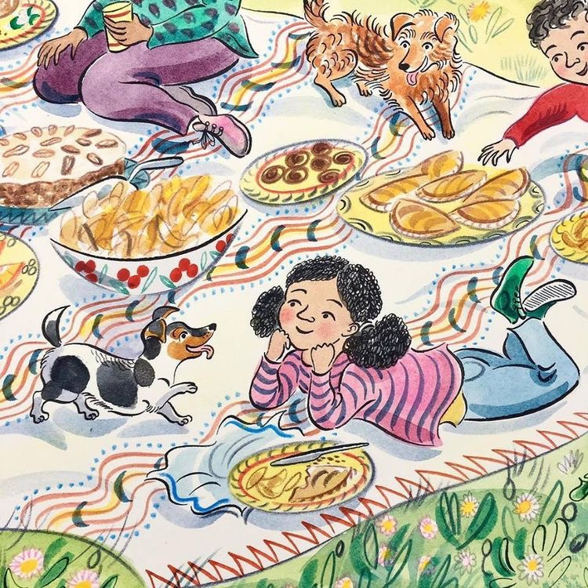
With all the four illustrators I have chosen to catalogue, I feel the first 3 Felicita, Adelina and Beatrice are all very similar in their use of texture and colour within their illustrations. The use of characters is also similar in that the characters are exaggerated. Emily’s work although similar in the use of mixed media her work is more realistic, more refined a slightly grown up version of the others.
Emily’s work I would say is more from real life observations and places; where as the other 3 are more from their imagination. The first 3 exaggerate the use of texture in the illustrations and the atmosphere and use of colour is exaggerated. Emily’s is taken from real life so it’s just as it is and how you see it.
I feel my work is probably a mixture of the two, I like my animals and characters to be realistic not cartoon like, but I like to use my imagination for textures and exaggerated colours and the feel of the atmospheres. But is this something that would look right together and work? Or would it just jar against each other?
I have chosen Felicita’s woodland scene which I like the most out of all the illustrators illustrations, I like the use of colour and texture in the tree bark, I like the use of coloured pencils and the softness it gives the picture. I like the rainbow of colours used in the trees and leaves and the simplicity of the white background and just a few animals, but the animals are detailed with cute hats etc.
Giving the picture depth by using smaller trees towards the top of the picture, focusing on the biggest tree by adding some animals, the main girl character and her dog up the tree, focuses the image to this area as well as using pinks in the tree draws the eye in and shows the hierarchy in the picture. Having lines to add texture on the bark of the trees and hash mark making and using tonal coloured pencils and blending these creates a soft feeling.
Using coloured pencils gives the picture a young child like feel, which is what this illustration is for; it’s a happy woodland theme.
Using a white background gives the feeling of space. It gives the illustration a gentle and calming feel, having the little girl in the middle of this space makes you look right at her.
Having another tree off to the right hand corner in the same pink tones draws your eye around the picture and having animals spotted around draws your eyes to the tiny details. All the animals are in tonal white or grey, links these together, having small details, lines and coloured hats helps make the picture fun and adds fine details.
I decided to choose my illustration I created for exercise 3.6 which was ‘VIEW POINT’
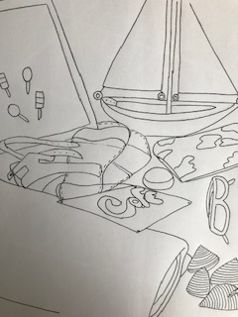
I started by drawing the picture again, then deciding on what mediums to use and mix and where to put these. I also printed out a copy of this picture so I could annotate areas of where I thought the mediums should go.
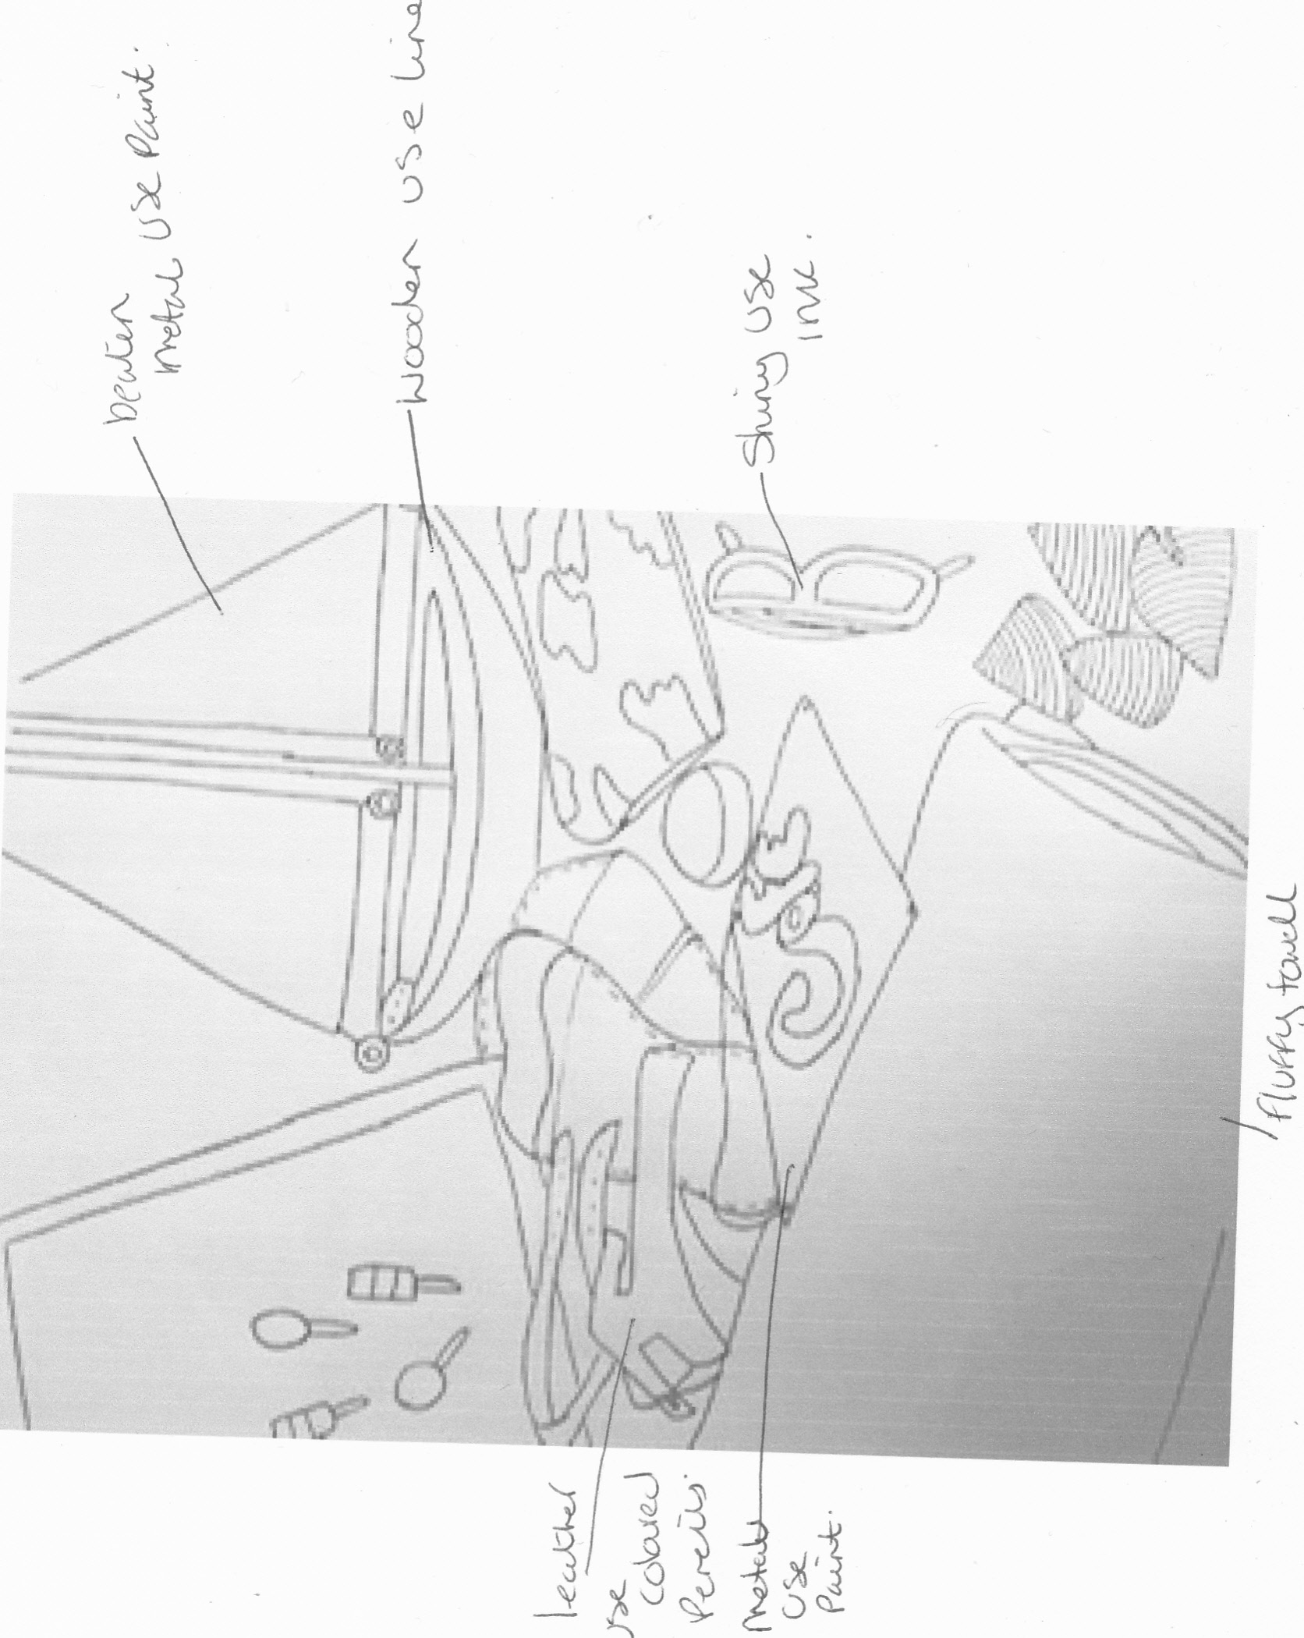
I started by water colouring the biggest areas of the picture, leaving the background white like the illustrators picture, I found that studying her picture there seemed to be a wash of background colour behind the mark making, so that’s what made me decide to use watercolour.
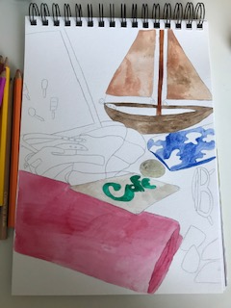
I then moved on to using coloured pencils to add the mark making lines and textures over the top of the paint, I was surprised how hard this was! I really struggled to get the lines to look like the illustrators and to work in her way. I think maybe the paper was not the right type it had quite a hard grain to it, but something smoother would have buckled with the watercolour paint. I got quite frustrated with this picture, I tried crayons instead which did work and gave the effect I wanted but it made it look messy and not so delicate and neat like the illustrators.
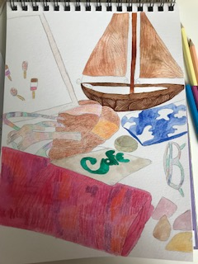
I gradually got the hang of the pencil lines on the straps of the sandals, but you can’t quite see it in this photo, I think not using watercolour as the background wash may have been better. I think the towel, boat and sandals looked the best and most successful, but I still don’t think it’s great.
The final scanned in picture is better to see the detail with, I used a fine liner in brown in the end to give the boat a wood effect on the base, and then I used crayon to do the same on the sails. I feel the base was more successful. If I used coloured fine liners on all of it, it would have worked with the watercolour and given the delicate neat feel across the picture, but that was not the idea of the exercise. It’s probably because I’m more confident in using fine liners for those types of details rather than coloured pencils; I use coloured pencils for softer textures.
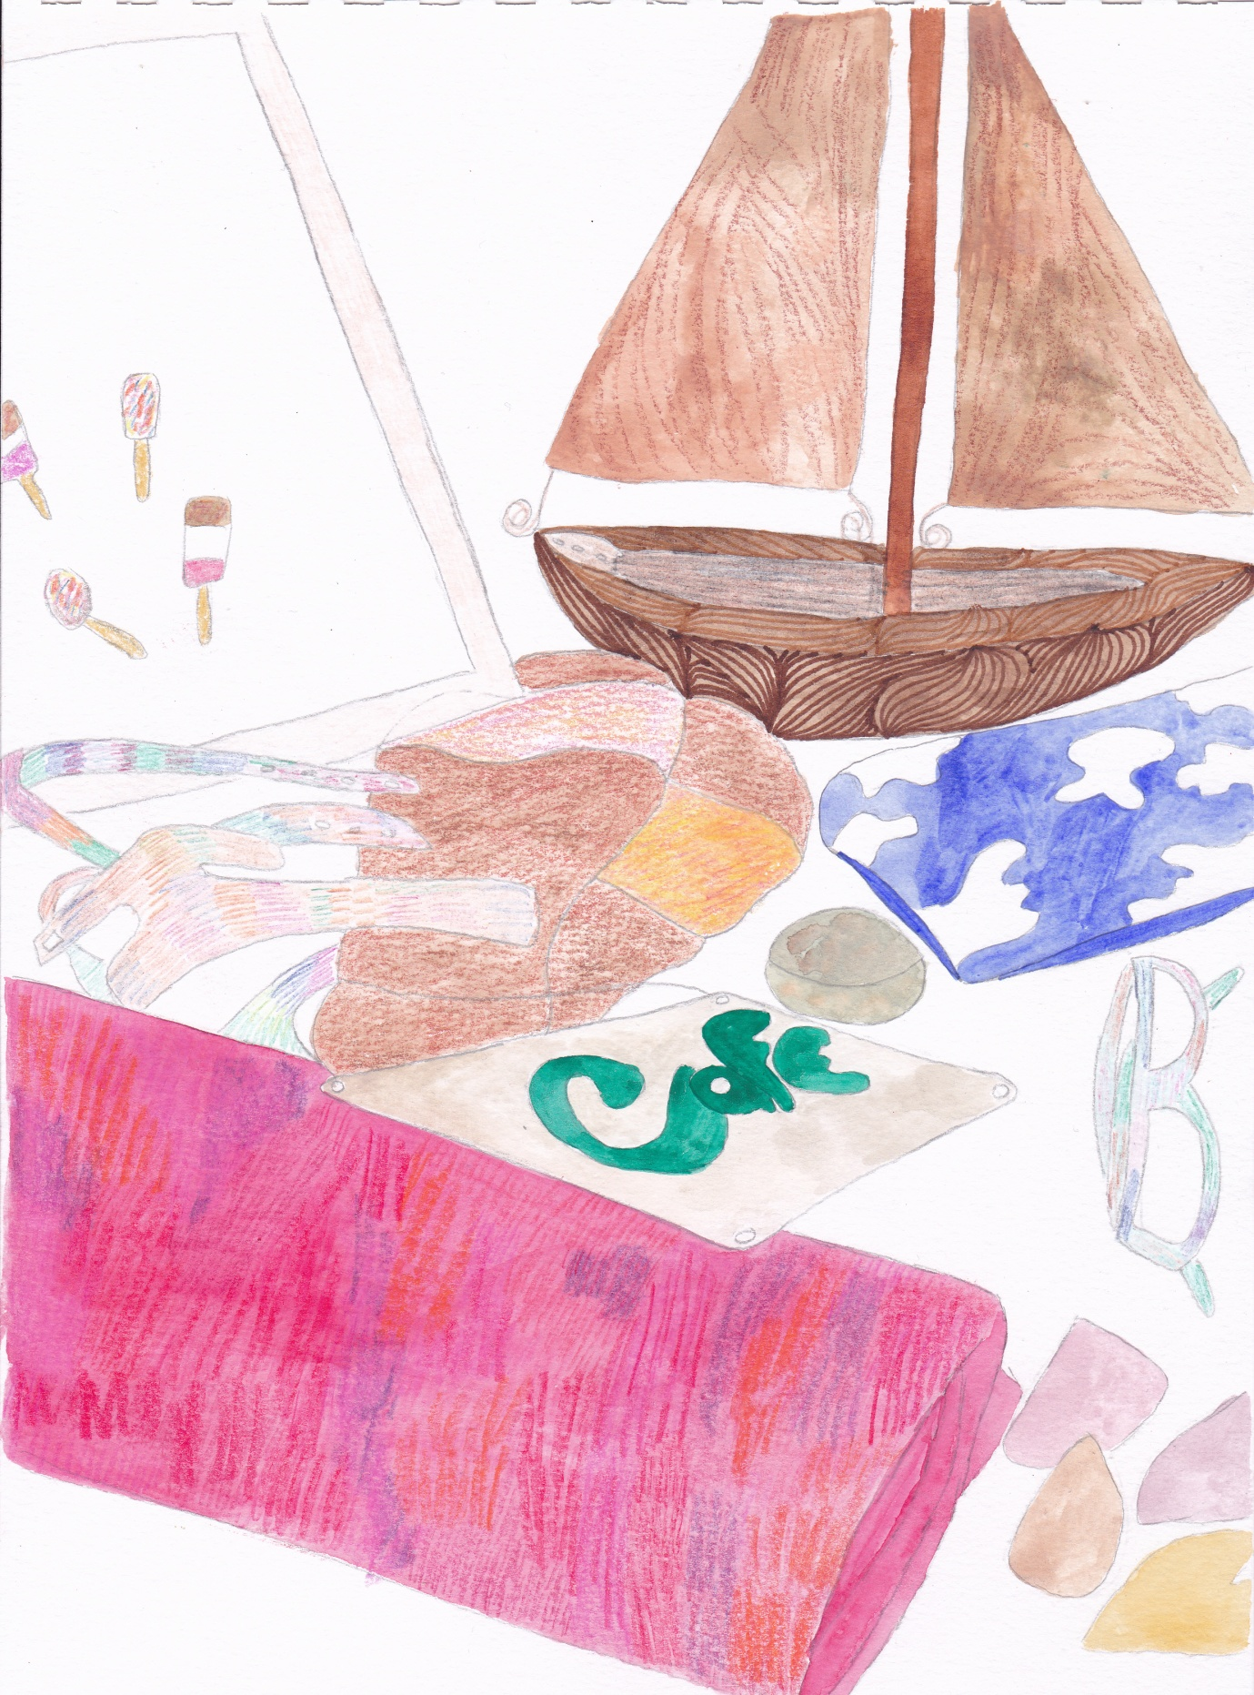

My second picture which was slightly more different was the illustration I had created for exercise 2.9 ‘Black and white’. I thought this illustration might be more successful as it’s simpler and I could focus on the tools instead.
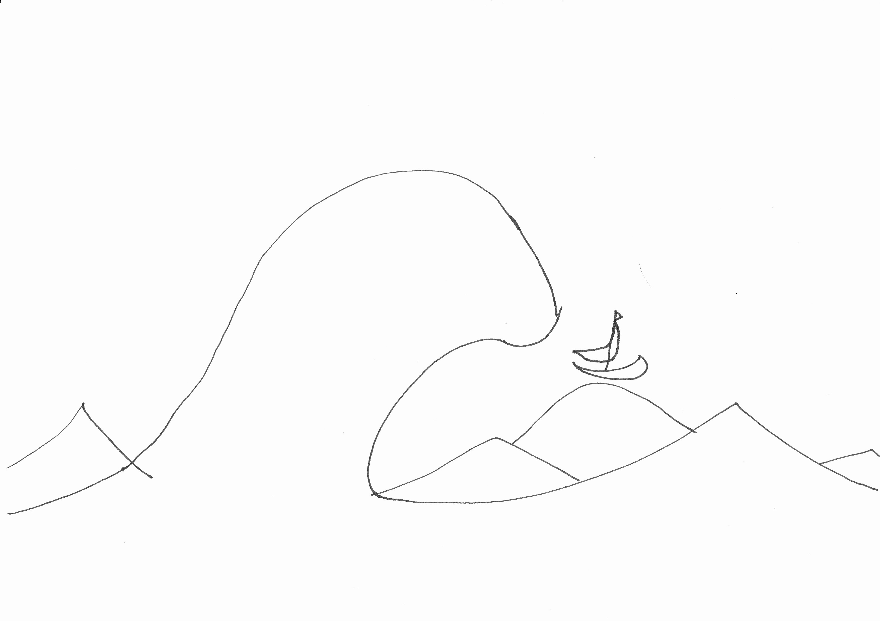
I decided to do this one with the tools like Emily Sutton, this picture below is created using paint washes for the background, with pen over the top, some crayon texture work in the sky, brick work and floor, then rendered in Photoshop to neaten up and finish off.
I started by looking closely at the picture Emily produced and annotated some of the tools she used to create it.
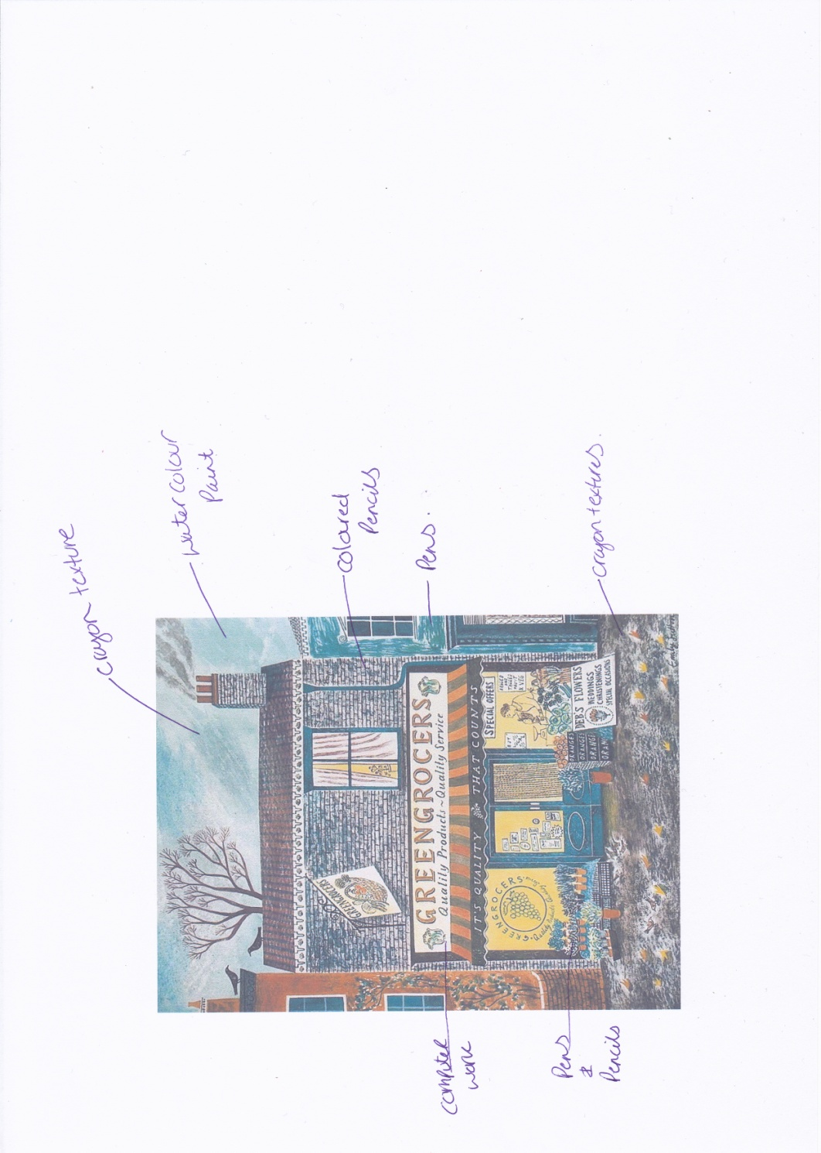
From this I started to water colour my picture; I used a very dark navy for the sky and a lighter blue for the sea and waves. I then used coloured pencils to give the waves some texture and for the sky I used crayons. I picked out the boat in red and brown in coloured pencil too, I then used a blue coloured fine liner to get the shape of the waves with line work, like I did in the original black and white illustration.
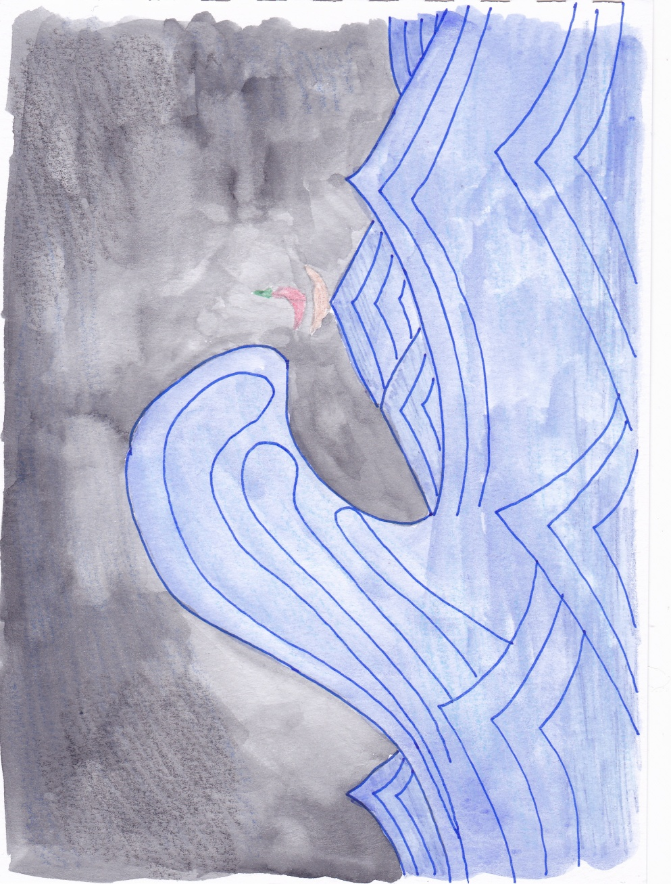
I then put this image through illustrator to neaten it up and add some more texture to it. I played around in Illustrator for a while and chose different brushes and textures to get to where I wanted to be with the image. I love the fuzzy background of the sky and the soft texture it gives to the picture, it has created a real atmosphere.
I used a few different brushes for the sea and waves, the placement is a bit random of some of them, but it something I just came across whilst playing around, so it’s something to explore further.
I found a really lovely texture for the boat, but it did not show up much on its own, so I printed the picture out then added a coloured line with fine liner in red and brown around the edge.
It’s all a bit hap hazard but definitely something I will continue to explore with the tools in Illustrator and how to use them more confidently. I am pleased with this picture more with the tools I chose and how I used them, I feel it was much more successful than the first one, and I have learnt something new which I will no doubt explore more. Actually with this one the picture could have been more detailed as I feel this is more how Emily works, maybe it would have been better, if the illustrations I had chosen to render were the opposite way around?!
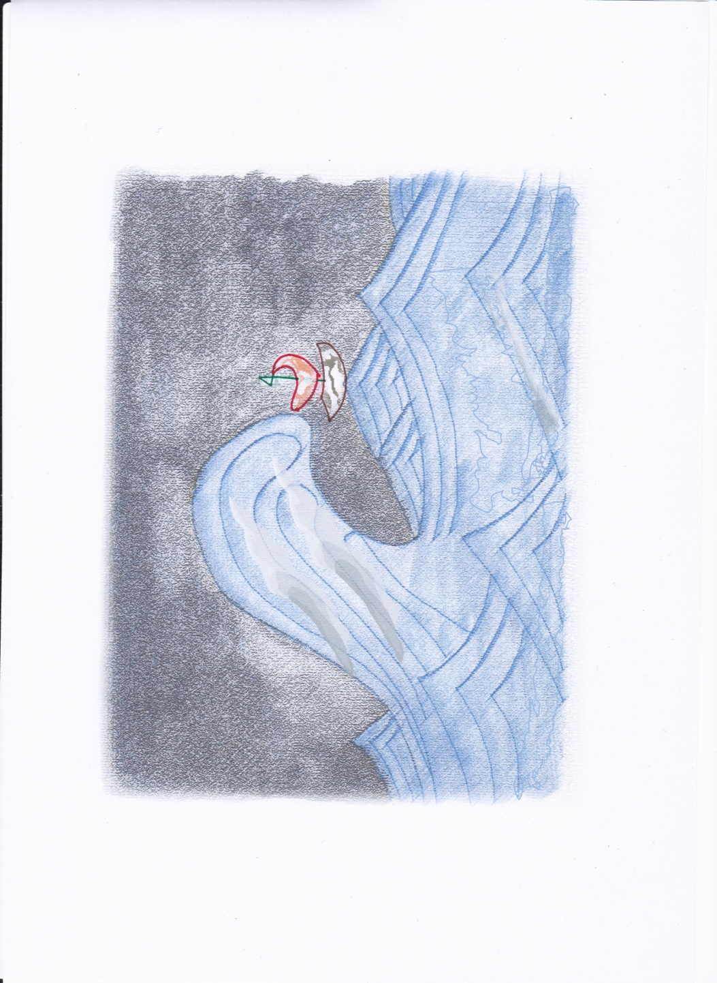
What did you think of this exercise?
I was really looking forward to this exercise; I really enjoyed looking for mixed media illustrators that used the same tools as me. I found some great pictures of theirs which I enjoyed looking at. I did struggle initially with trying to work in a similar manor to the illustrator I had chosen, it frustrated me to work in a similar style but not create the same look. Whilst creating the second picture though I worked out that it was to use the tools they work with rather than to copy their style, so this became easier for me then. I enjoyed creating the second picture and liked exploring more through Illustrator and some of the textures available on there.
What have you gained from doing it?
I have gained a better understanding of how to use the tools I know in other ways, and how much more available there is on Illustrator to help create textures and brushes.

Are there any materials or ideas you would like to explore further? What will you do?
I am going to have a play around on Illustrator every so often to look at other things available on there, textures, brushes and how to arrange these in a more affective way.

