Client visuals
I had a look at my book collection and found this book ‘The princess and the pea’ which I thought was quite a busy illustration, so this would fit well with the exercise at hand. The second illustration I came up with was from Beatrice Alemagna, her Fluffy, squishy, itty, bitty, which is one of my favourite illustrations. This book cover was also fairly busy so again it would fit well with the exercise.

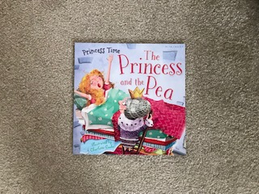
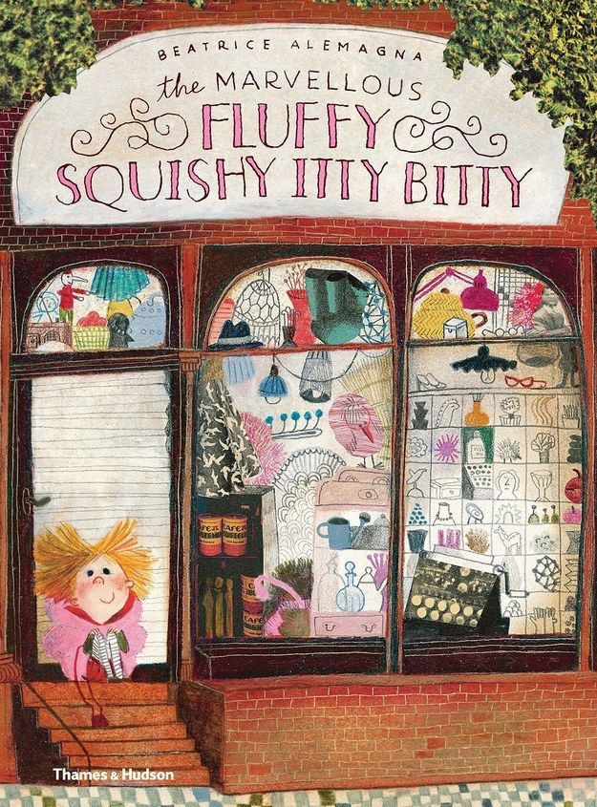

I started with the Princess and the pea and really studied the front cover illustration to look at the lines, details, composition and colours. I did the sketch of the front cover, but just drew the main illustration and title.
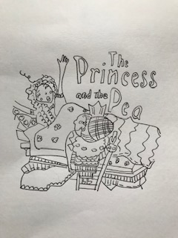
I did the sketch in black fine liner as I found this helps with small details, to decipher each line.
I then scaled this up in to the larger proportion to illustrate.
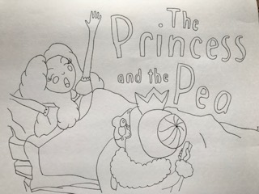
I again used black fine liner to draw this sketch; I decided to use less detail in the illustration to make it simpler so I cut out the patterns on the bed covers, the curls in her hair, the detail on the queen’s head and outfit. I also simplified the typography by rounding off the fonts to make it simpler, I think this adds to the overall effect I was after. I also cut off a section at the bottom as I thought this composition was more direct. Personally I wondered why the original illustration didn’t have a ‘pea’ in it, so if I was doing this myself I would have added a pea somewhere.
I can see also the reverse observation with this exercise, so you could say the simpler image is too simple and lacks texture and feeling, so the original illustration could be how you work it ‘up’ into a more exciting illustration for children in that it includes details, textures, and feeling.
The second illustration I did the same and sketched the original illustration myself, again I used black fine liner.
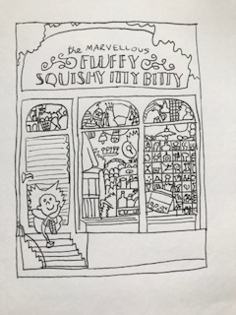
This illustration was extremely difficult and busy; I must say it did take a while! All the little images in the shop window were exhausting. You begin to realise how much work is involved in a fab illustration that Beatrice has completed.
I then scaled this up as required and came up with a much simpler sketch, again in fine liner.
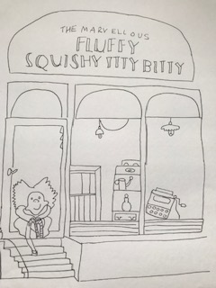

With this larger illustration I did take out a lot of the detail in the shop windows, I still kept a few items in there; I also didn’t have the decorative details around the fonts or the leaves around the outside. I also simplified part of the typography too; this made the whole top section airy.
I feel taking away a lot of the shop window stuff hasn’t distracted from the meaning of the illustration or book, I feel it adds more mystery to what’s inside the shop as not everything is on show!
Again you can also see the reverse to these illustrations and maybe Beatrice’s editor suggested more details than what she may have originally set out?

Two more book illustrations I found that you could simplify are:-
A place called perfect
The Vanderbeekers and the hidden garden
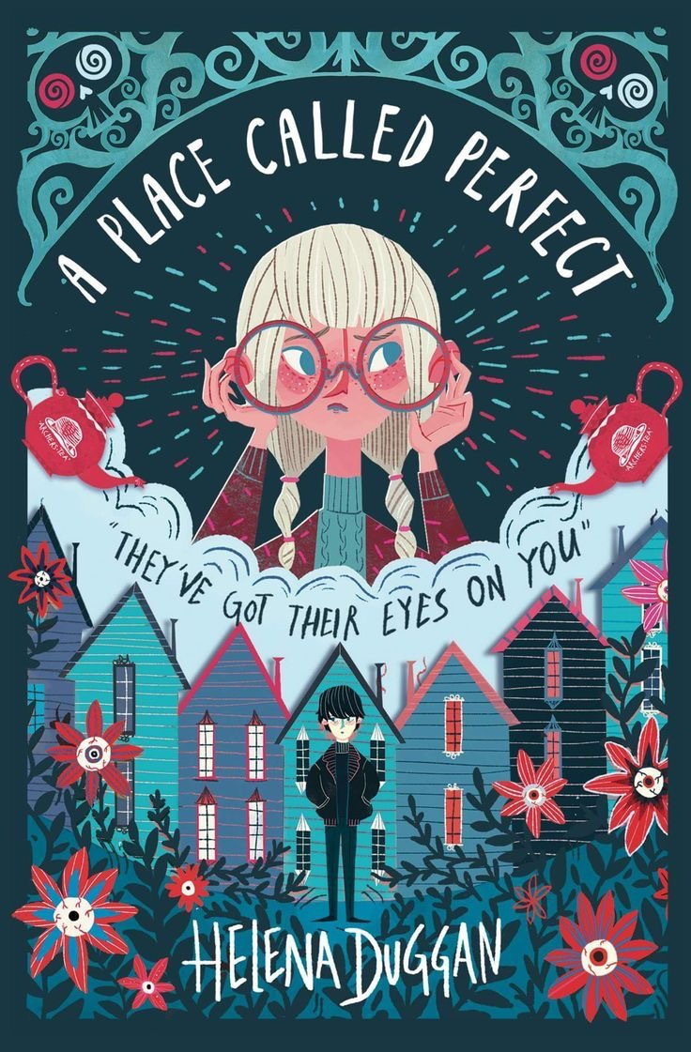

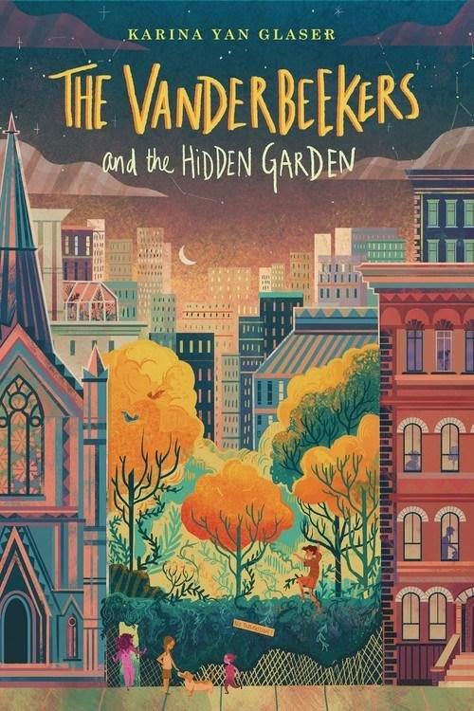
I annotated both of these illustrations as though I was the art director, I added in directions as though they had submitted a simpler version and I was asking them to add to it, the reverse of what we have just been taught. This would be what the illustrator sent back with what the art director wanted.
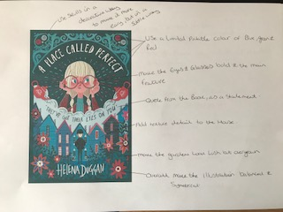
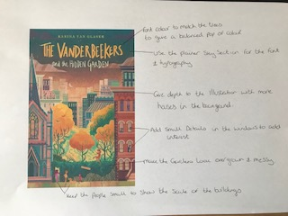

What did you think of this exercise?
I found this exercise interesting, I enjoyed looking at other illustrators work for front covers of books and how you could increase the detail or de-crease the detail to give different effects and compositions. Its interesting working out what works well for each individual piece of artwork, it’s good to try out different options so you are sure that your final decision is the right one for the book.
What have you gained from doing this?
I have gained an understanding of sometimes less is more or sometimes more is more, each individual artwork needs to be given both options and something in between as pre-drawings to make sure you choose the right one. Scaling up or down also helps with this.
Are there any materials or ideas you would like to explore?
I will definitely be using this process with this type of work in the future; it gives me more ideas and options to use before making the final drawing. I makes you look at all the small details and what is necessary or not to the meaning of the book or illustration.
What will you do?
I will follow this process of scaling up or down depending on the artwork, and I will use the simpler or detailed versions to see which I feel look better.

