Viewpoint

I started this exercise by choosing the word ‘summertime’ I then did a spider diagram to find out to me what summer time means.
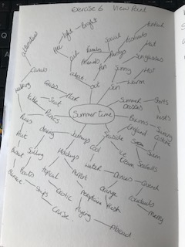
So from this I chose items that I thought conveyed summertime the most from objects I had at home.
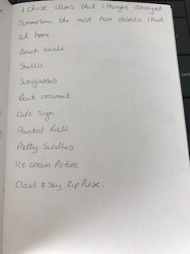
I then put these all together on a table and arranged them how I thought they would look best.
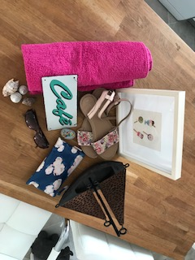 1.
This photograph was taken from above, it shows all the elements and you can see them all clearly.
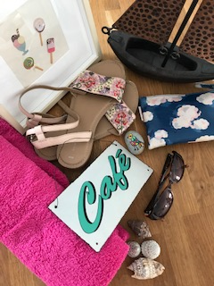2.
This was a closer photo, but I felt didn’t have enough of the boat in it, for someone who didn’t know it was that to see.
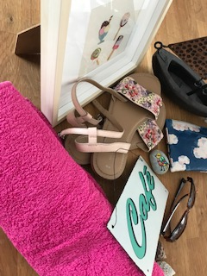3.
This was taken from the left hand side, I like the close up and the angle is interesting, but again you lose the boat.
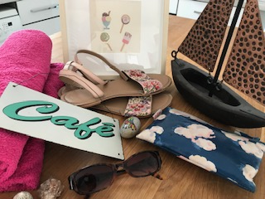4.
This was more of a long photo landscape style, this is nice as you can see all the elements and they are clear to see.
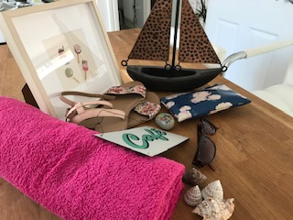 5.
This again was taken more to the left but from lower down, which helps get the boat in the composition. I feel the sandals lose some of the refinement though.
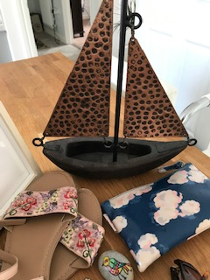6.
This one I tried something different and chose a very close up style photo, I thought maybe simplifying the elements to look at just a few might help. I like this but I’m not sure whether ‘summertime’ would be identified as this!
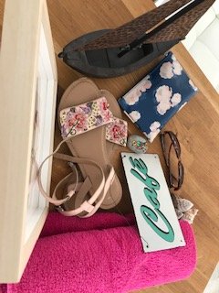 7.
This was looking from the back and again from above, you can clearly see all the elements bar the frame, but I feel a little confusing to the viewer with regards to the composition, would that say more than the objects?
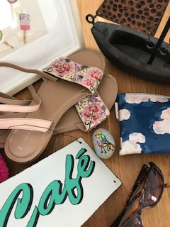8.
I liked this photo composition, it’s got a lot of angles in it from the objects which make it interesting, but again the boat is an issue.
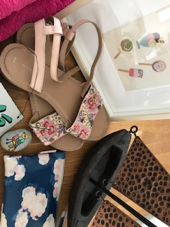 9.
This was similar as the above photo, but I tried to get more of the boat in, but then I lost other elements instead.
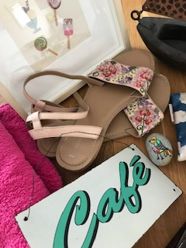10.
This was moving the photo back again to the other elements but then you are losing the boat more or less completely now.
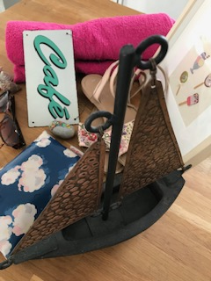11.
This one is unusual, I took the photo from behind the boat looking over and through to the other objects, you lose the shells and the sandals slightly, but this is a good composition.
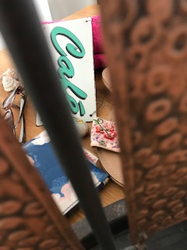12.
This is looking through the boat, but doesn’t work at all.
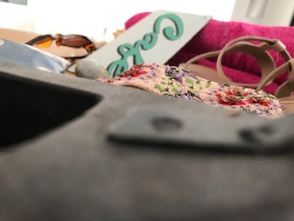 13.
This is taken from looking under the sails through the boat, a really unusual photo, but you can’t define most of the objects so it would be difficult for people to relate this to summertime.
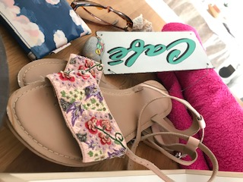14.
I really liked this photo, I like the way the sandals are foreshortened, which adds another element to the photo, but it lacks and other real objects, so would get summertime from this?
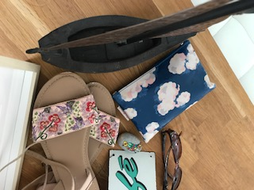 15.
This was looking over on top of the objects and zooming in, but I don’t like this one.
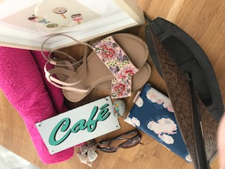 16.
Again this one is taken from the back looking over the top, it has everything in it and an unusual format, but something is just not what I’m liking at the moment.
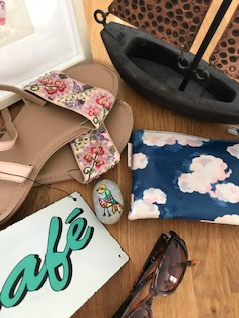17.
No strong enough for me.
At this point number 14, 11 and 3 are my most favourite.

From this point I started to sketch thumbnails in my sketch book to look at the compositions and how they would relate or change on paper with a physical drawing.
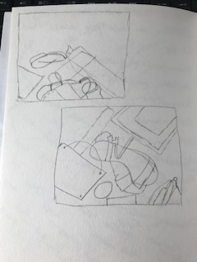
I noticed with these two that the first one most of the paper was blank compared to the second one.
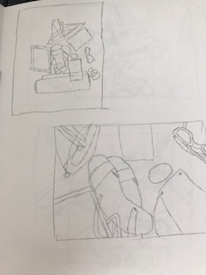
With these two the top one is too small, the bottom one is much better.
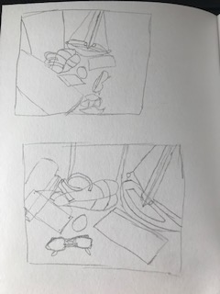
Again the top one has too much blank paper to the right side.
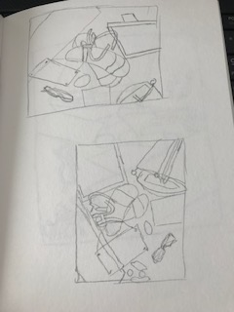
Sometimes it helps to spin the paper, as you get another angle or idea from doing this.
So from doing the thumbnails, I realised that I didn’t want any blank paper around my image, I wanted an angle to add a different dimension and I wanted to show all the objects in the drawing.
I decided I liked number 3 the best as it had all the elements in the picture, plus it was at an angle, you could see most of the boat, and to me this just looked like summertime to me.

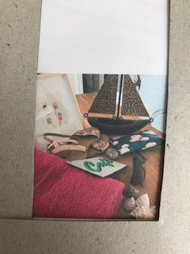
I decided to use my view finder though to zoom into the picture more, and take out some background to give a stronger composition and image.
I then sketched this as a better drawing in my sketch book
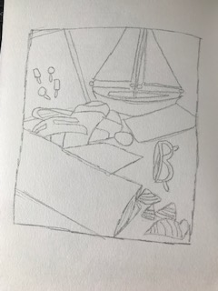
This looks good, I like the angle of the towel at the front of the drawing, it draws your eye down the picture. I like that you can see the frame and the boat still although parts are off the page. You can define and see all the objects well.
I then drew this onto an A4 sheet of paper and used a black fine liner to simplify the drawing more; I feel the black line gives a cleaner look.
I added in more detail at this stage, like the word ‘cafe’ on the metal sign and the clouds on the purse, the detail on the shells and the ice creams on the picture frame.

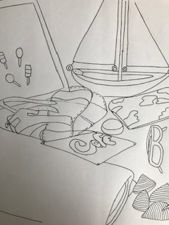

With this exercise I could have just re-arranged the objects to fit better to my requirements, but I thought it would be interesting to see how I could change the view of the elements instead to fit my idea of how the image should be.
What did you think of this exercise?
I enjoyed thinking of objects that could represent the word I had chosen. I also enjoyed working with compositions and to look at them differently to achieve the outcome I wanted. I am really pleased with the final drawing and think it has a strong composition to it.
What have you gained from doing this?
I have gained more of an understanding to try different ways of doing this and to not think of the one fixed idea I might have initially.
I think the outcome is much better than what I had in my mind also.
Are there any materials or ideas you would like to explore?
I would definitely choose to do this more with exercises and briefs in the future, it’s a great way to generate new ideas and to gain more ideas and exciting out comes.
What will you do?
I will continue to create thumbnails to help explore compositions; I would also take photographs of everything but in different ways to capture different elements of them.
It’s given me lots’ to think about.

