Giving instructions
To start with I looked at the internet and Pintrest for some inspiration and illustrators I could look at for reference.
I decided to go with the ‘Getting to my house’ instruction map.
I found the illustrator Martin Haake, who had done some map illustrations which I found great.
Martin Haake is an award winning artist and illustrator; he has recently freelanced in London and Hamburg, but currently living and working in Berlin. His work has included major international projects from around the world and he has received numerous awards among the acclaimed Yellow Pencil from the British art directors club.
Haakes work is inspired by the DADA artist and surrealists as well as 1950’s book illustrations.
I found Haakes work to be Quite stylised in the shapes he has used, I love again all the texture and feeling within the illustrations. It looks like he uses collage work too to achieve the texture, I love this look but I think my style is more flowy and natural, I prefer to get my texture from paint or mark making and line work.
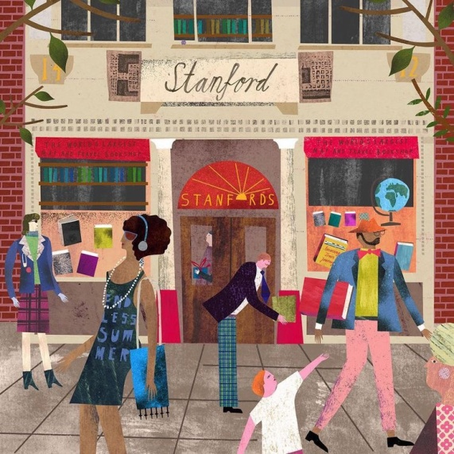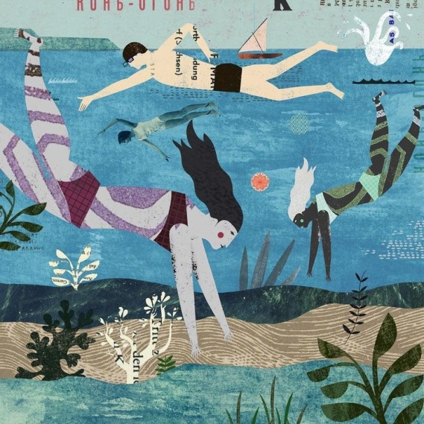

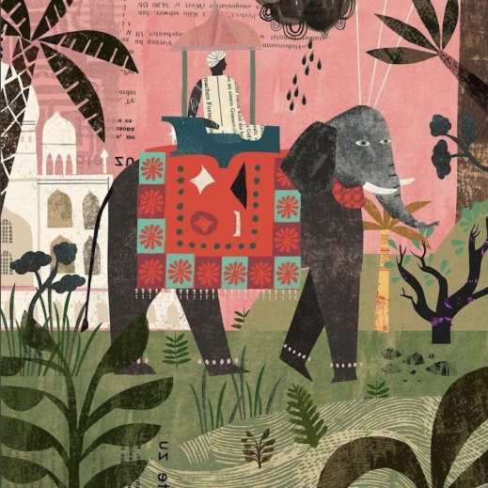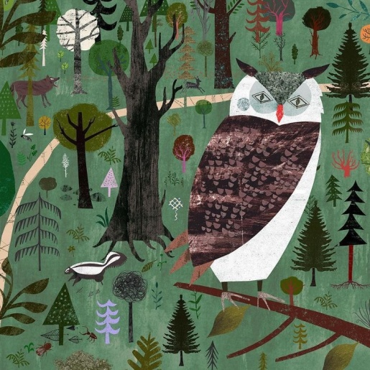
I really love the colours he uses; the illustrations are usually really colourful and tonal. Haakes use of composition is lovely too, the varying sizes of elements adds real interest.
With his map illustrations I particularly liked the way he used a illustration element for each area on the map, so for example here, he used a flamenco lady dancing in Seville. Haake has obviously researched each area and done an illustration on what they are famous for in that region.
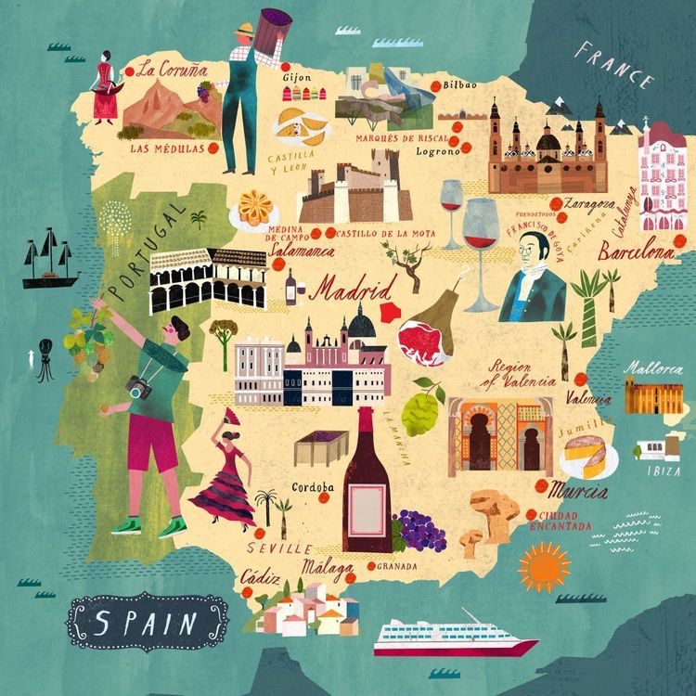
I love the use of colour in the map illustrations, he uses colour to represent the land, and here it is very hot so the colours he has used make it look parched. Where there is a small section of Mexico, he has used more spicy colours. I like the aged affect of the sea colour, and he has used lines so it looks like an aged map, all this attention to detail creates a wonderful overall effect.
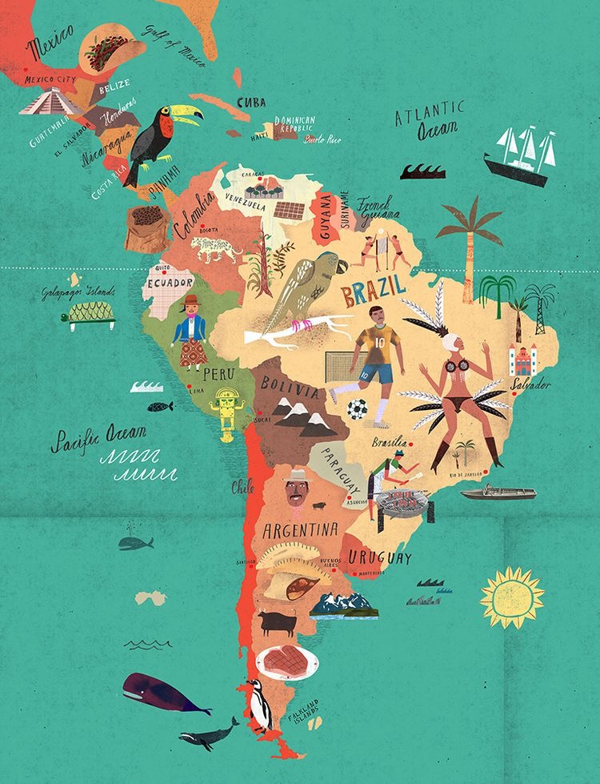

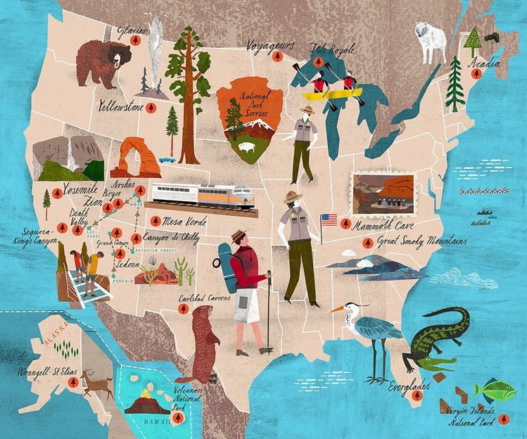

I like the Yosemite map below as it is in between a map and a poster, which is really nice. You could have this on the visitor centre to the park, which shows a general map and promotes the park.
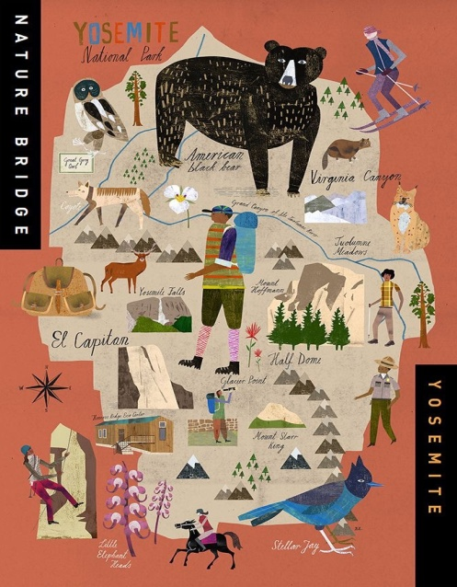
Looking on Martin Haakes website it has a whole section on map illustrations; it looks like it is one of his best areas of work. He has done illustrations for countries, regions, the world map, encyclopaedias and atlas maps.

After looking at Martin Haakes work for inspiration, I then found some other work on illustration maps, which I have compiled below to show different styles of work.
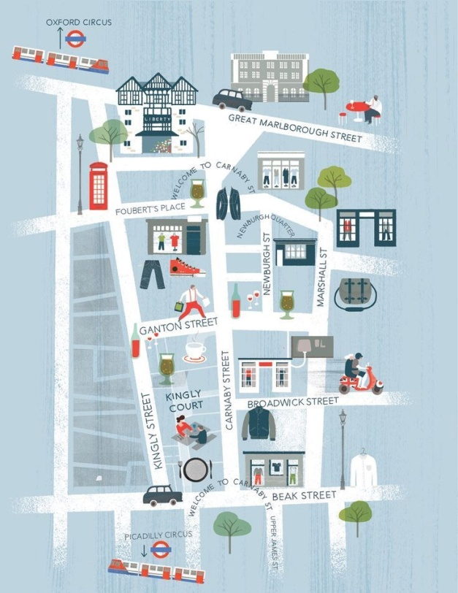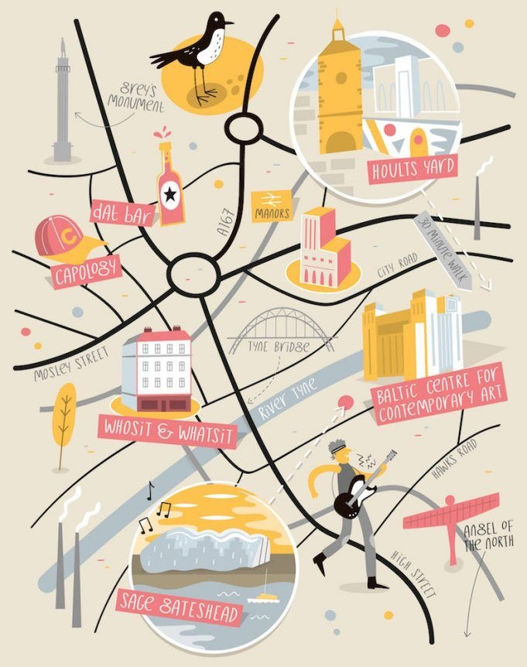
I like the different ways you can separate the areas of the map into sections, you can use the roads to do this or lines, train lines or mountains, Path’s or buildings.
You can have icons for each area, or something famous from that city, or something from the country, wildlife, food etc.

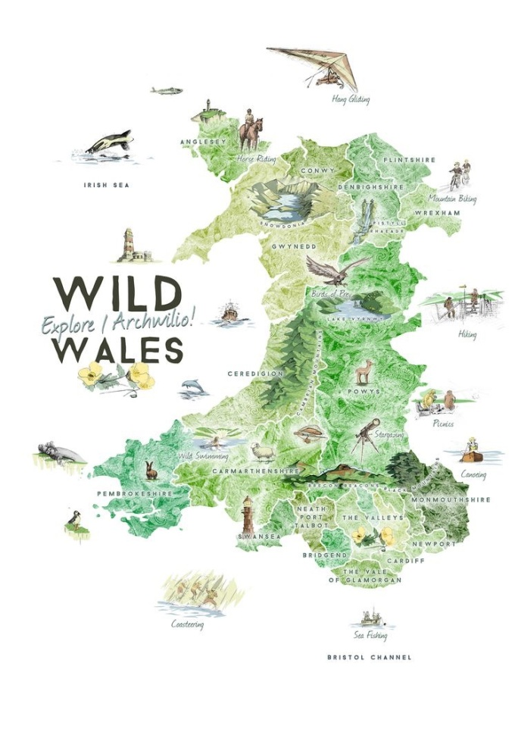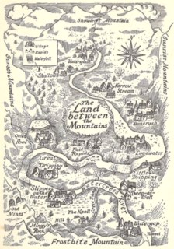

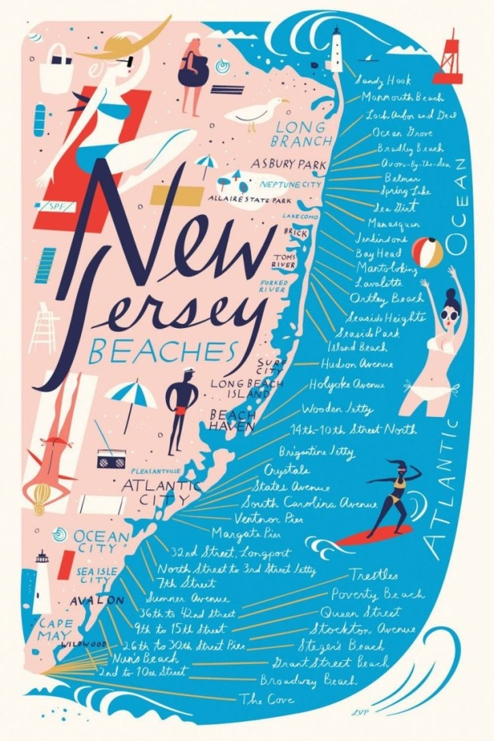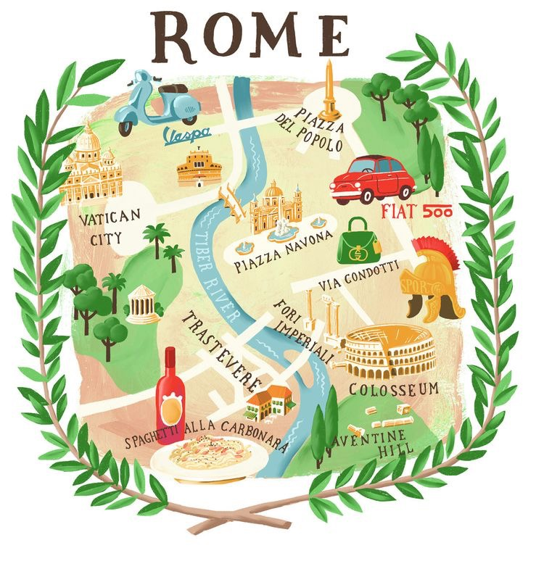

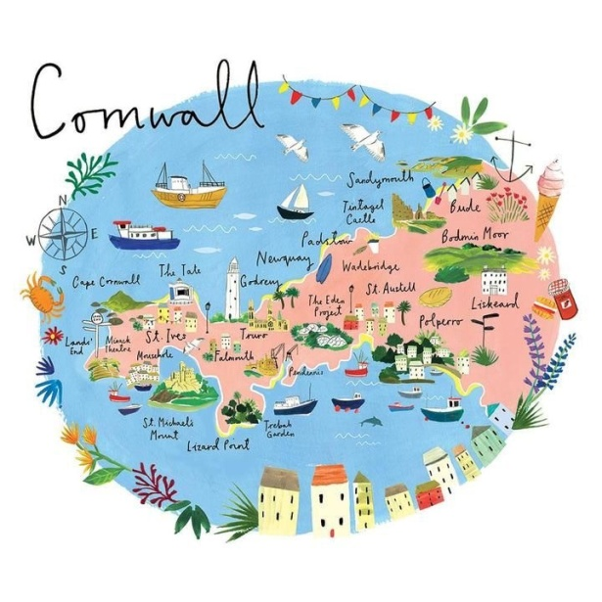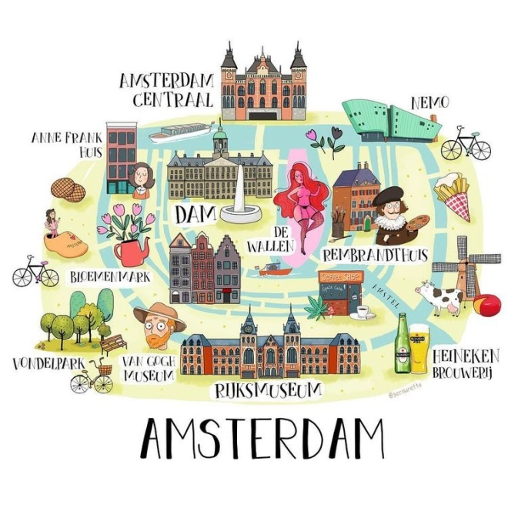

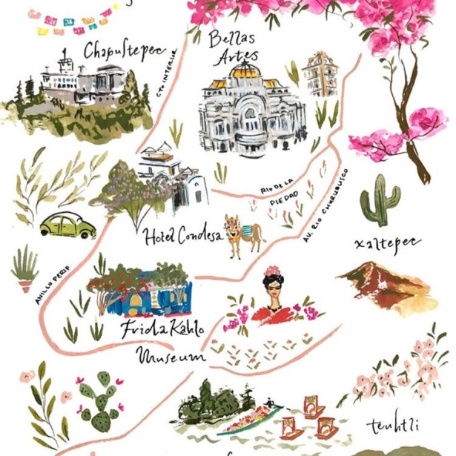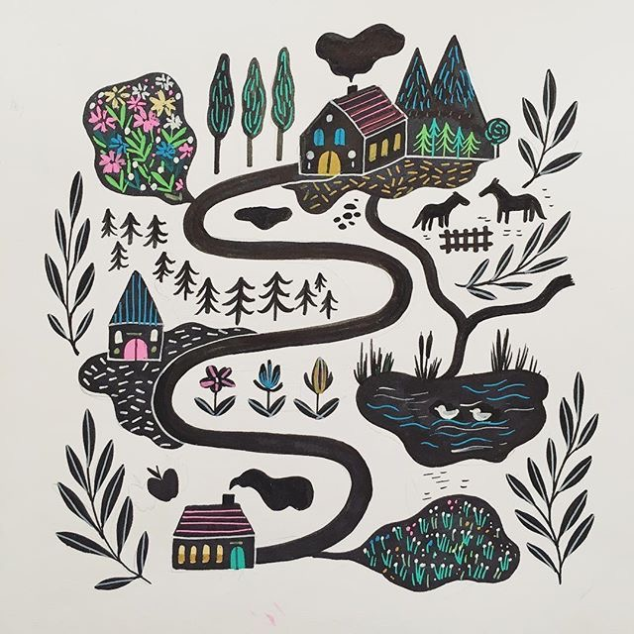

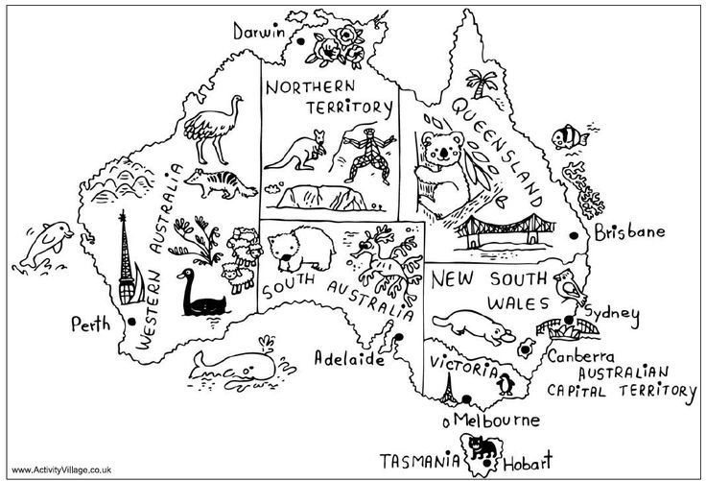

You can have lots of writing or no writing, some writing or just icons. There are many ways you can illustrate a map, I think the things to consider are:-
The style
Detailed or simple
What icons
How to separate it
To use words or not
Colour and texture
I then decided to do a spider diagram on ‘getting to my house’ adding in roads, places, how it makes me feel.
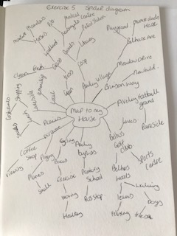
From this spider diagram I got a real feel for what was around my home, and what I could put on my map illustration.
I then decided to move on and look at the layout style that I wanted; I drew some thumbnails to get me started.
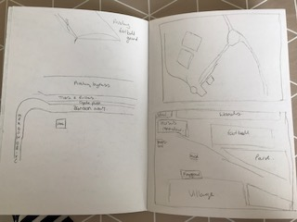
I picked out the main areas in my local area, which probably equates to 2 mile squared.
The main elements I wanted to add in were the football ground and golf course. Horses and meadow, the secondary school, mums house, my house, the playgrounds and Aveley village with amenities. Whichever way you come into to my house you would have to go through one of these 3 ways.
I did some thumbnails with the roads that separate the areas; I thought this was quite strong and realistic.
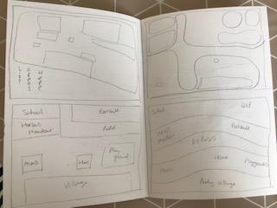
The 4th thumbnail I tried was a similar illustration but the areas were listed below. (top left)
The 5th was separating them into blocked areas (bottom left)
The 6th was to do a continuous line and have organic shapes coming off for the area’s Top right)
The 7th was to look at it from the front and do it like a 3D effect, so start at the bottom and work upwards as though you are looking at it from the village (bottom right)
I liked 2 of these designs the best which were the 3rd and 7th ones, I then tried to do these bigger to see the effect more and which one worked the best.

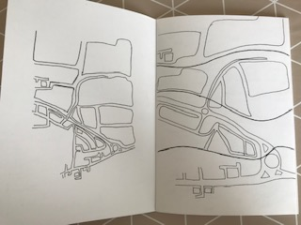
I did the one separated by the roads first; I like this one as it’s the most realistic. The second one was good, but I think it would be hard to achieve the effect I wanted and I didn’t know if the outcome would work, so I decided to stick to the safe option.
I then started to think about content and pictures, what I would draw to represent each area; I decided to set up a mood board for this.
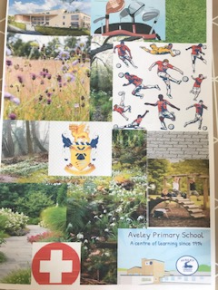
I pulled together things that represented each area, and had some woodland and grass park areas too, this helped with colours too.
I then used this mood board to create a spider diagram for each area to gauge some textures, feelings and colours.
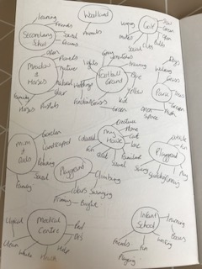

From this I had a good idea of what illustrations I wanted to draw to represent each area, but I wanted to start on the roads and background areas first.
I decided to try and experiment with watercolour and inks on tracing paper to get a overlay paint effect that I could use as a layer in Illustrator to build up my diagram.
This was my first go with watercolours, it didn’t really give me the effect I was looking for, the paper wrinkled too much and even after laying it flat and putting a book on it, it still didn’t look good.
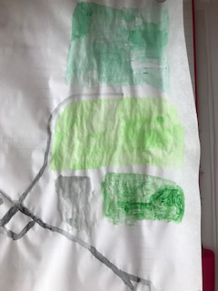
I tried again with ink as I thought this might work better as the colour is more intense and already liquid enough to not have to add water.

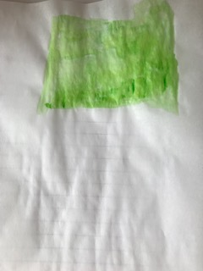
It still gave a similar effect to the watercolour though! I think it is slightly better, I think this idea needs more time to develop further in experiments before using it in a picture.
I decided to go back to the original thought of using watercolours; I did a few colour tests first, as I wanted all the different green areas on my map to have different intensities to show the density of the green land or woodland.
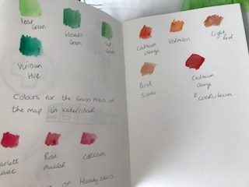
I drew my map larger to fit on an A4 sheet of paper, I then started to paint the background using watercolours.
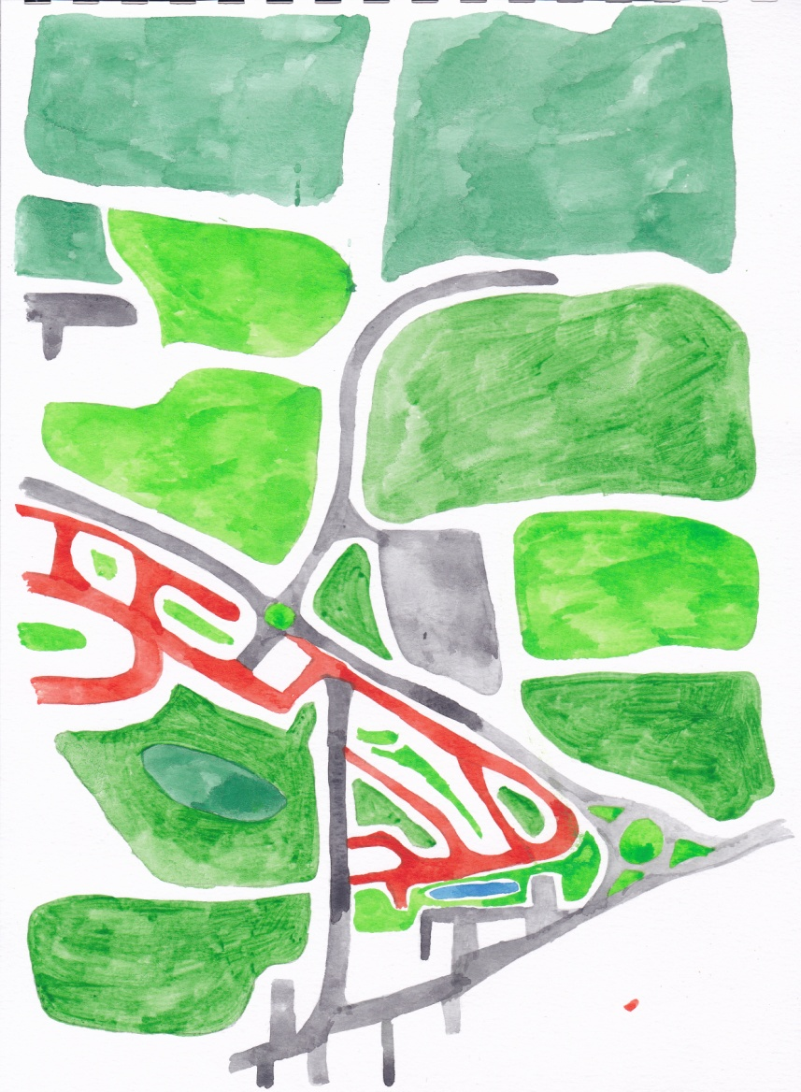
I am happy with how the map has turned out; this is just the background layer, so there will be more depth to it once I put it through Illustrator.

I did a few sketches of some illustration ideas for some of the areas, I thought I might draw the school building, but I’m not sure if this would give enough variety, as there are two schools on my map, maybe the emblem would be better for this school?!
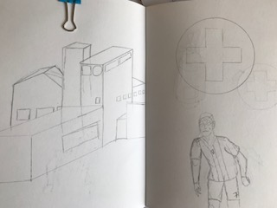
I drew the medical sign to represent the medical centre; I also drew a footballer but didn’t give myself enough room on the page for his legs!
I did some more illustrations using a black fine liner, which are a bit neater. I like the medical sign and the gold clubs, the horse is looking a bit like a unicorn so will have to be re drawn.
I think the building of the secondary school is just the right size and a simple enough design to work well. The footballer I made smaller and simplified the outline to work better.
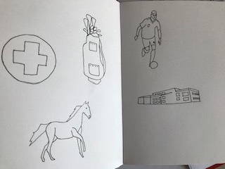
I started to draw these onto some watercolour paper to paint, and then I will put them through Photoshop to clean them up.
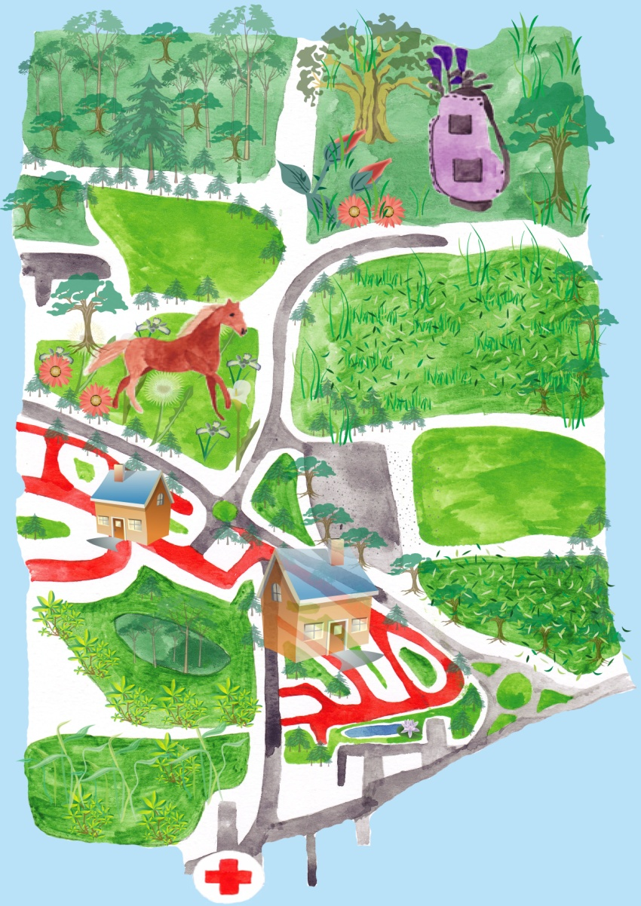
So here is my diagram so far after putting the elements through Illustrator and Photoshop. I started with the watercolour illustration of the map I did as a background layer, then I added a background colour of blue. I added in my watercolour illustrations of my icons to represent the areas nearby. Then I used some swatch libraries to add some trees, grass and plants to add texture and depth to the illustration. I felt this was important as it represents the woodland and green areas nearby. We are on a new build section, so the road colour changes from grey to red, I thought this would be good to keep on my maps the red would add the hierarchy colour to show the most important area which is where I live on the map, I chose to colour the footballers ball in red too and place a few red flowers around the map, so the eye would journey around the illustration to take in all the areas. I tried to make my house the biggest icon on the map as it was the most important, but I did change the transparency of it, so you could still see the roads behind it as you would need this information to get to my house. I chose not to add words to my illustration or road names to see if by asking friends whether they would be able to guess where it was.
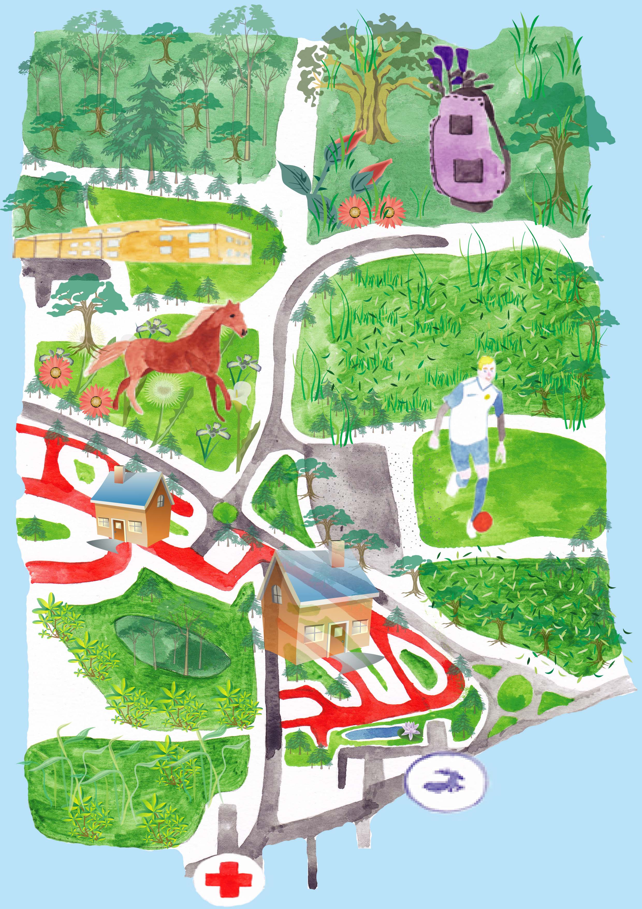

This is the final illustration, as there are 3 ways you can get to my house; this diagram shows the ways you can arrive. I would add road names to this if this was going to be a proper map, but for the exercise it says not to add words so I haven’t.
Two of my friends that live nearby got the gist of the map straight away, 3 others it took a little while, but once they worked out what each icon represented they understood what the illustration was for.
What did you think of this exercise?
I was looking forward to this exercise and looking at Martin Haake’s work first really inspired me.
I was going to choose ‘making a cup of tea’ but thought that would be easier, so I decided to push myself and choose ‘Directions to my home’.
I found it interesting researching and looking at the area I lived in more closely, I’ve only lived here for 3 years so it made me appreciate more how green and natural my area was.
I liked working on thumbnails to decide on a layout for my map. I also loved using layers and textures in my map, by putting together all the elements I’ve learnt in this section.

What have you gained from doing this?
I have started to put together all that I have learnt over the last few sections, both in the ground work of the exercise and the illustrations too.
Are there any materials or ideas you would like to explore?
I want to continue to pull together all the elements with this exercise, some bits I wanted to put in, either I thought it wouldn’t work or I was not sure how to incorporate it.
I feel I am getting to know my style as an illustrator, but I’m not sure or confident enough yet to put all these bits together, it’s something I’m hoping will come together over the next few exercises and definitely into section 4.
How will you do this?
Over the next few exercises I will be more confident and start to add in more details of the elements I want to use.
I’m realising I want my illustrations to include:-
Watercolour or gouache as a base element
Coloured pencils to add subtle detail
Ink to add fluid paint effects
Fine liners to add mark making and texture.
I feel this illustration has helped me to see how to pull things together and how I can incorporate the elements I want to into illustrations, it’ll take a lot more practise, but I can see ways these can come together now.

