Image development
I started this exercise by cutting out 2 ‘L’ shapes out of some thick paper.
I looked through my photos to find an interesting picture and composition, I really liked this picture that I had of Italy ‘Cinque Terre’ I love the colourful houses, the boats and the scattering of people in the distance.
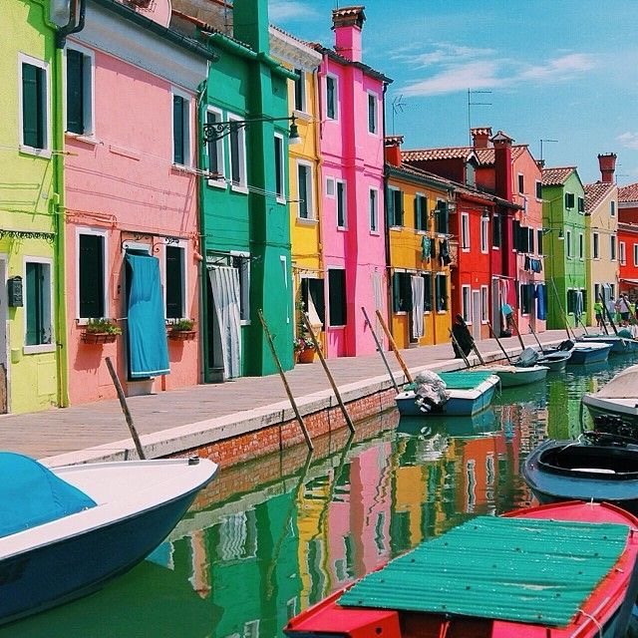
So from this picture I took 10 photocopies and printed them out, I then used my 2 ‘L’ shaped cardboard to use as a composition viewer. I created 10 different compositions which are as follows: - I’ve also added in the one word I chose to describe them.
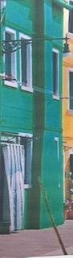 Verdigree 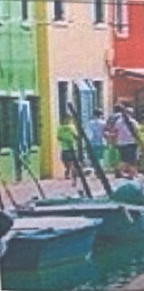 Lunch

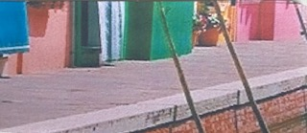 Walk

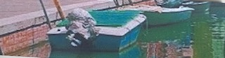 Riverside

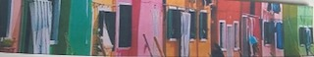 Rainbow

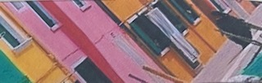 Diagonal

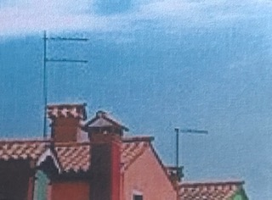 Tiles

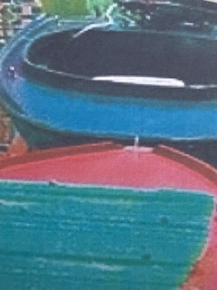 Boats
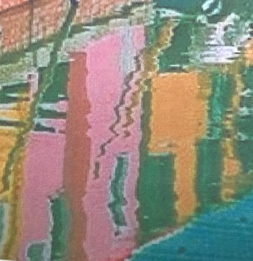Breeze

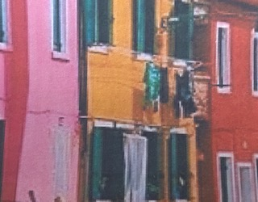
Washing
From these 10 compositions I decided to leave words for my 2 favourites, then I wanted to create a spider diagrams for these 2, I thought this might generate some interesting words for me.
I started with this one, which was the first composition I came up with.
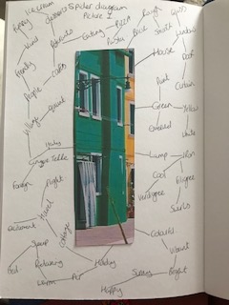
From this spider diagram I came up with the word ‘Verdigree’
The second one was this one as I thought the composition was quite different:-
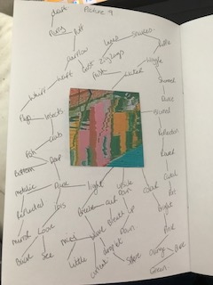
From this spider diagram I came up with the word ‘Breeze’.
From my 2 favourite compositions I decided to go with the one above ‘Breeze’, I thought this would make an unusual illustration. I felt this was quite abstract already, so I was keen to see how this would turn out!
At this point I had a look at some illustrators and artists to see if I could find one which portrayed unusual compositions.
I found the artist John Piper; I have included some of his works below, which show some interesting view points and textures to his artwork.
John Egerton Christmas Piper CH was a English printmaker and painter, he also designed stained glass windows and opera and theatre sets. His work was mainly of churches and the English countryside. Piper also designed tapestries, book jackets, fabrics and ceramics.
Piper trained at the Richmond school of art followed by the Royal College of Art in London. Piper started off in abstraction but later moved to a more natural style when he started painting churches and landmarks in England.
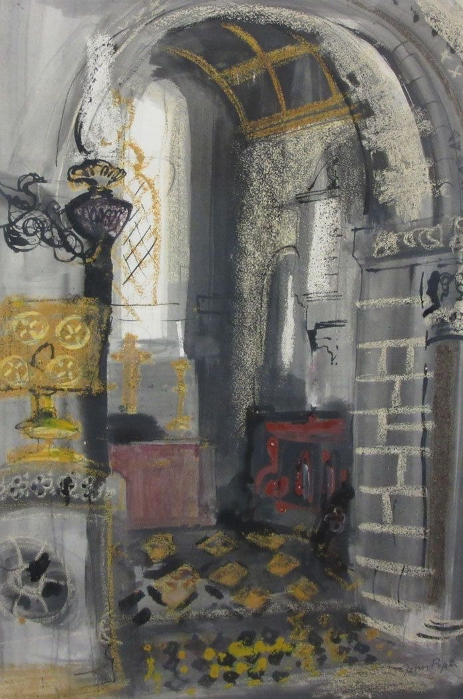
Piper John (1952) Chancel, church of St Peter [gouache, ink and wash on paper] Rowlestone
This is an example of an unusual composition, a close up of the chancel in the church, then looking diagonally through the arch. Some great use of media here with experimental use of the gouache and ink washes. I love the colour in this picture, using the yellow ochre colour in different sections around the room, takes your eye around it too, to follow. The red in the picture automatically brings your eye to this point. I like the spongy effect of the cream colour used over the top of the black ink wash is really effective, it’s like highlights.
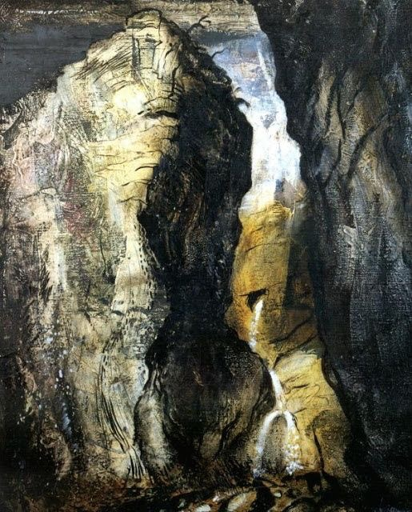
Piper, John (1943) Gordale scar, Yorkshire [oil on canvas] The Tate.
This is obviously a close up of a cliff or gorge, Piper has chosen to paint one part of the gorge, probably because of the textures and formations where interesting to him. It looks as though he has used some scratching techniques in this painting with his oils. There are a lot of marks on the lightest cliff, lines and sponge textures; you can see pinks and blues used in this too. Again I love the use of yellow ochre in this painting too; it brings a sense of warmth and brightness, in between the two darkest areas of paint. The yellow also helps highlight the little waterfall/stream which is flowing through the rock.
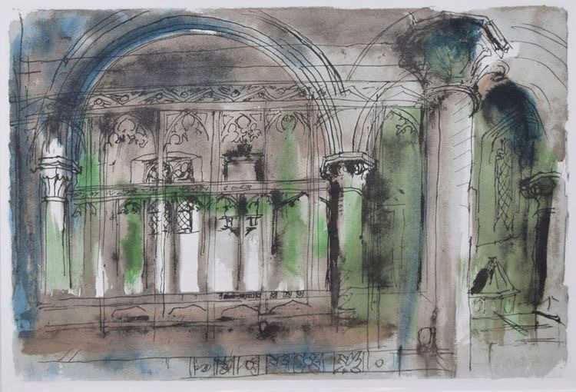
Piper, John (1989) Inglesham church Wiltshire [lithograph print]
Again this is a good composition of a close up of a section of the church, It looks like he has used some coloured washes first to create the atmosphere on the paper.
I like the way he had caught a section, which has a lot of detail within it. The delicate shapes of the arches and pillars, it’s all very decorative and intricate.
I can imagine for a more unusual view point you could go in even more close up and jest sketch some of the detail on one of the pillars.
So starting with the picture ‘Breeze’ I decided to do some colour paint tests, I started with watercolours as those are my favourite to work with. I chose the colours that best matched the picture.
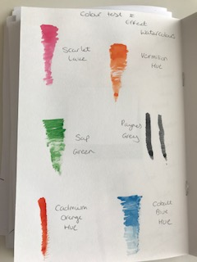
I liked the translucent quality of the watercolours; these would be great to achieve the water effect.
I then chose some coloured pencils, as I’ve used these before for some similar work, and they blended well, but after this test I felt they were too faint as the picture is very bright with pops of colour.
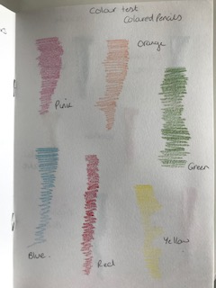
Then I decided to try Gouache which is similar to watercolours but have a deeper pigment to them.
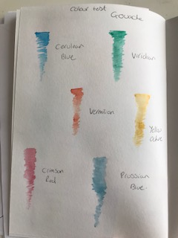
Although I liked these, I felt as though watercolours would still be best to use. Especially as it is water I will be painting.
So having decided I would use watercolours, I then sketched out my drawing and filled it in with the paints, I used a technique so as not to literally colour the drawing in, but use the paint more flowing so the colours merged into each other. I felt this would give a more natural look to the picture and give the ‘breeze’ feeling as though the water was rippling with the breeze.
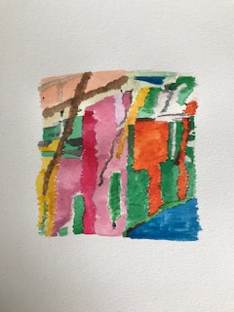
I like the way the colours have worked, I feel as though I have still kept the bright pops of colour as it is in the picture. It was harder than I thought it would be to create the wiggles in the paint, to show the ‘Breeze’ feeling. When I even finished it, I didn’t like it; I thought it didn’t work well. But now I have stood back from it and can see it on the computer, I think it worked well, the bottom half of the painting has the more wiggle effect.
I decided to try a few different typography fonts out on the computer first; I picked 6 that I like the most.
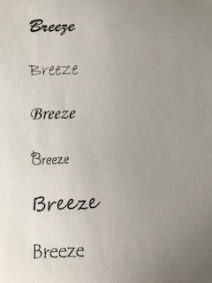
The fonts were, in order going down:-
Brush script STD medium
Bradley hand ITC
Monotype corsiva
Giddyup STD
Segoe script
Tempus sans ITC
I liked Bradley hand ITC the best, I felt it had a light breezy feel to it.
I used Illustrator to then compile a mock up of the picture with the typography; this is how it turned out.
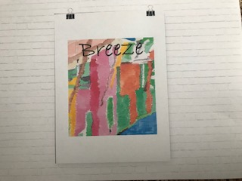
What did you think of this exercise?
I was looking forward to doing this exercise, as I was eager to learn more about compositions. I enjoyed looking for composition within the picture and it was exciting to come up with some unusual ones.
What have you gained from doing this?
I can see that you can create lots of compositions even just from one picture, and you can interpret a picture in many ways to give different meanings. I have a better understanding of trying out lots of compositions as this can give more excitement to pictures.
Are there any materials or ideas you would like to explore?
I will try and use this technique with some of the up and coming exercises and within my own work, as everyone wants to create new and exciting pictures/ compositions.
What will you do?
If I have an illustration that needs to be explored more or needs more fun, excitement or unusual angle, this will be the technique I will use.

After my tutor’s feedback, She suggested to research more into poster designs and to experiment with paint tests and mark making. To design with the text in mind from the beginning stage, and to try different poster mock ups, before going ahead with the final image.

So I made a few experiments with the watercolours and paint techniques in my sketch books, (you can find this in the video of my sketchbook work also)
I then looked into poster designs and researched these a bit more, so I found these images on Pintrest of different styles of posters and how they were laid out.
This first ‘Japan’ one I liked as the word was at the top, yet the picture filled most of the space, I also liked the black border around the design. This is simple yet effective and modern.
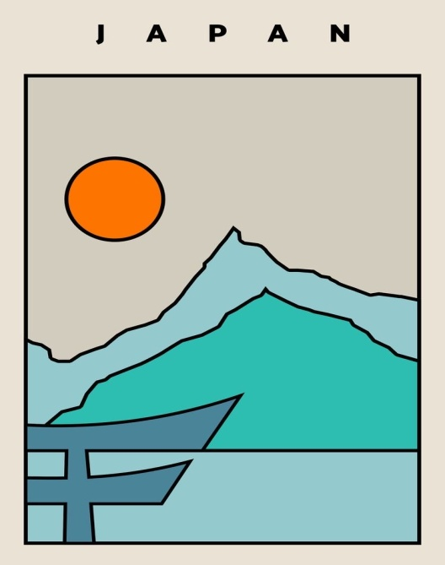
The next one ‘Sun’ fills the whole page with the image, and the words are part of the design too, which I think is really lovely.
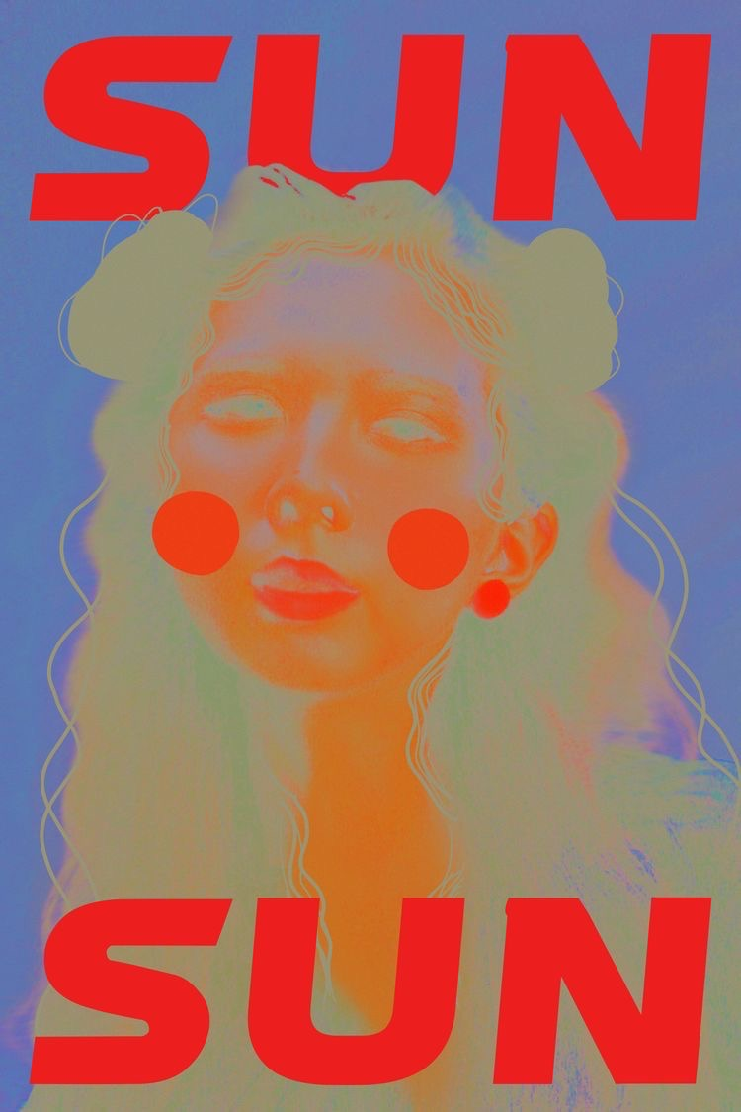
The third is this ‘London’ design, which has the image above, then the words on the foreground space, but they are two separate pieces I would say. I think it’s effective and works well with the design, but I have preferred some of the others better.
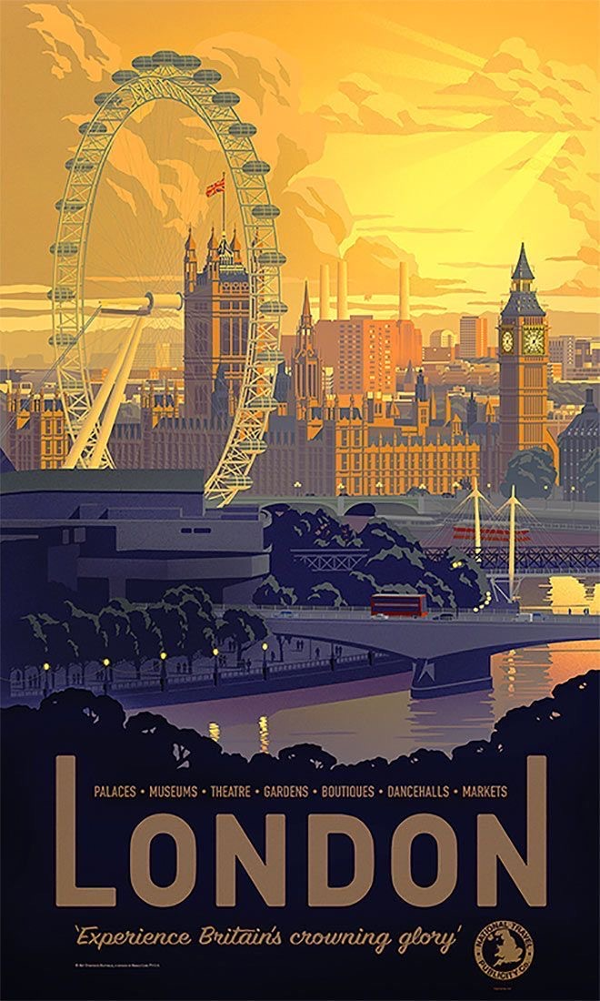
The fourth is this poster by Henry Matisse, which is very simple, has limited colours, the words contrast with the rounded organic nature of the art work, the words are very structured and square in comparison. The art work is separated top and bottom by the information.
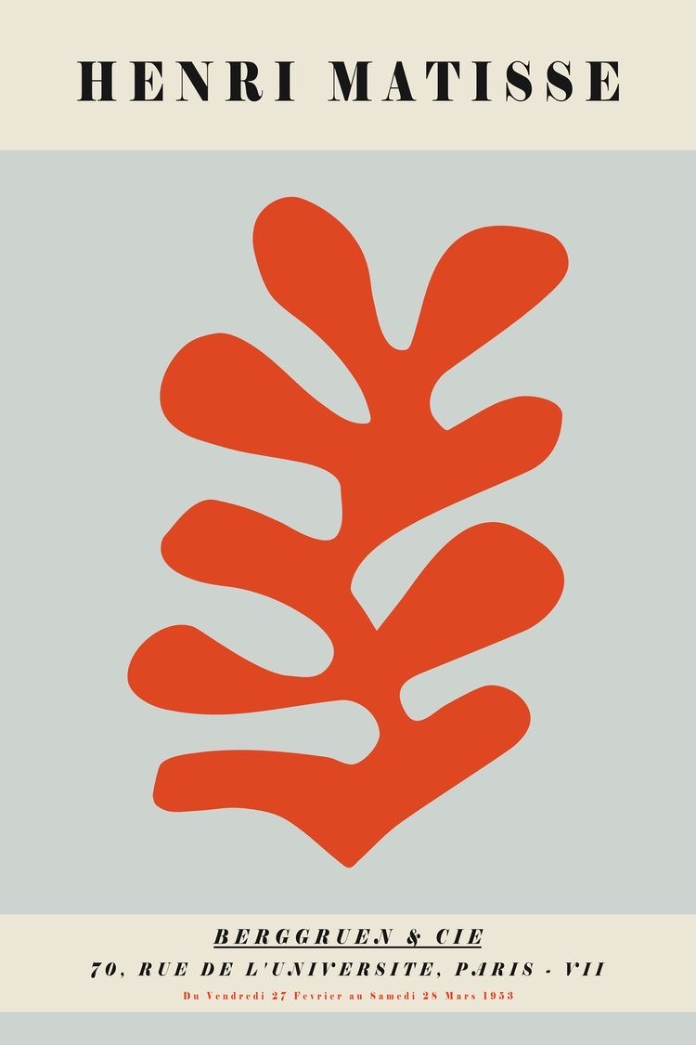
The fifth is just the art work, no words and the artwork is surrounded by white, like an informal border. The black edge on the frame also helps this poster echo the black of the line work in the art, so marries the two together.
After looking at these I went back to my poster and tried to compare and try some new ideas.

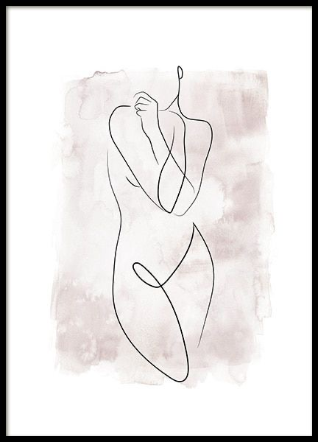

After having looked at these poster ideas, I started to take my artwork back and try the design ideas above, with my poster mock up’s.
So this is the poster full of the art work edge to edge, and then with just a white border, but so the word ‘breeze’ was part of the art work.
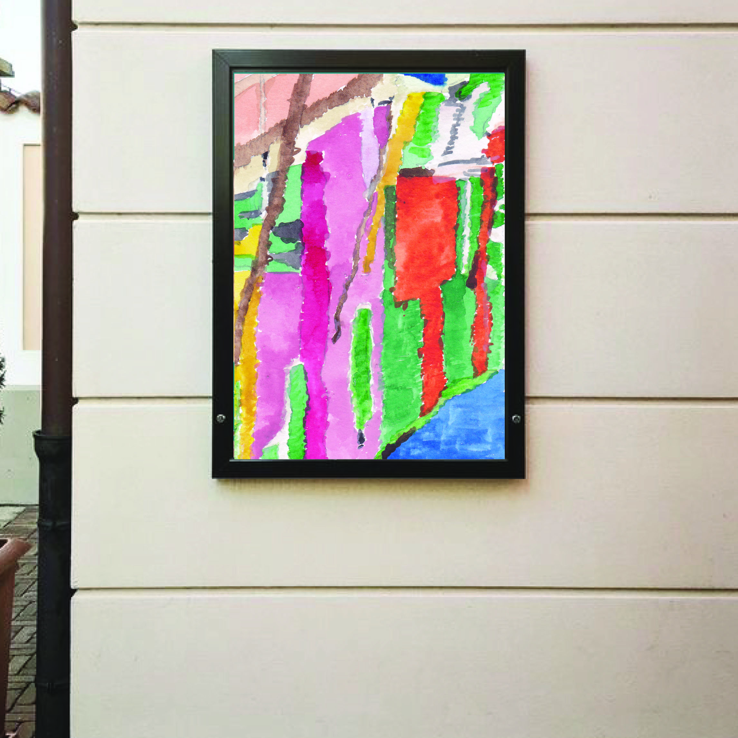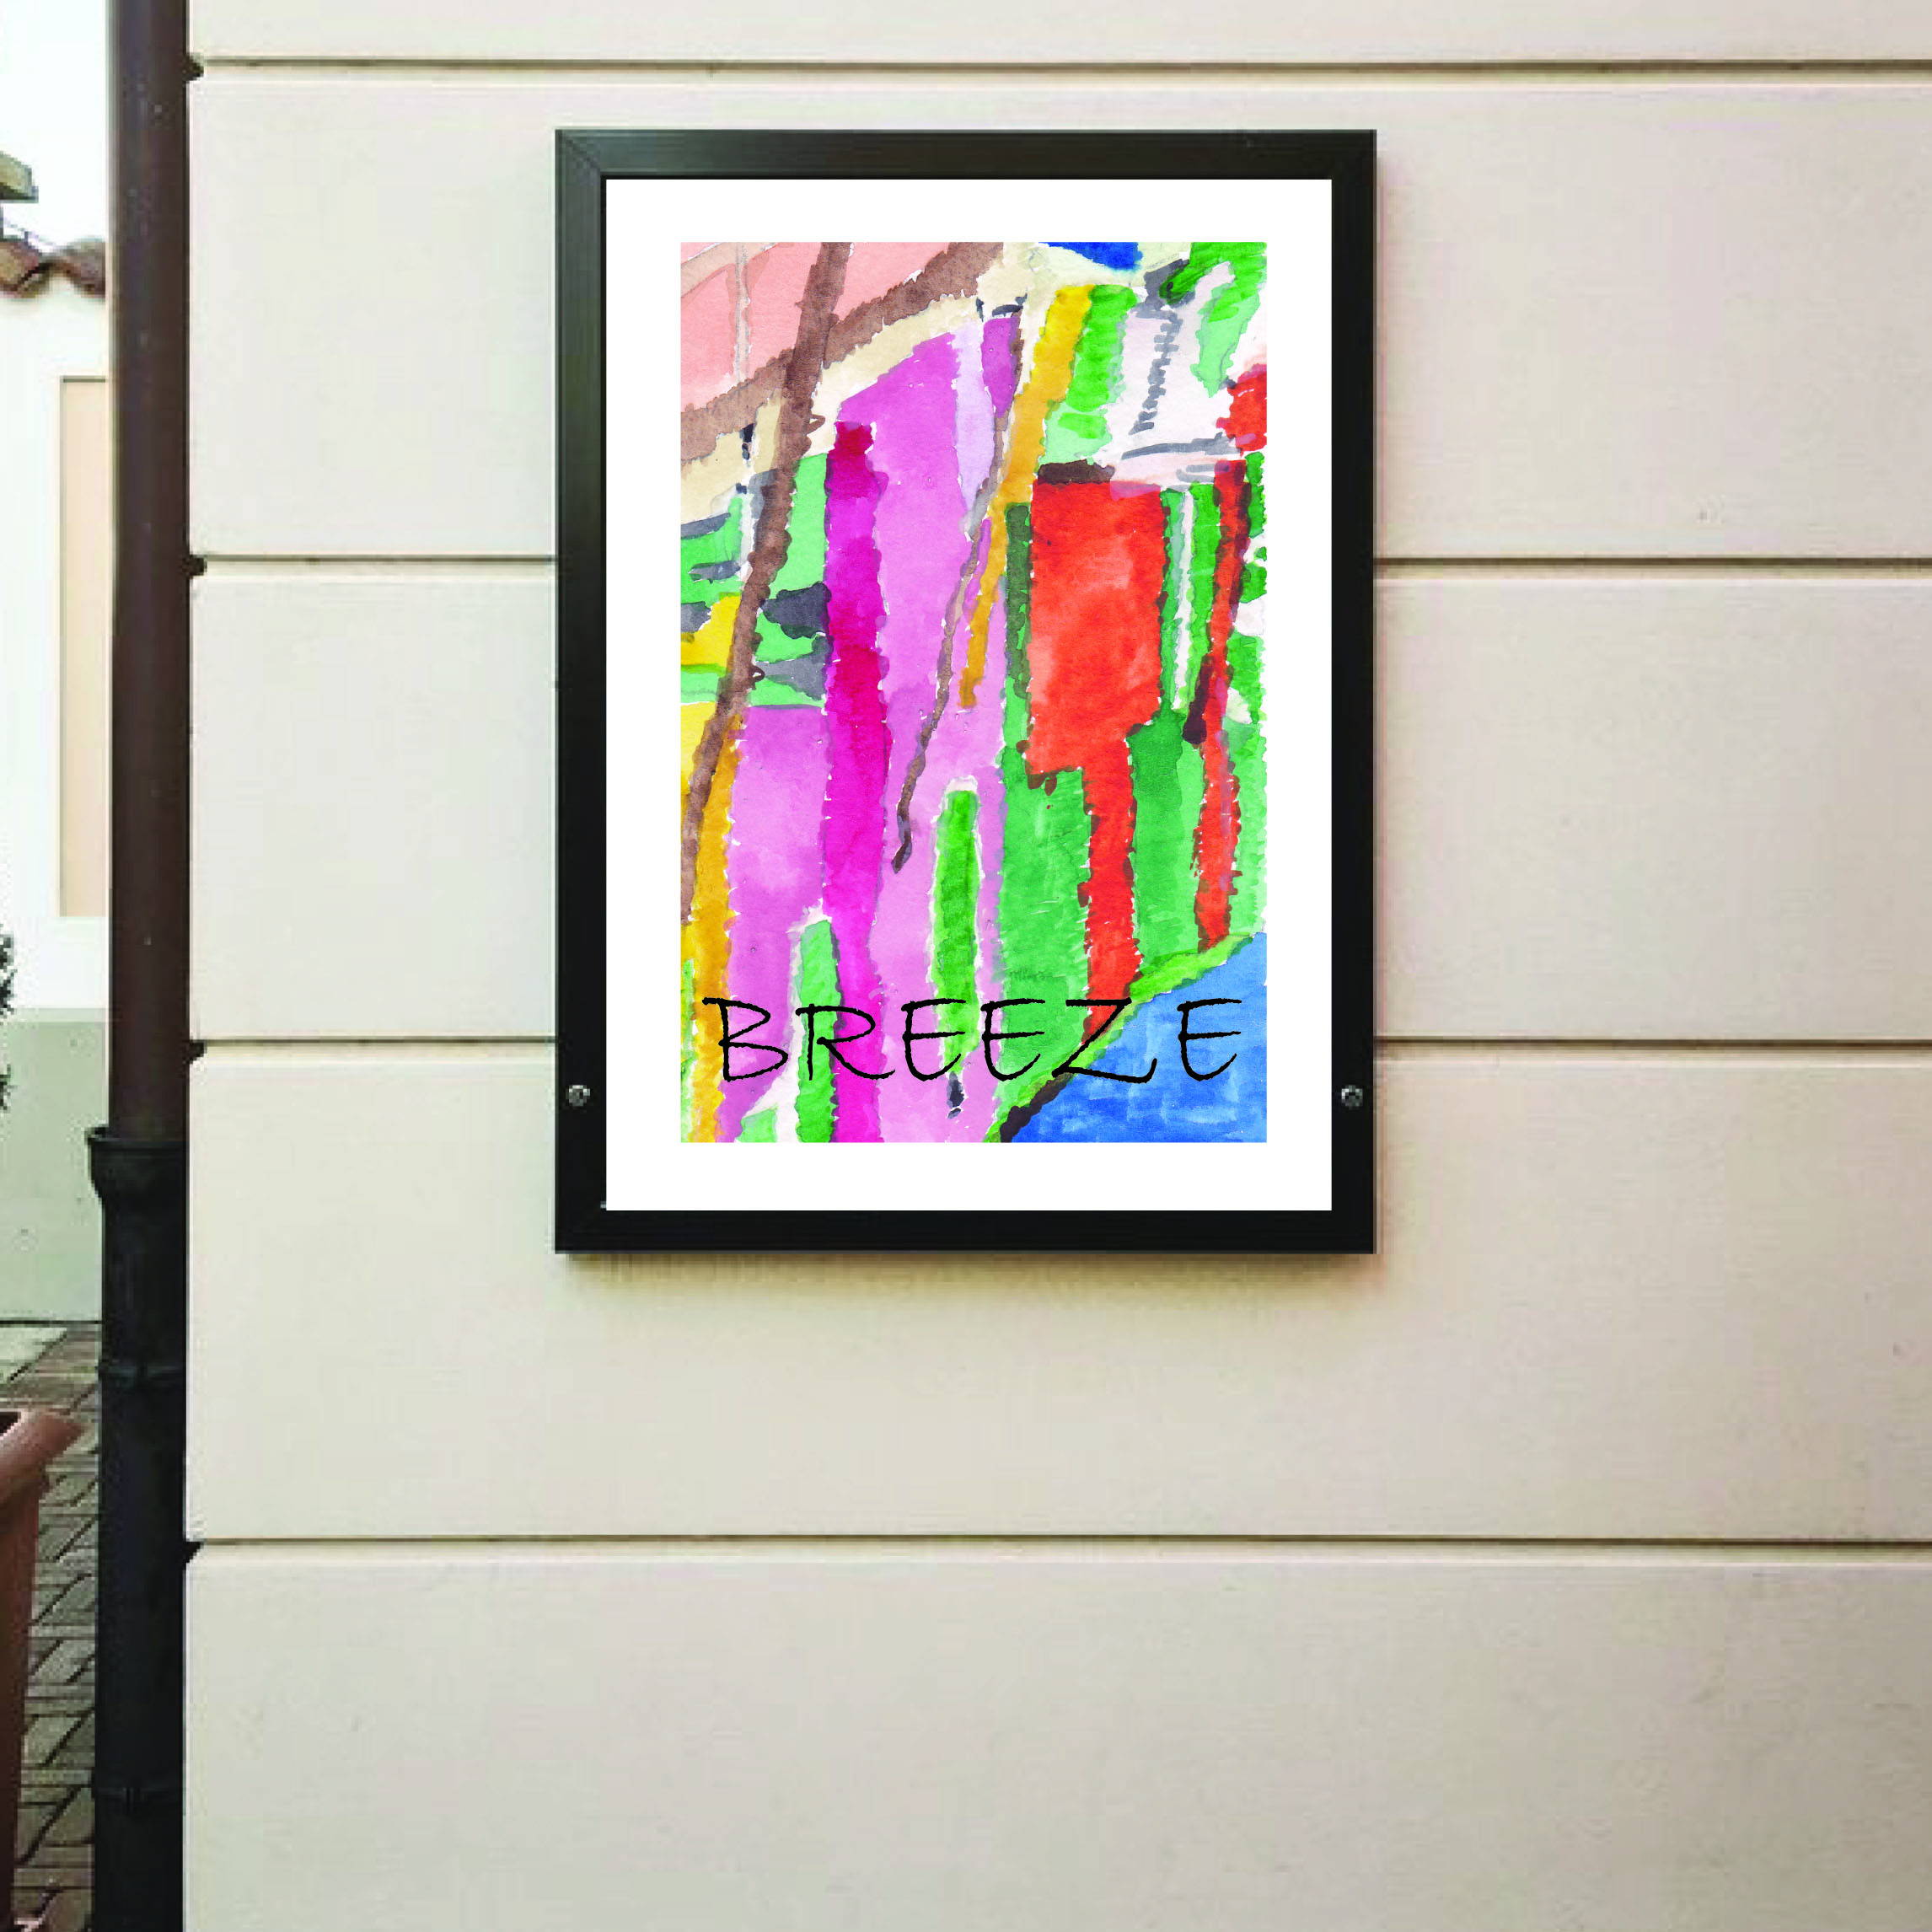
Then my original art work (with no cropping, just the natural edge) with the word ‘Breeze’ above. The art work with a white border and the wrod ‘Breeze’ seperate below.
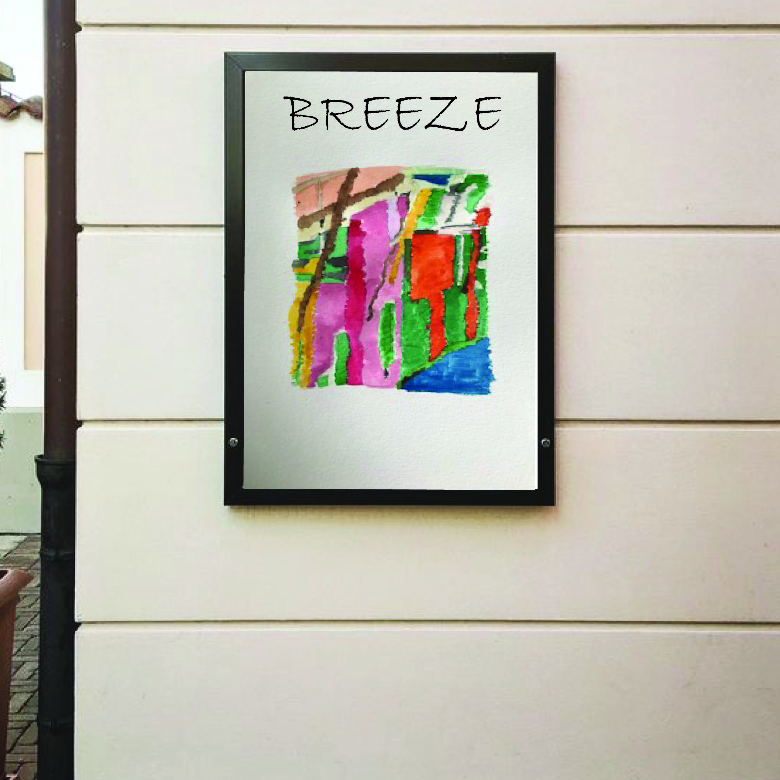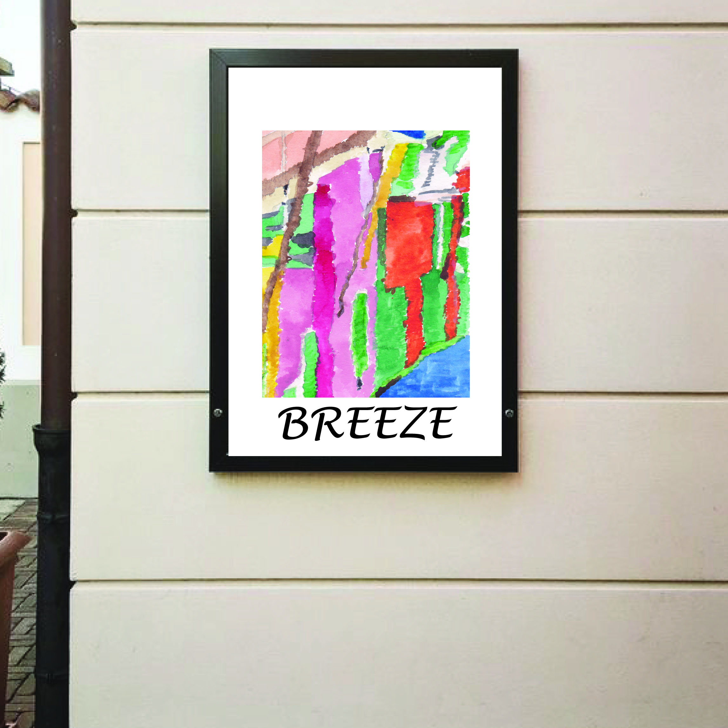
So on reflection of all of these, I don’t like the first one with the art work full to the edge and no words, it’s too much and I think some white border adds to the exclusive look of the poster design, I think the word ‘Breeze’ adds also to the artwork, it’s a piece that needs some explanation.
The second one I like that the word is part of the art work, I think it explains the art and being a part of it, seals it off as a finished work.
The third one, I really like the natural edge to the art, it makes it look more painted, rather than printed, and I don’t like the works above though.
The fourth one again I’m not keen on, I tried a different font, just to be sure the first one was what I was looking for, but yes I prefer the first font better, it feels more like the word ‘Breeze’. I think the art work needs to go up slightly on this one, the proportion at the top is off balance with the rest of the design, and it’s all happening at the bottom!
So overall I prefer number two the best, it works well together and feels complete now, so this will be my final piece of art work and poster mock up.

