Reading an image

I have listed below my initial thoughts of the image for this exercise:-
Dragon, cave, hot, gold, treasure, weapons, fire, little people.
I would say the image is about a cave with a dragon in it, sleeping, protecting some gold. Two little people have come to see what there is.
They could see with the light of their torch light, there deep in the cold damp cave was the fire breathing dragon! Lying on the treasure of gold. The dragon was asleep! Could Pip and Tom (little people) get to the gold where others had tried and failed before?
The palette for the background and the cave are cool colours, blues, greens and purples, it makes the cave feel cold. There are small textural marks on the floor to give the effects of stone.
The torch light is a flame, which glows and shows up the shapes in the cave roof, the stalactites. The flame shines red, yellow and orange colours which show the heat and hotness of the flame. The contrast between these colours and the cool cave colours are extreme, I think this shows how cold the cave is and how just the torch light feels so hot in comparison.
The dragon is coloured in red which I feel says danger, he is supposed to be a scary character and what with his spines which are spiky, this gives a jagged feel which adds to the scariness and danger. It shows his claws and horns which are on show to see.
The little people are in green colours, which to me show they are nice, gentle people.
I think the colours used in the picture especially the hot colours are important in telling this story, for example if the dragon was coloured in, in yellow or green, there would not be any impact and the atmosphere and maybe your idea of the story would change. Here the red shows the Hierarchy in the image.
At this point I had a look at other pictures that show hierarchy in the image.
Hierarchy means: - A system in which you are ranked to status or authority.
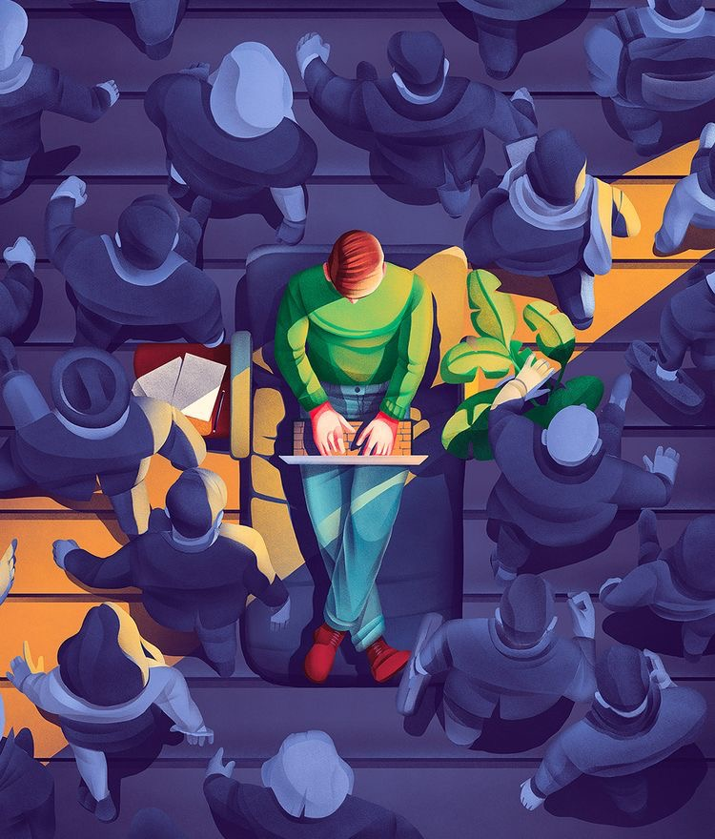
I thought this image showed good hierarchy with the use of colour. The non focus is coloured in a monochrome palette, whereas the part of the image the illustrator is trying to convey is used in ordinary colour. There is also a cool and warm use of colours here to show the difference also.
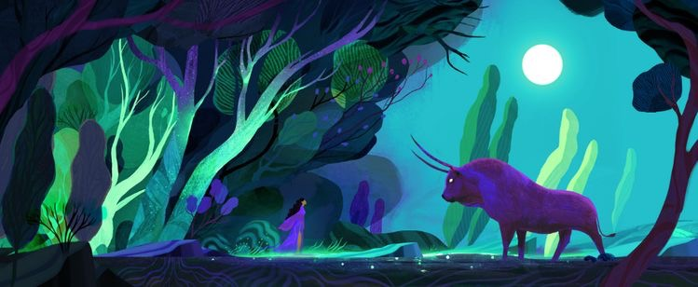
This illustration by Juliette Oberndorfer is more interesting in its use of hierarchy. With this one it’s the use of light and shade that show the hierarchy in this picture, Juliette has used the bull in shade with the dark purple tones and the moon light behind him to make him look important, strong and scary. Whereas the lady in the picture is lit by the moon so the purple tone is lighter and her dress is flowy to show gentleness and lightness.
I really liked Juliette’s illustrations from researching her, so I have written more about her in my inspiration section.
So the hierarchy in this original image is the dragon using the colour red, then your eye goes to the flame glow, which then leads your eye to the little people, then back to the little details like the weapons and gold, it takes your eyes around the image, you don’t really notice the background.
What did you think of this exercise?
Again I was unsure where this exercise was leading, but once getting started I understood what the idea behind it was and how it would help to compose a picture for the reader.
What have you gained from doing this?
I have gained an understanding of Hierarchy and how using this, can help the viewer/reader move around an image to tell the story. Also using colours and textures in an illustration helps this process more.
Are there any materials or ideas you would like to explore? What will you do?
I think after having researched Hierarchy in other illustrators work, this has helped me to see how it can work in many ways. I will continue to look at other artists work and start to try this in my illustrations from now on.

