Illustrating visual space
I started this exercise with looking for the 3 images on Google; I chose these pictures that represented a tree, a building and a boy running.
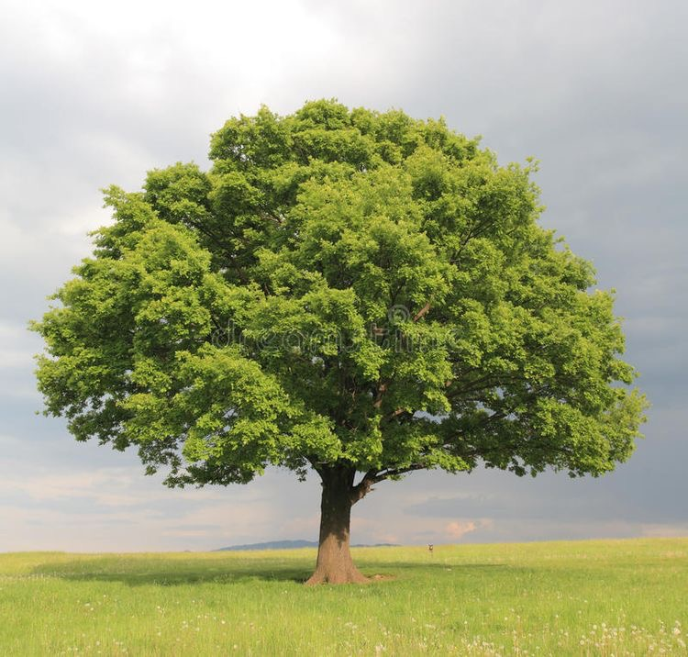
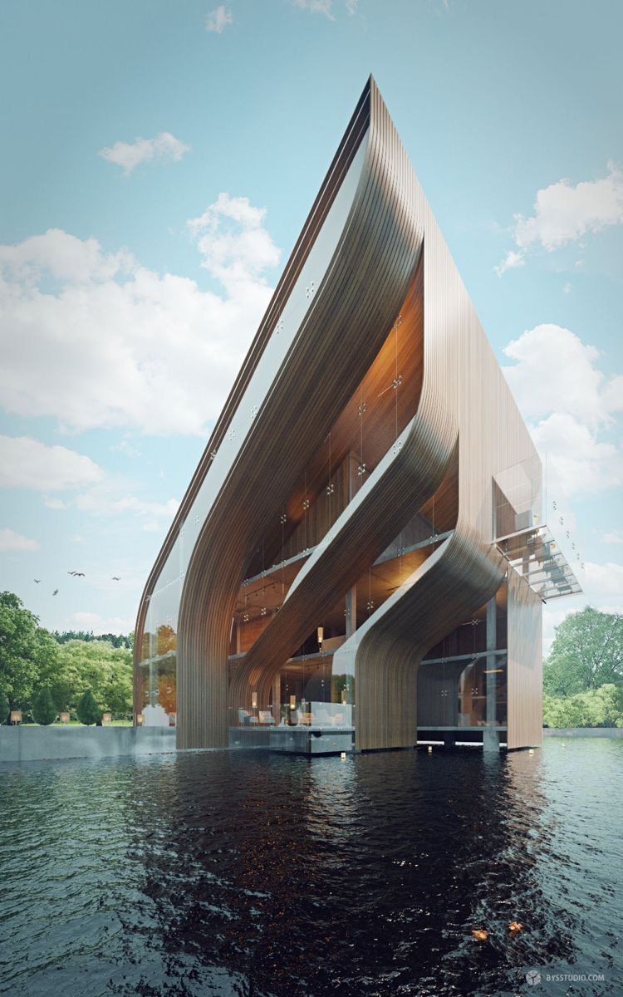
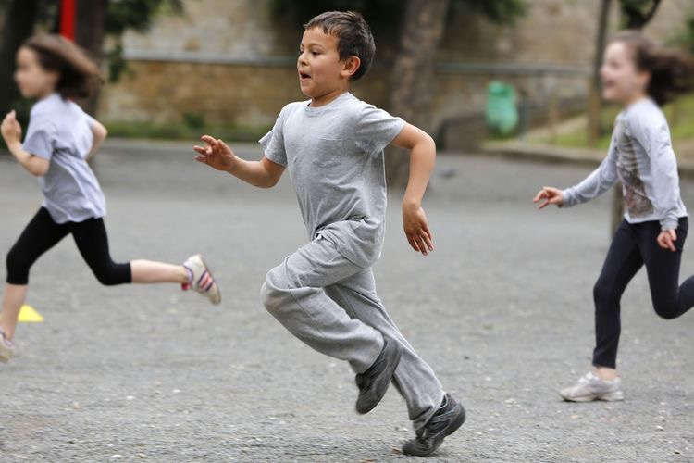
I changed the images to black and white and changed the sizes to create 6 copies of each.

I had a look at Edward Bawden as an illustrator that uses black and white in his linocut work; I wanted to see if I could see any sense of scale in his work, compositions and how they would look different if they were at different scales.
I found a few images of his that I could see scale in them:-
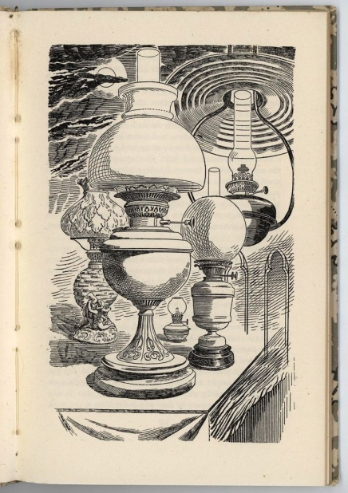
This one the lamp in the foreground is at the biggest scale, compared to the other 3 table lamps. The sky in the background is very small in relation to the lamp. The angle of the table is also moving off into the distance which adds to the feeling of space. Plus there is a lamp coming down from the ceiling, which is at a similar scale to the main lamp, but because it is placed just behind it, it feels still in the background. Although the picture is busy and crowded, you can still feel a sense of space in the distance.
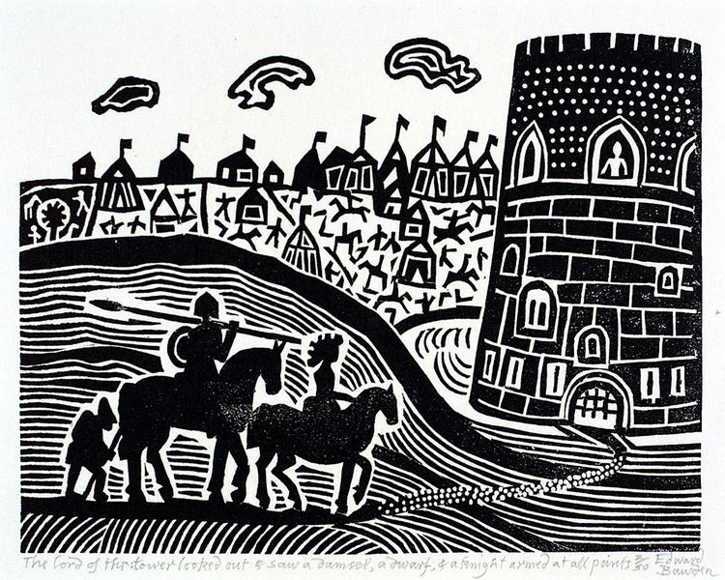
This picture again of Bawdens, the castle is at a large scale, but because it’s off the page and to the right, it doesn’t feel as imposing as it would be more central. The horses and riders are of a medium scale and more to the foreground, and the little tents and people in the background are of a smaller scale. Because of the horizon lines that flow around, you eye is drawn around and to the castle. The scale in this lino cut is crucial to the story that’s being told.
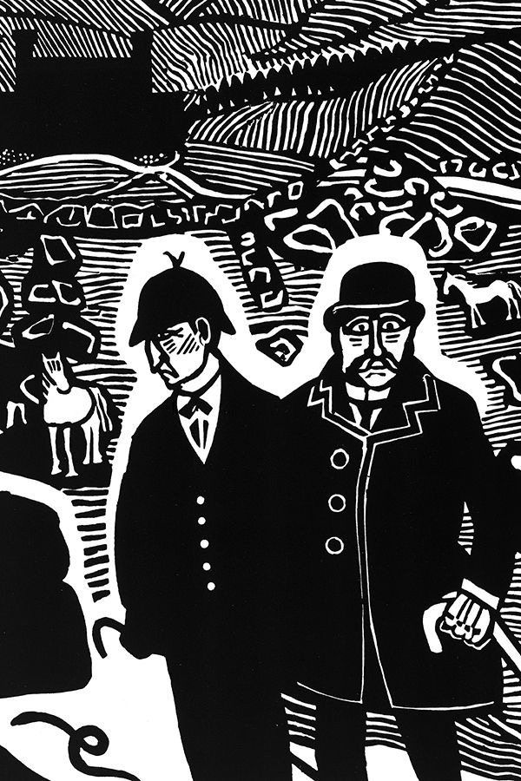
In this last lino cut that I have found of Bawdens, The main characters are on a large scale and right at the front in the foreground. These men must be crucial to this story as the feel important and right there in your face. The odd horse in the background at smaller scales and the backed out building behind, shows that this is not really important in this picture, it is just maybe for atmosphere or for placement.

I then cut them out as requested in the brief; I started to arrange them on pieces of plain paper to see if I could get some interesting compositions and visual space.
The designs I came up with are as follows:-
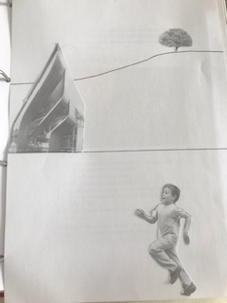
So in this first picture I had the boy in the foreground the building half way up the page, and the tree in the distance. I did this because the tree was the smallest scale so to me that had to be in the distance. The building needed to be in the middle ground somewhere and the biggest scale was of the boy running so I put this in the foreground. I think this works nicely as a composition, it’s fairly standard in the way it is set out, and I don’t feel the dynamic is anything special; it’s just a typical composition. There is a sense of space here, but the scales are not that far apart from each other so I feel the space is not as big.
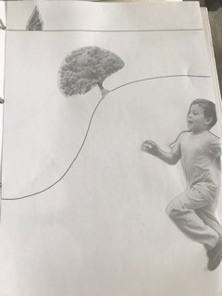
No.2 I tried to change things up a bit, I used the boy running in the largest scale and put this half way off the page to look as though he is just running in front in the foreground. I decided to use a hilly horizon line next, 2/3rds of the way up the page, and put the tree at a slight angle for this one. Then the building in the background as this was the smallest scale for this one. To me this has quite a good dynamic to the composition, I hadn’t realised but the images are all in a row diagonally which I feel adds a sense of ‘moving forward’ in the picture. It has a good flow about it and the scale decreases the higher you move up the page. I feel there is more space from the middle to the background in this picture, I think it is because the scales are moving down the more you get to the top of the page.
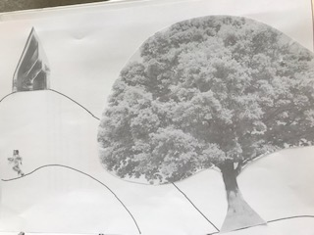
With this one I decided to move the paper to landscape, I had the largest scale of tree and the smallest scale of boy. I put the tree in the foreground as it was the biggest; I then created some wavy horizon lines and then placed the boy to the far left hand side, in a dip in the line, then added the building above to a hill in the horizon line. I love the movement in this image, the rolling up and down; it looks like the boy is running away from the tree, maybe running towards the building, is it home? I felt there is a real story to be told behind this composition. I feel this composition has the largest sense of space within it, I think it’s because it has the biggest tree and the smallest boy by scale in it.
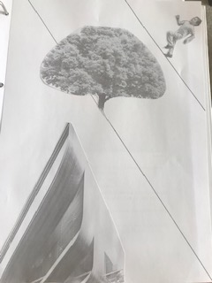
This next one was I put the horizon lines down first just to see what would happen with the images after. I played around with the house first, but felt because this was quite big to have this half off the page, to look as though it was right in front of you. The boy I added into the distance and used the line to decided at which angle to put him, I love the way this looks as though he is running up a very steep hill, I think the pose he has anyway really adds to this. Then I used the tree but rather than put the tree at the same angle to the line, I put it vertically but cut a piece of the bottom as though it was growing from the side of the cliff!
This sense of space is more close together for me, again I think it’s because of the scale sizes used.

Again this is another picture that you could create many stories from as it is very dynamic.

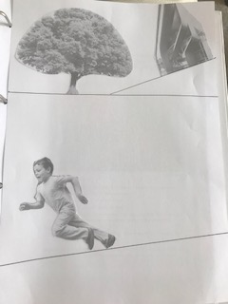
With this next one I kind of wanted to do the opposite of the last one especially with the boy running. I chose to use a slopped horizon line and place the boy on it at an angle leaning forward. I feel this makes the boy look as though he’s running really really fast as is almost going to trip over, it looks like he is in mid fall! I wanted to try how the building would look at an angle too, I felt a slight angle tipped downward would be the most realistic, I feel this works well in relation to the tree, and they are at similar scales so look ok nearly next to one another. It makes it feel like a topsy turvy place, with different horizon lines up and down. This again has a closer sense of space within it, because the scales are very similar in size.
This last one was something I wanted to experiment with, I liked the running boy with the largest scale and wanted to see how I could make it crazy, so I used the tree at the smallest scale and the building one up from that. I played around for a while then I came up with the boy using the tree and the building as ‘stepping stones’ as though he was a lot bigger than them and they were tiny and small. This then created a ‘giant’ look for the boy running, which again added another twist. This composition would have exciting stories you could create from this.
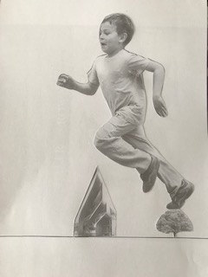
Answer to question 1:-
When the figure is the smallest, I have the boy running away so to me, it makes the tree and the building look very big in comparison. I feel like they loom above him, and maybe that’s why I had him running away!?

Answer to question 2:-
When the elements are at different angles, I feel it has a frenetic wobbly feel to the dynamic, it doesn’t feel stable, and maybe that’s why the boy is tripping up!?

Answer to question 3:-
If all the elements are vertical and horizontal to the frame like in my first picture, it makes the image feel very normal, stable and a bit boring. It doesn’t feel exciting or dynamic; it is just the same as everything else!

Answer to question 5:-
I am torn between 3 that I like the best:-
I like all these 3 because I feel they all have many possible stories that you could create from them. The one that has the biggest sense of space is the first one, But I would probably say my most favourite was middle image, just because the dynamic is quite crazy, you could really have some fun unusual stories that you could create from this image, it’s not at all normal and its all flowing upwards, there is a sense of space but more of a sense of upwards space, space you can’t see yet!

What did you think of this exercise?
I was unsure to begin with what the idea of this exercise was! After cutting all the pictures out and playing around with them, I could understand what actually the process behind the exercise was.
What have you gained from doing this?
I have gained a great idea of how to play around with composition and how sometimes you may have a fixed idea in your head of how you want a picture to look; if you experiment you can find some other exciting possibilities.
Are there any materials or ideas you would like to explore? What will you do?
I will use my thumbnail drawings to experiment more with composition, and I will print and cut out ideas to make it easier to generate some interesting pictures in the future. I felt this was a really valuable exercise and it has helped me to see how to experiment more.

