I started exercise two with looking for an article. I found one online that I was interested in about Gault the asteroid. (Article below)
Live Science website

Doomed Asteroid 'Gault' May Finally Explode After 100 Million-Year Death Spiral
By Brandon Specktor, Senior Writer | March 29, 2019 06:41am ET

An asteroid named Gault is spiraling into sloppy self-destruction — and, like watching a car crash, scientists are having a hard time looking away.
Gault is about 2.5 miles (4 kilometers) wide and, for now, lives in the asteroid belt between the orbits of Jupiter and Mars, along with 800,000 or so fellow space rocks. Soon, however, Gault may be nothing but a smear of dust on the cosmos. [The 8 Strangest Objects in the Universe]
Recently, telescopes around the world caught Gault "misbehaving," as one German scientist phrased it in a NASA statement. The asteroid is apparently wobbling and tumbling about itself faster than a healthy asteroid should, and it's beginning to avalanche little bits of itself into massive streams of debris that stretch for hundreds of thousands of miles behind it.

Astronomers at NASA, the European Southern Observatory (ESO) and elsewhere recently measured two such debris trails following Gault through space — one measuring approximately 500,000 miles (800,000 km) long and the other about 125,000 miles (200,000 km) long. These long tails are telltale signs that Gault is spinning out of control — probably completing a full rotation once every 2 hours, which is about as fast as an asteroid can theoretically spin before it disintegrates completely.
What's causing this self-destructive pattern? According to NASA, it may be the final throes of a 100 million-year-old death spiral that began shortly after Gault got too much sun in its youth. Solar radiation warms the surfaces of asteroids, NASA wrote, but it also causes those asteroids to release infrared radiation of their own. When asteroids lose heat, they also lose a bit of momentum. Over time, this momentum loss can create torque on the asteroid, which, in turn, gradually increases its rotational speed. (This is known as the YORP effect.)
Researchers predict that Gault's rotation started speeding up about 100 million years ago and has steadily accelerated by 1 second every 10,000 years since. Now, it's near the theoretical limit at which asteroids stop being asteroids and lose hold over their constituent pieces.

The two dust trails streaming out behind Gault may be the result of landslides on the asteroid's surface that lasted for hours or even days, NASA wrote, and there may be more to come as Gault continues its journey of self-destruction. If and when the rock finally loses form and crumbles to dust, astronomers hope to see it happen; events like this are considered extremely rare in the asteroid belt, happening roughly once a year.
A paper on this rare cosmic meltdown has been accepted for publication in a forthcoming issue of The Astrophysical Journal Letters.

After reading the text I use a yellow highlighter to highlight the words which I thought where important and stood out. I then re-read the piece again and found the following words and sentence was how I had condensed it down and understood it to be: - A asteroid called Gault was misbehaving and spinning out of control in between Jupiter and Mars, too much sun in its youth is creating the Yorp effect, dust streams behind, and will self destruct and crumble to dust.
From this sentence I did some sketches to draw what it means.
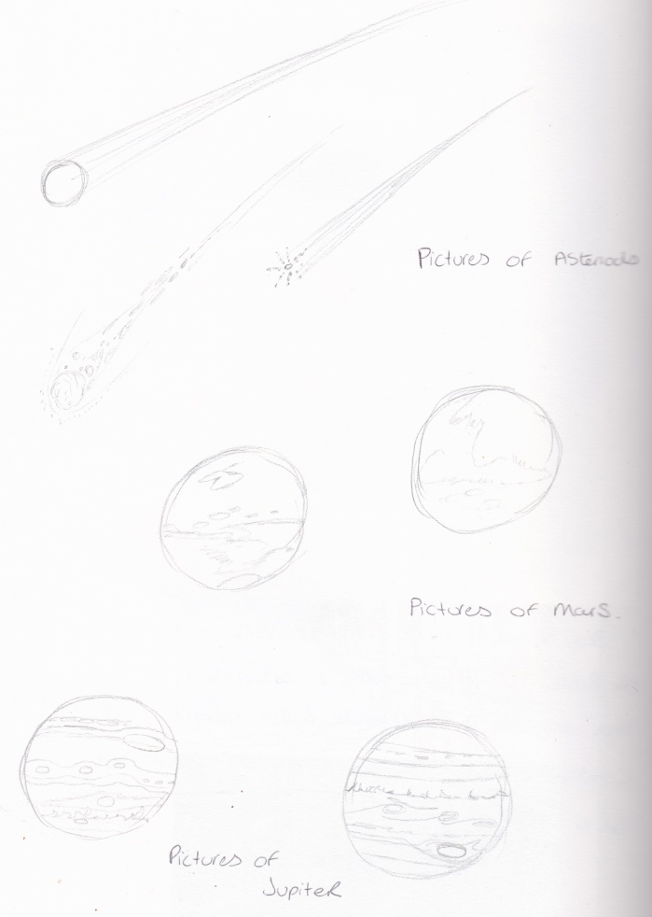
I drew some pictures of asteroids in different stages of its life, and pictures of the sun, Mars and Jupiter.
I had a look at a diagram of the solar system to see whereabouts Mars and Jupiter were, I noticed the asteroid belt there too, as this was also mentioned in the article. A plan was forming in my head of how to draw this in 3 stages. I drew a little plan; the top half had the sun in it, with a young asteroid. The second section had Mars and Jupiter in it with a middle aged fast asteroid. The third stage was the destruction and old asteroid.
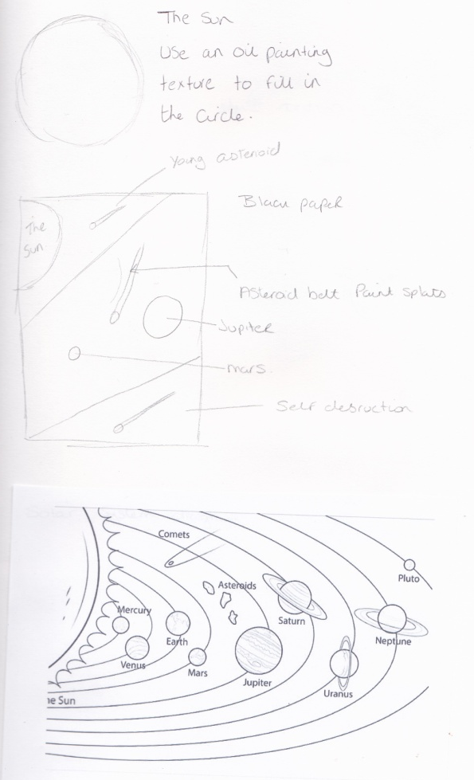
I was then thinking would this work!? I really needed to add a few words into the picture to make people understand more. So I thought about a comic design instead. I drew the asteroids but so they had faces on them, to give expressions. In a similar style I planned out the 3 stages again, the first again with the sun and a young asteroid but with a shocked (OH my god) face on it. The second with a mischievous face on it and with extra tail spin to show fastness, and the third as self destruction.
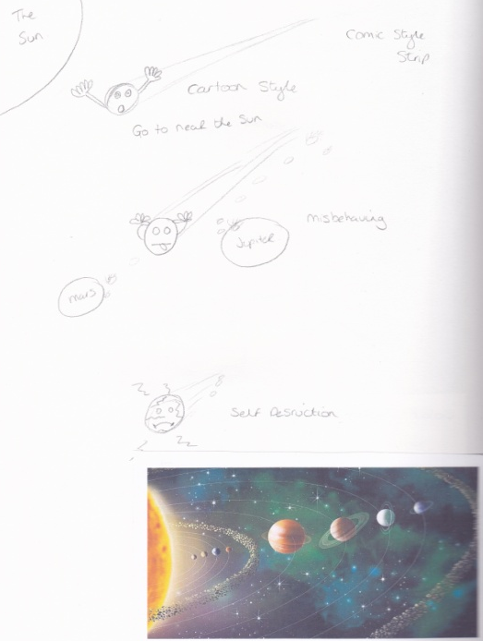
I liked both ideas, so decided to try them and then see which worked the best. I did some fine liner sketches of the 3 stages of asteroid life in my sketch book.
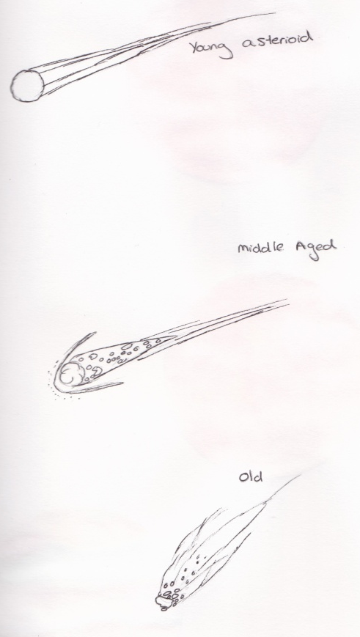
Then 3 planets, the sun, Mars and Jupiter, using some watercolours to get the colours nice.
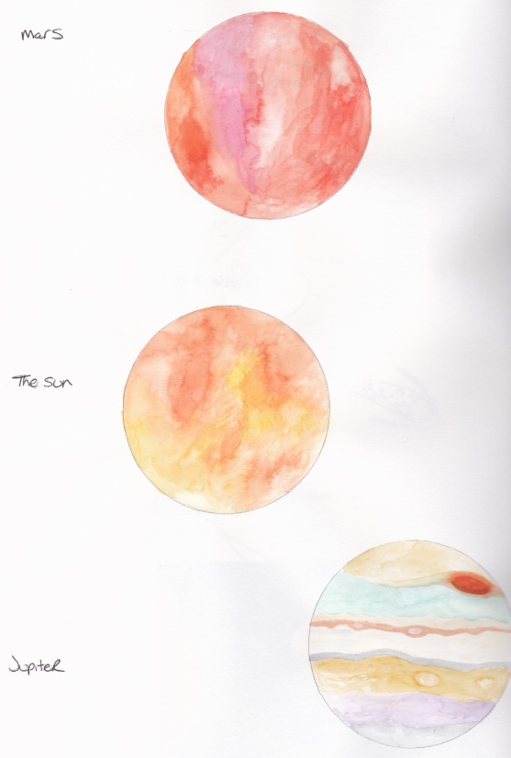
I then used a dark blue piece of pastel paper to create the drawing, so I set it out as planned and did the 3 stages, which told the article.
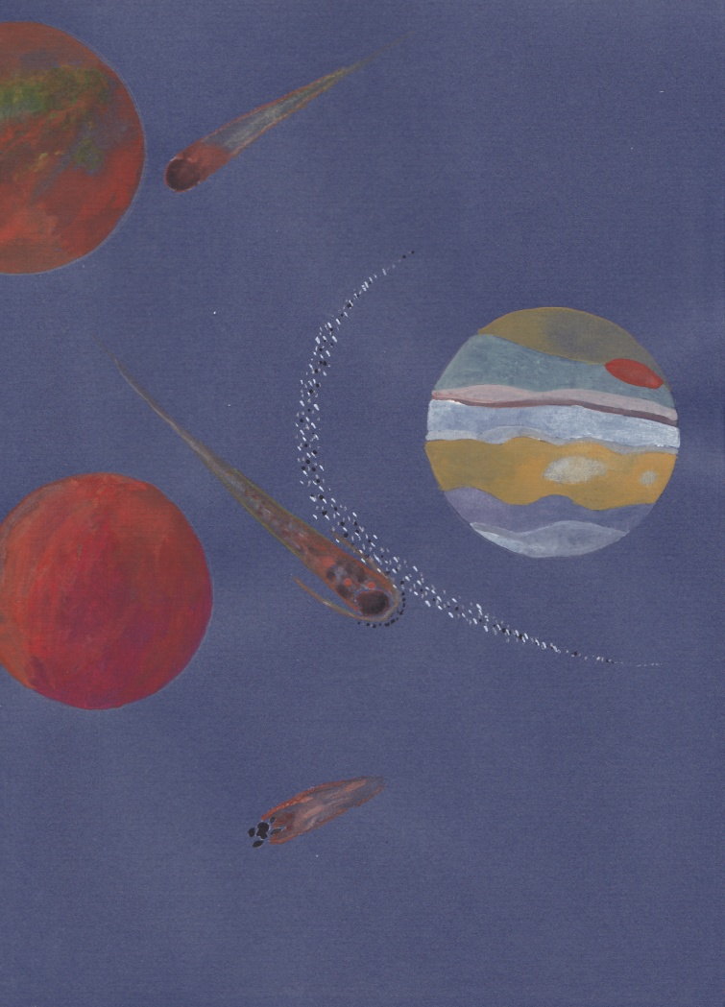
I liked the piece very much, but I still felt that because I knew the article, am I seeing what I wanted too, rather than what other people would see with the picture. So I decided to leave for now and ask a few people if they knew what the picture was saying.
I asked a few friends there feedback and they said that they understood the picture to be meteorites, they didn’t recognise the sun or Jupiter, but new it was Mars, but they don’t know the planets anyway! They didn’t know the picture was in stages.
After this I decided it needed a bit more clarification, so i decided to add a few words to the top half and bottom half of the picture to show time scales, which I think will show people the picture is in stages and a travel through time.
I did this in Illustrator and used a space style typography and in white so it would show up on the blue background.
The feedback after was better, they now understood the piece to be in stages showing the journey of the asteroid, and along with the article they thought the illustration was good.
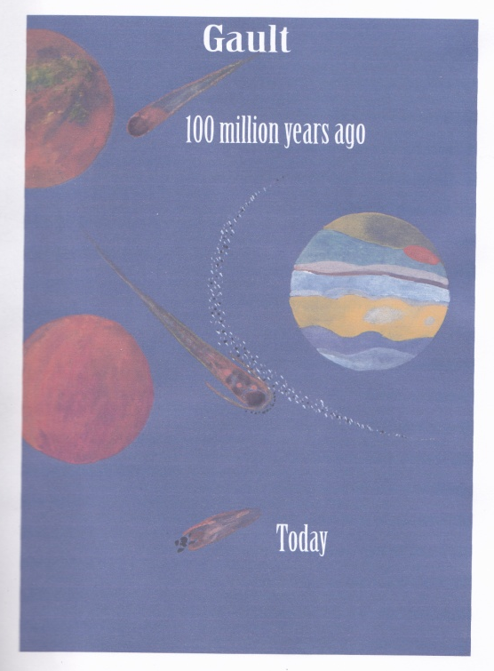

I then went onto my comic strip idea, I put a few more sketches down in my sketch book, although I knew the 3 stages for this, I had never drawn any sort of comic book before.
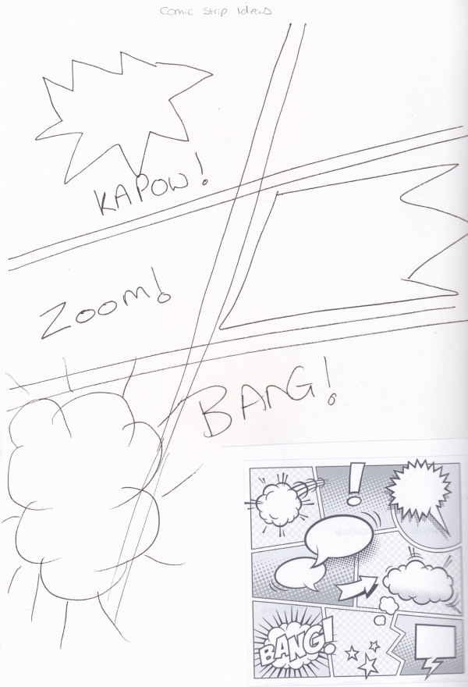
I found a few template ideas in Pintrest as seen in my sketch book.
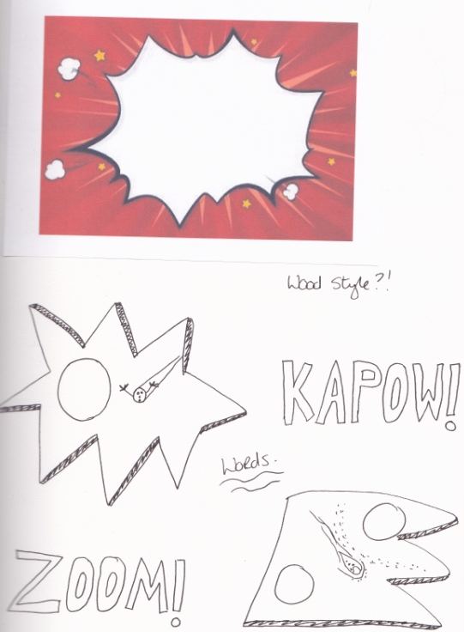
I designed my own template with the 3 stages on to a piece of paper, I intended to do most of this idea in Illustrator to give that modern crisp design. I scanned my template into Illustrator then built up the layers and ideas into that.
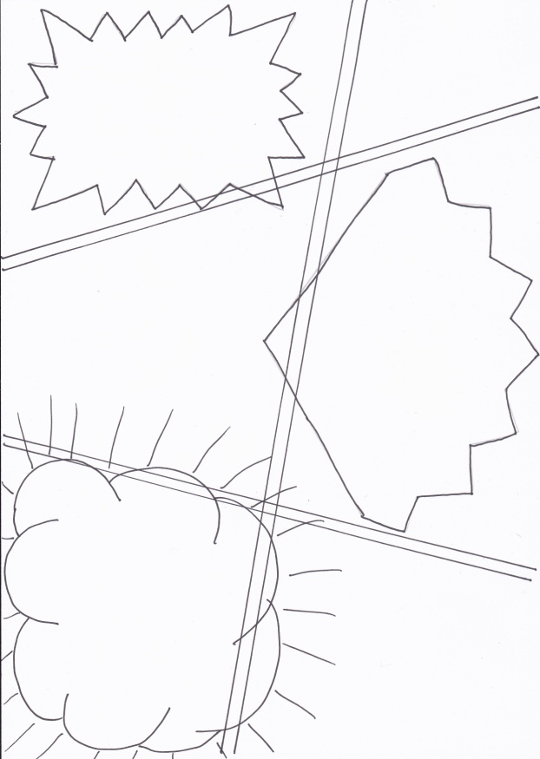
I used some retro typography to give the words some impact, and used bold primary colours with it edged in black to make it pop! I did have trouble trying to draw the asteroids in Illustrator, but I kept the motifs simple and basic.
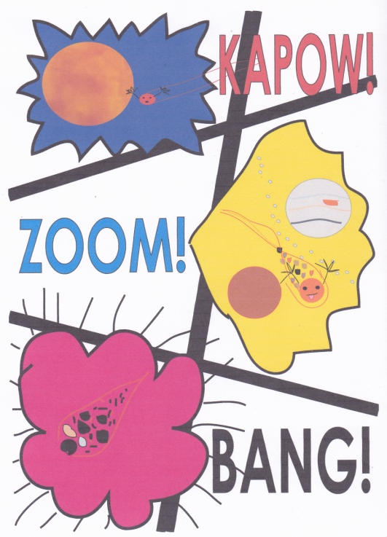
After achieving what I wanted to I printed this out to see how I felt about it. I really liked the modern simple idea of the comic strip and felt the 3 impact words helped tell the story, but again as I knew the article I was sure if I was really seeing it.
I decided to stop at this point and get some feedback from friends.
The feedback I got was that they thought it was about little people and evolution, they didn’t seem to think it was about the same article and they were a bit confused about the comic strip layout. After telling them it was for the same article but done maybe to appeal more to children, they said that they thought the first idea was much better and more suitable for both adults and children, they were unsure really what I was trying to achieve in this piece, I explained it to them but they still didn’t see it! They all agreed the first illustration was the much stronger one and really liked it.
After feedback from my tutor I have added the following:-
Look back at mood and tone of the article what was it trying to communicate?
So I looked back at the article I had chosen and read through it again, the feeling I get from the article is one of slight panic, destruction but also some child like humour in explaining some of the theory. The image that I get in my mind when I read this is a vast atmosphere with lots of stars and planets, a asteroid travelling at high speed through the sky spiralling out of control with bits of debris falling off and deconstructing before our eyes. So I guess in my illustration I should have created more of an atmosphere around the asteroid images, stars and more of an action piece with more marks to create that feeling. Looking back at my illustration it doesn’t create that feeling I have just explained, in fact it feels quite calm and serene.
What did you think of this exercise?
I was looking forward to this exercise and creating an image from words, I liked how you condense the words to a small section to really get the main gist of it. I liked trying to opposing styles too and trying one which was out of my comfort zone.
What have you gained from doing this?
I now have a basic understanding of what illustrators are trying to create when they have to create a picture or illustrations from words, a text or story. It’s interesting how many ways you can interpret one set of words.
Are there any materials or styles you would like to explore from this?
Yes I think textures still and mark making, how to create atmospheres and feelings into the illustrations.
What will you do?
Continue with the texture and mark making sketch books and research illustrators that create strong feelings in their work.

