Pareidolia
I started this exercise by looking around my home to see if I could see any objects that had faces in them. After looking around I actually found quite a few things that had faces, so I took pictures of these.
I looked up Keith Larsen and found out some information and research on him as an artist. Keith see’s shapes and faces, not just in clouds, but in everything, furnace’s & soap dispensers. Keith finds himself doing this with everything, he has taught his mind to work in this way, as he says he lives in his own world of pareidolia. Here are a few pieces of his work below:-
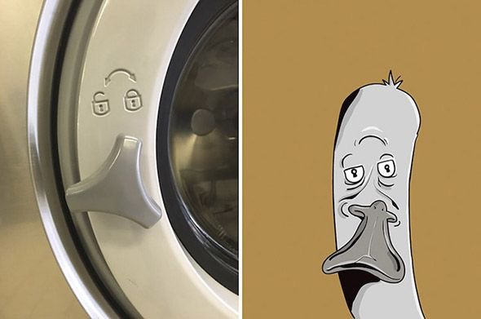

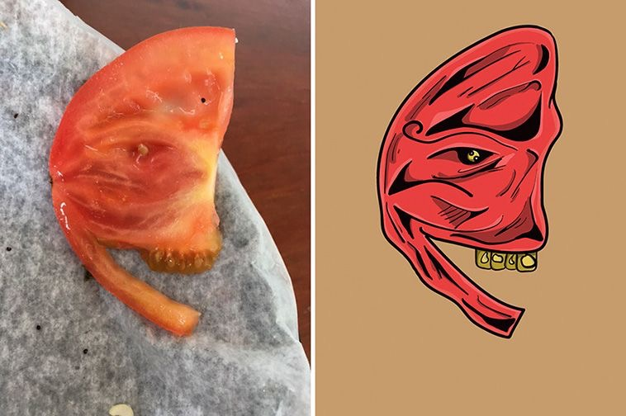

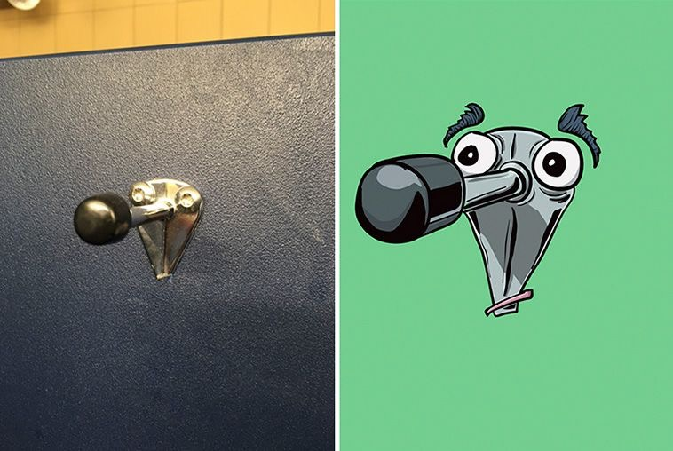

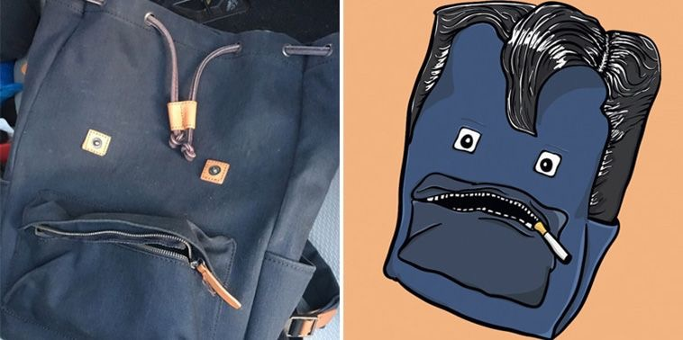

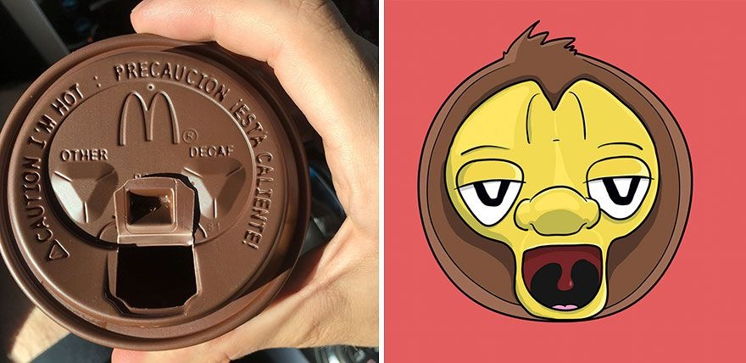
All images © Keith Larsen

I then went on to look at Justin Sutcliffe and his art, with Justin he uses pareidolia in a slightly different way to Keith, he finds arranged items and objects to become faces. Justin completed a project called ‘objects are people too’, this was a photographic project.
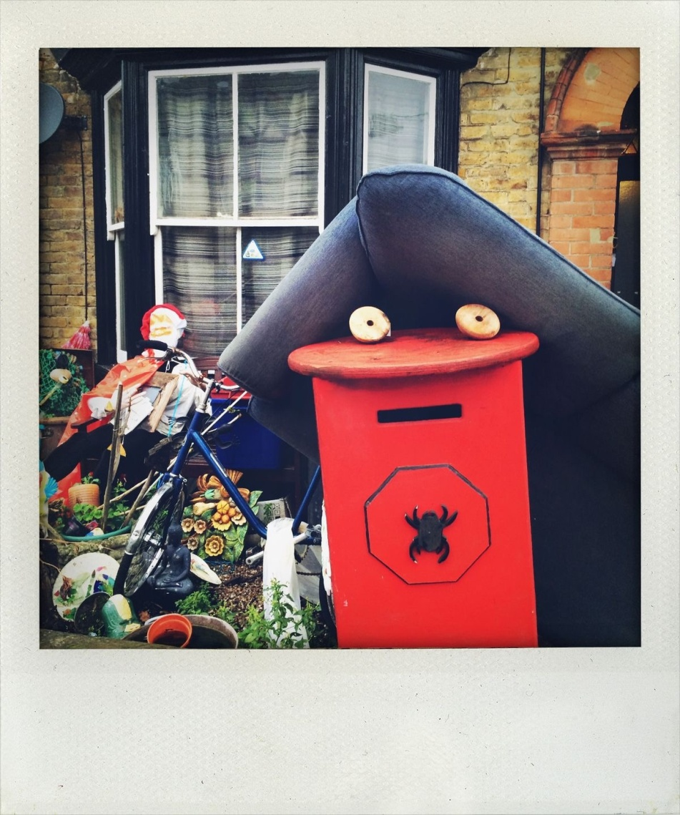
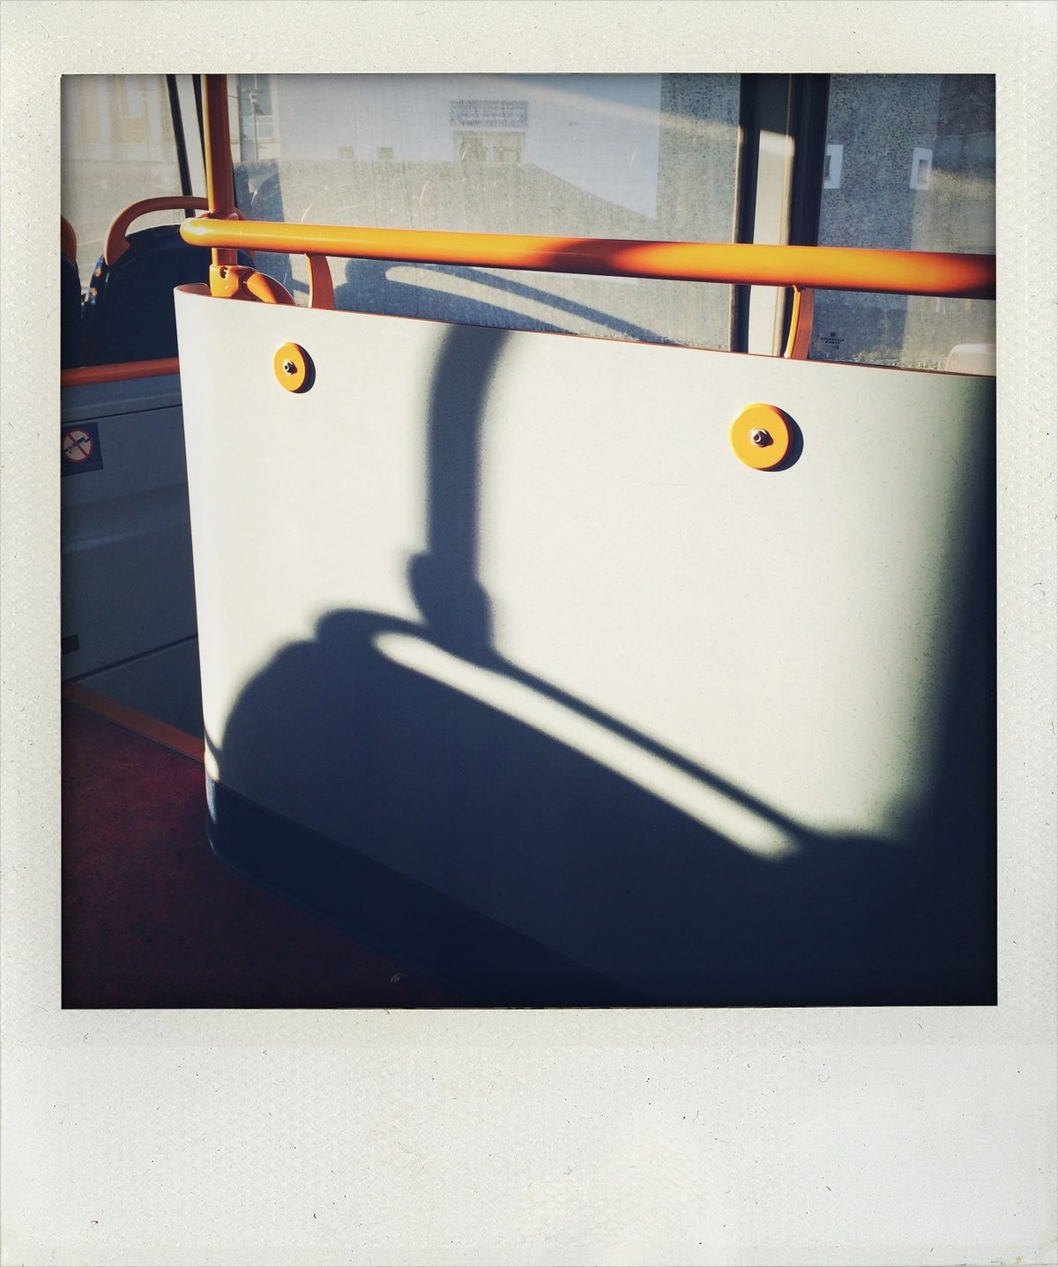

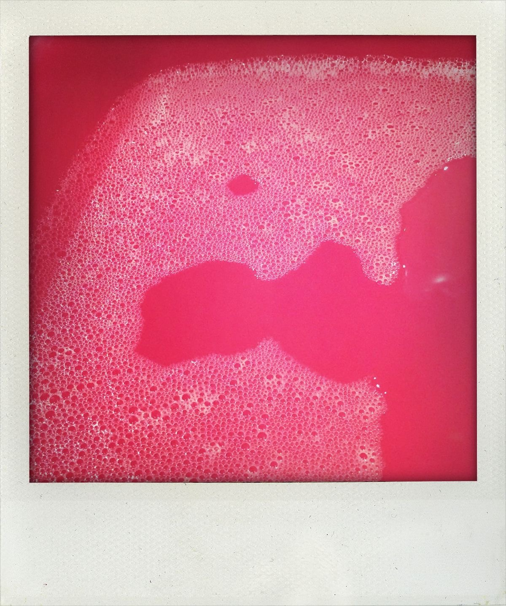

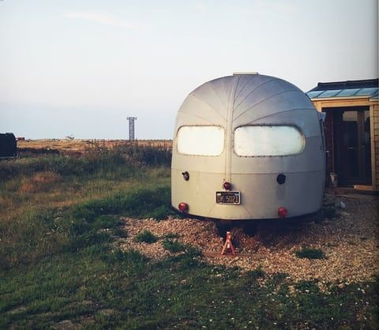

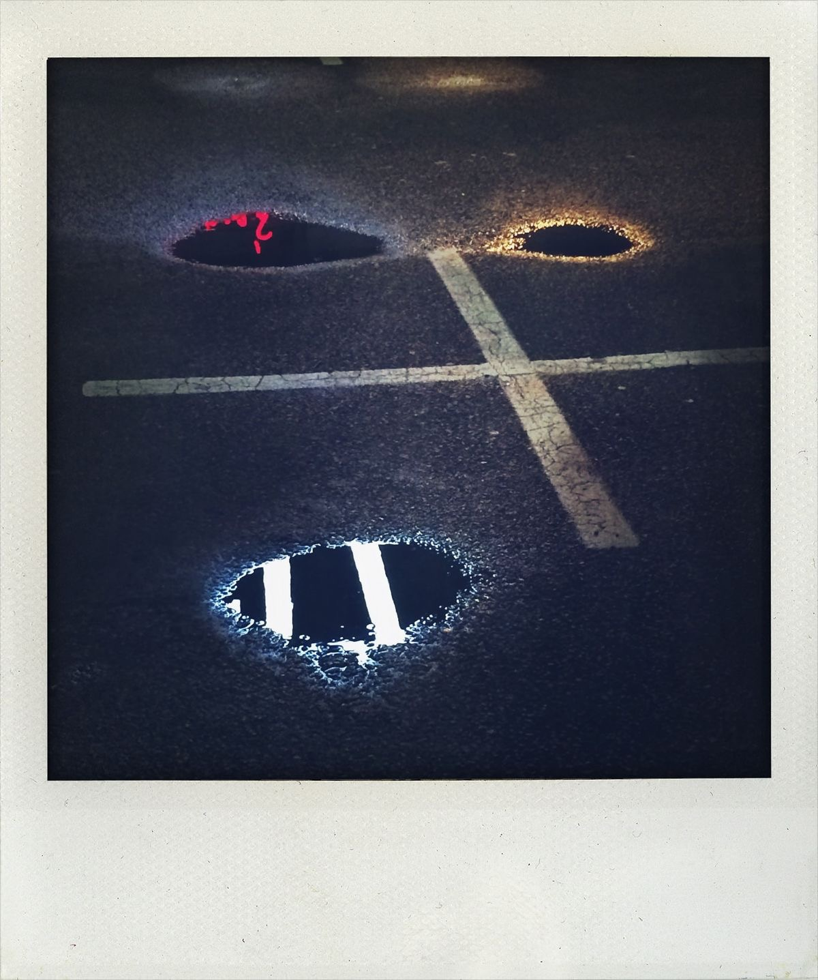
All images © Justin Sutcliffe
I found both of these artists very interesting, it made me realise that you can create characters from anything, it can act as a starting point for you to start thinking about quirky people and how they might look.

From this research and the ideas gained, I then went on to print out my photos and went over the faces I could see with a black pen, so you could see what I was looking at.
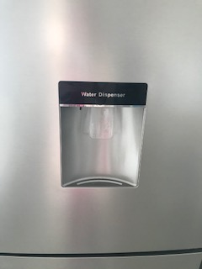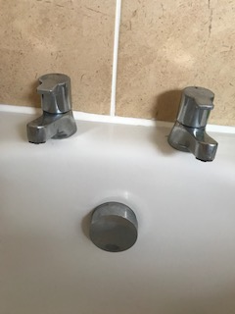

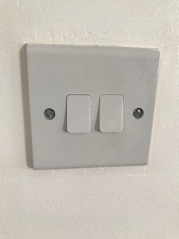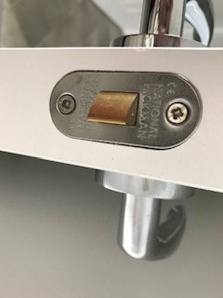

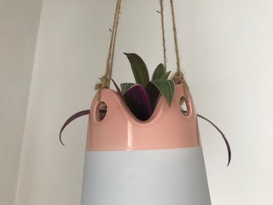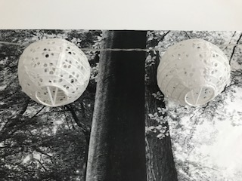

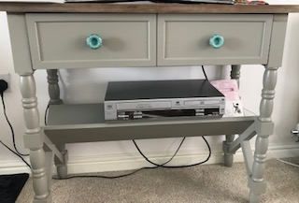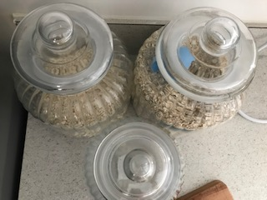

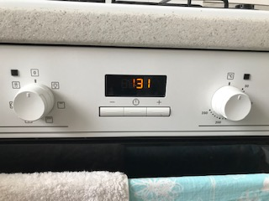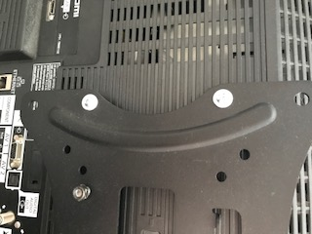

These are the ones I stuck in my sketchbook and made into faces:-

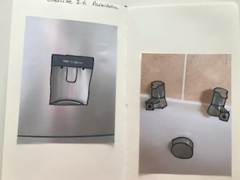

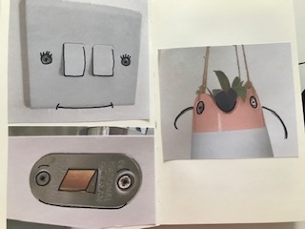

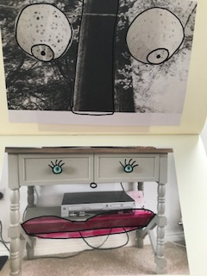

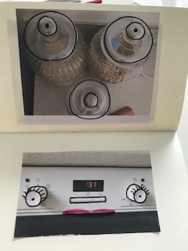
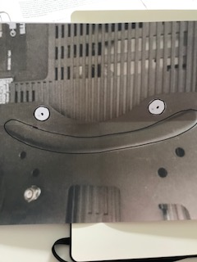

I found the process of Keith Larsen’s the best with things I had around the home, I added some colour for the lips on some of the characters to define them more.
I enjoyed doing this exercise and found it was full of ideas for creating characters that I can take forward with me.

