Drawing with objects: a journey scrapbook
So I started this exercise by going out to the Thames barrier park, I was not sure how I was going to incorporate anything with in my journey but I thought I’d go and see what happens.
I took some photos of different areas on my journey around the park and tried to capture different views and buildings, paths and planting.
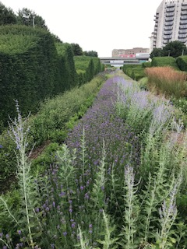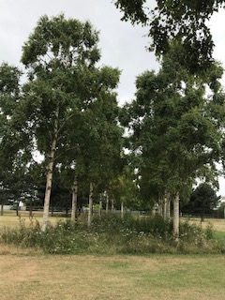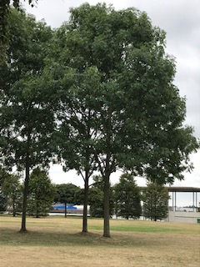

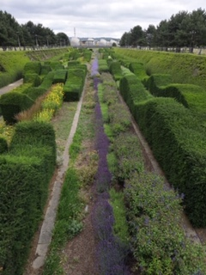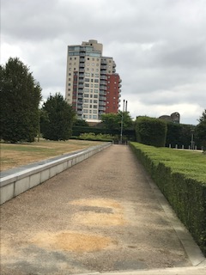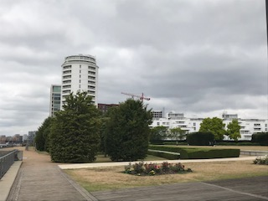
I collected different leaves from the trees whilst walking around, some I picked from the tree and some I found that had dropped to the floor. I sat down on a bench and then thought to myself how can I add these physical leaves into my sketches, could I cut the leaves up and make a collage? Could I paint with the leaves rolled up? Could I make marks with the leaves? Could I make the leaves the buildings? Could I make the leaves the trees?
So I decided upon the last idea which was to make the leaves the trees in front of me, I then sketched the rest of the view I was looking at around these leaves (trees), then once I was happy with the sketch I went over this with black fine liner. I think I will need to flatten the leaves to make them stick in my sketch book. So I will press them for a while when I get home, before I stick and finish my sketch.
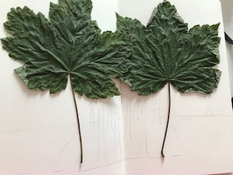
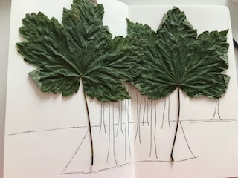
I then went on to look at another view and thought how I could incorporate my leaves within this? I decided to cut the leaf and make it into the path in this picture; it was mainly because of the colour of the leaf that I decided to do this. I then drew around the leaf path and sketched the rest of the view.

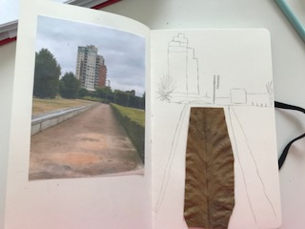
I then went onto my last view and sat down and thought of a different way to make these leaves involved with this sketch? Because of the shapes in the garden and the planting, I thought the leaves might work to mimic these of the rolling hedge.
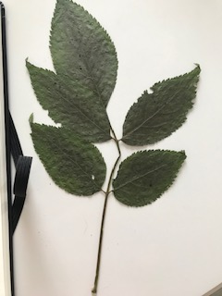

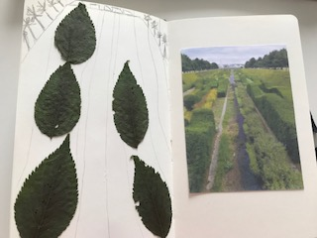

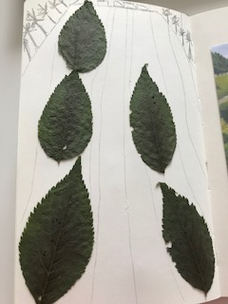
I think this sketch would look better if it was painted, I would choose different colour green watercolour paints, and I think this would make the leaves and the sketch mould together and incorporate each other so the leaves become part of the picture.
I think to further this exercise I would use some leaves to dip in green paint also to draw with; also I could have picked a few little flowers that would work well on the above sketch especially.

