Drawing with Tea bags
I started with the tea bag idea of drawing with unusual materials; I popped a tea bag in a mug and poured hot water over the top, let it ferment for a few minutes then took it out to cool, so I could handle it better. I then used the bag to stamp onto the paper and spread the tea around the page and also squeezed and let the water drip on the page. Some of the colour was darker than others which looked good and gave different tones of the tea. I really liked the effects this gave and the patterns and textures you could create. These definitely look natural forms; they could be coral from the sea, mud, dirt, stones, liquids, puddles and rain clouds.
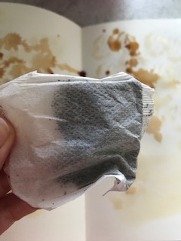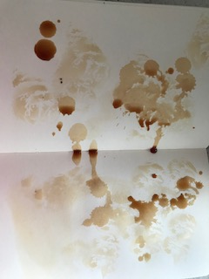

I then went on to look in my make up bag to see what I could use in there, I found my bronzing powder. I run my finger over the powder and spread this across the page, it was a consistency was you could draw and write with it and create swirls, but it was also easily bendable and you could develop really good cloud effects and atmosphere effects. The tone could change from light to dark and had a pearliest effect to the powder which also made it great to use. I thought these marks looked quite natural they could be from the earth, stone, granite and nature looks as well as clouds and gasses.
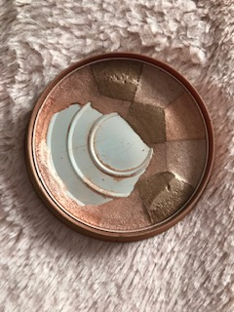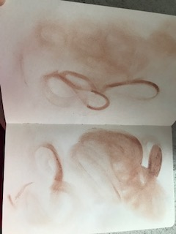

I then also saw in my make up bag my mascara and thought I could create some good marks with the wand. I managed to create lines and splatter / splodge marks, marks like car tyres create. I thought these were good background textures the colours were both faint and dark and the tones of black through to grey that was created was full. I think these would suit both natural and manmade forms, they look like textures from bricks and concrete as well as rubber.
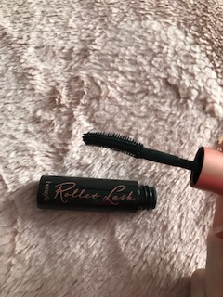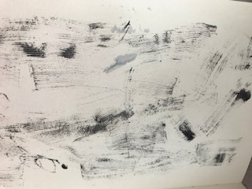

I then thought I would try some string, I had some that was left over from some packaging, I thought this might work well by dipping the string in paint then seeing what you could do on the paper. I found some silver acrylic paint and used this to run the string in the paint, I then help both ends of one piece of string and run it down the page. This created some lovely effects and because it was in silver it looked like marble and stone slices, but it could also be a landscape or clouds in the sky. It could be cliffs and the earth below the top in a monotone colour. It could be concrete, wood knots and features, it could be markings on a animal, it could be fabric or even forms like in science under the microscope.
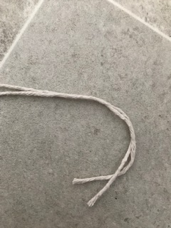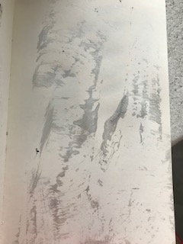

The next one was an art sponge I had in my pen pot, I used this with emulsion paint in a pale blue, I could swipe the brush to create a heavy stroke and then two others as the paint wore off, so they were broken strokes. Then I stipple the sponge to give splodge/ sponge effects, then this got fainter as the paint wore off. This again looks very natural to me, it could be sky forms, rain that is pouring down, the sea and waves, it could be textures of a pavement, wood textures like driftwood that is really worn and baked. It could also be foliage and tree leaves (the sponging) it could be landscapes like mountains and deserts.
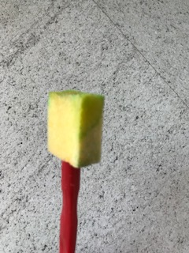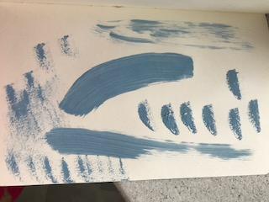
I really enjoyed this exercise, it made you really think hard about what you could see within the textures and marks and how you could use them further in work and expand upon the effects and take them to another place.

