Investigating a process
I started this exercise with thinking about what sort of process I wanted to explore in my sketchbook, I have done some watercolour explorations with Illustration 1 so wanted try something different. I had also explored coloured pencils and graphite pencils already, also interior paint like emulsion, collage and doodling.
So I finally came across wax resist ideas and painting, I found this process interesting as it was about layering.
I started with a basic idea of drawing lines with a white crayon and then painting over it with watercolours.
I did this with both lines and swirls:-
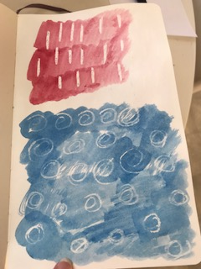
I liked the effect this gave, it had atmosphere from the watercolour and the resist was very clear and you could see the white paper behind it.
I then thought about how I could layer this more and follow through with the process, I then layered up the line style with another wax resist on top of the first layer then went over the whole lot with pink watercolour, and this then showed the white resist lines and then the purple resist lines as the second layer.
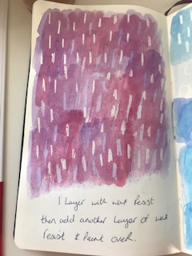
I then went on to explore the swirls and multi shapes into two layers with two resist layers with watercolours in between.
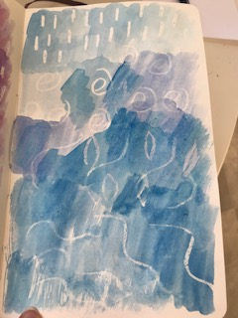
I was enjoying the effects this was creating and liked how the resist was showing through and changes colour with the second layer. So I then pushed this further to create a third layer and used swirls, lines, and scribbles for the wax resist and chose colours that complemented each other in the colour wheel, so yellow to start with, then green, then blue.
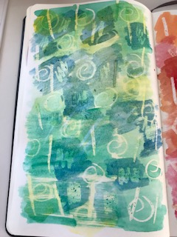
This was starting to look really good, and I liked the effect better with tonal paint colours rather than opposing paint colours. I liked the textures of the paint and the shapes and the more layers the better it looks and the more depth you can create.
I then went onto explore another colour way with three layers and different shapes, In this one I tried to use shapes that also complemented the colours, so I went for Aztec shapes like lines, diamonds and zig zags.
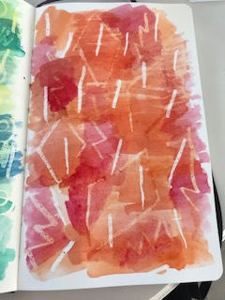
These shapes were less busy than the swirls, which give it a more open and spacious feel, but I think the colours of pink, orange and red give more depth so having more simple shapes worked better.
I really enjoyed this process and getting creative with colours and shapes, this is something I hadn’t thought about using my sketch book for, but I like the free and easy way you can be creative and explore a certain process.

