Rapid sketches
So I started this exercise by setting up a still life on my bench, I chose a house plant which was already on the bench, then I added my handbag and purse, plus a tall giraffe ornament which I had.
This is the still life:-
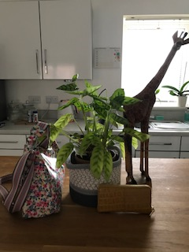
I started to time my first sketch by 3 minutes and sketched this view.
I completed this in pencil as I thought this would flow better and work fast. I chose to start sketching in my new Moleskine A5 sketchbook because it has a good thickness to the pages and can take paint also.
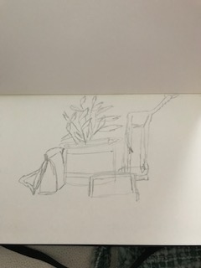
So above was my first sketch of 3 minutes, I chose to use the pad in a landscape position, but I did lose some of the giraffes head due to starting with the sketch in the middle of the paper.
I think as a quick sketch its fairly successful, You can see what the objects are roughly and it’s a sketch you could refine to develop something better.
I decided to keep the objects where they were and I moved for the next sketch, this was the view I was looking at:-
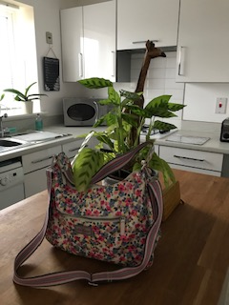
Below is the quick sketch I did of 3 minutes again, I found this sketch looked better. I feel I had a bit more confidence and using the pad in the portrait position I could get the giraffe in.
You can’t see all of the plant and much of the purse, but it’s an unusual view point and works well as a fun still life.
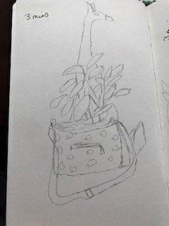
My third view point when I moved again was:-
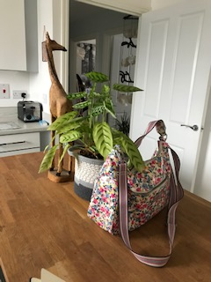
I decided to use the pad again in a landscape position as you had more of the objects to get in, but I again made the same mistake and lost the giraffes head! This sketch was ok; I feel I got the shapes and the likeness in the leaves of the plant more in this drawing.
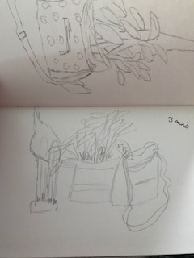
I then went on to do my last view within 1 minute, this was view point I had:-

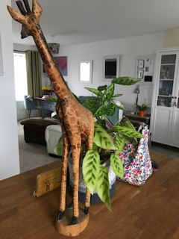
This sketch was obviously much quicker and I did a few lines of each just so I could get the whole picture down in one, before the time ran out. I did have a few more seconds after doing this left, so I added a little detail and some leaves on the plant.
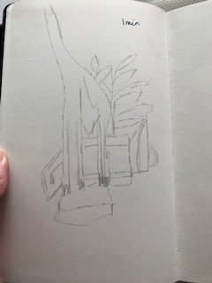

So for the next test of looking at moving objects, I’m due to visit my brother tomorrow and see my nephews in a football match, so I thought this would be a good idea to sketch moving objects.
Well I didn’t have much success with the drawings, it was really cold over the field and I’m not very good at drawing figures anyway, so it didn’t turn out well, but it has given me more of an incentive to really get to grips with drawing figures.
This first sketch was for 1 minute where I just got the outline down of the footballers and tried to show the action that they were doing.
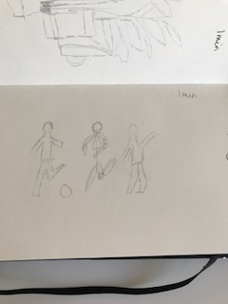
This next one was for 2 minutes, but I concentrated too much on drawing a proper figure that I ran out of time for a proper sketch.
The sketch below was for 2 minutes again, and again I got caught up with drawing too much detail, rather than the shape of the action.
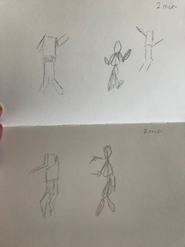
This last one, I thought I’d give myself a bit longer 4 minutes, I feel I got some sort of action out of one of the figure sketches, but the other one I ran out of time to finish it.
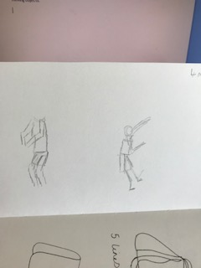
I then went home and practised more about figures and decided to go right back to basics and start with stick men to show shapes and actions first, rather than a finished figure.
Doing this exercise has made me more aware and loosened up in not getting things right, and just trying to get something down on the page. I think going back to basics with my figure work will really help in starting right from the beginning and learning that way and just practise my people and figure sketching.

