Exercise 1: The History of Illustration
I started by looking through the illustrators listed, which we had to chose from. I liked aspects of all of them, but because I am interested in nature, animals and children’s books and character design, I decided to choose EH Shephard.
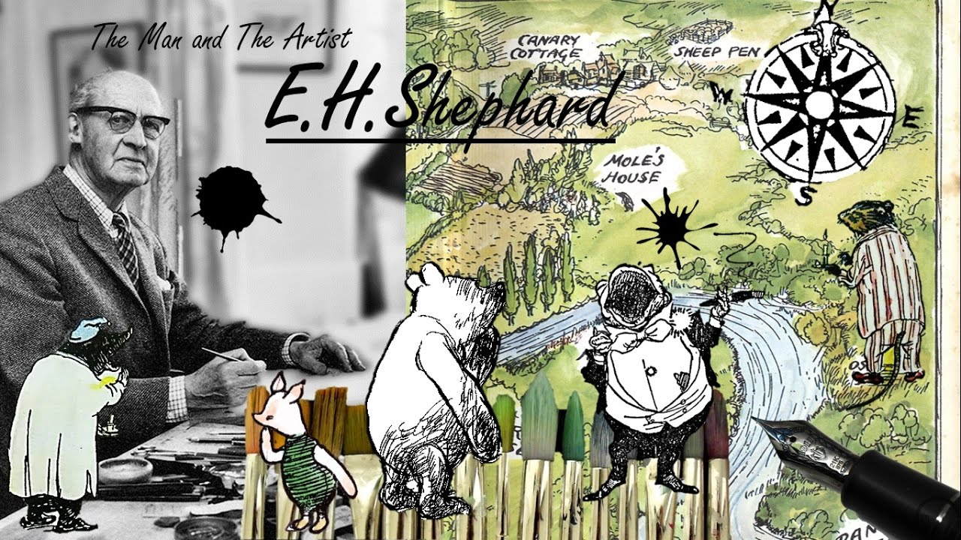
You tube, (2017) The artist and the man [digital design] Watermillfilms.
I read a number of articles and did research on both AA Milne and EH Shepard to find out the cultural context of the ‘Winnie the pooh’ books.
Winnie the Pooh books came from the Golden age of children’s literature from the mid 19th century to World War 1. Children’s views of the world was a more natural one, more about playing and being outdoors in nature, more innocent than children’s views today.
Memories of AA Milne’s own childhood before the war was the inspiration for his Winnie the pooh book’s, back to a time before the destruction and loss of war. This feeling comes out in the depressed character of Eyore.
Both Milne and Shepard served in the war and then became great friends whilst working on the Pooh books; they used their relationship and experiences through the union of words and pictures, which neither would work without the other. Word’s were changed and adapted to work in unison with the pictures accordingly.
I looked at some of Shepard’s work and early sketches to see and look for the techniques and tools used to create his work.
I found some early sketches of some trees around Ashdown which were created using a fine graphite pencil; he has quite a loose technique but very detailed and small. The background in the sketches are more rough, some scribbles to represent the bushes etc, focussing on the foreground only.
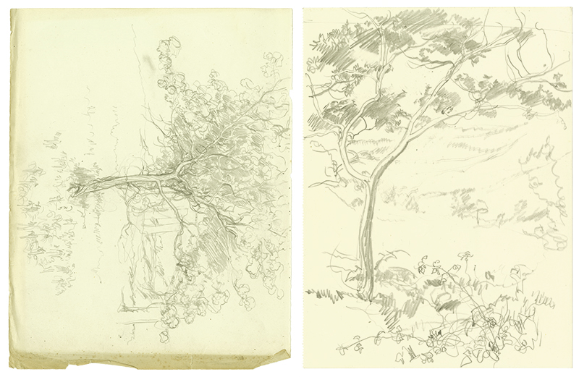
Shepard E, (1925) Trees [pencil drawings] Unknown.
The second image is of Pooh climbing a tree; the sketch is in graphite pencil and is more detailed than the last sketch. The tree has more form, Shepard uses mark making techniques to show shadows and highlights and textures of the tree. Pooh is a very simple outline sketch using the anthropomorphic qualities Shepard has attributed to Pooh.
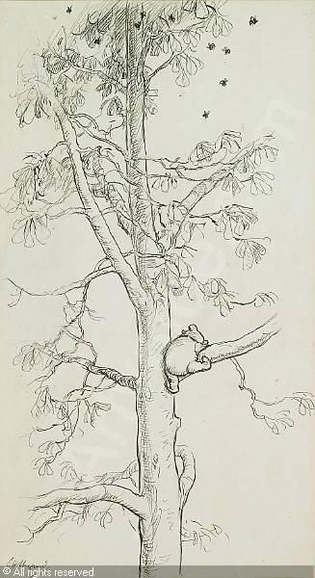
Shepard E, (1926) Winnie the pooh in a tree [pencil drawing] Unknown.
The third sketch is of Eyore floating in water from the book ‘The house of Pooh corner’ It’s a quick sketch using ink pen, lots of mark making lines and a simple outline of Eyore similar to the one of Pooh in the previous sketch, again using the anthropomorphic qualities to create a sense of character.
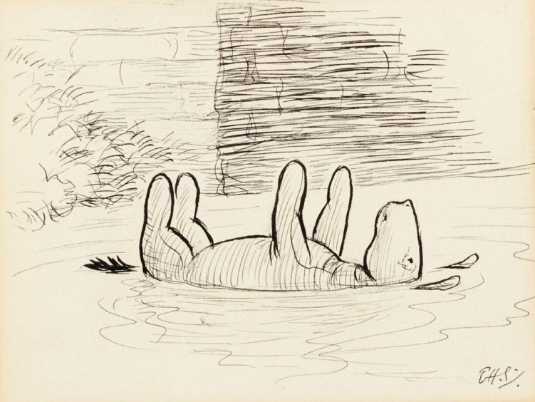
Shephard E, (1926) The house at pooh corner [ink drawing] Sotheby’s London.
The forth image is of Shepards original ink drawing of Pooh, Christopher Robin and Piglet. Again a simple out line sketch of the character’s with the more rough mark making lines to the background, using harder strokes of the pen to give shade and roundness to the lines.
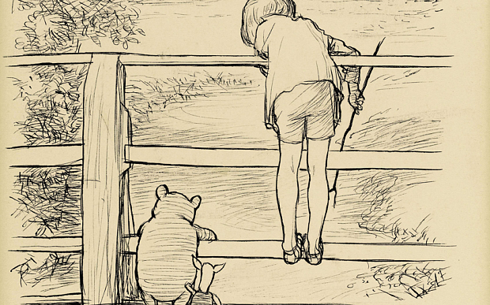
Shephard E, (1928) Poohsticks [Pencil drawing] Unknown
From looking at those sketches and more online, I felt I knew how to go about creating a sketch of my own with Shepards techniques, using a fine graphite pencil for the first sketches then ink pen for the final sketches. I decided to go for the natural scene and one from nearby woods that I visited. I took some photos of different angles I liked of a gate, path and trees.
I then wanted to create a character, so I chose to draw my cat Angel to be my character in the sketches. I have drawn and painted her before but not with these techniques, I wanted to try and capture an anthropomorphic trait to her as well.
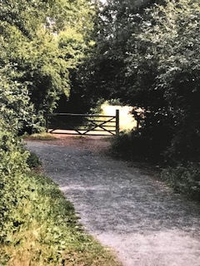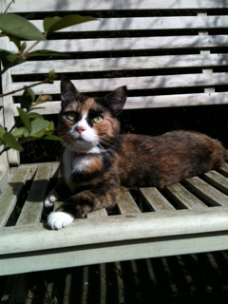
The first sketch I did I used a 5H pencil, I used Shepards techniques and did rough loose sketches to the background and stronger detailed sketching to the foreground and main focus. I used some mark making to get some texture and difference.
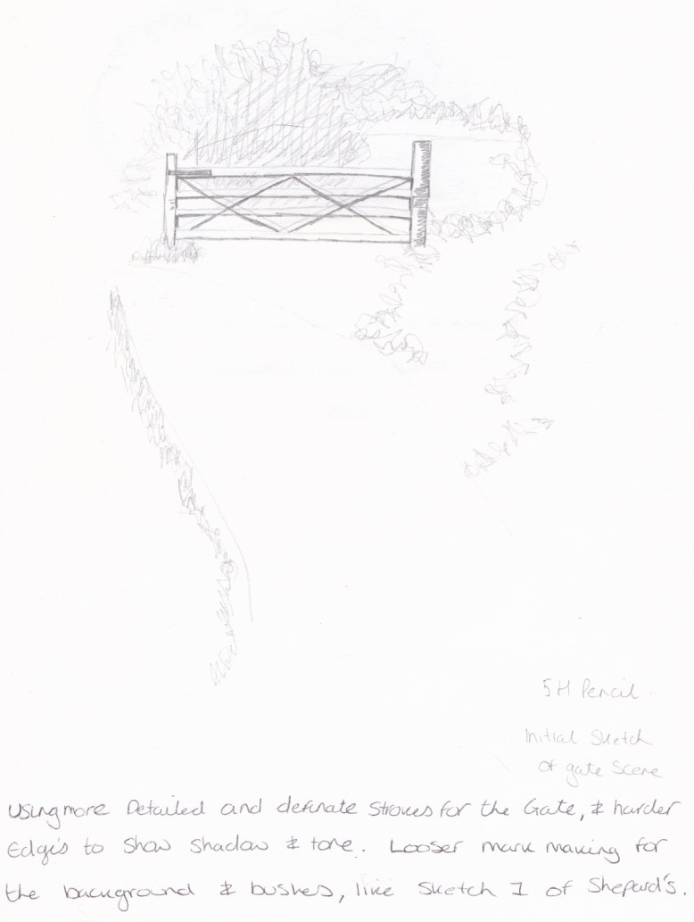
The second sketch was using a 2H pencil; I decided to use a harder stroke with this pencil to see if I could get some definition and more shading to the picture. I used a more close up view and looked at the dark area behind the gate and the light area to the ongoing view to the right. I thought this would show up the gate better.
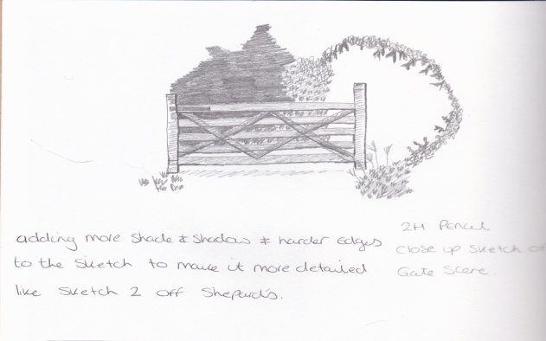
The third sketch was using a 0.8 fine liner pen, I decided to make the background looser and just use some simple strokes to represent the bushes as did Shepard in the picture of Eyore. I added the darker line work to the gate to give the same look as Shepard.
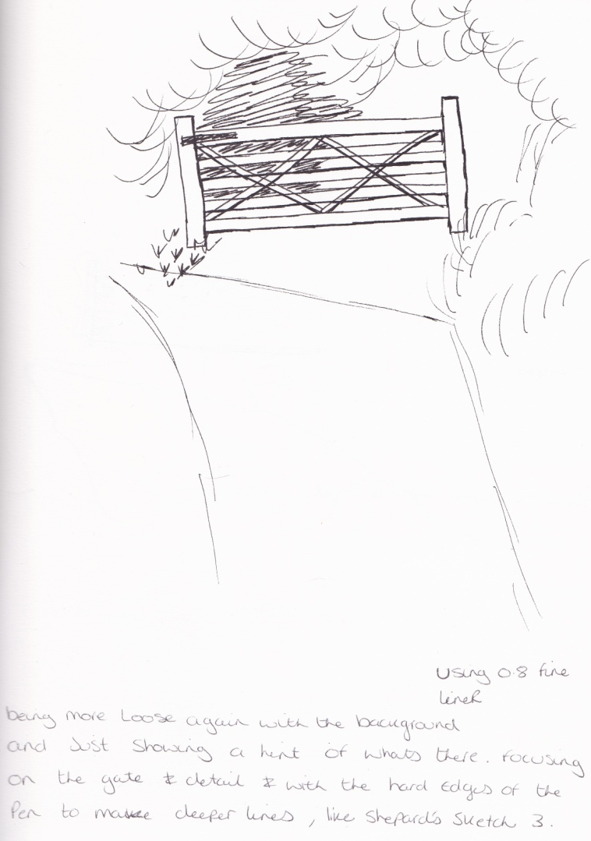
With the forth sketch I used a traditional ink dip pen like Shepard would have used for his sketches. I thought I would have trouble first using this pen, but I seemed to be able to use it fine. I decided to add more detail to the gate again on this sketch and make the background even simpler by just using a running line.
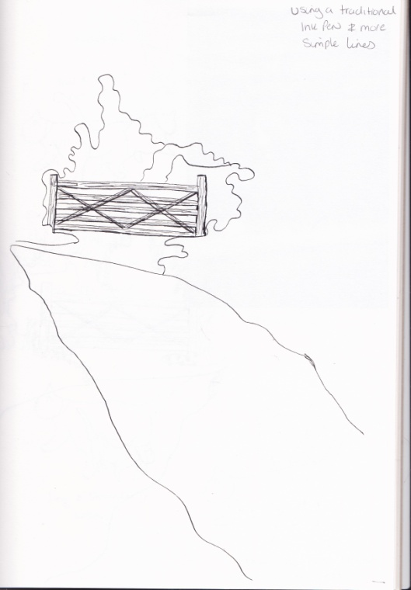
I’m trying to use different techniques and get the right balance between the simple sketches and more detailed ones like Shepard. I had a break after I had completed this sketch; I wanted to come back with fresh eyes to get the balance right.
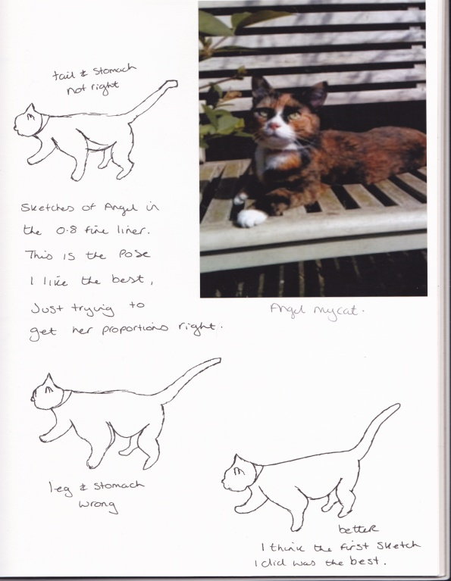
I used this time to look at the sketches of Angel I wanted to create, I managed to get her to walk around for a bit, so did some quick sketches with the same pencils as I did with the gate scene. I also wanted to get a good pose/ position for her that I could use in the scene which looked natural. Ideally she would have been there in the woods too, but like Shepard I had to use my imagination for this. I liked the first pose I sketched of Angel, where she was looking forward; I thought this would be good as she could look at the gate, which would lead the eye through the illustration. I decided upon the second pose as I felt this looked more natural, and you could use her pose as some writing in the story ( i.e. Angel was looking for something) if this illustration was going to be in a book.
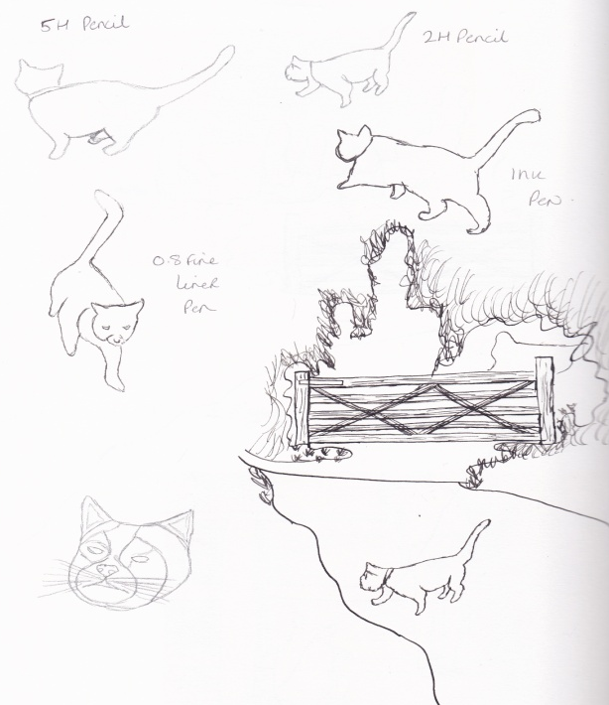
Back to the gate scene, I decided to try the simplest lines again for the background but then to add a few details around the gate, and keep the gate the same as within the last sketch. I then added Angel into the path, trying to get the perspective and proportions right between her and the gate.
I tried to balance all aspects of the techniques Shepard used, I’m not sure if it works that well, I’m not that pleased with it. I think I will try another sketch in a few days to see if I can get it better, I’m happy with the gate and Angel, it’s just the background that’s not quite what I want.
Louise Cunningham
Louise Cunningham is an illustrator and pattern designer, I first came across her in an article of 10 of the best most up and coming illustrators of the year. Louise has been designing for over 10 years and although has not illustrated fiction children’s books, she has illustrated nonfiction books and magazine editorials.
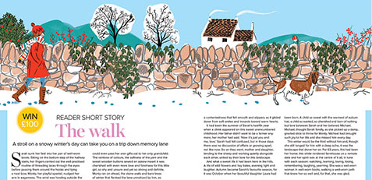
Cunningham L (2017) The walk [digital drawing] Prima
I was immediately drawn to her sense of colour and free style. Louise has a distinctive style both modern and retro in influence. I would say her inspiration was from travel and her French feel.
Louise uses ink drawings which she paints in from Photoshop using pre made collages from hand painted papers and textures, to give multi layered effects.
I decided to compare Louise’s work with EH Shepard’s as I found there sketching style to be similar in the techniques, using ink pens and detailed yet free style.
With Louise’s use of colour and modern techniques, I feel this shows how you can move on from a style to make it more modern and show progress.
The biggest cultural context between them is the feel of colour and positivity and freedom, obviously this shows because of the aftermath and experiences both Milne and Shepard had from the war, and the memories of their simple childhood.
I have looked at some of Louise’s work mainly greetings cards as I still feel they had a story behind them.
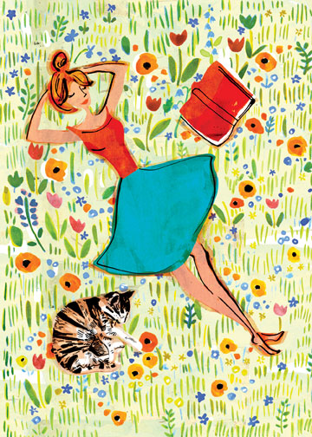
Cunningham (2018) illustration for greetings card [digital painting] Louise Cunnungham.
This was the first illustration I saw of Louise’s and this was what drew me to her. I love the vibrant colours, mainly primary. The feeling the sketch gives out, positivity, relaxation, happiness, freedom, summer. I love the way she sketches in black ink first, which looks like a whimsical effect and how just a few simple lines make such an impact. Just this picture could be the start of a book for a writer.
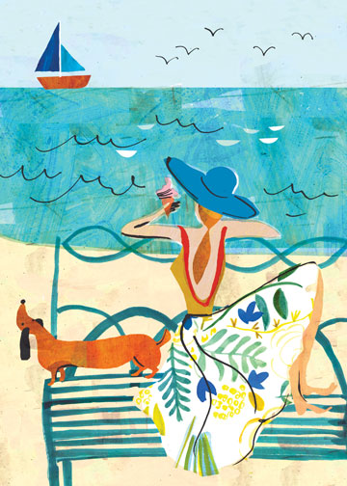
Cunningham L, (2018) illustration for greetings card [digital painting] Louise Cunningham.
This second illustration had the same feeling for me, summer, Holidays, Freedom, Relaxation, inspiration. Again a simple style and line work, with a sense of colour and fun. An innocence and child like technique.
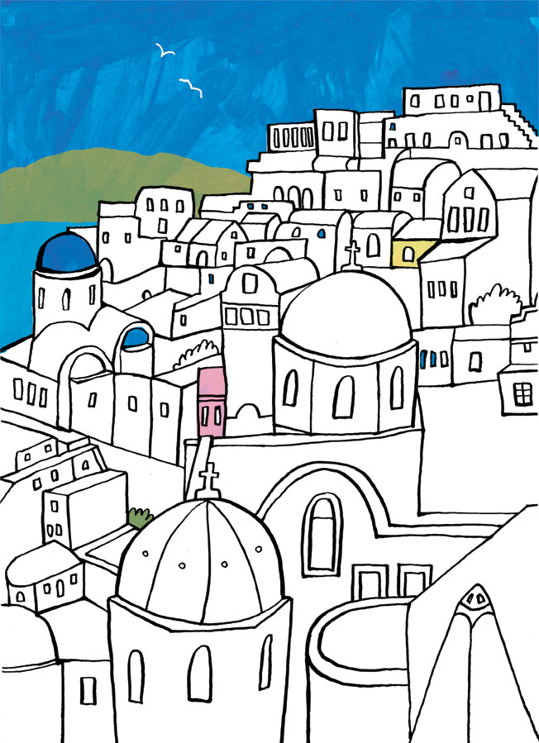
Cunningham L, (2018) illustration for greetings card [digital painting] Louise Cunningham.

I again enjoyed this illustration, a slightly different technique in that she leaves most of the picture white. Again a great use of the ink pen, and simple style and lines.
I decided to use a picture I had taken on a trip to Whitstable, to re-create Louise’s style in my own way. I thought I would try to get into her head and use inspiration from travel, which gives the sense of colour, freedom with simple lines.
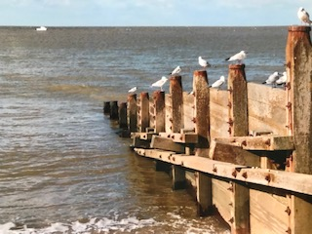
I did a quick sketch using a pencil first; I didn’t want to add too much detail, so I left some bits out, The Sea and the sky I wanted as loose and simple as possible with using just a few lines. I didn’t want the seagulls to be realistic either, and wanted to create a modern style. The second sketch I used a black pen, like Cunningham had in her sketches, I then scanned this into my computer to Illustrator and made this bigger, and simplified it more.
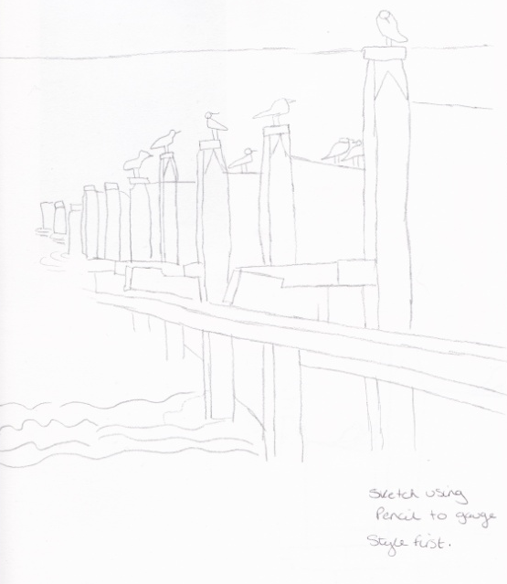
Like Cunningham I wanted to create some texture and paint techniques to add the colour in Photoshop. I painted some watercolour squares and used some salt to add some texture; I used a few shades of blue as I wanted different shades of the sky and sea. I liked these for the sea, but wanted to try something different for the sky. I used some pastels to try colouring in the sky on paper, this came out really well.
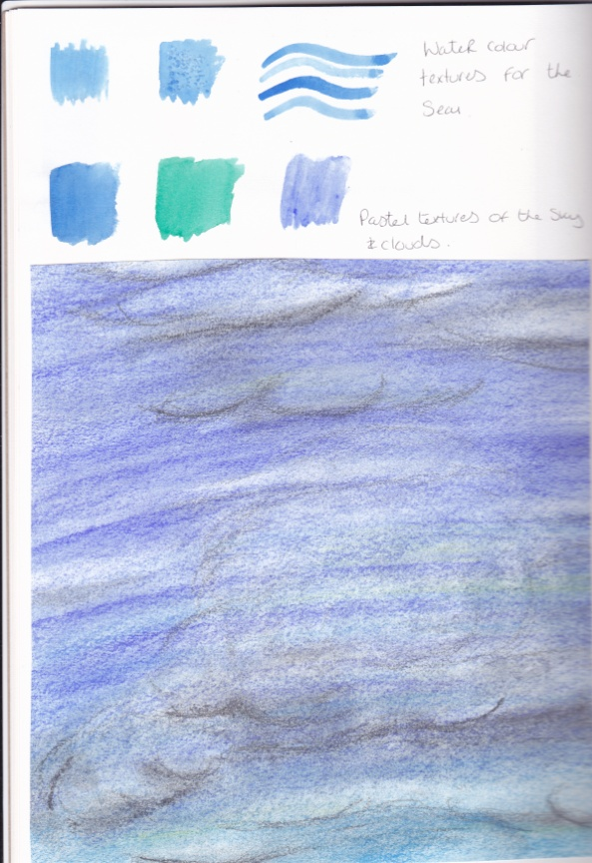
I started to build this up in Illustrator, I added some textures of sand which comes with Illustrator and a textured paper I already had to fill the barriers with. I was really happy how this had come out, but felt it needed more colour, it felt a bit flat although the textures were good.
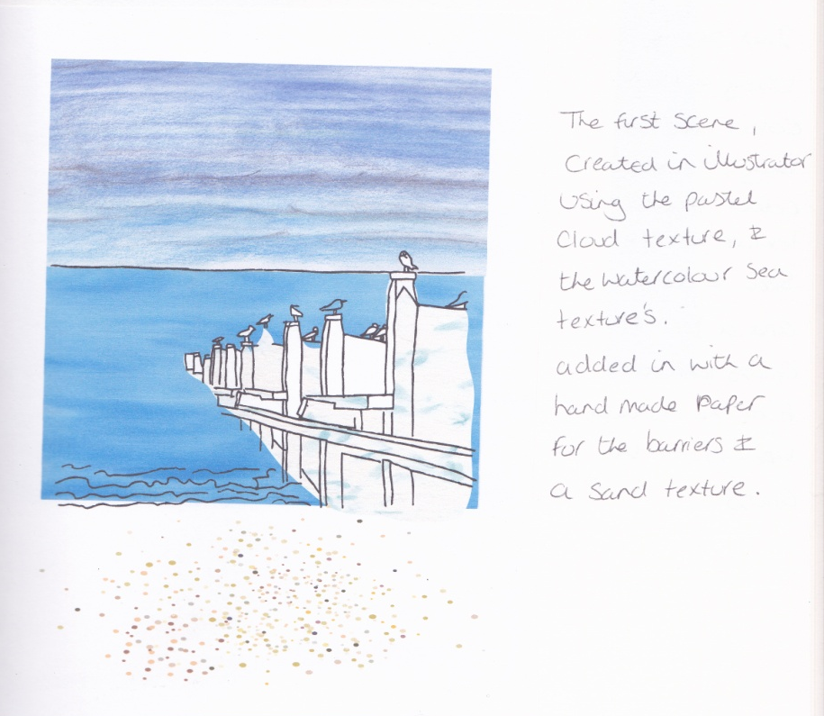
I tried again in Illustrator with a new set of textures. The sky was a watercolour brush with blue colour. The sea was again a handmade paper I already had. The barriers were another watercolour brush but using a brown colour. The foreground was where the colour was missing before, so I decided to change this to grass on the illustration. I used a grass texture from Illustrator then washed the whole of the background in green colour. This was a lot better colour wise, but the textures were too much, they were competing with each other and Cunningham’s illustrations weren’t this busy.
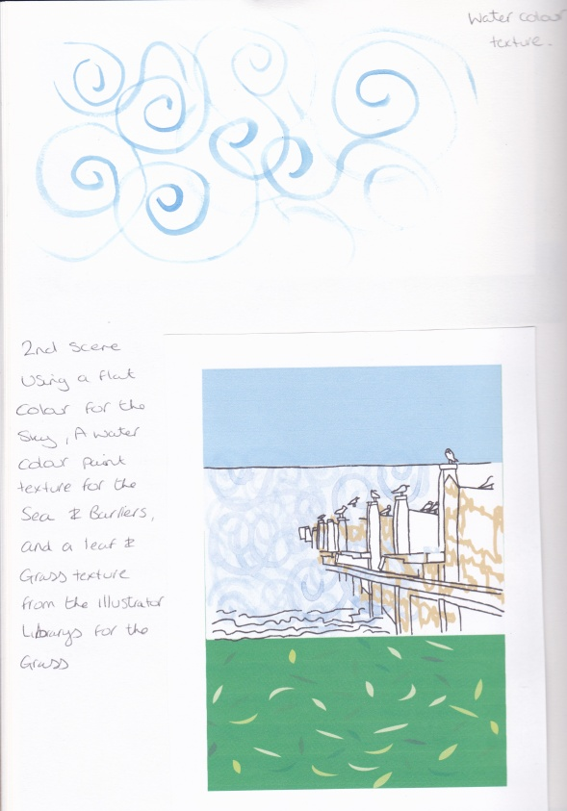
So to simplify the textures but keep the colours I used the sky, sea and barriers from the first attempt, then used the grass from the second attempt, changing the colour slightly to a lighter greener green. I added a few grass motifs from Illustrator too, which I thought was Cunningham’s style to finish it off.
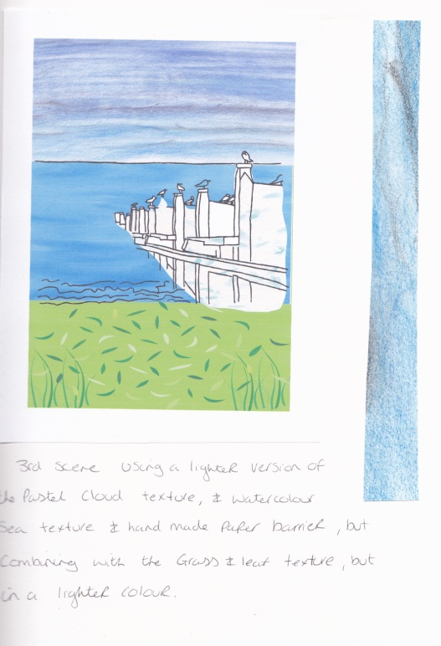
I love the way this has turned out, and have learnt a new way to add colour and texture to designs, which I will use again. I still think this design lacks some red, pink or Orange colours, Cunningham’s designs seem to be balanced with colour using lots of primary colours. I need something else to add into the illustration to be coloured in red. I will come back to this at a later date to see what I can come up with.

After feedback from my tutor I have added the following information.
What did I think of this exercise?
I enjoyed this exercise and researching illustrators, their lives and background and how they use and experiment with different materials and how they use them for their work. It was good to compare older illustrators with new contemporary ones; I was surprising to see similar ways of working and seeing how things have developed over time.
I enjoyed working in a similar way to both illustrators and producing the small illustrations for this.
What have I gained from doing this?
I have learnt from EH Shephard that simple drawings are ok and sometimes the simpler the better. Just a few lines can add something or create a character. I think the main thing is creating a feeling or atmosphere to the illustration which brings it to life.
Louise Cunningham’s technique is again simple, but her use of colour is the main thing I got out of this exercise and how she creates textures.
What materials would I like to explore more?
I have started to create a texture sketchbook which I have started with acrylics, but I want to explore a few mediums and techniques. It will be handy to create a sketchbook of textures which I can use in the future and along the way of this degree process.
My tutor has suggested creating a mark making sketchbook too, which I think is a great idea, I think both processes will help with creating feeling and atmosphere within illustrations.
What will I do?
I have set up my mark making sketchbook, I have chosen a very small book for this, and so I can use a mark for each page and flow from each implement or technique easily.
My textured sketchbook is already started in a hard backed A5 size book. I have used acrylics first and will continue with other mediums throughout.

