How personal do you want your sketchbook to be? To hide, or not to hide?
So with this exercise I started by researching sketchbooks with hidden elements, I started with Emma’s Pinterest board that was mentioned in the brief.
A lot of the ideas with the envelopes I have tried already, but the folding paper ideas were really unusual.
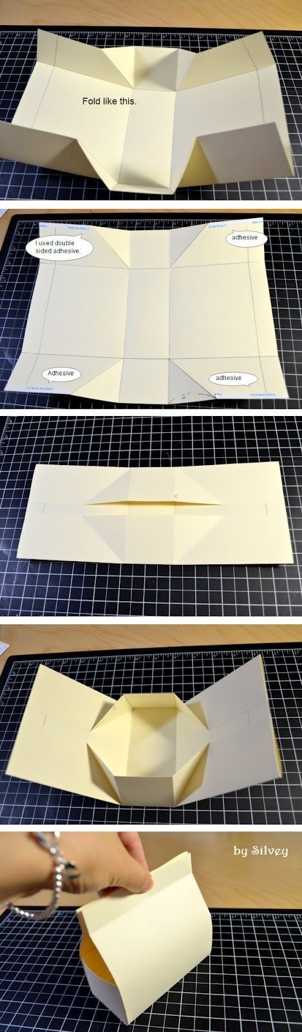
This one above was particularly interesting, but looks quite difficult to achieve, but I thought I’d give it go and see how it turned out.
So here is the template drawn out, I wasn’t sure of exact measurements so went with just what I thought and guessed.
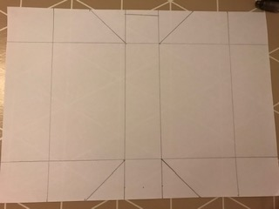
Here is the next stage with the lines folded and the two end ones stuck down.
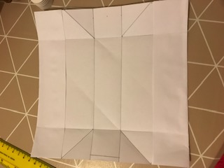
Here it is with the rest stuck down and I used a pencil to show up the opening as it was hard to see on the white paper.
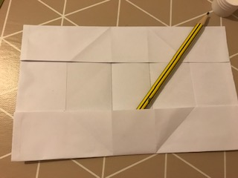
This is the other side with the pocket as shown with the pencil in it again. This wasn’t too complicated in the end, but I think the final pockets should have been closer together, but all in all I was pleased with the outcome.
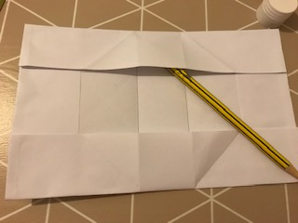
This next one I found which looks extremely complicated and tricky to achieve, but its very well thought out and is a piece of art within itself!
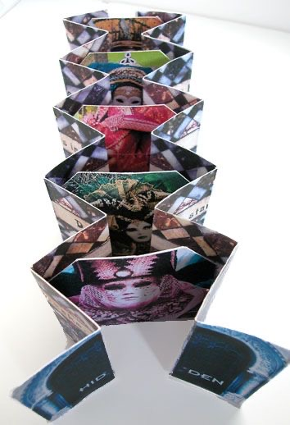
© Philobiblon.com
This piece was actually called ‘Hidden’ and it was for a booklet for a festival in Italy, the book is based on the mysterious personas of the people in the photographs, foreign and detached from the viewer, not divulging what is within. Designed as a tunnel booklet, it collapses open to reveal both the inside and outside of the book, but from every side it looks just like an ordinary book.
This next one is for many pockets in one; it’s made with card and is used for traveller’s notebooks which are called Midori’s. This looks like you can hide many items in one wrap over pocket, but then you could also hide the pocket! So it can be used for a layered effect or double hidden element.
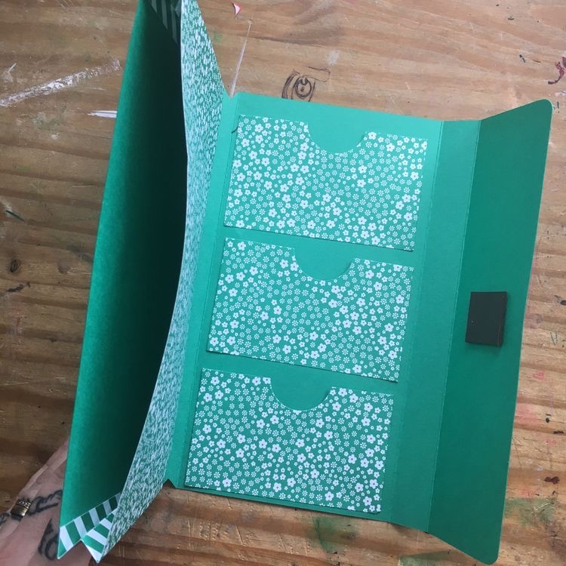
© uglybugplans.com

The last one is like a envelope but has more storage in it as it flaps open and has a gusset style sides, this would be a good idea if you had some chunky to hide or a few things you wanted to keep together. It would also be easier to get to; to pull the things out you needed, sometimes old style envelopes can be tricky to access.
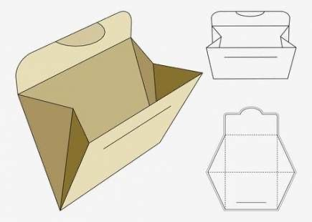
© Journal Bethany Craft

I finished one of the little mini zine booklets with more mark making, this one was the one where I had created windows, so I carried on with that idea and painted little sky or sea scenes using different colours of watercolour paints, this was a little study that continued the theme, but is difficult to work out if you don’t know what it is, which gives the little booklet another hidden edge to it.
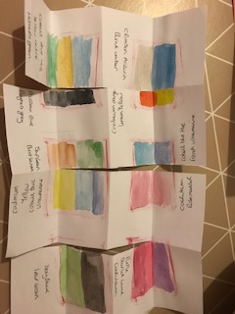
With one of the others I continued again with the original theme which was painting pine cones, but this time I did little study’s using different mediums to try and work out what would work the best.
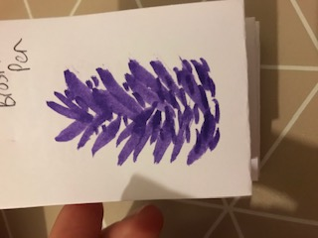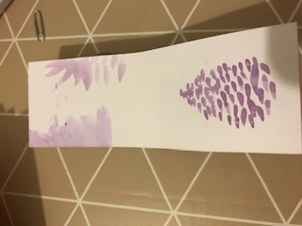
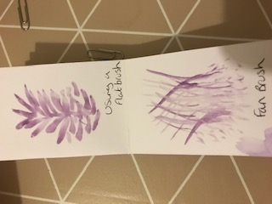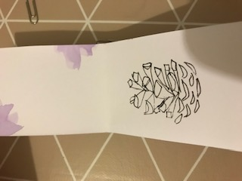
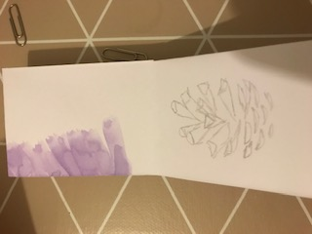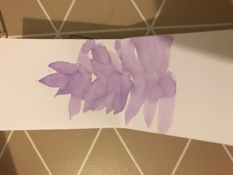
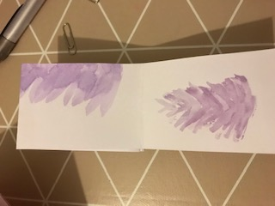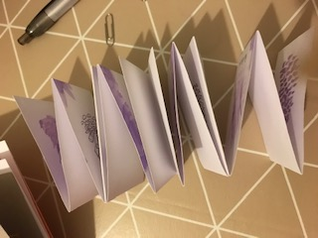
I really liked this little study booklet, some of the drawings I will expand further on as I found them really appealing.

I then started to use one of the sketchbooks I made for exercise 1 and started to draw some mock ups of the ideas above and some new ones.
So these two are just basic ones, using envelopes and creative ways to use them and larger ones, folding them in half to then create an extra page, which can then be used for more sketching.
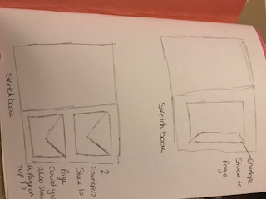
This next one was taking this idea further, by hiding the envelopes with another page which then in turn creates another pocket which can hide things.
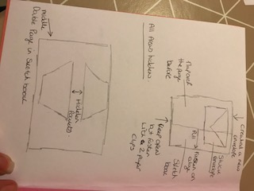
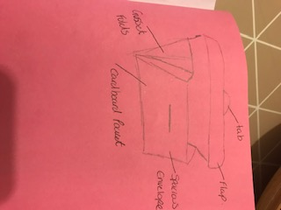
Then I went on to create the basic mock ups of these ideas above, the first one I created was the basic envelope ones.
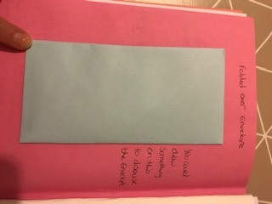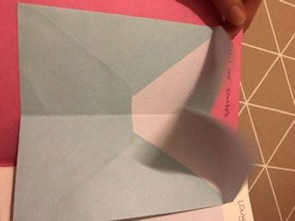
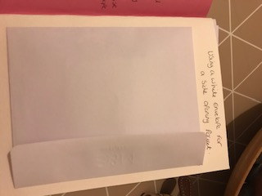
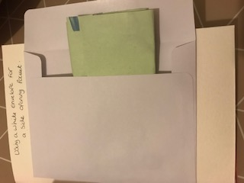
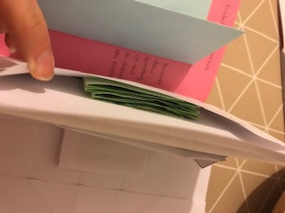
The next one was the gusset pocket which again I created, this is it drawn out on the paper, and then cut out of the paper.

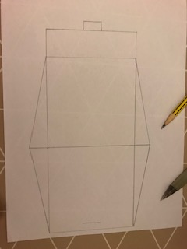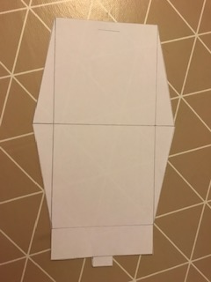
Then here it is folded, unfortunately for some reason the gusset at the side doesn’t seem to be big enough, I re-looked at the instructions but I still cannot see what went wrong. Anyway I carried on and stuck it in my sketchbook and used it anyway, I still kind of worked for the purpose.
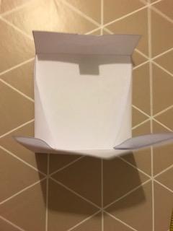
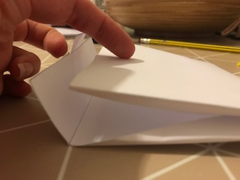
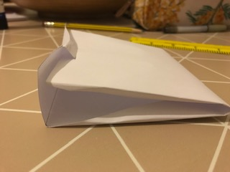
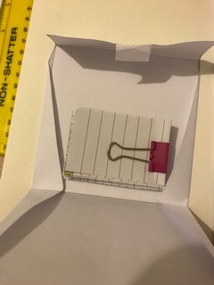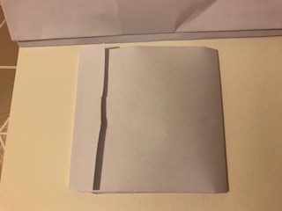

This was the last mock up I did, which was the double envelope one, but with a page to cover it but which then becomes a pocket itself.
These are the little pockets stuck in my sketchbook.
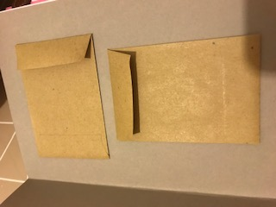
Here I am putting one of the mini zine booklets in the top envelope to hide it.
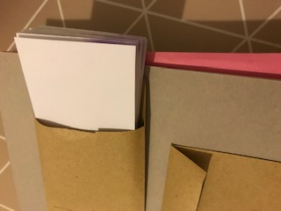
It does look a little chunky.
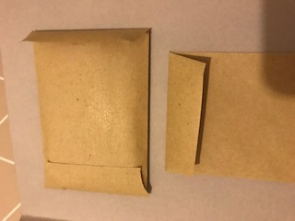
Then I used the blank page that I kept clear before it and paper clipped this to the envelope page, leaving the top open.
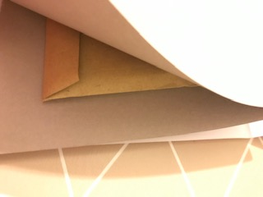
The blank page that now becomes the new page can be decorated to disguise the page as a pocket!
I do think it needs better fasteners to support what you put in this new pocket, something I will look at in the mean time.
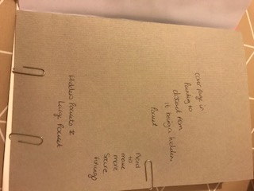

How personal is your sketchbook? For example do you include personal thoughts or imagery? Do you hide bits in your sketchbook? If so how?
So to answer this question now: - I have not hidden bits in my sketchbook before, I had never thought of doing so, I have always just used a sketchbook in an open way. I don’t write down personal thoughts but I do write down ideas and I draw ideas, to me it has never bothered me if anyone sees this because I just presumed they wouldn’t really know what it was about or for!
After doing this exercise though I wouldn’t say I would change this about myself, but it has given me some ideas of how to store ideas or collect items and add them to my sketchbook and maybe after time I would hide more personal things in my books. It has opened my eyes to being more creative and more free in what I feel I can explore creatively, so maybe because I feel more open creatively this is because I know I can hide these elements now!?

