Making mistakes – Working fast and cutting work up.
Do you allow yourself to make mistakes in your sketchbook?
I do leave in all mistakes in my sketchbooks but it is hard to leave them there. It does make you learn from them though, it makes you look at what you have drawn or created and you think to yourself ‘next time I draw that I will change this or draw that bit different’ so it does help your learning process.
I proceeded to make the 4 small books:-
I found making the little booklets a little fiddly; I think making larger ones would have been better but its working out of my comfort zone so it’s all a learning process. I liked working fast and loose and enjoyed looking for mark making implements to try out and different paint too.
For book one I chose a thick white card, and then I chose watercolour paint in purple to draw something loosely. I drew a pine cone which was on a table display in front of me, I started small and the drew 3 others on the page, looking back I think it would have been better to work larger and fill the whole page with the paint and drawing.
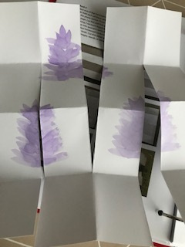
Once the pages were cut I managed to create the little sketchbook, some of the pages were still plain and some had some of the drawing on them, but you could re-use the booklet and create more things inside it.
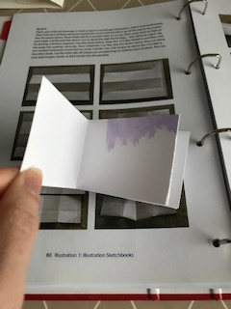
The booklet concertinaed outwards; I’m hoping this is how it was meant to turn out. I can see these would be handy to capture drawings and ideas if you had limited space or was travelling.
The next booklet I created was number 2:-
I used some copier paper for this one, a toothbrush and some acrylic paint. The thinking that was to the back of me was a window, so I kept it simple and just drew the outline, which was rather tricky with a toothbrush! This time I tried to use more of the page, but I repeated the image over and over again to fill the page.
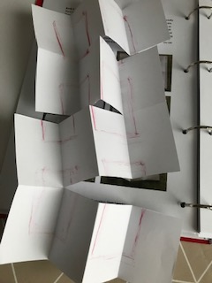
I then cut the page into the sections required and started to fold the booklet into a sketchbook. The pages again were just as small but were in a portrait style instead. Again the pages were fairly easy to work over again with and re-use to create more drawings or artwork and ideas.
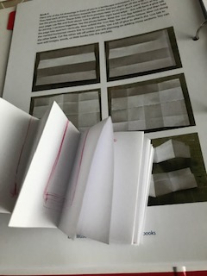
The next booklet I created was number 3:-
For this one I used some graph paper which had lines on the back also, I used a sponge and some house hold paint for this drawing. The item that was around was a glass cabinet; again I kept it simple with just a square out line and a rough idea of the doors and panels.
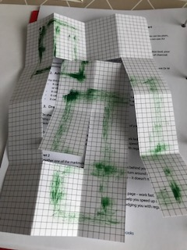
I then cut and folded this is it stated in the brief. This was a fairly busy booklet because of the graphs and the paint; I’m not sure whether if you drew anymore on this it would be definable?!
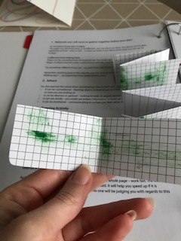
The concertina was quite tight with this little booklet, so it was hard to manage, but I think the use of a paper clip here would work well.

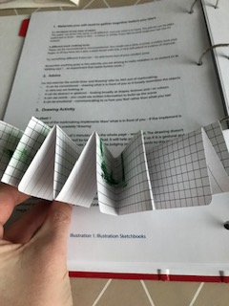
Booklet 4:-
I use some very thin green sketch paper for this one and some oil paint; I also used a cotton bud to draw with. I drew a terrarium which was on the table in front of me; again I kept it simple with just the outline of the plate and glass jar.

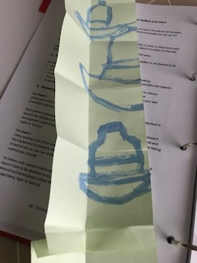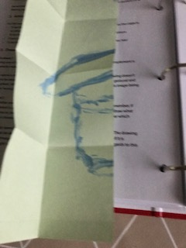
This booklet was trickier because of the fold/ flap that you had to glue together, it was not very clear in the photos where you had to join the booklet together, so I’m hoping this is right?
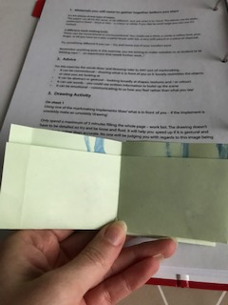
I liked the idea of this booklet with the hide place to put things, this booklet is just as small as the others but I think working larger with these ideas and concepts would be beneficial.
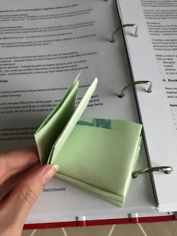
I think overall I would still work in 3 of the booklets but not the graph paper one, it’s too busy already.
The things that sparked with me were the idea of these booklets but I would prefer to work larger.
I prefer the 2nd booklet the best, it felt the easiest to handle and work with, I would defiantly create more of these, as stated above but larger, but I would still create some this size for when I’m travelling about.

