What is your relationship with your sketchbook?
So I started this exercise by highlighting the descriptions in yellow of the way I currently feel about my sketchbooks, I have recently had a bit of a confidence crisis with my sketchbooks. I had previously been confident that I was keeping them well, excited to use them, but recently I have found it to be a love/ hate relationship. I feel as though that the ones I need to keep for my Uni word have become a little tiring, I love colour and expressing myself through it, so I feel this is lacking in them. I rarely keep sketchbooks for my own work, but I feel I would have more ideas and excitement for these books.
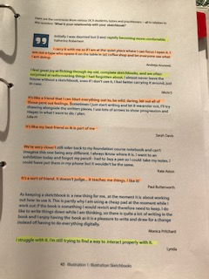
Here I have highlighted ‘rapidly becoming more confident’ ‘I feel a great joy in flicking through old books and rediscovering things’,’ I struggle with it’, ’ I’m still trying to find a way to interact with it properly’
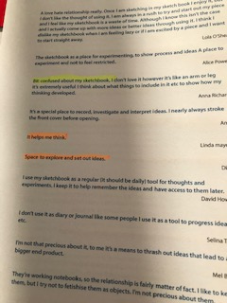
‘Bit confused about my sketchbook’
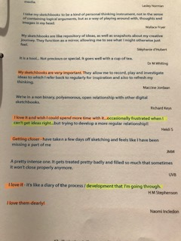
‘Occasionally frustrated when I can’t get ideas right’, ‘development that I’m going through’
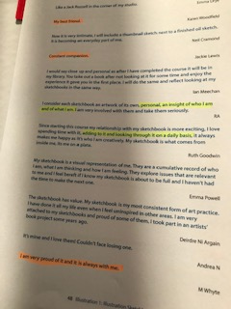
‘Personal, an insight of who I am and what I am’, ‘adding to it and looking through it on a daily basis’.
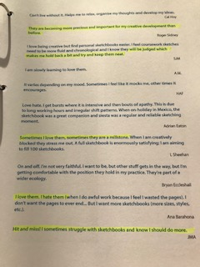
‘They are becoming more precious and important for my creative development than before’, ‘makes me hold back a bit and try and keep them neat’, ‘sometimes I love them, sometimes they are a millstone’, ‘love them, hate them’, ‘Hit and miss!’,’ Sometimes struggle with sketchbooks and I know I should do more’.
Then I went back over the words and highlighted in orange what I wanted my books to be.
‘I carry it with me so if I am at the quiet place where I can focus and open it’, ‘It’s like a friend that you can blurt everything out to’, ‘be wild, daring, let it all out’, ‘It’s a sort of friend’. ‘Doesn’t judge.... it teaches me things’. ‘I like it’ ,’ It helps me think’ , ‘Space to explore and set out ideas’, ‘ My sketchbooks are very important’ ,’ I love it and wish I could spend more time with it’ , ‘Getting closer’, ‘I love it’, ‘I love them dearly’, ‘My best friend’, ‘constant companion’, ‘I am very proud of it and its always with me’.
From this exercise above I feel I have lost the love for my sketchbooks and I need to get this back! I find my sketchbooks for Uni a bit frustrating as you are confined to what you should put in them, so I think doing this unit will help me bring new ideas and new excitement into my books, that’s why I want to try a different way and maybe try making some sketchbooks or hiding things in them, or experimenting more, being more confident to go wild and be free with them.
The relationships I have with my sketchbooks have lost the way, I need to bring back some freedom, expression and colour into them. The sketchbook I expressed myself in visually to respond to this question was a handmade watercolour sketchbook, I chose a watercolour one because I wanted to use a lot of colour and paint, and watercolour is a very wet medium, so this needed the proper paper for this. It’s a small booked let sketchbook.
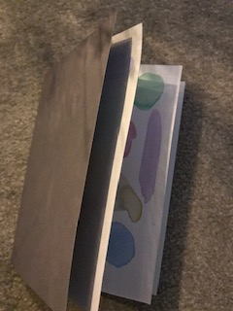
I used some different techniques for each page; this first one was just layering the watercolour paint horizontally to create a landscape effect.
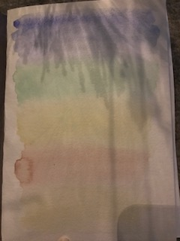
This one was using a flat brush and using the tip of it to create swirls, which added different widths within the curves.
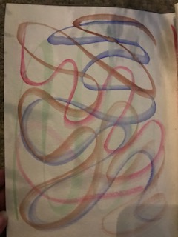
This page was using wet on wet paint, so they merged into each other, created drips or blended themselves. It creates a very free effect and makes you think about colour combinations and what works well together.
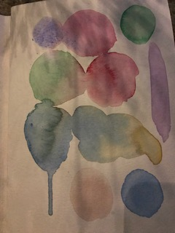
The middle page on the left was using coloured watercolour pencils and creating a more defined landscape effect with the colours.
The middle page on the right was using a brush in a stipple effect and how this can create a softness with the paint and the colours.
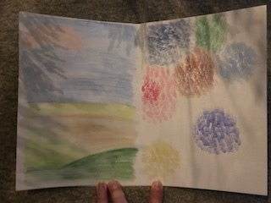
This next page was about mark making techniques with the different brushes I have, again using both watercolour and acrylic paint. The page on the left is mark making shapes and the page on their right is using a fan brush and the effect it creates when the pain runs out and goes dry at the bottom.
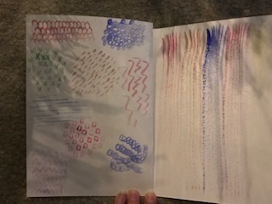
This last page was about creating drips and how the overall picture then can become something else, like a tree or a lollipop!
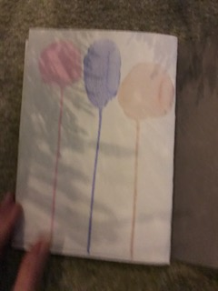
So this is visually how I want my relationship with sketchbook to be, colourful, exploring colour, tones and partnerships. Ideas and exciting experiments and finding shapes in mark making. I want it to be vibrant, exciting and fun, learning from mistakes and happy accidents.

