Seven days
I started this assignment by thinking about seven days, and what sorts of things could happen in those seven days? I started to write down some ideas I had that were brewing in my mind, really though I didn’t know at all what I was going to do for this assignment! Having the pandemic and being in lock down has limited what sort of things I could do.
I had an initial idea of a flower blooming over a few days and how I could document that, maybe make it in to an educational piece?
The second idea I had wrote down was something I had been thinking about for a while, and that was to write a short story about a fairy for children, the book would be small, a paper back and similar in size and style to the Mr men books.
The third idea that came to mind, which was very relevant, was something about a pandemic! Maybe an advice leaflet, or some guidance, or a step by step guide for children to understand what was going on?
The last idea I had was to draw about a butterfly going through the stages of egg, pupa, caterpillar and butterfly. To do an educational or countryside leaflet/ booklet to show the growing of the butterfly and its life’s journey.
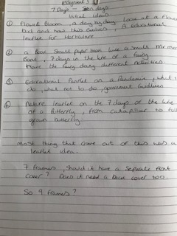

From these ideas I then went on to complete a spider diagram for each, to see if this would help me to decide or give me some more or other ideas to work on.
This was the flower bloom idea:-
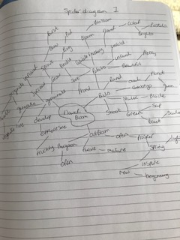

This was the fairy book idea:-
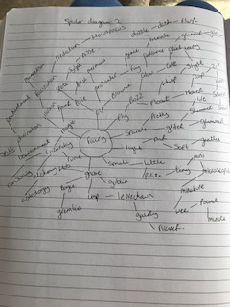

This was the pandemic idea:-
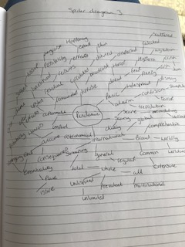

And this was the butterfly life idea:-
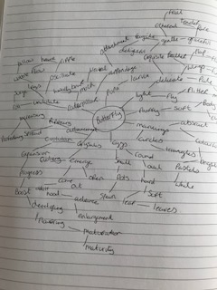

From these four ideas I decided to whittle it down to two, and thought about which one’s would be the best that would culminate in my skills as well as push me further?
So I decided upon the first idea the blooming flower and the last idea the life cycle of a butterfly, with both of these I then went on to create a mood board for each.
The blooming flower idea, I started with a quick search of Pintrest to get some reference pictures and overall feel of what I wanted to achieve. I found some time lapse videos of flowers blooming to show the whole stage of this, I then found some photos which was this idea but condensed down into a few frames.
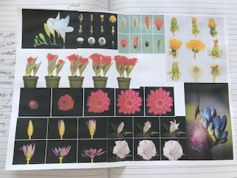
I then did the same for the butterfly idea, but with this I found more educational material, which I was not sure if that was the route I wanted to take, or more of a countryside/ insect route.
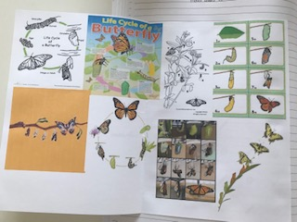
I also found out that the life cycle for a butterfly is much longer than I thought! So I could not condense this down into seven days, or even achieve part of this. So by default my final choice was made for me, the blooming flower it is.
So from the blooming flower spider diagram I picked out a few initial words that I would take forward and make into a design/ direction.
The words I chose were:-
Swell, Burst, Petals, Un-ravel, Buds, Stalk, Open and spring.
I then decided to think about a brief that I could write based on this idea of the flower blooming in 7 stages/ frames, one for each day and to see how the bud changes into a flower over the time.
I started with the first stages of a brief hoping that the rest would just follow and evolve as I went along writing it.
The brief
Overview
Horticultural/ botanical leaflet 7 days of a flower blooming
What sort of illustration?
Seven folded leaflet
What type of project?
National leaflet for the Royal Horticultural society
Project description
I am the marketing manager for the Royal horticultural society, we want to produce a new leaflet to promote our flowers and provide some insight/ info on how a bud changes into a flower over the course of a week and how beautiful the process is. This will be available as a hand out leaflet for the six RHS flower shows across the year.
Cardiff, Malvern, Chelsea, Chatsworth, Hampton court and Tatton Park.
The leaflet will be aimed at gardeners of all ages, it will be a A5 size and we will have a large poster and exhibition stand for this at each show, so it needs to read into a large format poster, A1 size posters and a time lapse video (we will arrange a videographer for this part) but you will need to liaise together to decided upon the flower and how this will work hand in hand.
Vision of the project
I want the flower to have a botanical hand painted feel to it with small details prevalent, I want the look to be spring and summery, all the shows are from April – July so these are the two seasons we have to cross.
I want the typography and font to be flowy, script style, slightly French in feeling.
I want a small amount of info on each page but to be kept simple, the main focus is the bud/ flower illustration.
The leaflet does not have to have any info about the shows on it; it is purely factual/ educational to promote how beautiful flowers are. The back cover has to have the RHS details on, your information (Illustrator) only.
Details
RHS (you can start with the Chelsea flower show)
Illustrator: Ruth Goodwin
Target audience
All ages genders, universal
Skills I’m looking for
I am looking for a commercial Illustrator that has a good portfolio of botanical/ flower illustrations. An eye for very small delicate details, and have a fresh spring / summer feeling to their work.
Experience of script lettering and typography an advantage, or calligraphy.
Deadline
This is for the year 2021, so the first show is in April 2021 at Cardiff, we will need to sign off on the final artwork by November 2020. I want two weekly updates to show how you’re progressing and to discuss any changes; this will be a conference call between me, you and the videographer, after an initial four meetings face to face together.
Budget
£3500 for the whole project, 7 illustrations, and typography, plus 1 final complete design/ mock up.
Point of contact
You will be dealing directly with me and the videographer together.
Any other information
The following mood board is the look and feeling I am after for the time lapse video, the illustrations must be lighter, with a spring summer feeling.
I then went on to find an illustrator that I could compare this brief to, I came upon the illustrator Lizzie Harper who is a botanical illustrator.
Lizzie Harper is a freelance botanical and natural history illustrator, her favourite subjects are grasses, wild flowers and beetles, and she uses watercolour pencil and pen.
Lizzie trained as a zoologist so this helps with her illustrations; she has done freelance work for Countryfile magazine and Harper Collin’s.
Lizzie has also exhibited in the UK and internationally, she also teaches workshops and has a range of greetings cards.
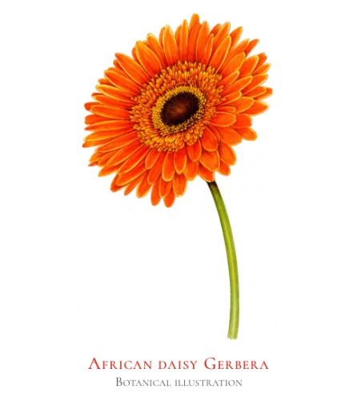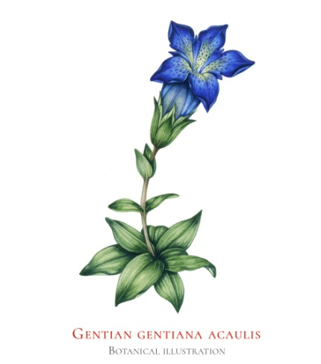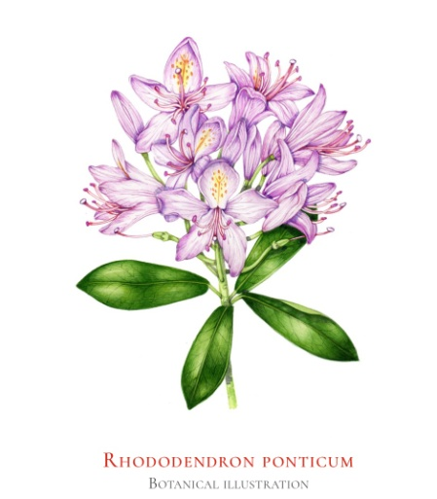

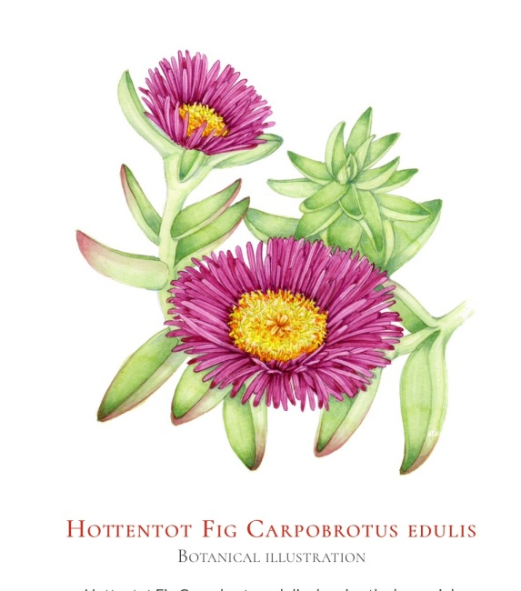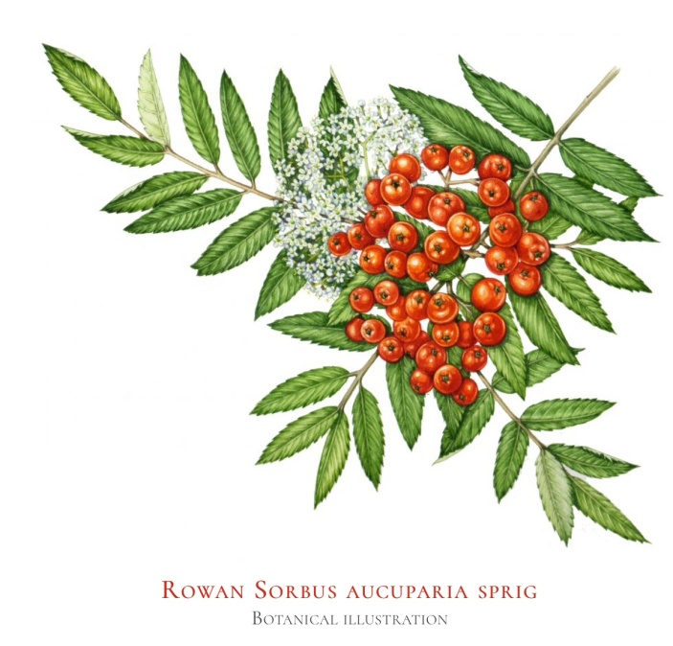
All images © www.lizzieharper.co.uk

I have found with Lizzie’s style and the paint she likes to use which is watercolour, we have a very similar style. My illustrations are probably less detailed and less accurate, but we both like flowers and plants and like to achieve a very light and specific look.
I watched one of lizzie’s videos on her website and found she uses magnifying glass to see all the smallest details on the flowers or petals and all the markings that she see’s.
I thought this would be a good tip to help me achieve a similar look for this brief.

After researching and looking at Lizzie’s work, I then went on to create a botanical mood board to get a feel of the look I want to fulfil the brief.
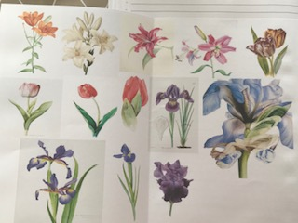
I also then went on to create a RHS mood board to get the feeling for the leaflet and the colours I might need to use and the graphic style of the RHS.
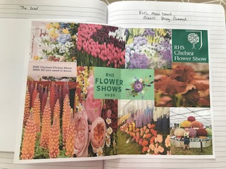

I then had a bouquet of flowers delivered, luckily it was my birthday and they were delivered as I couldn’t get out because of the Covid pandemic! I took some photos of the flowers in the bouquet and then took pictures of three of the varieties to focus on for my design.
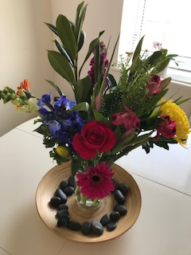
I then took pictures of the flowers a few times a day over the seven day period, so I have some reference pictures to work from.
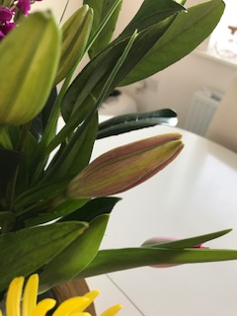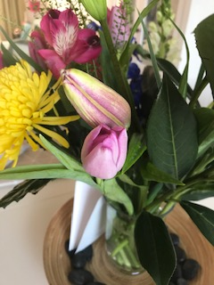

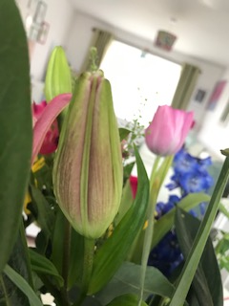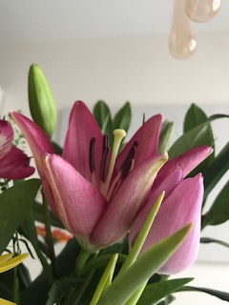

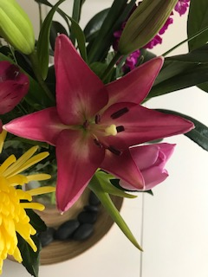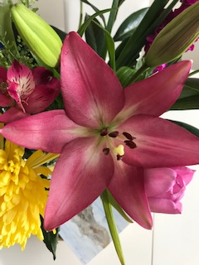

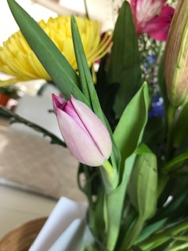

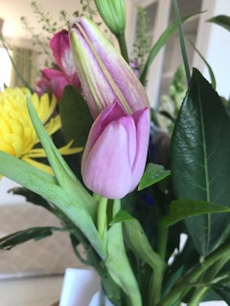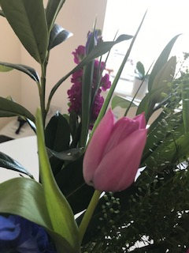

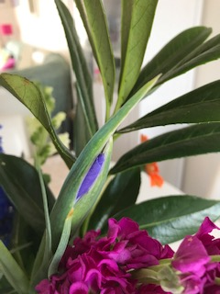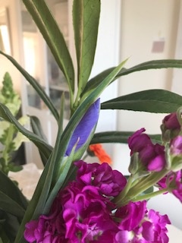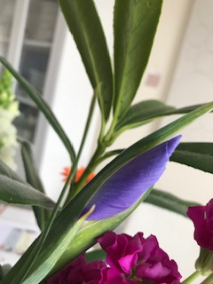

So I then started to think about mediums, should I continue with watercolour which is my preferred paint, or try gouache which will give a brighter pigment and will show up better after being put through Illustrator and Photoshop, which has been a problem in the last few sections with contrast?! Or try to mix both and use some pencils, like I have done before?
I think I’ll do some colour tests to see how the gouache performs and then go from there.
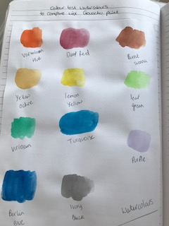
So these are the colour tests for the watercolours, I tried to chose colours that I had similar of for gouache so I could compare the two.
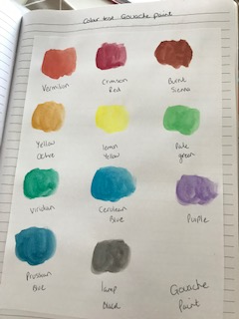
These are the gouache colour tests, I didn’t notice that much difference between some of the colours, the main difference I found was the feel of the colours, the watercolours had more of a translucent feel, but I still think the colour was bright. The gouache didn’t have that translucency, but had a darker tone to them.
So I think I’ll try to use both the watercolours and gouache paints, as I think this would help with the spring summer colour feeling and maybe the gouache will work better with contrast, or help pep up the watercolours where needed.
I will probably use watercolour pencils as well for the smaller details.

I drew some thumbnails of the tulip flower and then the Lily flower in 7 frames, to show the growing process and the bloom. I wanted to do the Iris as well but it is taking longer to bloom, so I think I’ll have to leave that one out of the running as we are already on day 4 of the blooming process.
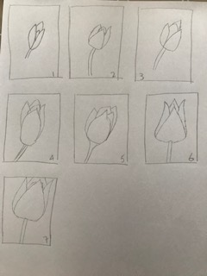

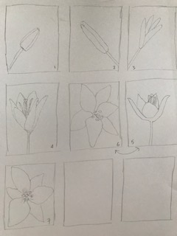
These are very rough thumbnails for the moment, just to get the process and idea on paper. I then went on to do a few studies of the tulips so far, again just sketches at this stage.
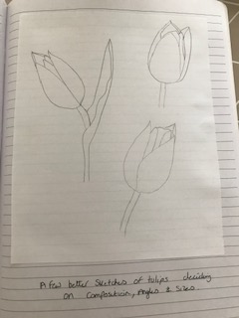
I was thinking whether to add more of the stalk and leaf in the frames or keep them to just the buds and flowers only?!
I did a better sketch of one of the Lily flowers that was half open when I got it.
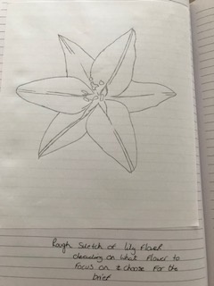
I then started to think about which flower to focus on? Did I want to choose the Tulip or the Lily flower, so I had a look at them intensely in the vase, and I decided to go with the Lily flower? I thought this would be the best to choose at it had more colour, more details, bigger, bolder and it had more about it.
Although I prefer Tulips myself I think this would be better for the leaflet and overall ascetically pleasing.
So now I am at the point of knowing which flower I am going to be working on I can move forward and draw some better sketches then move onto painting the different stages of the blooming process.
But before I start on that, I want to think about the typography and what words are going to be on the leaflet.
I think on the front page I just want to keep it simple like the brief and have the word ‘Blooming’ on the front, along with the RHS’s logo.
I started to sketch the word in my own script handwriting, then I turned to the computer to see what script styles it had and how to make mine look more authentic.
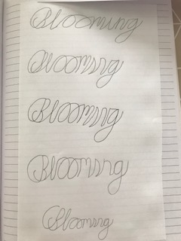

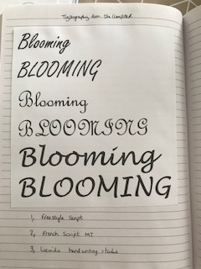
So I started to paint my illustrations with watercolours, Gouache and coloured pencils, I took a picture of each stage of painting, but acuminated them into this 3 photos. (Ignore the first two photos that’s just my orchid)!
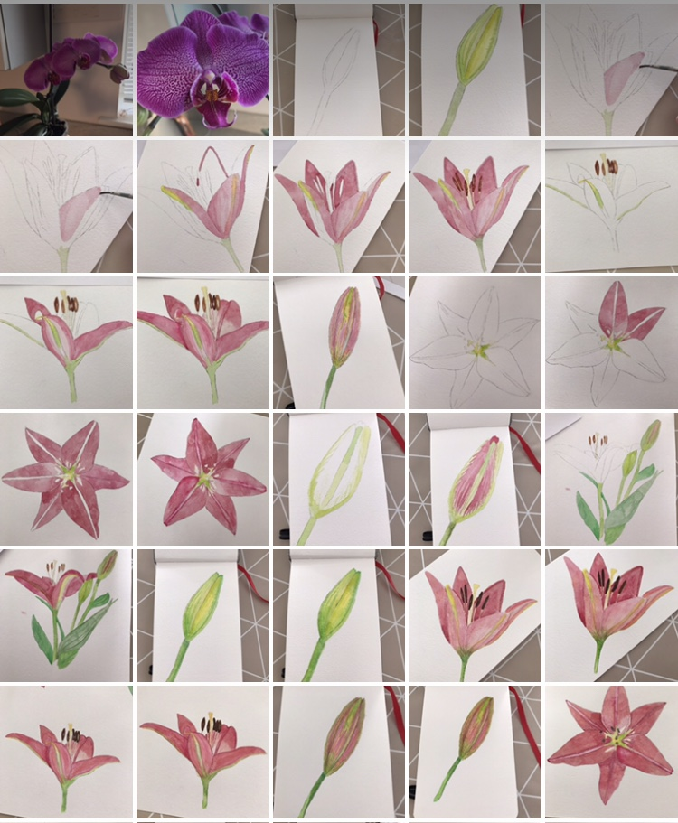

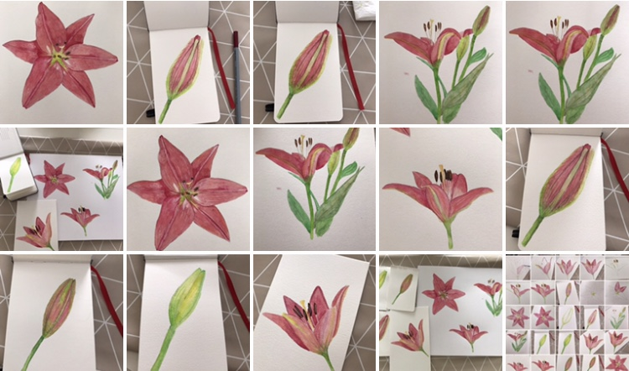

Then the finished illustrations painted.

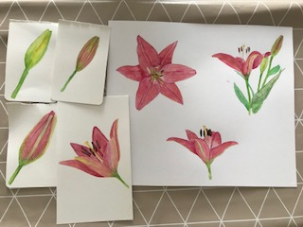

Next I scanned them into my computer and saved them, then went into Photoshop and erased the backgrounds and saved all the images separately on a PSD file.
I then went back to my hand drawn typography as I had been thinking about what words I would need, I needed Illustrator, Day, Blooms, Flower, in, days, gorgeous and blooming.
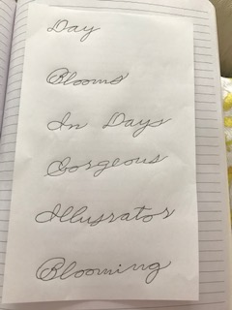

After getting those words ready I then scanned them into Illustrator ready for pulling all the elements together and creating the layers.
I started with the front cover and pulled these together in a layer, then printed this off to start the annotation process.

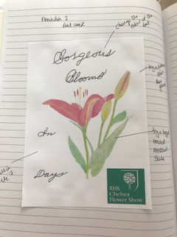
I wanted to try a darker background, just to see if this would make the flowers pop more, try the flowers in a larger scale to give it more of a modern look, try the type in different colours the black looks too harsh for the background.
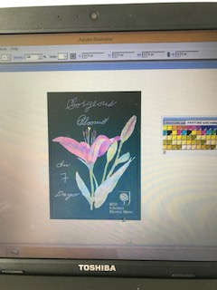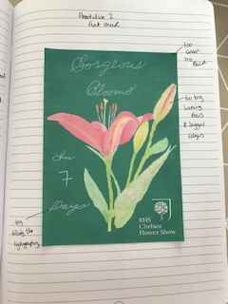
I tried the background in the same colour as the RHS logo, but it looked darker on the computer, when I printed it off it was too green!
I thought I’d try it in black to see what that looked like.
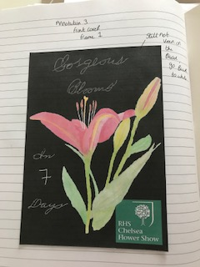
I liked the black background, but the larger scale of the flowers made the outline wobbly and looked un-professional, so I scaled the flowers back a bit. Then I thought is the black background in line with the brief? And no it wasn’t, they wanted it to bit spring and summery and light. This would have been good for the autumn or winter with a seasonal flower, something to keep as an idea for the future.
I reverted back to the original I had done, but changed the colour of the type and filled the type so it looked slightly bolder but still script in style.
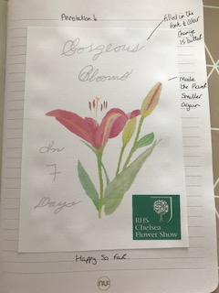
I then started with the next frames and pages and followed the ideas of the first front cover page, so there was little annotation with these.
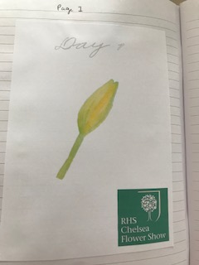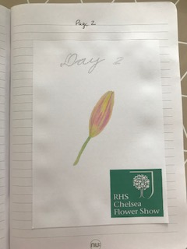

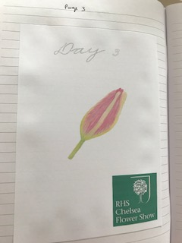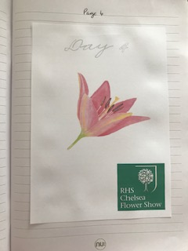

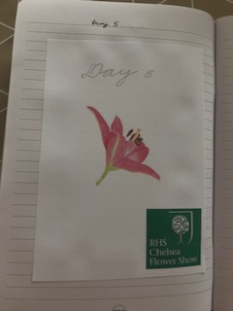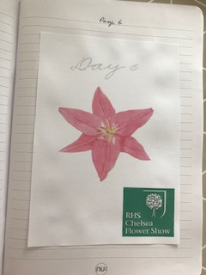

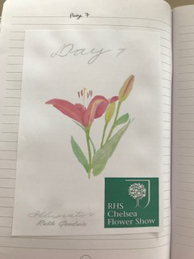
I did this with all the rest of the frames and pages, I decided to add the logo of the RHS for the Chelsea flower show, to show how this would work for each show, but keeping the main leaflet the same.
Although the design is very simple, I think it does look effective and more stylish because of the simplicity.
I then turned all the Illustrator files of each of the frames into Jpeg files and pulled them altogether onto one page, to see how these worked as a whole.
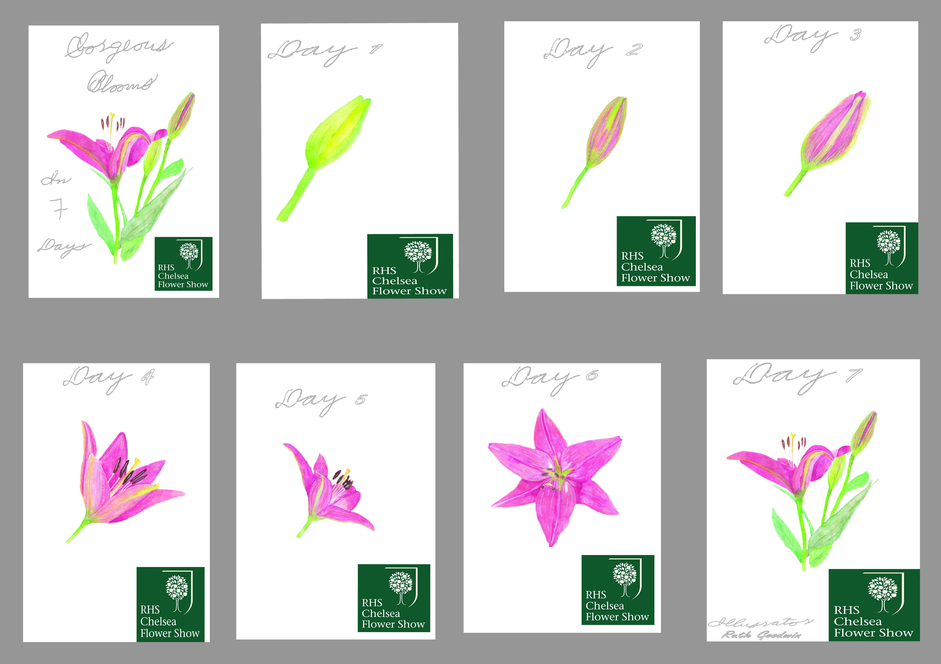
Then from this I made the frames/ pages into one long strip so I could see the continuity and I could print this off on card, and then make it into a physical mock up.
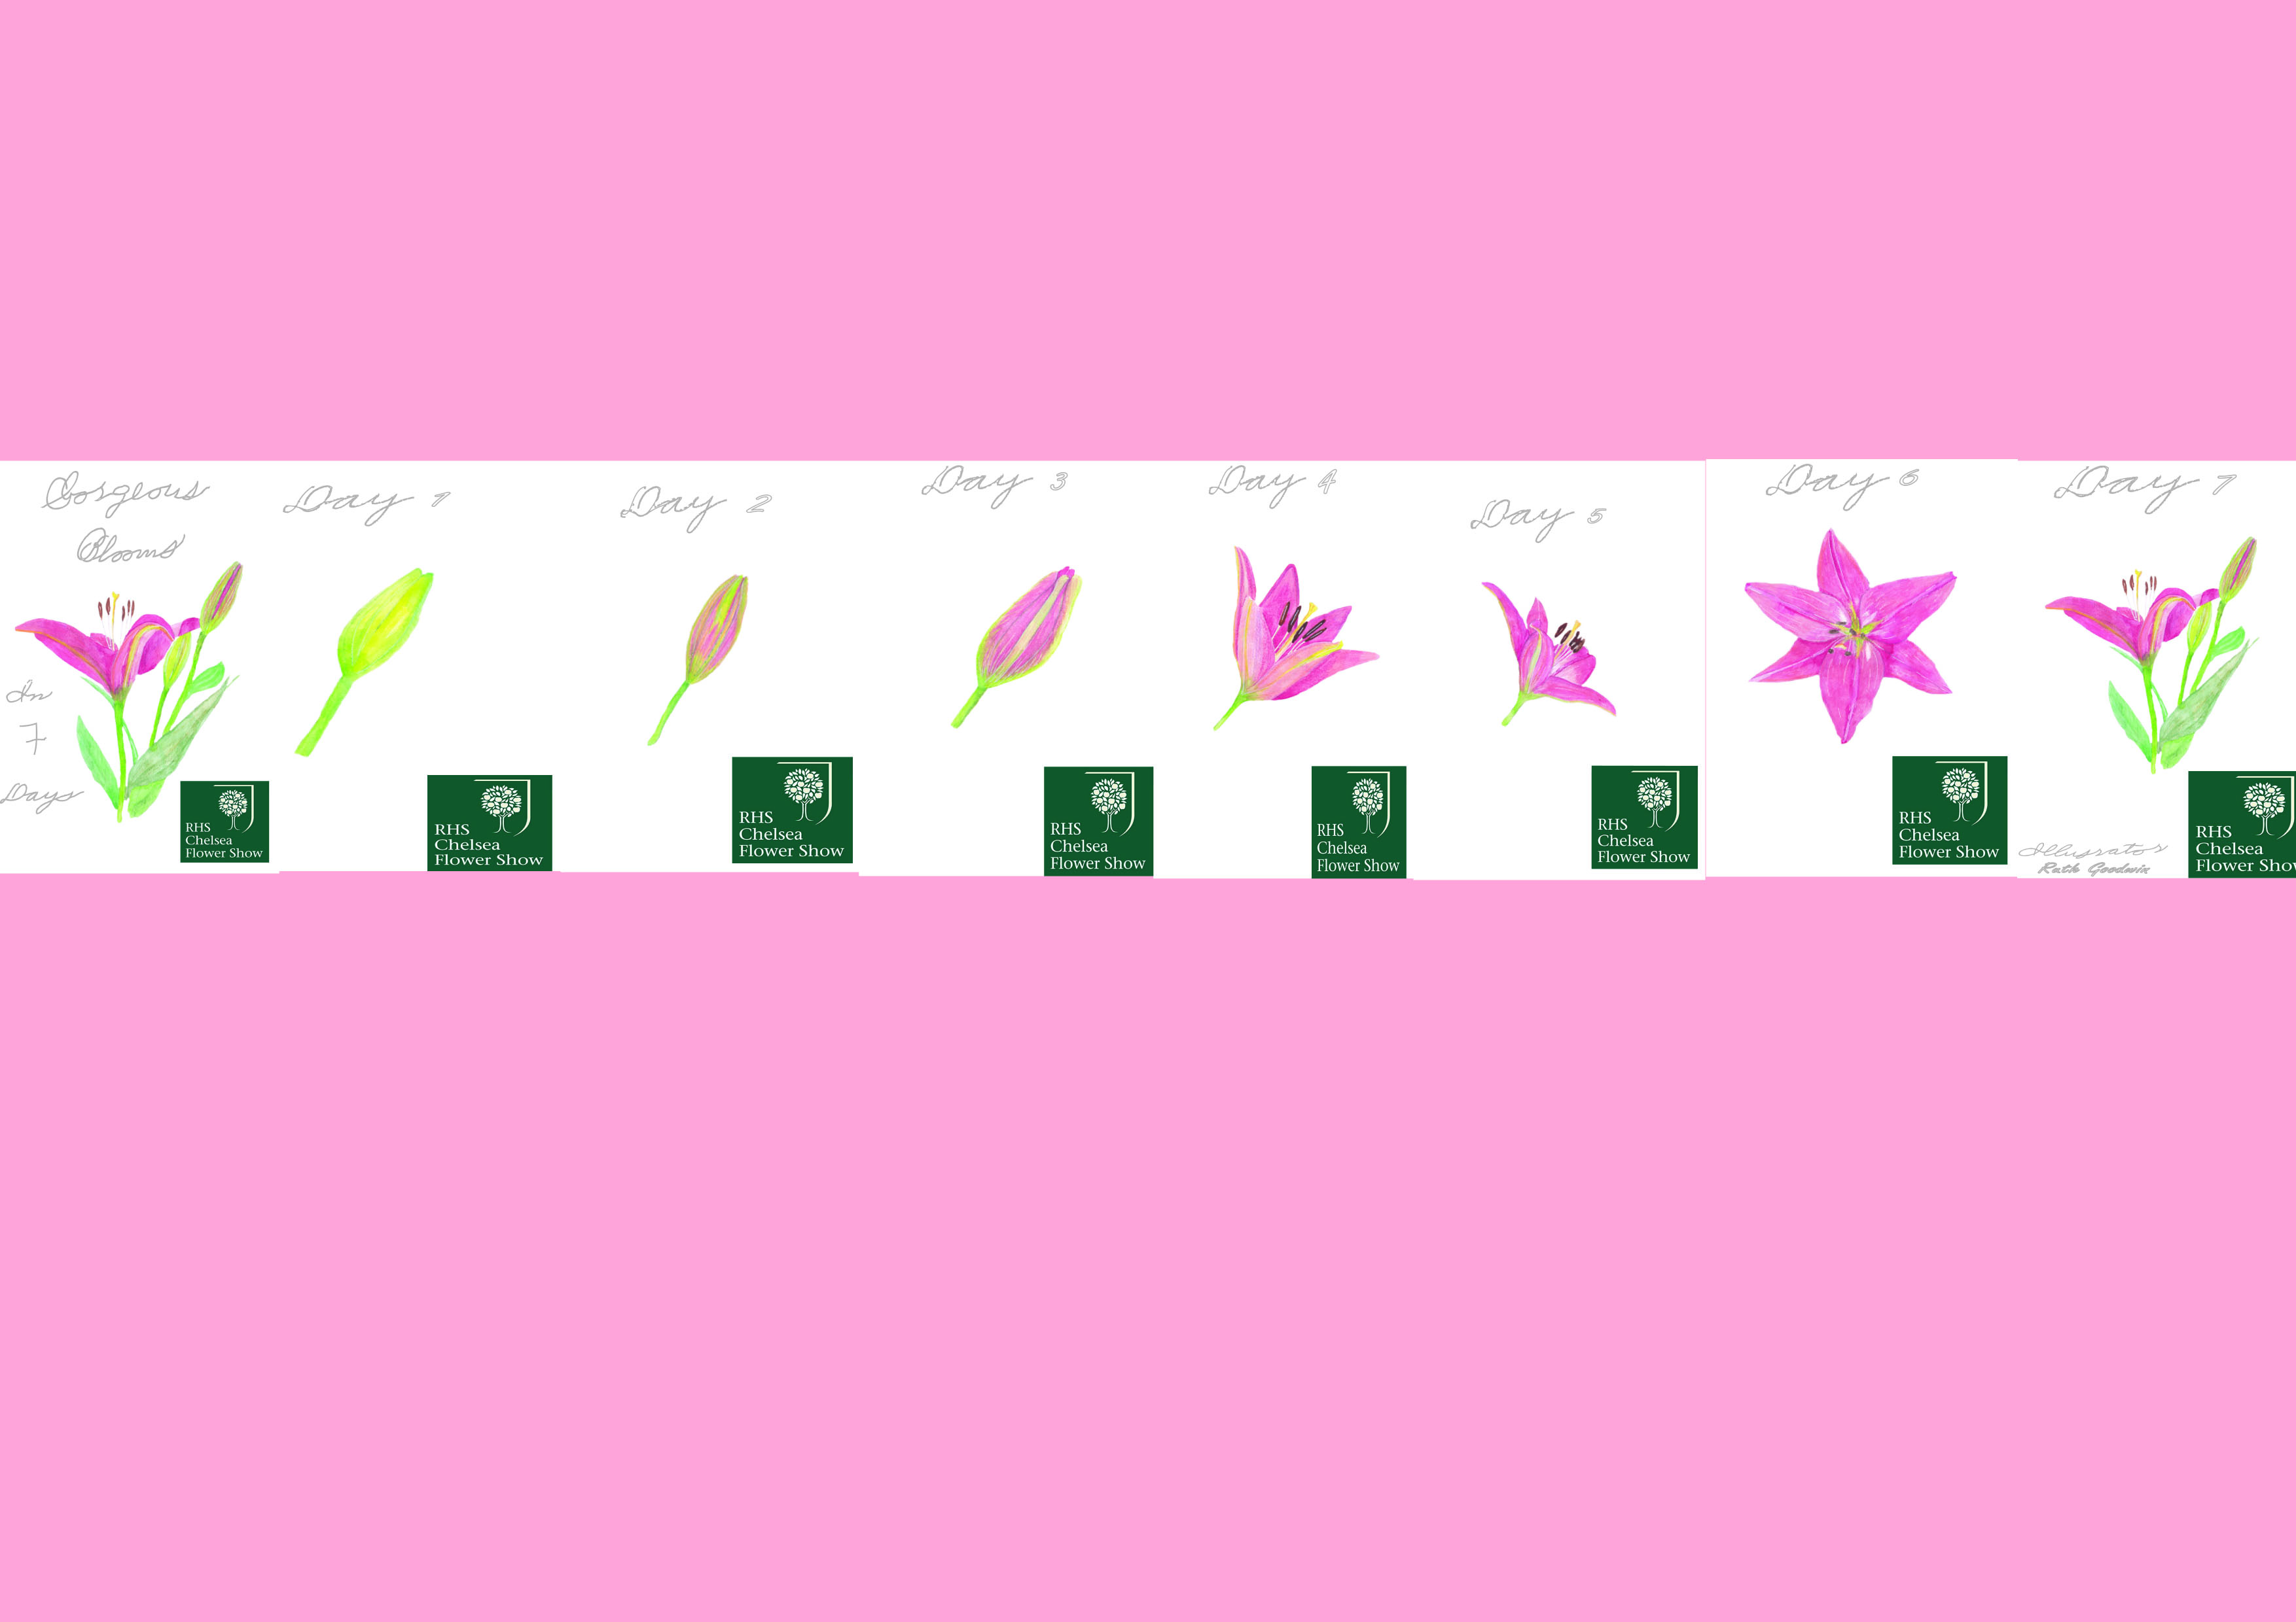
I then cut this out from the card and made it into the mock up, the scale is smaller than I wanted but I think it gives an idea of how it would look. The actual design would be A5 in size, but I would have had to print them on a few pages and stuck them together, which was something I wanted to avoid, as I wanted the most realistic mock up I could achieve.
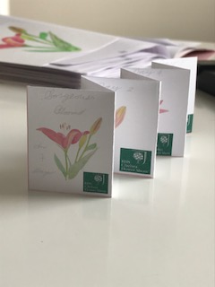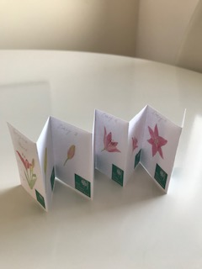

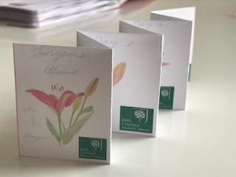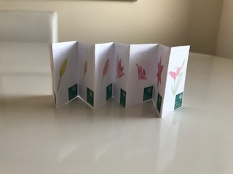
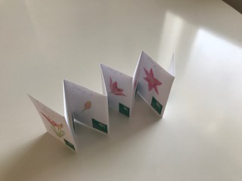
I was happy with the little mock up, and thought it looked effective.
What have you enjoyed and why? How might I expand my knowledge in this area?
I enjoyed thinking about the brief in this assignment and coming up with the idea for this leaflet for the RHS. I like the idea of leaflets or small booklets and designing them and trying to achieve the physical mock ups is creative too.
I am going to sign up for a free trial for Adobe Illustrator (the most up to date version), so I can practise and produce proper professional mock up’s not just for this assignment, but I will go back over the areas I wanted to use mock up’s in this unit so far and hopefully produce the right mock up’s before assessment.
I also still need to get to grips with contrast; having used gouache paint mixed with watercolour the brightness is better, but still not great! I will try and find a short course over the summer to help me in this area.
What are the strengths and weaknesses of these images? How might I tackle the weaknesses?
I would say the flower illustrations are the strengths, although some more knowledge of contrast would help. The weaknesses are the typography, it could be refined more, and look better with more practise. Also as suggested above a better way to produce mock up’s that look more professional.
It can be useful to return to your brief, check you are meeting the criteria (are the colours/ character/ feel of the image communicating the right idea?
I did return to the brief a few times throughout the time I was completing the assignment, I wrote about this above in the writing up. Yes it was handy to go back and think again, choices you have made and double check you have got the right ideas and colours and feelings correct.
What have I learnt in this exercise and how might I use it on future projects?
I have learnt to research thoroughly all aspects of the brief and produce many mood boards if needed to get the basic feeling of the project to begin with. I found it has really helped achieve a better design and idea overall. This will help other projects and briefs in the future and give the feeling a more rounded and whole feel, to deliver better ideas.
I have learnt so much about annotation over the last few exercises that I find it easier now to get things right or better straight off, so less annotation is needed. I will still annotate obviously on future projects but it is nice to know you are seeing things in that way before and during your creating the designs, so your work is more effective and time management is working well.
Has this inspired me to go on and delve into any new research?
I think I would start to look at books, leaflets, booklets, comics, magazines, mini zines and flyers more, on how they are set out, how they work visually and how they communicate what subject they are on to me. I think research of a practical/ physical nature would be the most beneficial way into the research. Although I have done this for some exercises and for this assignment already, I think keeping up to date and looking at new ideas would be something that would be good to do as an ongoing process.
After feedback from my tutor, I must admit that maybe I had not concentrated as much as I could have done, but my Nan had passed away whilst I was completing this assignment, my dad is seriously ill and I had just been made redundant, so I have looked back on what I had done and changed a few bits from my tutors recommendations.
My tutor recommends having the flowers at different scales, and flowing off the pages. Adding more flowers to the compositions.
To experiment with the placement of the typography and the connection to the image.
To compare my design with other RHS products.
So I went back to each design individually and played around with the compositions, to try to make them look more cohesive. I had a look at some RHS designs and looked back at my mouldboards, which had some of these in.
The following pictures are the new finished frames:-
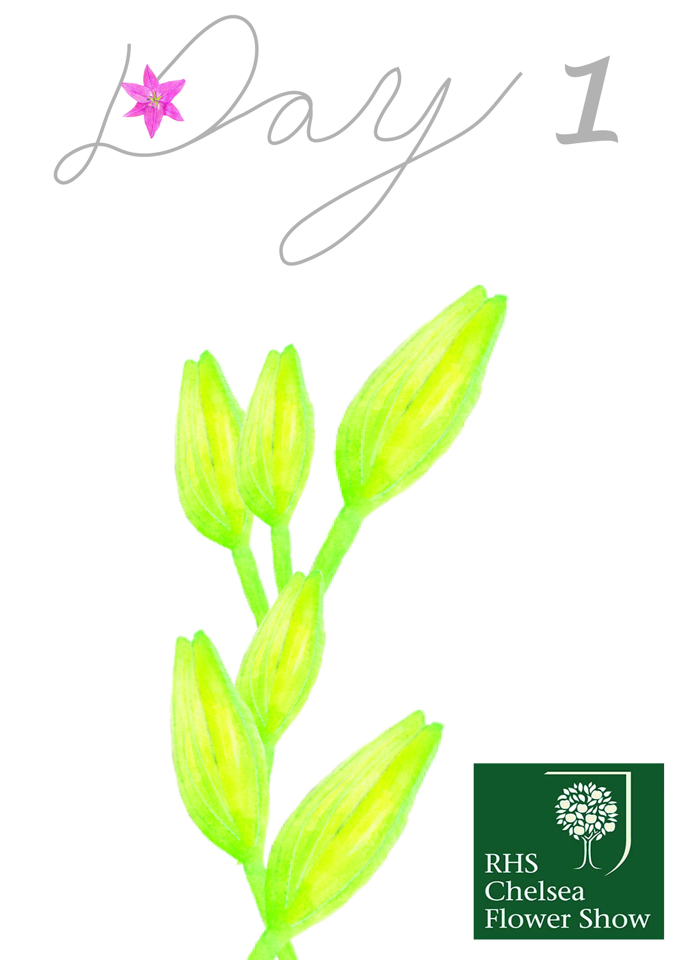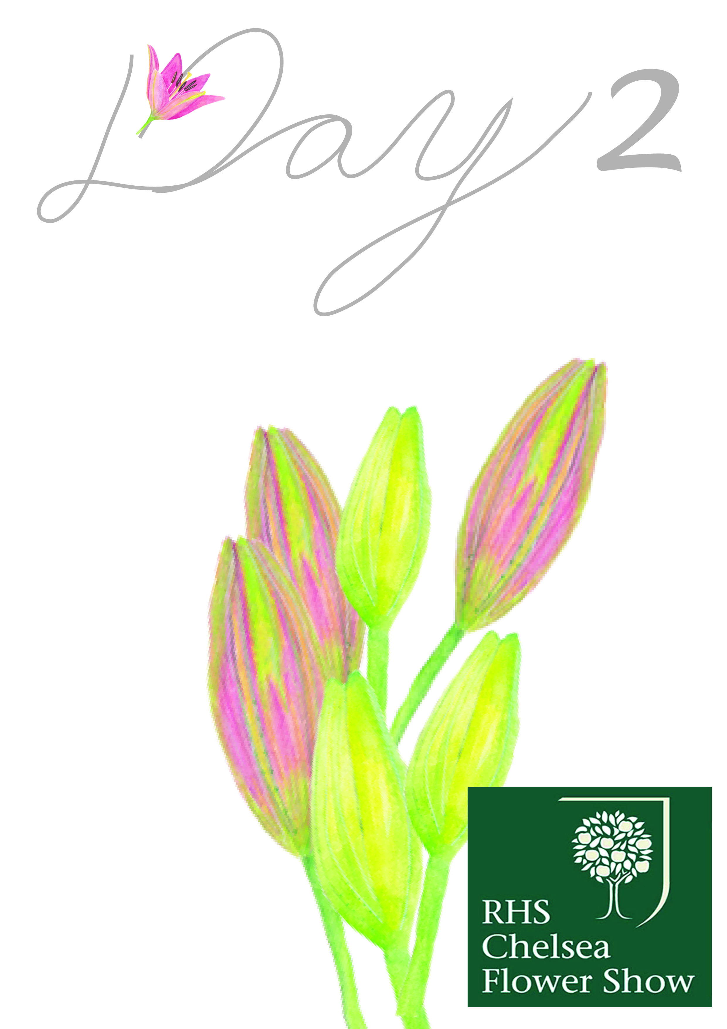
I chose to change the font style slightly, but kept the colours of it the same as before, I also added in one of the smaller flower illustrations to connect it with the artwork. I made the main image of the flowers, groups of the same illustrations, more like a bouquet, then showing that in the step by step 7 days.
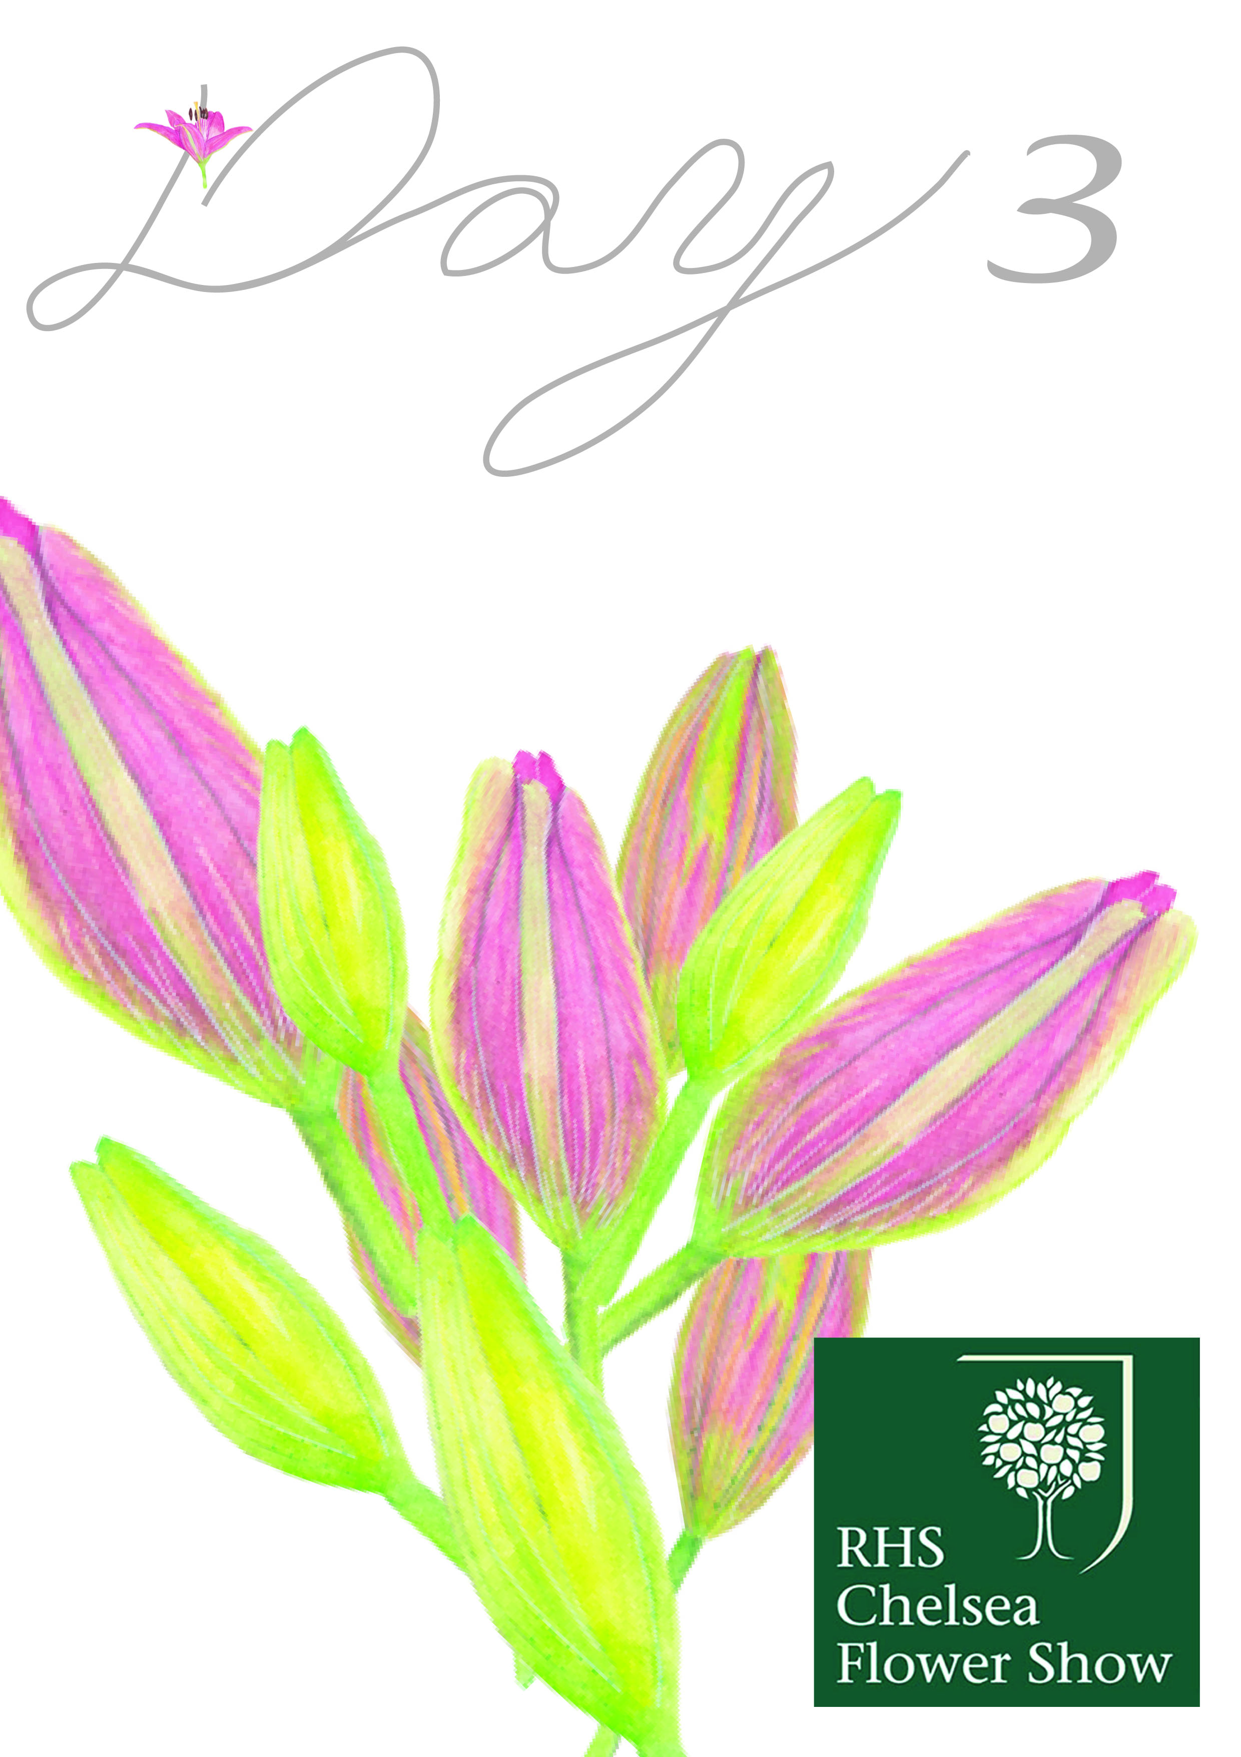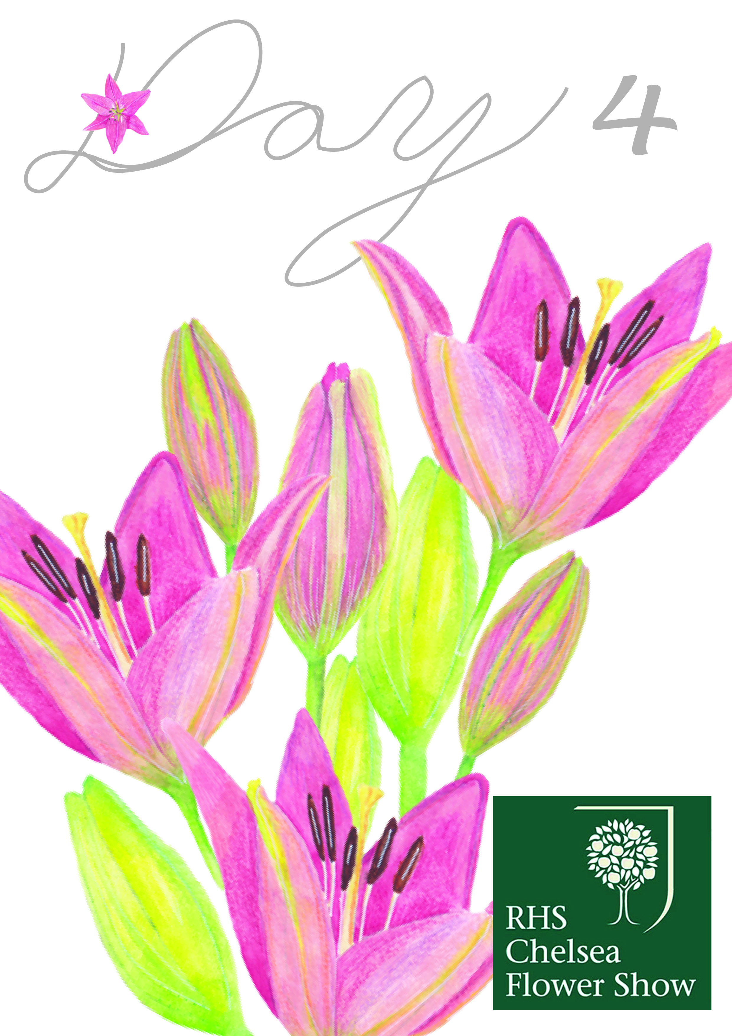
These two designs had the art work coming off the pages on either side, and I changed the scale of all the individual illustrations to give variation and interest. I like the way the pencil lines show up here, it brings out the colour more when all the illustrations are grouped.
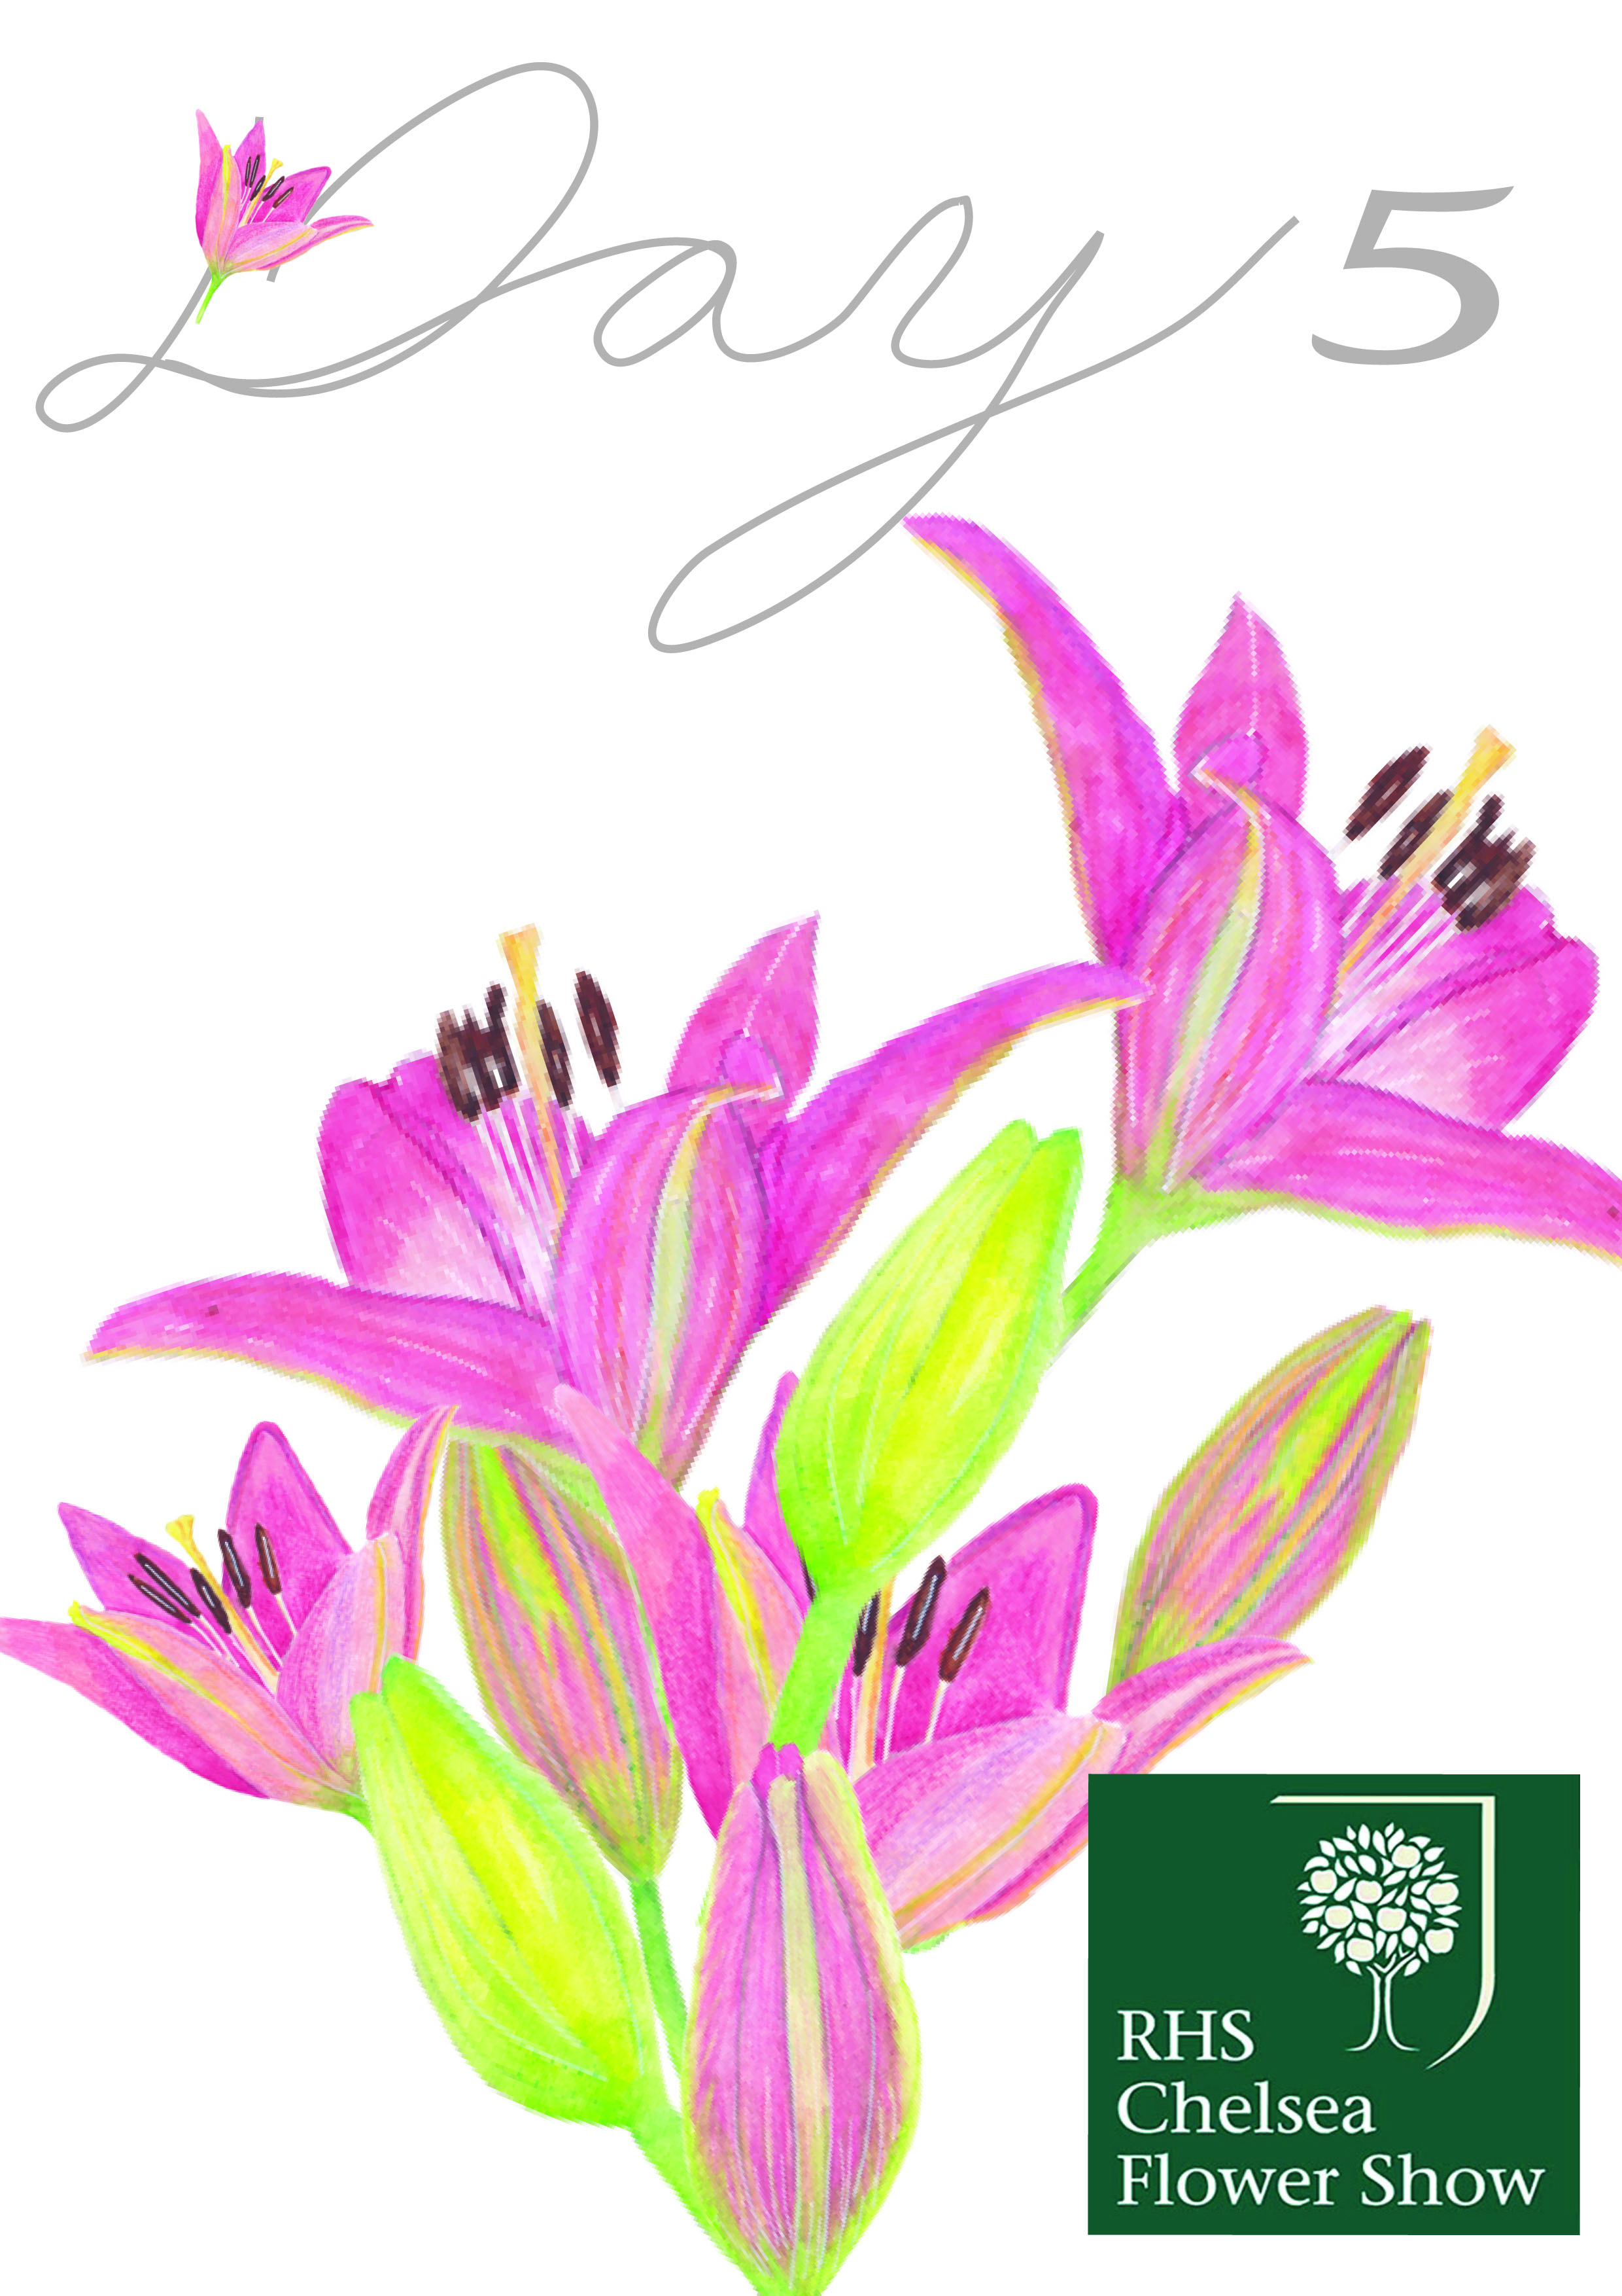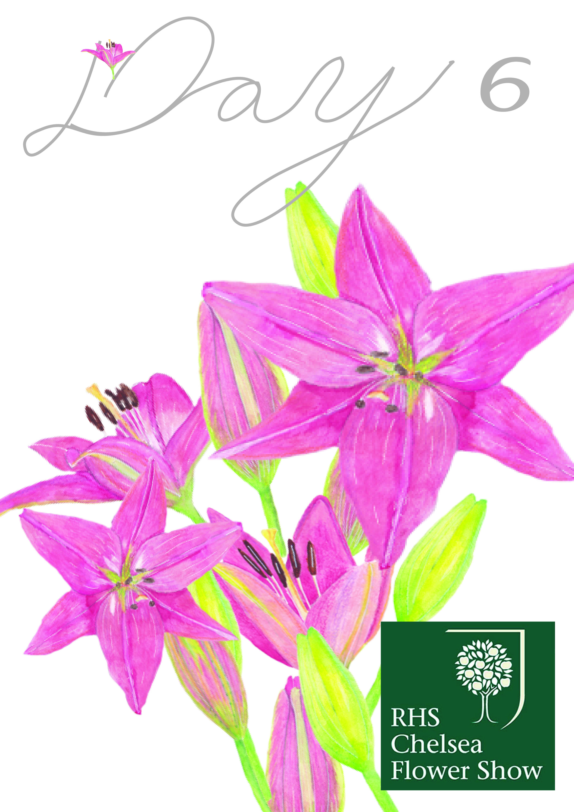
These two look much fuller and cover most of the page, I reduced the size of the RHS logo on all the frames so the artwork stood out more.
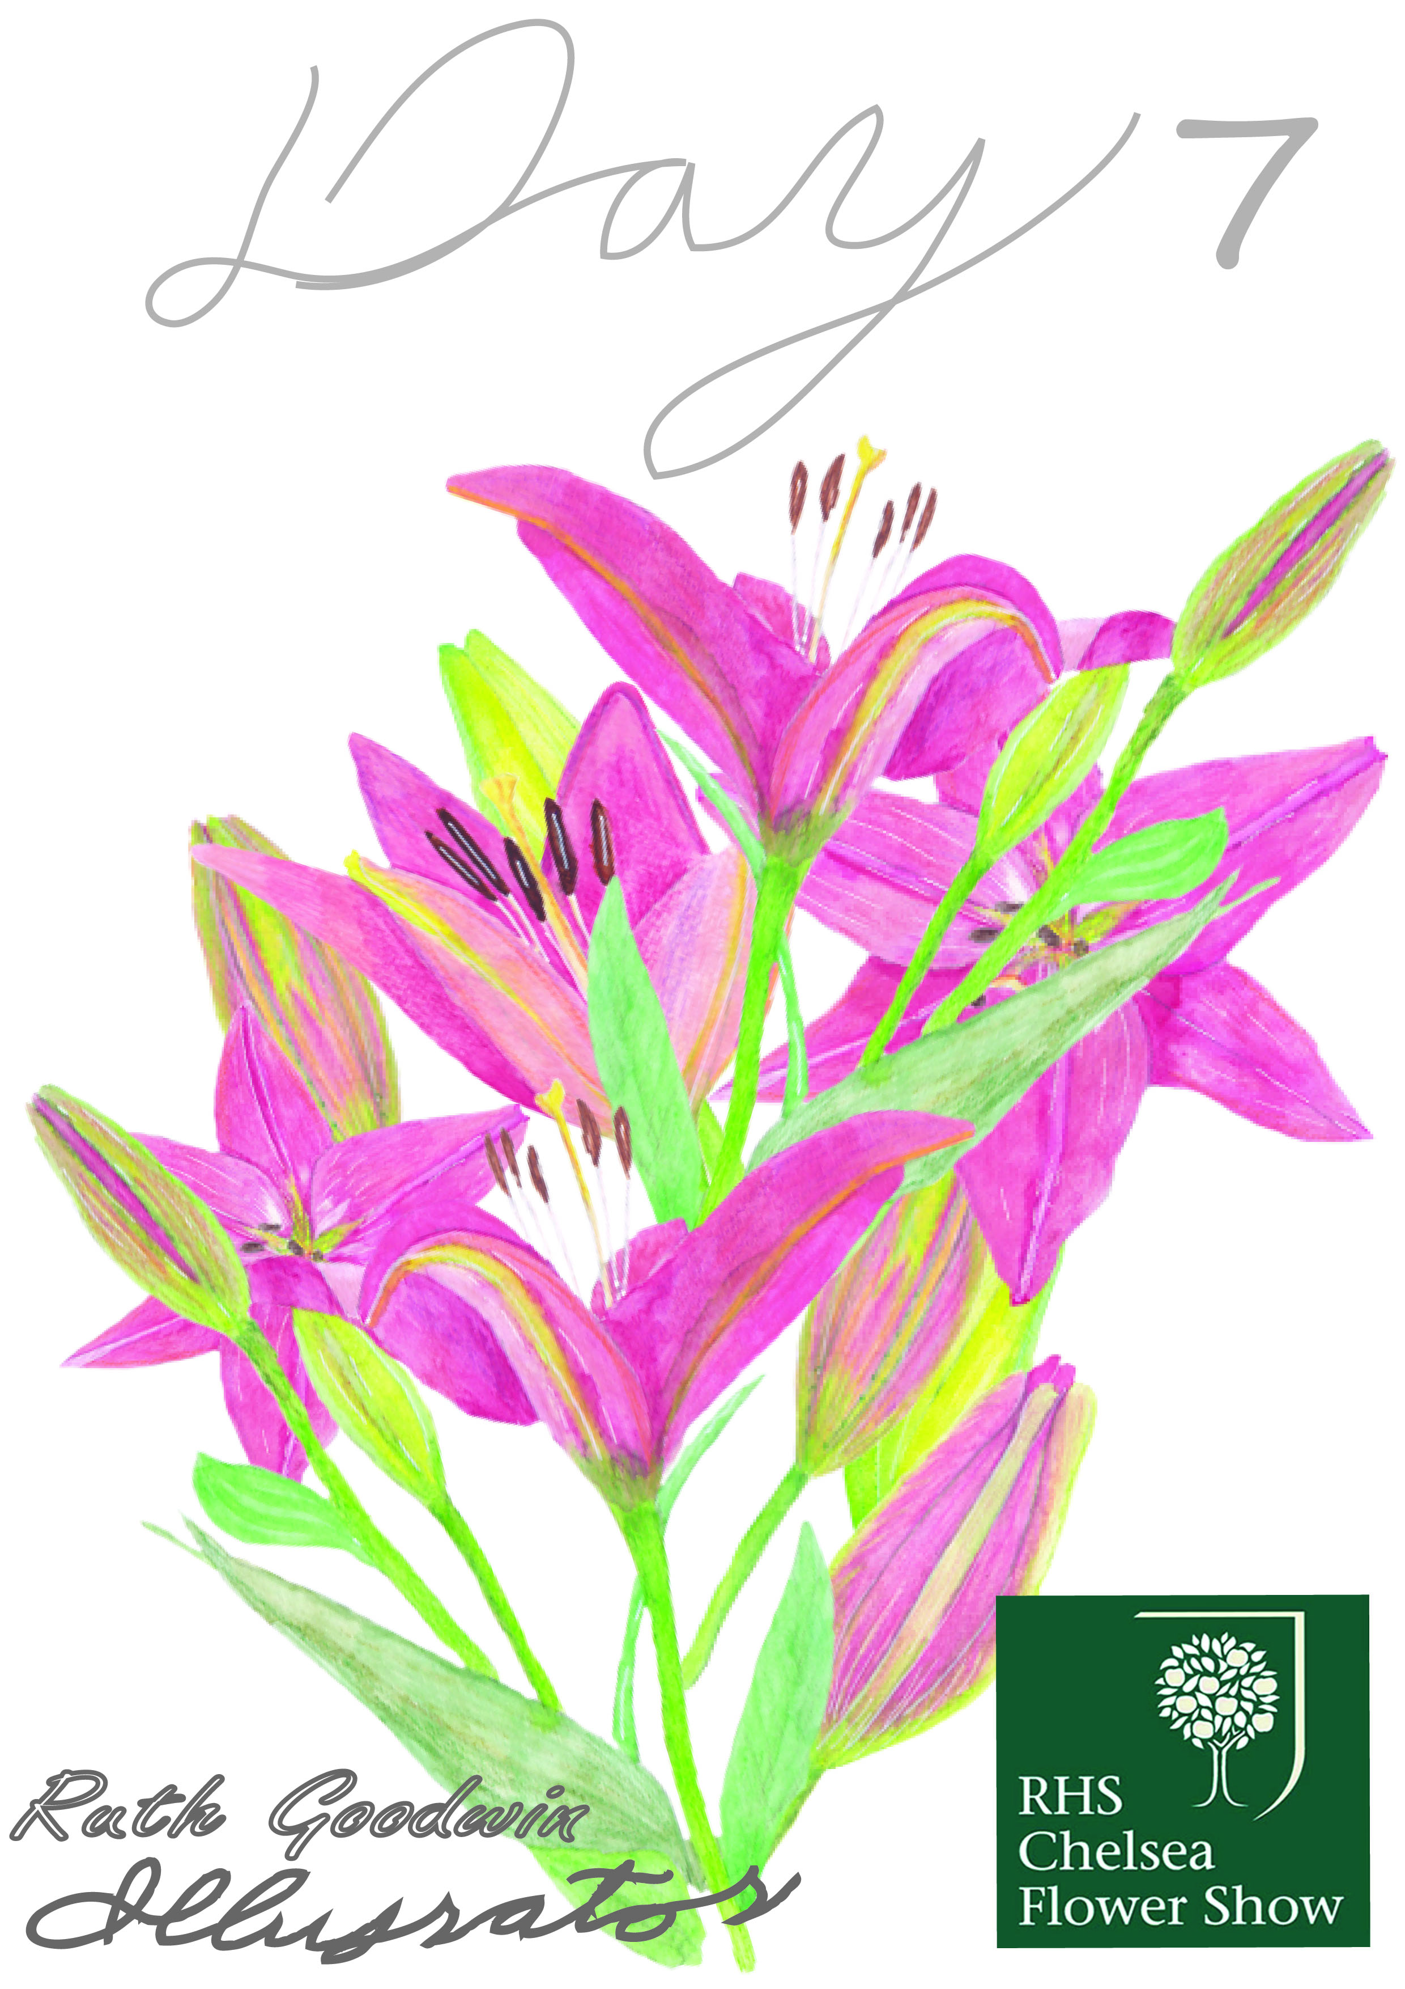
I changed the front cover so the typography was in different areas of the frame, so hopefully your eye moved around the page to read this.
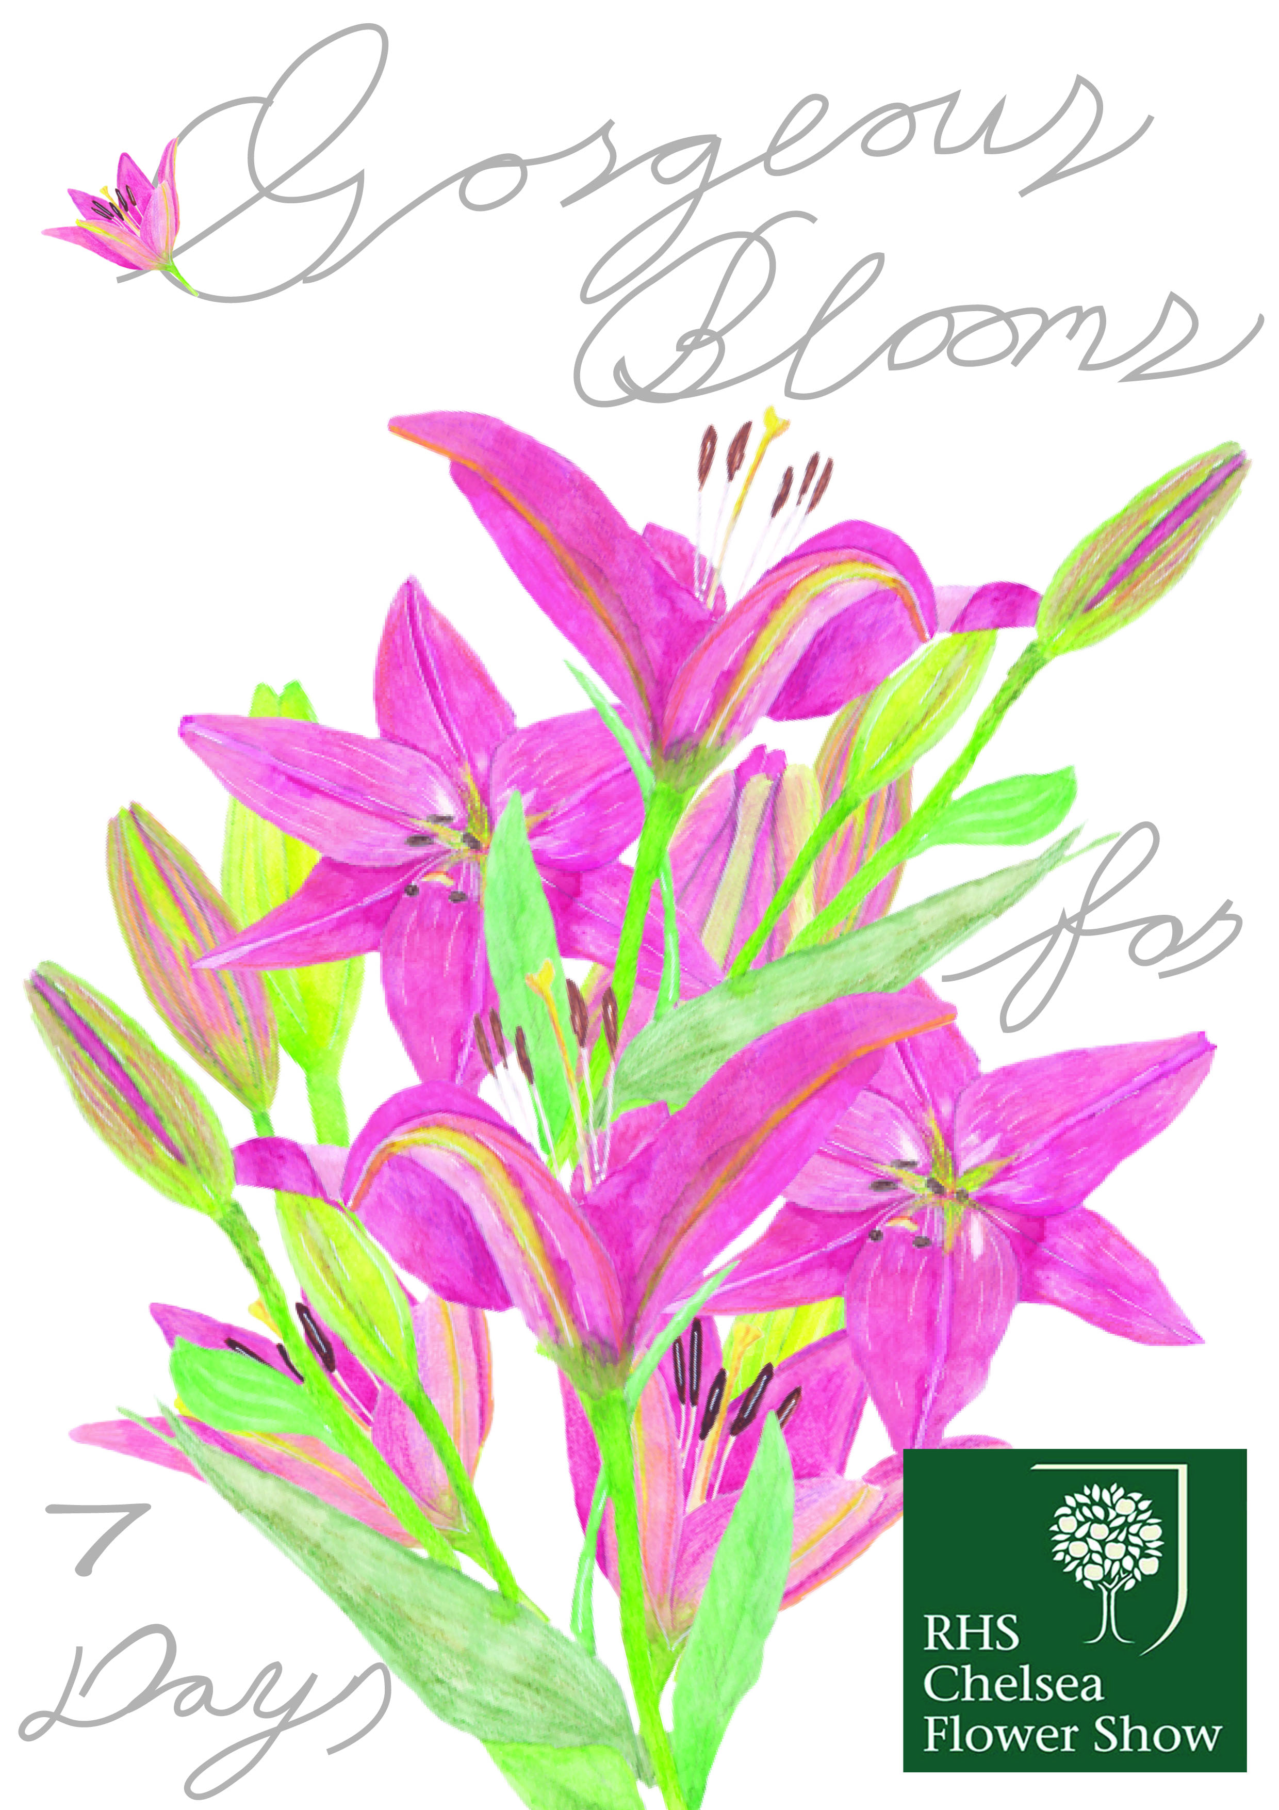
I made the title bigger and the font size, but kept the font style the same throughout. The front cover art work is now a bouquet of all the flowers I illustrated in one bunch.
Hopefully the leaflet still reads the same in that you can see how the lily flower buds and blooms throughout the seven days.
I have made a picture of all the frames together, to shoe the flow of the frames and how the flowers spill over onto the next page.
I found it difficult to make a good mock up as the size of the artwork had to be smaller as the files where really big now, due to all the layers, but I think it shows it ok.
