Assignment 2; Point of sale graphics
I started this assignment first by looking at some point of sale graphics from supermarkets on Pintrest; I collected a few for my mood boards which I knew I would be creating later.
I then started with some ideas of what I might want to create; I did a few sketches and put some ideas down on paper.
I decided to start some spider diagrams for the two subject’s summer and winter. I went for summer foods first. I kept it general in regards to foods, then added in subjects to divide the foods, into Vegetables, fruits and salads.
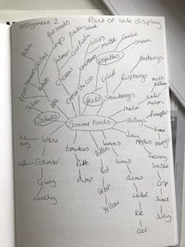
I did the same with the winter subject and divided those into other subjects too.
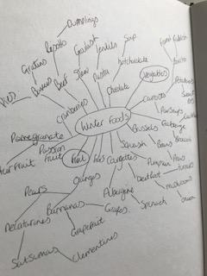
From these two spider diagrams I decided to go with summer fruits and winter vegetables as I thought they would lend themselves better this way.
From these I decided to do two more spider diagrams and create ones for textures and colours.
My summer one had colours and words that described the textures of the fruit: - juicy, sharp, plump, wet etc. I thought this way would give me a sense of feeling of the textures and a way the fruits should look to make them appetising.
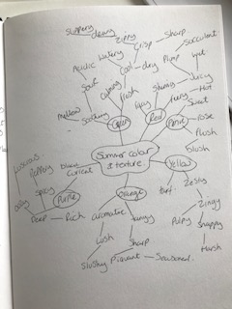

I did the same for the winter vegetables with words like: - sweet, flavoursome, spicy, hot, and deep.
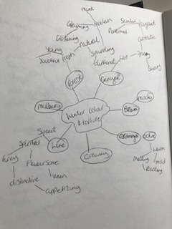

From these spider diagrams I was drawn to strawberries, raspberries and blackberries or blueberries, I thought these could look appetising and fresh the most.
For winter I kept thinking of Pumpkins, I felt it should be something that you could show other things too like autumn leaves and nature. I felt ginger and orange colours make you feel warm and cosy.

I then started my mood boards; I did one each for summer and winter and added in graphics from supermarkets, some typography ideas and packaging ideas too.
This is my summer one based on the summer fruits. I really liked some of the typography ideas on here and it has given me some thoughts and ideas for those later on. I think using the right medium will be crucial in pulling off the look of these summer fruits as the blackberries and blueberries could look off or mouldy if you don’t get the colour right.
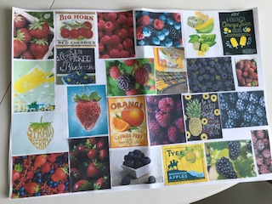

The winter one felt very warm, cosy, snugly and bright which can cheer you up in the winter.
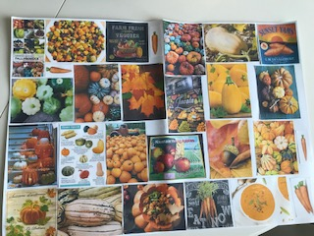
Using the spicy colours, having pumpkins, squashes and gourds, with some autumn leaves and nature items will create that lovely feeling and atmosphere. Ingredients that will give you a warm hearty handmade meal feeling.
To follow on from this I started to look at an illustrator who does graphics, packaging and food illustrations. I found Steinar Lund from a Google search and was surprised how perfect his style would be for this assignment.
Based in Eastleigh in the south of England Lund has a colourful, postmodern style which is bold with colour, his graphics are so life like that are good enough to eat. Lund specialises in cakes, pies, ice cream and fruit.
His influences are Salvador Dali, 1970’s album covers and artists like Roger Dean and the photorealism movement. Lund has a BA in interior design and photographs form the basis of most of his illustrations/graphics. Lund brings many photos together in Photoshop, then edits and enhances the pictures to achieve the life like edible graphics.
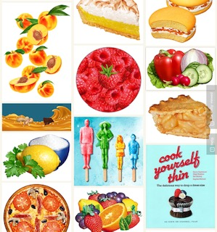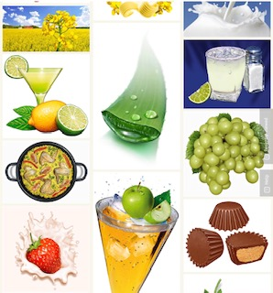
The way the graphics look after Lund has put them through Photoshop is amazing, the fruit and vegetables look shinny, plump, succulent, zesty, zingy and just so edible. I will take a few of his ideas and try to add them into my finished illustrations.

I decided to do a little market research for this assignment and went off to the supermarket, to the fruit and veg area. I noticed that there was not much POS in this area, just prices below the shelves. I thought to myself ‘what makes me buy fruit or vegetables’? I think the main answer for me is the look of the items, weather it looks healthy, juicy, cool, warm, comforting, organic, fresh. That is the main reason I would buy something from these aisles, I don’t think it would be because of a graphic!
I asked a bunch of my friends ‘what type of graphic would make you buy something from the fruit or veg aisles’?
Some of them 4/10 responded ‘a special offer’
5/10 responded ‘menu ideas’
1/10 responded ‘if it’s on my list’
With this information I had a think of how I could come up with a POS that gave you a recipe idea and a special offer (like a promotion) maybe for one week, while the item is new to the season.
This all has to look up-market and ediable.

I started with some simple sketches in my sketch book of the fruits Strawberries, Raspberries and Blackberries. I then tried some test colours with my watercolour paints to see if I could mix the right colours to use.

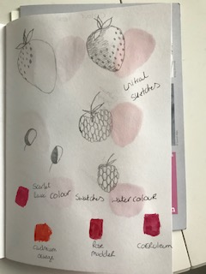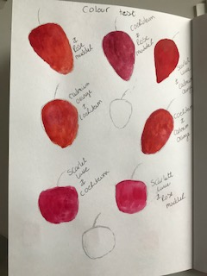
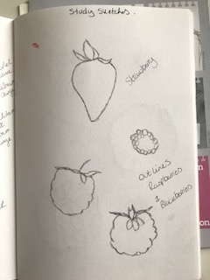
I then started on some more defined sketches especially of the raspberries as I couldn’t seem to get the shape right first of all.
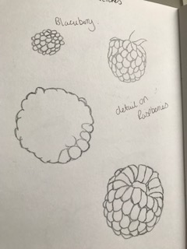
I looked at the detail of the raspberries and found they were made up of little plump segments; I did a small study of this.
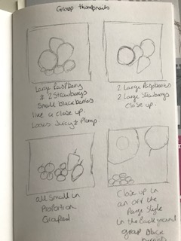
I started some composition thumbnails of how I could work out how the group of fruits should be, The first one I thought just the group in the centre of the graphic, the second one I had 2 large raspberries and strawberries in a close up. The third composition was all the fruits in a large group. The fourth was a close up of the raspberry and strawberry with some blackberries in the background.
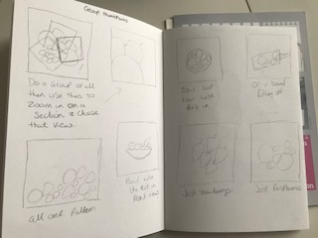
The fifth I thought maybe a group of the fruits but then after pick one particular section of that group to do a close up of it. The sixth was an all over pattern of the fruits. The seventh was a bowl with the fruits in looking from the side; the eight views were of the bowl looking from above. The ninth was the idea of the fruits on a wooden board with a few rolling off. The tenth was a group of just strawberries and the eleventh was just a group of raspberries.
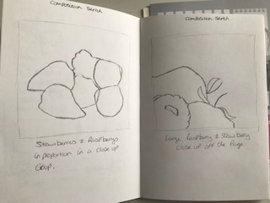
After doing those thumb nails I looked back through them and picked my two favourites, which I then did a better sketch off, the two were a close up group of the fruits centred, and the other was a large close up of one section of that group, from the right hand side.
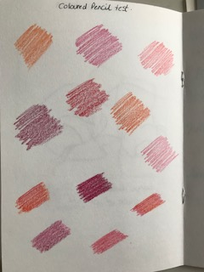
To get the life like quality of the fruits using watercolour paint, I was not sure if I would achieve this, so I did a test of coloured pencils too, I may use these instead or as well as, I think maybe the two combined would be better and achieve more of that look hopefully.
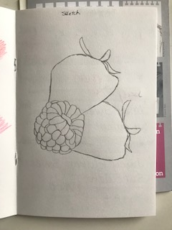
This is a better sketch of part of the group, I’m working on building the sketch up bit by bit, I like the raspberry but feel the strawberries need work.
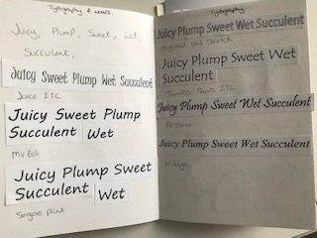
Looking back at my spider diagrams, I picked out some words which I felt represented the fruit I had chosen; they describe the texture or feeling of the fruits. The words I chose were: - Juicy, Plump, Sweet, Wet and succulent.
With these words I started to look into some typography fonts, I wanted the fonts to work with these words and make you feel them. I came up with 7 that I liked; my favourite two were the second one ‘MV Boli’ and the second from last ‘Prisina’.
After looking at typography I wanted to do some compositions of where the typography might go on the graphic in relation to the pictures of the fruit.
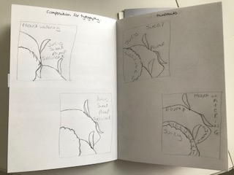
I tried to come up with some creative ways to show the words rather than just the standard styles. The third and fourth views were the most creative, the third I used the words around the fruit, the fourth I used the curves of the fruit to show the words.
At this point I started on the basics for the winter graphic and left the summer one for me to think about it so far.
So from the spider diagrams from the winter foods one, I liked the idea of pumpkins, I thought they captured that time of year really well of when we go from autumn into winter, you can add lots of nature images to the graphic to create a feeling of the season. I was thinking autumn leaves, chestnuts, acorns, then I was running with the pumpkin ideas and looking at Gourds and squashes too, like from my mood boards.
I did some quick sketches of these items in my sketch book to get a feeling of this.

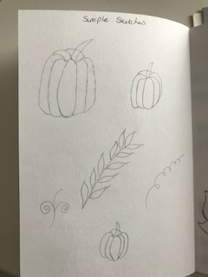
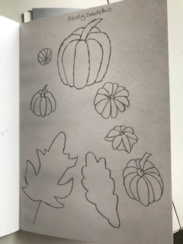
I then did some better sketches of these and some others to really get the autumn/ winter theme.
I did a few colour tests with watercolour paints for the pumpkins and squashes, and leaves etc.
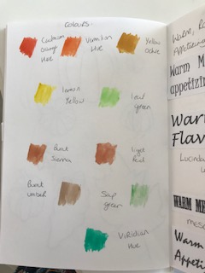
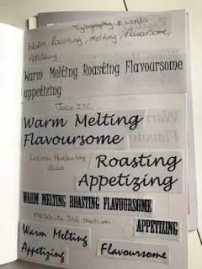
Again I looked at words which summed up the vegetables I decided to choose, my words were: - Warm, Roasting, Melting, and Flavoursome and appetizing.
I felt these words summed up the vegetables and how you feel in the winter, you want comforting warm food.
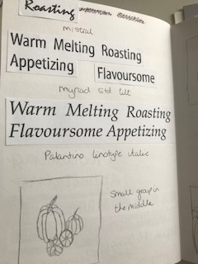
I chose 6 different fonts for this graphic, my favourite two at this point are the first one ‘Juice ITC’ and the third one ‘Mistral’.
I then went onto create some thumbnails as I did with summer, to get some composition ideas.
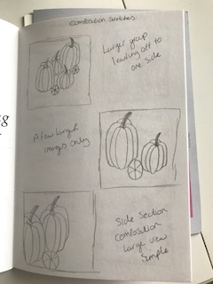
After looking and drawing different ideas, I then went onto look at the typography composition too.
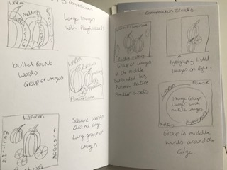
I am drawn to the last composition, with the group of vegetables in the middle with the typography written on curves around the images. I will draw this better and see how it looks from there before I decide.
I decided to draw the pumpkins and some nature elements and paint them in watercolour to do a test for the colours and to see how this would look with better drawings, than what I did with the summer one.
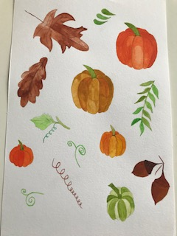
This has given me a really good idea of how the graphic and colours will look, this is just looking at the motifs really, this is not in any way the composition. I like the feeling this is creating, the colours feel like autumn and the colours feel rich and warm too.
I then created two composition sketches with better drawings to really get the idea of the top two.
This was the one with the autumn elements around the edge:-
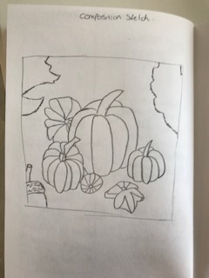
After doing this, I feel I should have left more room around the edge to fit the drawings in better, this will also be difficult to bring typography in too, as there will be no room.
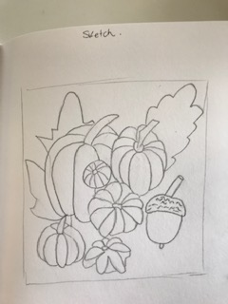
This one is all the elements together in the middle, which I like! I’m not sure how this will look once painted; it may look as though the pumpkins are on the ground and a bit muddy and dirty?!
I started with my sketch on watercolour paper for the summer berries, I decided to go with a composition of them all in the centre and then I could re-arrange these in Illustrator or Photoshop later if I needed to.
I decided to go for the mixed paint of Scarlet Lake and Cadmium orange for the strawberries as I felt this gave the best tone with and orangey red.

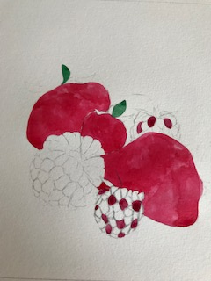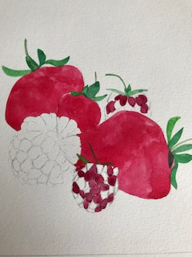
I used Scarlet Lake and Coeruleum for the raspberries as this gave a slightly pinker tinge to the colour.
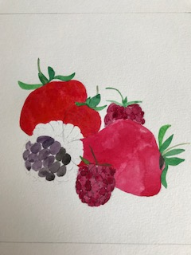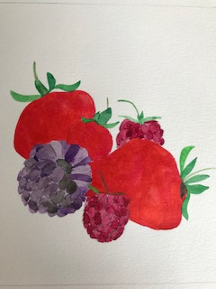
I used black and purple paint for the blackberry; I had trouble getting this balance right between the two as too much purple made it look a bit bruised, too much black didn’t make it look edible.
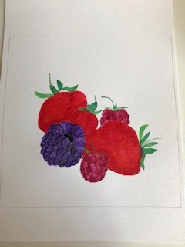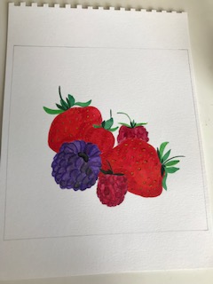
I think the picture works at this stage, I think the berries look fairly realistic, the shading and highlights could be better, but I don’t want to over work it and then it goes wrong.

I begin to start on the winter vegetables now, with a sketch to begin with. I chose to make the group of vegetables smaller in the middle to get the elements of autumn/ winter around the edge and have enough room for the typography too.
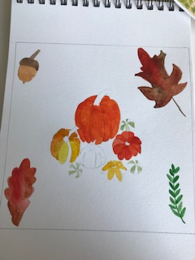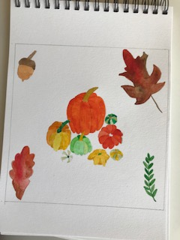
At this stage I was not sure at all about the composition but decided to stick with it and see how it turned out, I could always change it after. The main thing I was unsure of was the size of the pumpkins; I think maybe they should be larger.
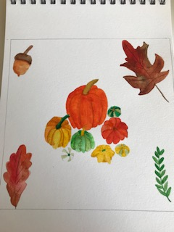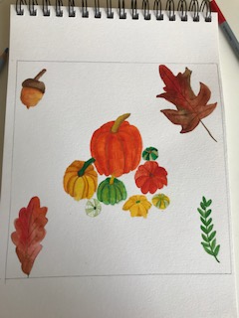
This is the finished illustration; I added some washes of the top of the pumpkins and added some watercolour pencil to add some shading to the curves of the pumpkins and squashes.

I used my finished illustration and scanned into my computer and then in to Illustrator, I used Illustrator to add in the Typography, I decided to go with ‘Juice ITC’ font, because it had a slightly Halloween feel to it. I created a little thumbnail sketch to decide how to create the wording for the POS.
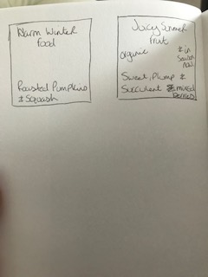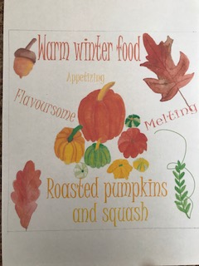

I used different tones for the typography to make them different colours, I think they complement the tones in the vegetables and give the feeling of warmth and autumn to the picture.
At this point I decided to step back and leave this for a while, I pinned a copy to my wall to see if looking at it differently I could decide if I wanted to change anything.

I went back to the summer POS and put this through my scanner and into Illustrator and Photoshop. I decided upon the ‘Pristina’ font for the typography, again I did a small thumbnail for the wording to see how I wanted this laid out and how the words would work.
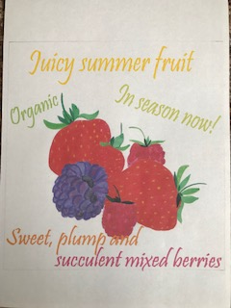
Again at this point I printed this out and put this up on my wall so I could stand back and see it in a different way.

After going back to the two POS graphics I made some notes on them of what I wanted to change.
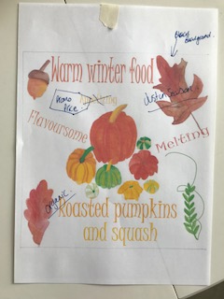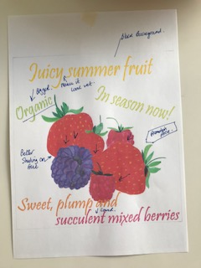
So on the winter one I wanted to change the background colour to black as I think this will make it look ore up-market and expensive looking. I wanted to add ‘Just in season’ as some typography, add ‘organic’ above the ‘roasted pumpkins’ words, and add a price label, like a promotion stamp.
I then went back onto Photoshop and changed these bits.
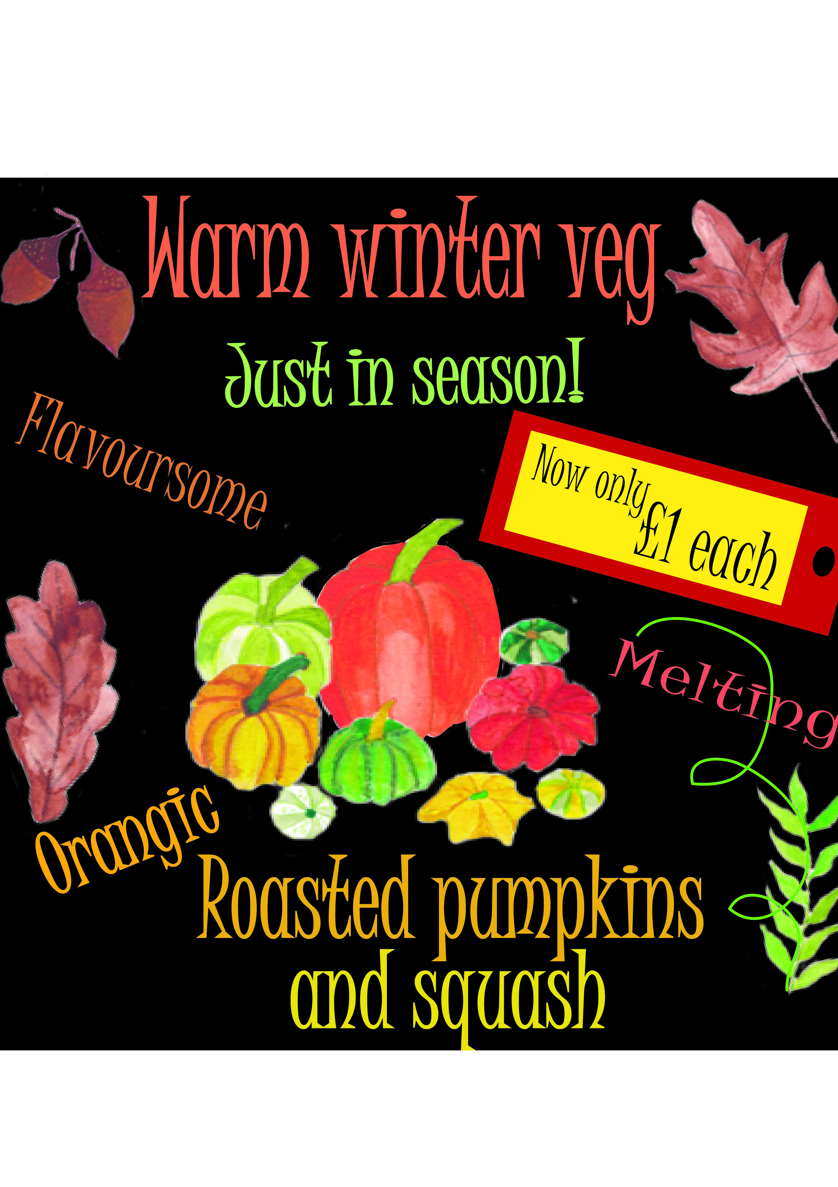

With the Summer POS graphic I again changed the background to black to match the winter one. I added a price label, promotion stamp, and again kept it within the same style and colours of the winter one. I made ‘Organic’ bigger, put some juice motifs below the word to make it feel more succulent. I added more shading behind the separate fruits to make them look more real and moved the words at the bottom down slightly to let them breathe better.
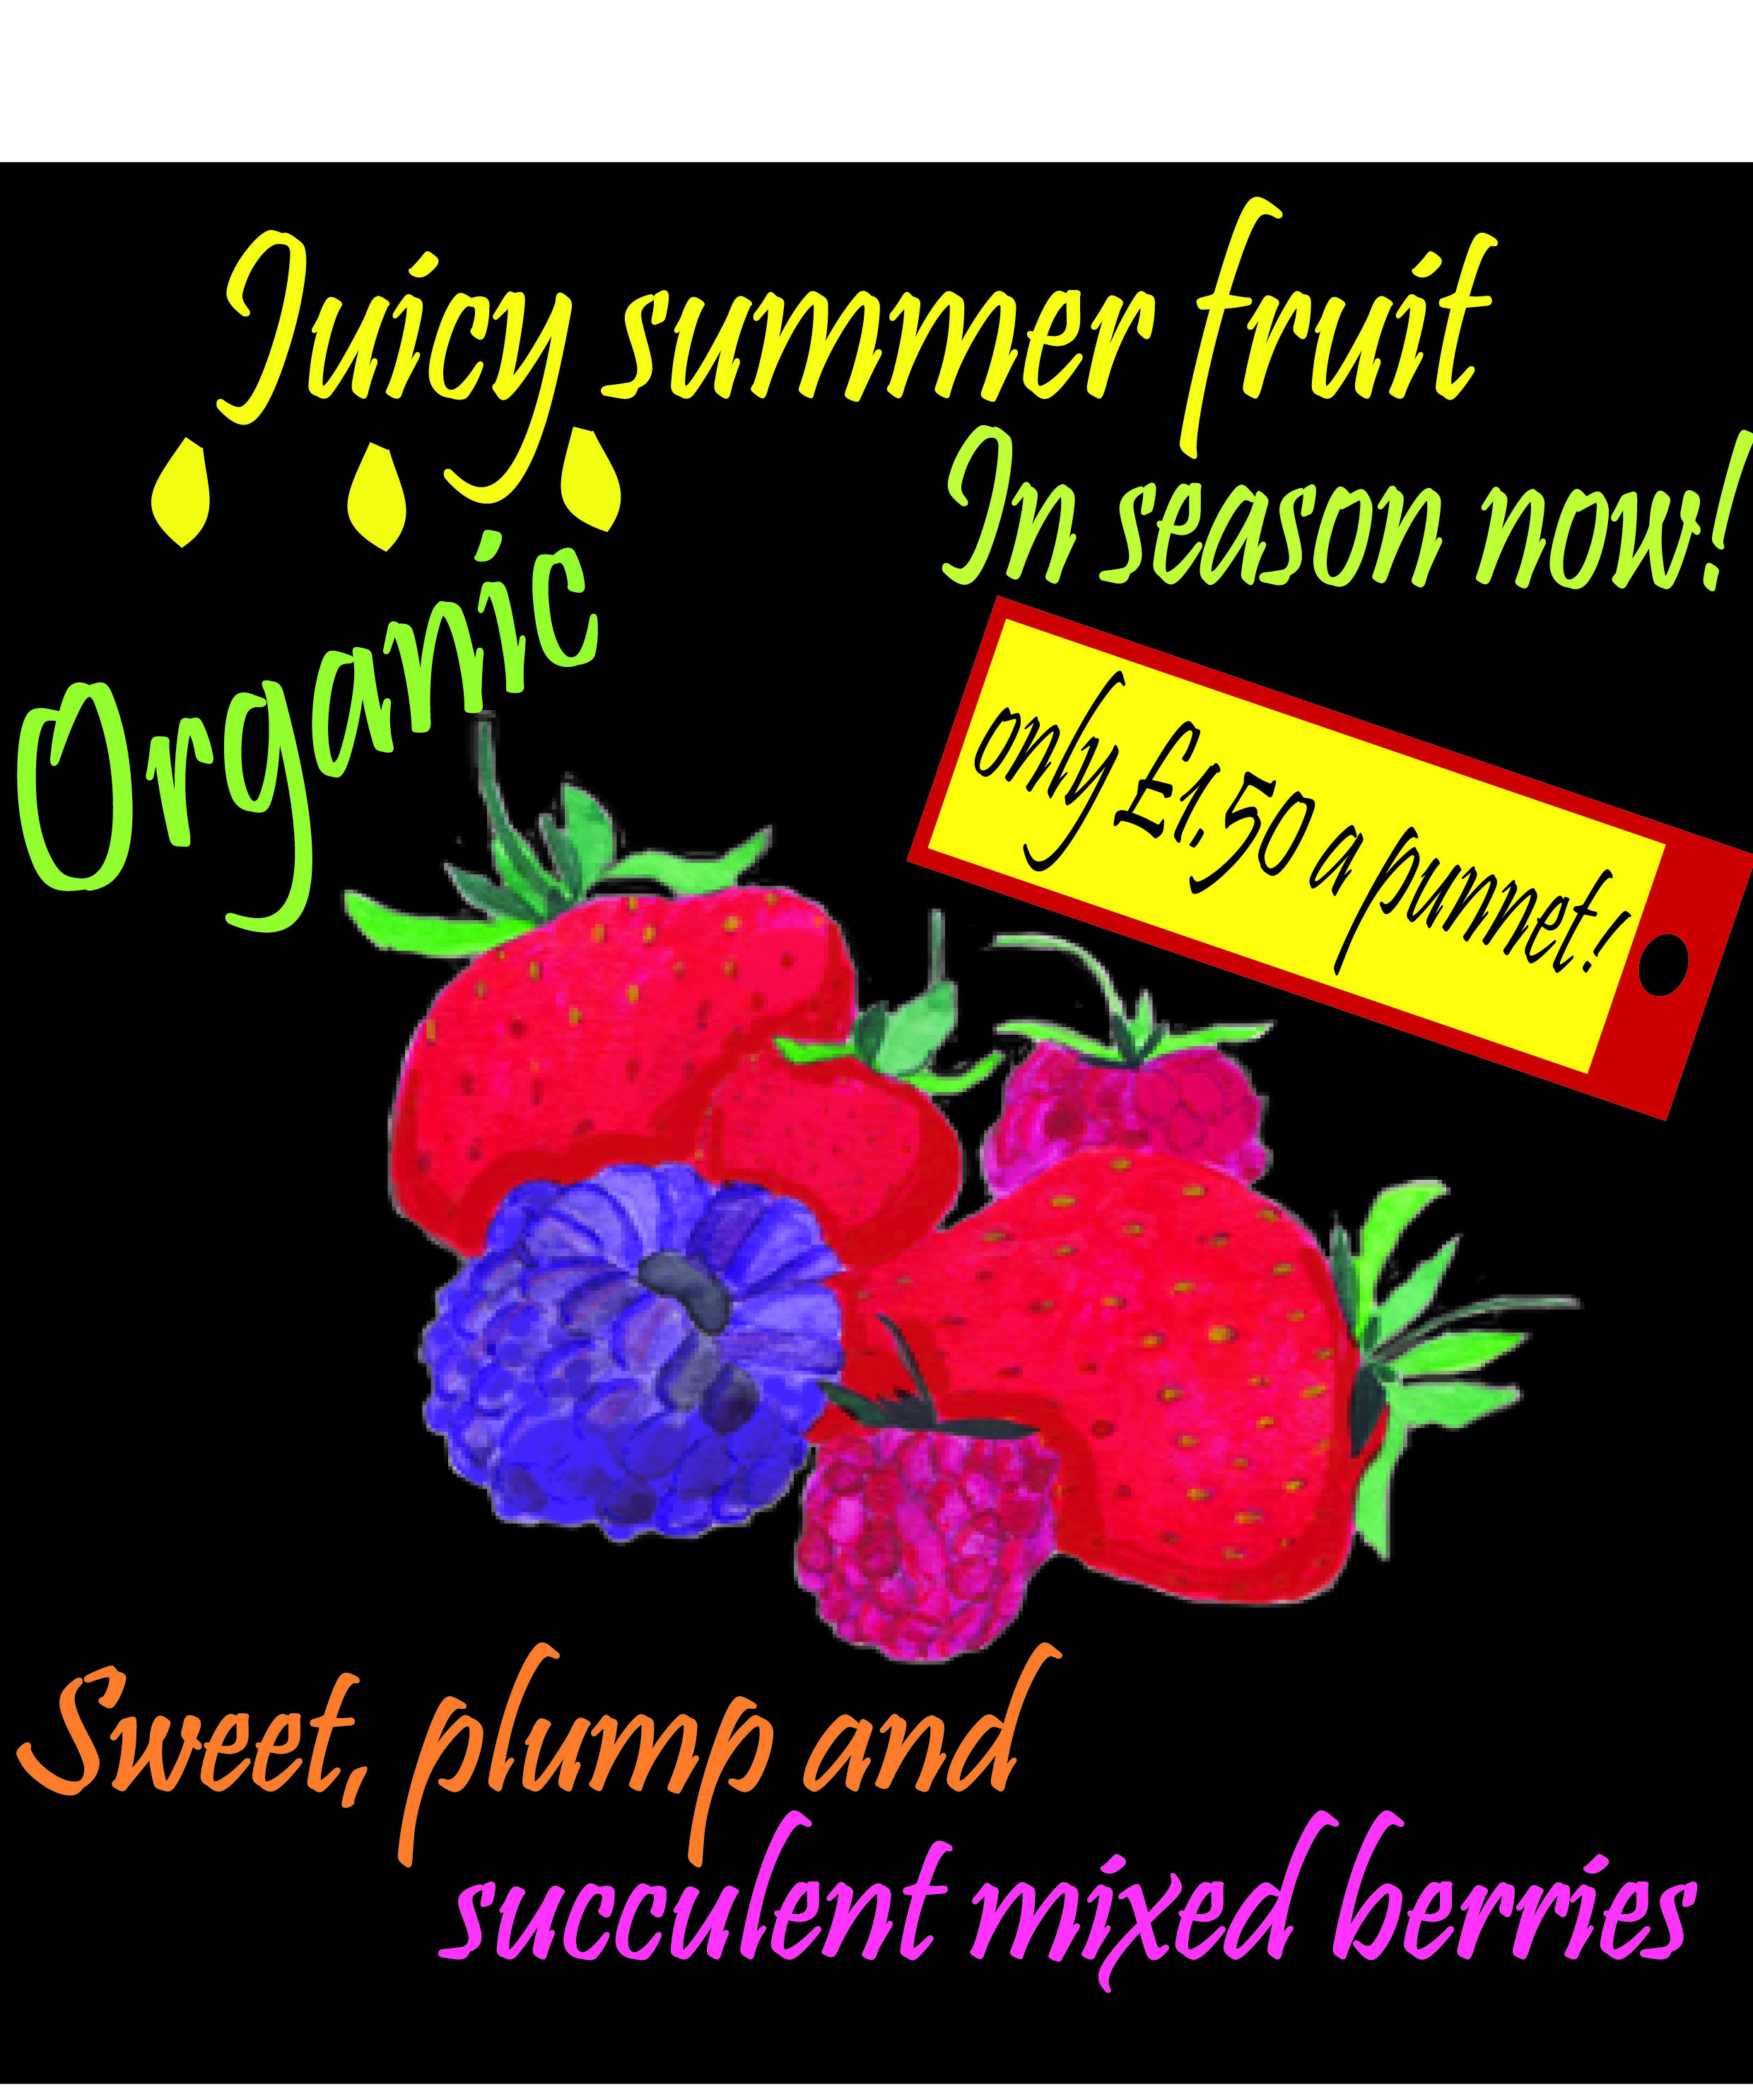

1.What have I enjoyed and why? How might I expand my knowledge in this area?

I have enjoyed the whole step by step process of using the elements learnt in this section, spider diagrams, mood boards, choosing words, finding textures, picking up on feelings, objective drawings and atmospheres and using them all to culminate in this assignment.
I have learnt in this assignment alone, about market research can be a good element too, and asking people for their opinions and to get feedback that way.
2. What are the strengths and weaknesses of this image? How might I tackle any weaknesses?

I enjoyed using Photoshop and Illustrator for these graphics, but I struggled to get the realism of the fruit and vegetables within my paintings and I think it also got lost more through using the computer, as my paintings looking stronger in person. I think the strengths are the graphic side of the POS, the typography is strong and the way it is set out is good, it’s clear, concise and easily readable. It’s a shame the painting looks weak, I think maybe if I decided to do this assignment again I would choose photographing the fruit and using those through Photoshop to create the summer POS at least. I feel the winter graphic is stronger.
3. It can be useful to return to your brief, check you are meeting the criteria (are the colours/ character/ feel of the image communicating the right idea?
I returned back to the brief before I started the second style on the computer, I checked I had read the brief correctly and met all the criteria.
4. What have I learnt in this exercise and how might I use it on future projects?
I have learnt the steps as previously said, and I would use these going forward with this degree and any freelance work I have coming up too. I have learnt to try different pictures first and use thumbnails to help get to a stage that I know I want to progress from. I have learnt also that sometimes your initial ideas you don’t feel are working but when you try something else, you realise that your first idea was the best, but it’s good to try something else because then you are sure on your final decision.
5. Has this inspired me to go on and delve into any new research?
I like the idea of using photographs in some designs or illustrations, I have used photos in my surface pattern designs before, but I was not sure if this was ok for this degree? I have taken lots of my own photos and have an archive of inspiration. So I think I’ll continue with that and start taking some pictures of food too, this might help in the future and if I get a chance ill re-do these POS designs with some of my own photos of fruit, (ill have to wait until autumn to do the pumpkins).
Up-dated 21/08/2019
After receiving feedback from my tutor, I re-looked at certain areas of the compositions for this assignment. I did feel myself that it did go slightly wrong at the end, as I felt as though I was rushing it to get it in for the deadline. So now I have had some more time to sort out the finial composition and some guidance from my tutor, I feel it works much better.
I started by working back from the paintings I created first and worked on composition, I cropped 6 designs to see how these worked and were they better?
Number 1
I cropped it from the top and bottom to try to focus more on the black berry and raspberries. I not sure if this works or not, so I carry on.
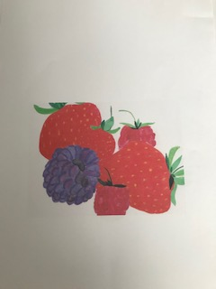
Number 2
I cropped it again further from the top to focus on the blackberry; this does not work at all!
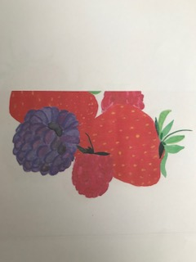
Number 3
I just enlarged the image to focus more as a whole; I think this looks much better although I feel it loses the detail again by doing this.
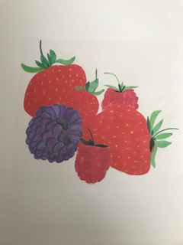
Number 4
I crop this from the side to now try if I focus on the raspberries, would this make it look any better?
This is a little better, but I’m not sure if it looks odd now?!
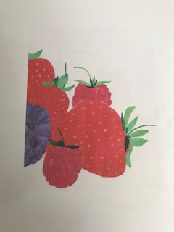

Number 5
I print out the enlarged copy I did earlier, then I used my cardboard set squares to try and gauge a better composition.
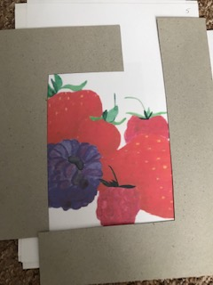
I feel this looks good, so I set this up as a mock up to see if this works. I decided to use just my own neat hand writing for the typography, my tutor suggested this would look more natural and would blend better with the paintings as it would have more natural flow. I used smaller sized words, and cut down on the amount of words I used.
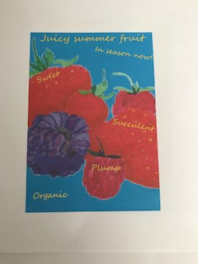
I decided to change the background colour too, from black to a bright sunny sky blue, and the typography I kept all in one colour a lovely happy yellow.
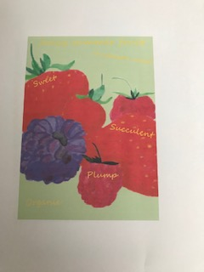
I wasn’t sure if the blue was too bright, so I tried it in a spring green instead. I felt this was nice, but not summer.
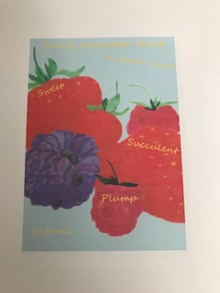
I tried it in a very pale blue, which looked nice, but didn’t have the impact I was wanting.
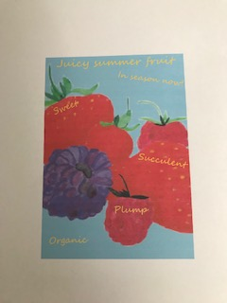
I gradually increased the tone of the blue background, but I feel this is neither bright or pale!
I decided the original blue had the effect I was after; it’s a very sunny blue.
I’m so glad I re-worked this point of sale mock up, the outcome is so much stronger I feel, the focus is now on the fruit not the words, the colours I have used for the background and typography are so much more sunny and bright. I still feel they look high end and more appealing and striking and eye catching for the customer.
I feel that going back to this after I have continued with project 3 has really helped me achieve what I needed to with this assignment. Working on composition more in project 3 has given me a better understanding of what assignment 2 wanted from me.
I continued with the winter illustration too, and started back with the initial illustration painting of the pumpkins. I chose to use a similar composition for these as with the summer one, as I felt this is what bonds the two points of sale graphics.
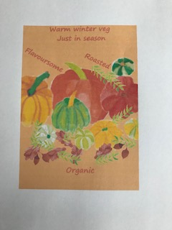
I enlarged the composition again, so it just comes off the page on the left and right sides, I used my hand writing for the typography but used a bolder font this time. I again took out some words and kept it simple, and I chose a warm background colour, which reflects the season better than the original black.
After printing this off, I still made a few changes, I made the background colour lighter still, as I felt this brought out the colours of the vegetables better, I also took out a few leaves that were unnecessary.
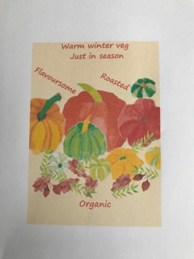
Again this feels much stronger than the original, and adding the leaves to the bottom of the pumpkins makes the image look more natural and organic. I feel the lighter background actually makes the image more sophisticated, and both point of sale graphics work well as a team, as they both represent fully the seasons.
I am very happy I re-worked these.

