Assignment 1: Recording and sharing your work.

I started to look at this assignment the first day I started Illustration sketchbooks, I knew it was based on the everyday and on a sketchbook, so I looked at the requirements for the assignment and worked backwards from that. Therefore I started my sketchbook on the 2nd Dec; I knew a lot of the work that was to be included was based on the exercise’s that we were going to explore, so I wanted this sketchbook to run alongside them, so I could capture all the elements required.
I asked myself a few questions to come up with an idea:-
I thought to myself what was an everyday sketchbook?
What would it involve?
Sketching something every day
What parts of the everyday would I capture?
Out and about, at home, people, objects, animals, nature, marks, colours, thoughts, ideas
Would it be things I see every day?
Yes
Things I do every day?
Yes
Things I’m working on?
Yes
Would it be more abstract?
Some would be mark making, colours, feelings.
Would it be a diary, or maybe a journal?
No, But it could be done like a calendar?
How could I achieve something every day?
Quick sketches, write down ideas, or more involved pictures if I have time.
Would my sketch book be physical or digital?
My sketchbook would be physical.
I then answered these questions (in Blue)
So from this I decided to do a month’s sketchbook to coincide with the unit work and to be able to sketch every day.

I had a look at Candy Jernigan’s work from Emma’s Pinterest board and Candy’s own work.
I liked the idea that Jernigan had of picking up things on her journeys and bringing them home to paint them. I liked that she painted them in categories, like tins or leaves, stones, books, but also named them after her travels ‘to and from’.
This does give another angle on ‘everyday’ and makes you think outside the box. I enjoyed her paintings and the way she created colours and her style with her painting techniques.
I don’t think it would be something I would choose to do, but I like the idea of collecting items on maybe holidays and days out which you could add to your sketchbook. I would prefer to draw or paint the things you see on these journeys, travels or days out.
My sketchbook:
So I started with the idea of making my own sketchbook, I had never done this before apart from the little ones within this unit. I wanted to include different papers as sometimes I draw and sometimes I paint, so I need paper which would work for these. I decided to work on an A5 size, which meant I used A4 paper then folded them in half. I originally wanted to bind my sketchbook with cotton and sew up the middle, but because of the thick paper this was too hard to do, so I came up with a piece of string in the middle that I tied on tight, to hold the pages in. This also was good as I could easily take out pages to work on them better or let them dry.
I used a piece of coloured card to wrap around the outside for the cover, I used white copier paper, watercolour paper, pastel paper, white card and yellow paper inside the booklet.
I started my sketchbook on the 2nd of Dec and decided to just draw or paint or write anything each day that I was doing, seeing and feeling, this could be anything I just decided to go with the flow and see what happened.
This is my sketchbook from the front:
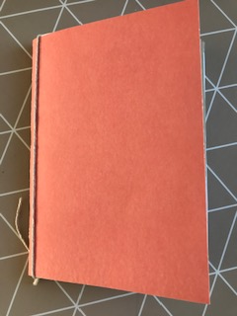
My first page was a quick pencil sketch of a koi fish, I had gone to a friend’s house and they have a huge pond of Koi fish, so I took a little time and drew a little study of one of the fish.
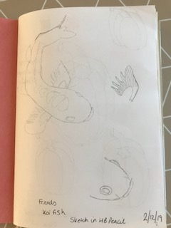
On the 3rd of Dec I was at home and did a quick drawing of some peppers I had in the fridge, I used a black fine liner for this, then used some coloured pencils for the colour tests.
On the 4th Dec I carried on the koi theme and did some watercolour tests of the colours I would need to do a quick painting. I had to stick in some watercolour paper as the copier paper was too thin.
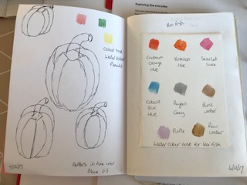
On the 5th Dec I went out for a walk, we have a lot of fields and farm land around, I saw this little fence and style, so I did a quick sketch with the grasses.
On the 6th I was looking through some gardening books and I’ve always loved the shapes of the Echinacea flowers, so I did a quick study of this, in pencil.
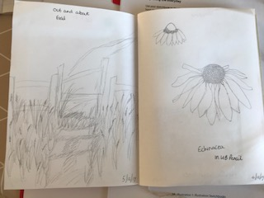
The 7th Dec, I had been to the shops and got the food for the week, so before I packed it all away I did a quick sketch in pencil of some of the products. I added a small envelope to this page. I liked the idea of hiding some little tests I did of the apples, as this was something I wanted to work on later, so I thought I would hide them in here.
On the 8th Dec we went to a spa which had woodland and park space around it, so I took my sketchbook here and did some coloured pencil sketches of some people, a lady sitting on a log taking a picture with her camera, her dog was running around too. Plus another lady from behind, I’m not very good at drawing people, so I’m still trying out different styles and how to capture people’s movements and body parts. The man was doing yoga in the spa, so a quick sketch of him too.
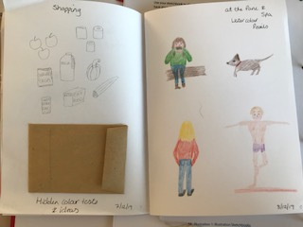
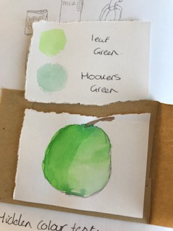
9th Dec I was at home, so I did a quick sketch of my poufee, with all my stuff on it, in pencil it wasn’t very good, but I kept it in.
On the 10th I wanted to look at colours for my Echinacea sketches, so I did some colour tests using watercolours.
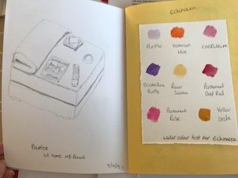
11th & 12th Dec was a small study of some dried poppy seed heads I had, I want to create some artwork with these, so thought I’d start with simple sketches in black fine liner and then pencils, I did a colour test in watercolours too, to see what tones I wanted.
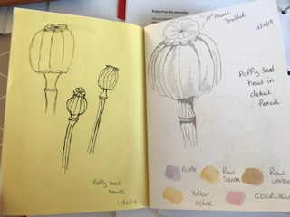
The 13th Dec was our work Christmas meal, I took my sketchbook along with me, but didn’t have much time to do a quick sketch, the composition is all over the place and some of my friends look scary in this, but at least I’m practising my people.
14th Dec I had a bit more time and did my watercolour picture of my koi fish I sketched first in my sketchbook, it isn’t the best but these could lead on to a finer watercolour at a later date, at least I’ve got the colours right.
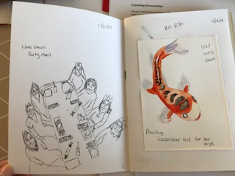
15th Dec was when I put my Christmas tree up at home, I like natural things so before I put some of the ornaments on the tree, I sketched it pencil. I have new brush pens, so I did a quick colour test down the side too.
16th Dec was when I visited my cousins; they have a new dog called Pippa who is a Cockapoo. I managed to do a sketch of her whilst she was sitting in front of me, I tried to focus on the way her hair was curled and waved on her face.
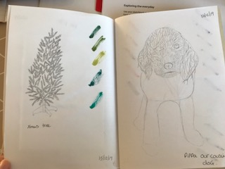
17th Dec was when I had finished the tree; I love the shape of baubles, so I did a sketch and colour test of these two which are my favourite ones.
18th Dec we went over the park again and visited the lake where the swans swim. I took my sketchbook and did a small study of one of them, it wasn’t very nice weather so we weren’t their long, but at least I managed something.
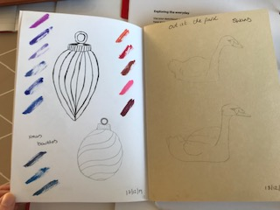
Hopefully you might be able to see it better in this photo:
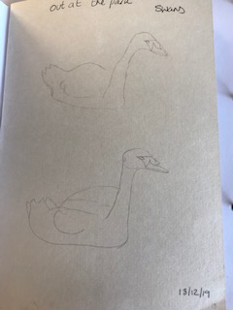
19th Dec we were up London visiting a lovely little tea and cake shop, luckily I took my sketch book and managed to capture some of the lovely interior and displays, again not great sketches but they were quick.
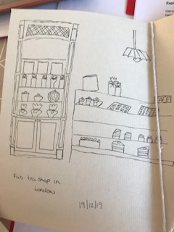
20th Dec we visited the Christmas markets on the south bank in London, a quick sketch of the little stalls that were there whilst we were having a hot cup of coffee.
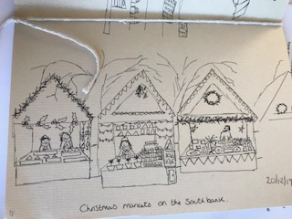
21st Dec I did a small watercolour of a penguin, I had more time to do this one and think it looks really good. I have also hidden an envelope under this picture, so it creates a flap over the top. The envelope contains a sneak peek at something I want to work on soon!
22nd Dec was when I drew the angel on the top of my tree, I really thought this sketch would turn out better, but I’m still learning how to draw people, so I’ll give it more time and practise.
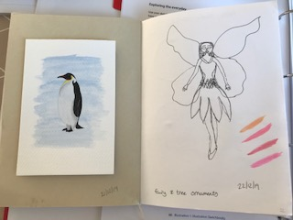

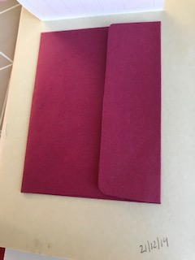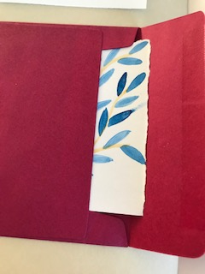

23rd Dec was some more studies of the apples I had bought; I did a pencil sketch of some still life’s I set up with them.
24th Dec (Christmas Eve) was when I was wrapping up presents and tying bows for the gifts, quick sketches in between wrapping.
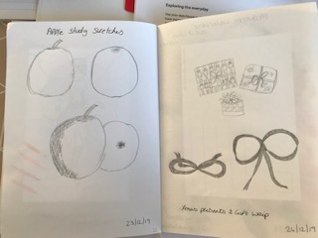
25th Dec was a nice watercolour of some mushrooms; I received a lovely set of new paints and a botanical book, so I started this little study.
26th Dec was also testing out my new paints and the subject today was some lovely lilies my friend had bought me, this was more of a loose rough watercolour and the paper crinkled somewhat but I like the feel of it.
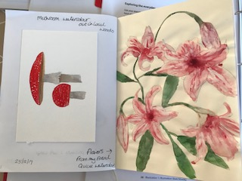
27th Dec I did a black fine liner doodle drawing of this leaf/ feather I’m not sure really what it is but I liked it. I decided to see how it would look in a surface pattern design, so I created a design and called it ‘winter fronds’.
28th Dec was doodling again with my black pen, this time a botanical flower, with bits!
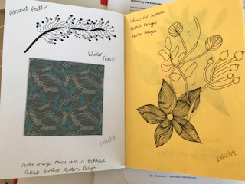
Continuing that theme on the 29th Dec I drew some line work flowers but this time I used coloured fine liners to see how these would look.
30th Dec was a day of cooking and I was drying some fruit to have as decorations, lemons, limes and oranges. Again a quick colour test with my brush pens.
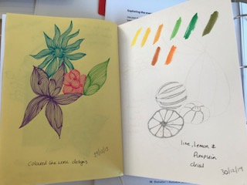
31st Dec I was working on a new pattern design, I had already created some watercolours of orchids, so I wanted some other motifs and sketches to add to this as a background. I drew separate motifs of a orchid plant, the leaves, flower and buds.
1st Jan was a spring cleaning day, so it had to be a quick sketch of the Hoover!
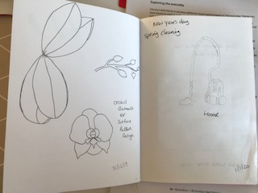
2nd Jan was completing my pattern design of the orchids; here is a print out of the design which I created today.
3rd Jan was a study sketch of my cat ‘Angel’ I was trying to sketch her when she was doing different things.
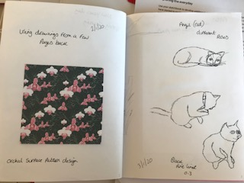
4th Jan was my painting of the apple, this time I created it using my new brush pens which also work similar to watercolours as you can blend them.
5th Jan was an outing to the coast, it was chilly and windy but I managed a sketch of the view, this could be something to work on at a later stage.
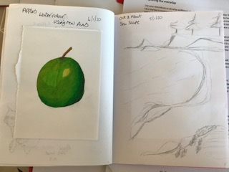
6th Jan watercolour tests of the colours we saw yesterday at the coast, lots of cold colours, fresh.
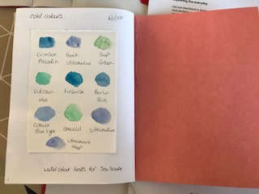

Reflection
So that’s my sketchbook completed, I was surprised how I managed to create something every day over the busiest period of the year. It was nice writing this up as you remembered everything you had done.
I enjoyed creating a sketchbook from scratch and making one this time, I feel as though the book was a little stiff and sometimes the right paper was on the wrong page for me to complete a painting or use paints.
I was surprised how my relationship with my sketchbook hand changed over the last few months until I started this unit. I didn’t realise that I had become a little disillusioned by them! After asking myself about my relationship with it, I realised I needed a fresh look at how and why I use it.
Creating the little made sketchbooks, the mini zines and foldy ones was refreshing to do; I was surprised how much fun I found it, it made a change.
I enjoyed working fast and using marks and mark making and just experimenting and having fun.
I initially was not sure about hiding work or creating hiding spaces, but I must admit I did find it interesting and it made me look at my sketchbook differently.
I wouldn’t say I would make another sketchbook as I found my one stiff, difficult to handle and because I use mixed media, frustrating that the paper didn’t hold the paint, so you had to add more paper (which is a waste) but I would continue to create mini zines and foldy sketchbooks to add into my sketchbook, these would be handy when out and about and travelling. I would also add in pockets and hiding places, not necessarily for hiding sake, more for collecting things or small colour tests or ideas that I want to keep separate or to not be on show.
This unit has made me look at my sketchbook differently and has given me a fresh eye to start the New Year with and to experiment further, A new invigorated perspective.
How do I feel about other people looking at my sketchbook?
I am happy for my tutor to see my sketchbook to get feedback for it; it is my first sketchbook for this unit so it will be interesting to see what he says. I am happy for other students to look at it also, a lot of the work is the initial sketches of new ideas or things I might like to work from later so I know it’s all about learning.
How did your interpretation of the ‘every day’ change as you have carried out the work for this assignment?
I realised whilst I was writing this assignment up that my ‘every day’ is mainly about the things I see, I sketch at places I visit or sketch from things I see when I’m doing them. It is MY every day, not everybody’s everyday!
I also love nature and this comes up a lot in my sketchbooks and what I choose to draw.
Are there any aspects of the everyday that you think you would like to focus on in more depth in future assignments?
I would probably say more focus on drawing people, body parts, actions and movement. It’s something I want to work on to be an Illustrator so something that’s necessary to achieve. I could probably when I go to places and draw nature, animals, flowers etc I should turn my attention more to the people around instead and draw them.
What will you take forward from your understanding of how other artists and illustrators use sketchbooks?
I have taken away with me that things don’t have to be perfect, mistakes are ok, and sketches that are not good or bad are ok. These are just works in progress or ideas, some might not go anywhere and some might become something amazing, but this is the first step in the process. I have become more confident and open because of this as I have seen other artists and illustrators sketchbooks and they are not perfect too.

